**DAILY ONLINE ACTIVITIES SUMMARY**

|  |  |  |  |  |  |  |  |
| --- | --- | --- | --- | --- | --- | --- | --- |
| **Date:** | **22/05/2020** | | | | **Name:** | **AKASH KUMAR S** | |
| **Sem & Sec** | **8thA** | | | | **USN:** | **4AL16CS006** | |
| **Online Test Summary** | | | | | | | |
| **Subject** | | **BDA** | | | | | |
| **Max. Marks** | | **40** | | **Score** | | **25** | |
| **Certification Course Summary** | | | | | | | |
| **Course** | Introduction to Ethical Hacking | | | | | | |
| **Certificate Provider** | | | **Great learning**  **Academy** | **Duration** | | | **6 hours** |
| **Coding Challenges** | | | | | | | |
| **Problem Statement::Given an array containing n distinct numbers taken from 0, 1, 2, ..., n,find the one that is missing from the array.** | | | | | | | |
| **Status: COMPLETED** | | | | | | | |
| **Uploaded the report in Github** | | | | **YES** | | | |
| **If yes Repository name** | | | | **Akash_Daily_Progress** | | | |
| **Uploaded the report in slack** | | | | **YES** | | | |

Online Test Details: BDA---Module 2

Snapshot of test

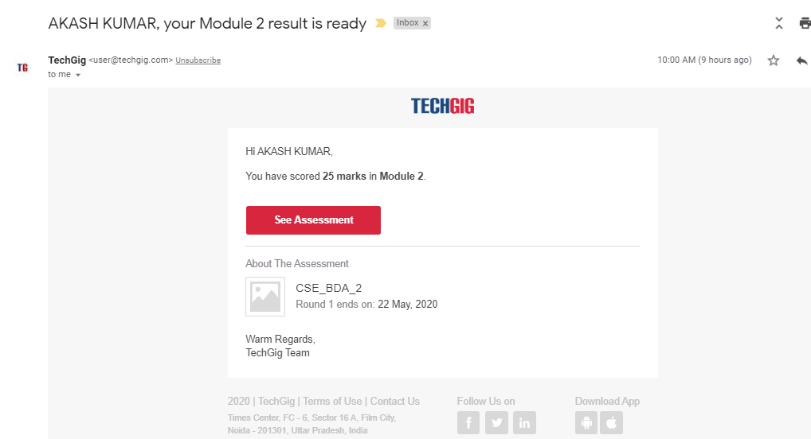

Certification Course Details:

#### Introduction to Ethical Hacking

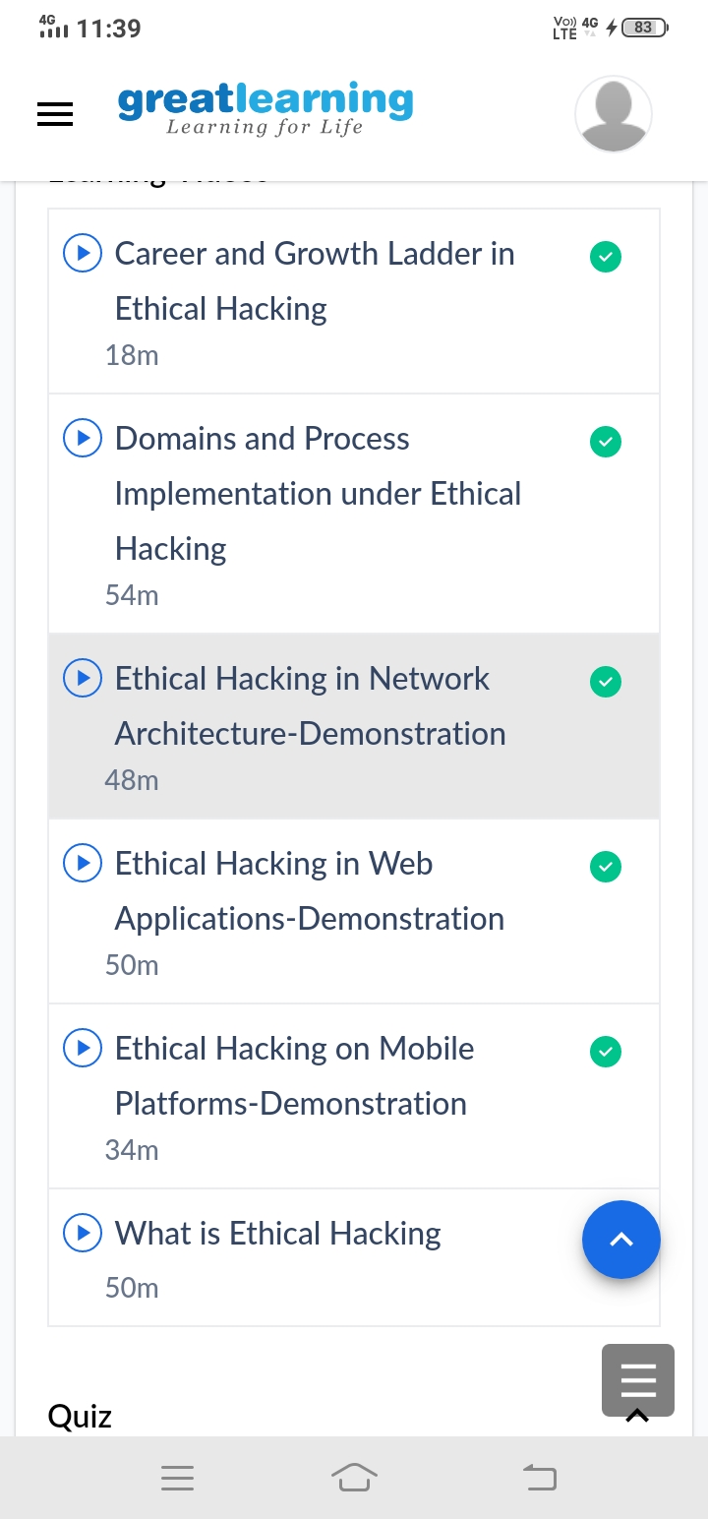

Coding Challenges Details

**Program**

# Given an array containing n distinct numbers taken from 0, 1, 2, ..., n,

# find the one that is missing from the array.

def missingNumber(elements):

max_element = max(elements)

x = max_element * (max_element + 1) // 2 - sum(elements)

if x == 0 and 0 in elements:

return max_element + 1

elif x == 0 and 0 not in elements:

return 0

return x

elements = []

size = int(input('Enter the value of n \n'))

print('Enter the Elements')

for i in range(0, size):

elements.append(int(input()))

result = missingNumber(elements)

print('The missing number is :',result)