DAILY ONLINE ACTIVITIES SUMMARY

|  |  |  |  |  |  |  |  |
| --- | --- | --- | --- | --- | --- | --- | --- |
| ***Date:*** | ***23/05/2020*** | | | | ***Name:*** | ***AKASH KUMAR S*** | |
| ***Sem & Sec*** | ***8th A*** | | | | ***USN:*** | ***4AL16CS006*** | |
| ***Online Test Summary*** | | | | | | | |
| ***Subject*** | | ***BDA*** | | | | | |
| ***Max. Marks*** | | ***No test*** | | ***Score*** | | ***No test*** | |
| ***Certification Course Summary*** | | | | | | | |
| ***Course*** | ***Introduction to Ethical hacking*** | | | | | | |
| ***Certificate Provider*** | | | ***Great learning***  ***Academy*** | ***Duration*** | | | ***6 hours*** |
| ***Coding Challenges*** | | | | | | | |
| ***Problem Statement:****program to check wheather the given strings are Anagram* | | | | | | | |
| ***Status: COMPLETED*** | | | | | | | |
| ***Uploaded the report in Github*** | | | | ***YES*** | | | |
| ***If yes Repository name*** | | | | ***Akash_Daily_Progress*** | | | |
| ***Uploaded the report in slack*** | | | | ***YES*** | | | |

**Online Test Details:**

**#No test**

**Certification Course Details:**

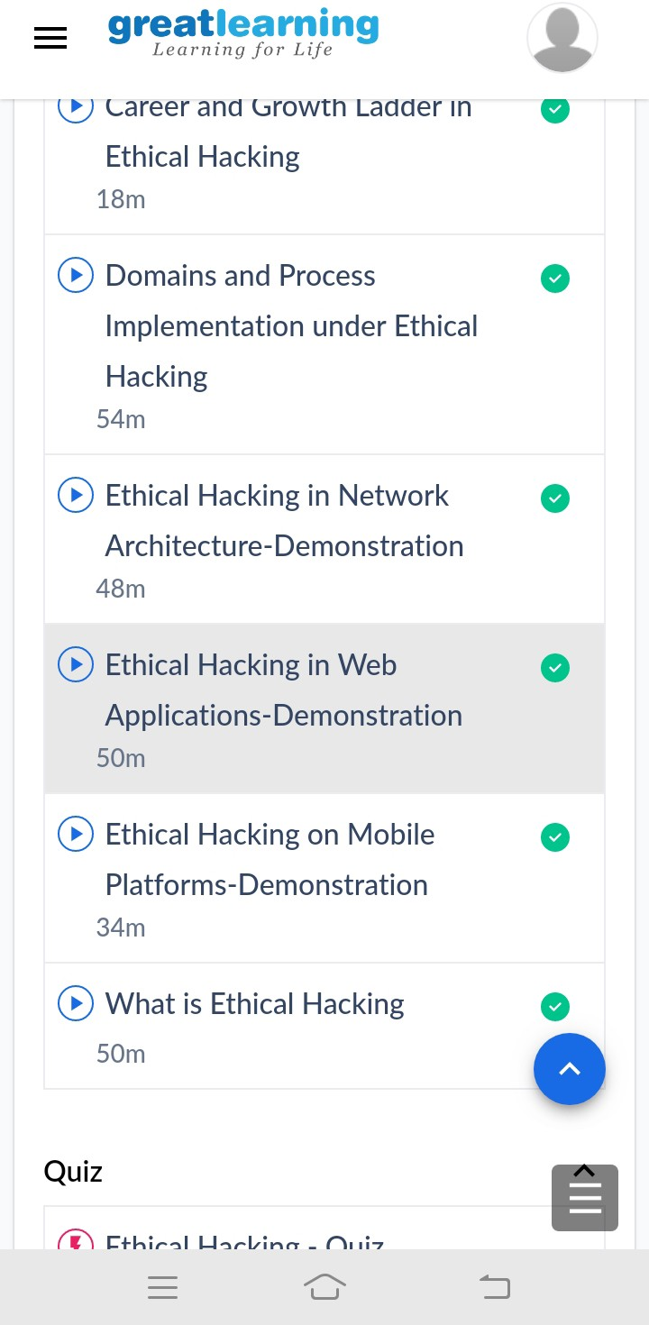

***Introduction to Ethical Hacking***

**Coding Challenges Details**

# program to check wheather the given strings are Anagram string1 = input('Enter the first string \n')

string2 = input('Enter the second string \n')

if sorted(string1) == sorted(string2): print('strings are Anagram')

else:

print('strings are not Anagram')