**DAILY ONLINE ACTIVITIES SUMMARY**

|  |  |  |  |  |  |  |  |
| --- | --- | --- | --- | --- | --- | --- | --- |
| **Date:** | **26/05/2020** | | | | **Name:** | **AKASH KUMAR S** | |
| **Sem & Sec** | **8thA** | | | | **USN:** | **4AL16CS006** | |
| **Online Test Summary** | | | | | | | |
| **Subject** | | **BDA** | | | | | |
| **Max. Marks** | | **40** | | **Score** | | **26** | |
| **Certification Course Summary** | | | | | | | |
| **Course** | Introduction to Ethical hacking | | | | | | |
| **Certificate Provider** | | | **Great learning**  **Academy** | **Duration** | | | **6 hours** |
| **Coding Challenges** | | | | | | | |
| **Problem Statement:**Micro and Array update | | | | | | | |
| **Status: COMPLETED** | | | | | | | |
| **Uploaded the report in Github** | | | | **YES** | | | |
| **If yes Repository name** | | | | **Akash_Daily_Progress** | | | |
| **Uploaded the report in slack** | | | | **YES** | | | |

Online Test Details:

Snapshot of test

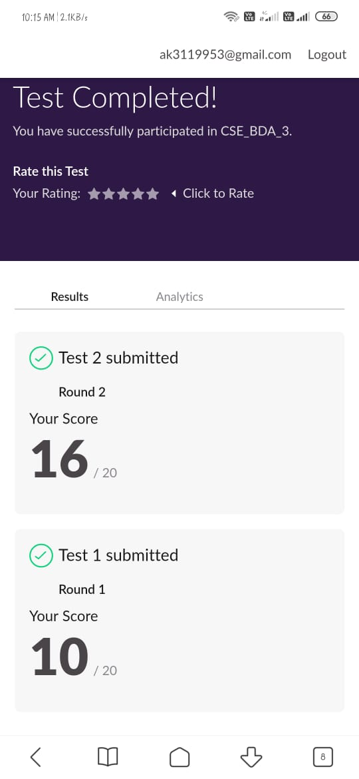

Certification Course Details:

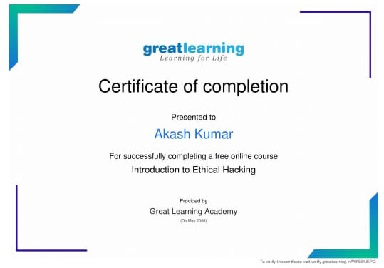

#### Introduction to Ethical Hacking

Coding Challenges Details

# Micro and Array update

testcase = int(input('Enter the number of testcase \n'))

while testcase != 0:

elements = []

differece = 0

count = 0

n = int(input('Enter the value for n \n'))

key = int(input('Enter the key \n'))

print('Enter the elements')

for i in range(0, n):

elements.append(int(input()))

for i in range(len(elements)):

if elements[i] < key:

differece += (key - 1) - elements[i]

print('The minimum amount of time is :',differece)

testcase -= 1