**DAILY ONLINE ACTIVITIES SUMMARY**

|  |  |  |  |  |  |  |  |
| --- | --- | --- | --- | --- | --- | --- | --- |
| **Date:** | **28/05/2020** | | | | **Name:** | **AKASH KUMAR S** | |
| **Sem & Sec** | **8thA** | | | | **USN:** | **4AL16CS006** | |
| **Online Test Summary** | | | | | | | |
| **Subject** | | **SMS** | | | | | |
| **Max. Marks** | | **60** | | **Score** | | **54** | |
| **Certification Course Summary** | | | | | | | |
| **Course** | Introduction to Amazon Elastic Compute Cloud (EC2) | | | | | | |
| **Certificate Provider** | | | **Amazon Web Service** | **Duration** | | | **10 min** |
| **Coding Challenges** | | | | | | | |
| **Problem Statement:** Pink Floyd and Happiness | | | | | | | |
| **Status: COMPLETED** | | | | | | | |
| **Uploaded the report in Github** | | | | **YES** | | | |
| **If yes Repository name** | | | | **Akash_Daily_Progress** | | | |
| **Uploaded the report in slack** | | | | **YES** | | | |

Online Test Details:

Snapshot of test

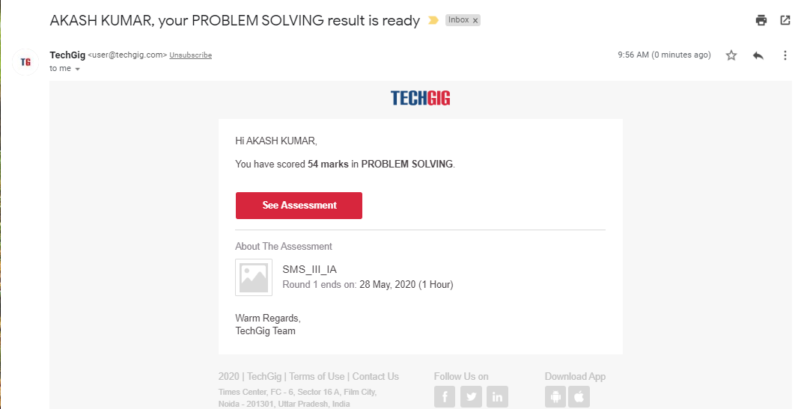

Certification Course Details:

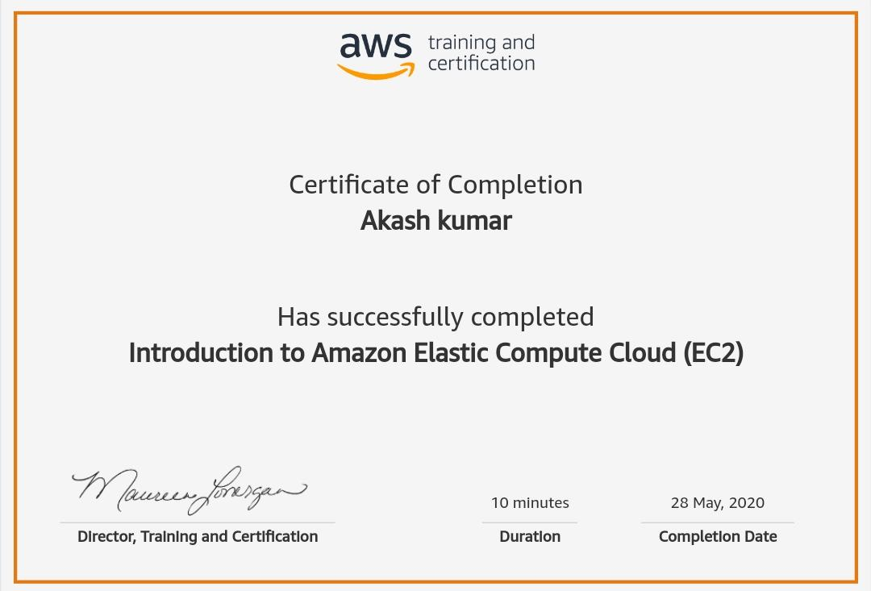

#### Introduction to Ethical Hacking

Coding Challenges Details

#Pink Floyd and Happiness

n = int(input('Enter the number of records'))

records = []

count = 0

print('Enter the records')

for i in range(0, n):

records.append(int(input()))

for i in range(len(records)):

if records[i] <= n:

count ++

if count == n:

print('Yes')

else:

print('No')