**DAILY ONLINE ACTIVITIES SUMMARY**

|  |  |  |  |  |  |  |  |
| --- | --- | --- | --- | --- | --- | --- | --- |
| **Date:** | **31/05/2020** | | | | **Name:** | **AKASH KUMAR S** | |
| **Sem & Sec** | **8thA** | | | | **USN:** | **4AL16CS006** | |
| **Online Test Summary** | | | | | | | |
| **Subject** | | **BDA** | | | | | |
| **Max. Marks** | | **20** | | **Score** | | **18** | |
| **Certification Course Summary** | | | | | | | |
| **Course** | Hadoop 3.0 | | | | | | |
| **Certificate Provider** | | | **Great learning**  **Academy** | **Duration** | | | **2.5 hours** |
| **Coding Challenges** | | | | | | | |
| **Problem Statement:** Find the quadratic equation. | | | | | | | |
| **Status: COMPLETED** | | | | | | | |
| **Uploaded the report in Github** | | | | **YES** | | | |
| **If yes Repository name** | | | | **Akash_Daily_Progress** | | | |
| **Uploaded the report in slack** | | | | **YES** | | | |

Online Test Details:

Snapshot of test

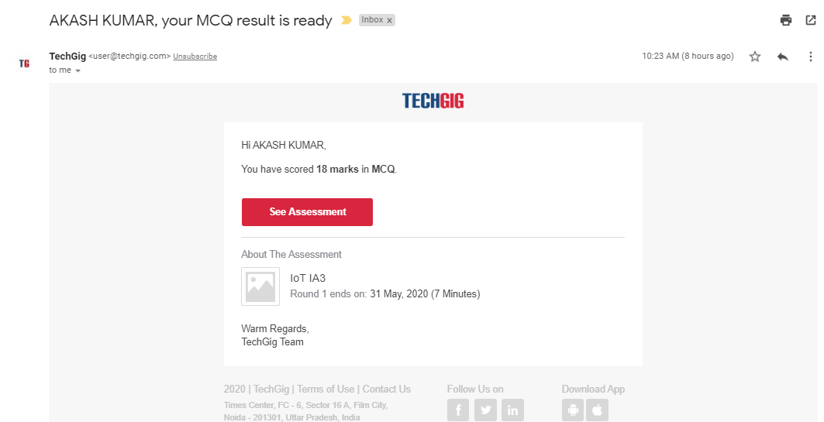

Certification Course Details:



Coding Challenges Details

**Program1:** **Find the quadratic equation**

#include <iostream>

#include <cmath>

using namespace std;

int main() {

float a, b, c, x1, x2, discriminant, realPart, imaginaryPart;

cout<< "Enter coefficients a, b and c: ";

cin>> a >> b >> c;

discriminant = b*b - 4*a*c;

if (discriminant > 0) {

x1 = (-b + sqrt(discriminant)) / (2*a);

x2 = (-b - sqrt(discriminant)) / (2*a);

cout<< "Roots are real and different." <<endl;

cout<< "x1 = " << x1 <<endl;

cout<< "x2 = " << x2 <<endl;

}

else if (discriminant == 0) {

cout<< "Roots are real and same." <<endl;

x1 = (-b + sqrt(discriminant)) / (2*a);

cout<< "x1 = x2 =" << x1 <<endl;

}

else {

realPart = -b/(2*a);

imaginaryPart =sqrt(-discriminant)/(2*a);

cout<< "Roots are complex and different." <<endl;

cout<< "x1 = " <<realPart<< "+" <<imaginaryPart<< "i" <<endl;

cout<< "x2 = " <<realPart<< "-" <<imaginaryPart<< "i" <<endl;

}

return 0;

}