**DAILY ONLINE ACTIVITIES SUMMARY**

|  |  |  |  |  |  |  |  |  |
| --- | --- | --- | --- | --- | --- | --- | --- | --- |
| **Date:** | **1-06-2020** | | | | | **Name:** | **John Alsten Tauro** | |
| **Sem & Sec** | **6th A** | | | | | **USN:** | **4AL17CS037** | |
| **Online Test Summary** | | | | | | | | |
| **Subject** | | **Cryptography network security and cyber laws (CNSC)** | | | | | | |
| **Max. Marks** | | **60** | | **Score** | | | **52** | |
| **Certification Course Summary** | | | | | | | | |
| **Course** | **A Full Stack Web Developer – Beginner to Advanced** | | | | | | | |
| **Certificate Provider** | | | **Udemy** | | **Duration** | | | **19.5hrs** |
| **Coding Challenges** | | | | | | | | |
| **Problem Statement**: 1. Write a Java Program to left rotate the elements of an array.  **2.** Python Program to remove duplicate elements from a list.  **3.** Given an array of positive integers. Write a C Program to find the leaders in the array. | | | | | | | | |
| **Status: YES, Completed all Programs** | | | | | | | | |
| **Uploaded the report in Github** | | | | | **YES** | | | |
| **If yes Repository name** | | | | | [**https://github.com/alvas-education-foundation/Alsten_Tauro**](https://github.com/alvas-education-foundation/Alsten_Tauro) | | | |
| **Uploaded the report in slack** | | | | | **YES** | | | |

Online Test Details: (Attach the snapshot and briefly write the report for the same)

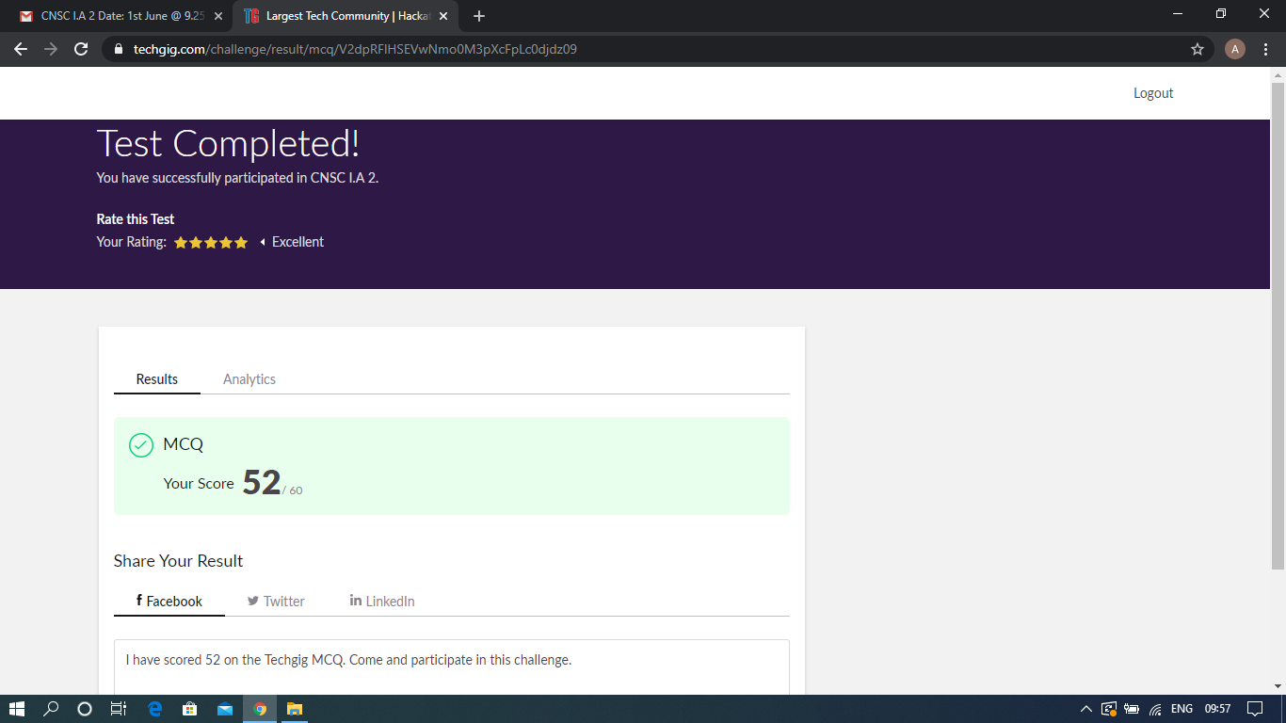

Scored 52 out of 60 in CNSC 2nd I.A test

Certification Course Details: (Attach the snapshot and briefly write the report for the same)

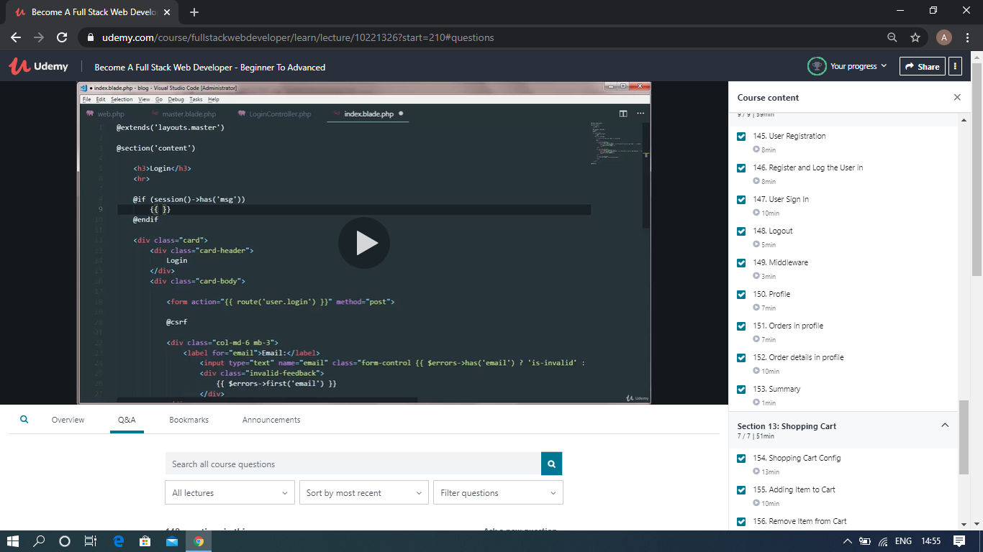

The above course is being taken up by me which is based on the full stack web development. It started with the basics of HTML, Today in Online course I studied about User registration, Register and log the user in, User sign in, Logout, Profile, Orders in profile, Orders details in profile. The details of the course and certificate provider is mentioned in the above form.

Coding Challenges Details: (Attach the snapshot and briefly write the report for the same)

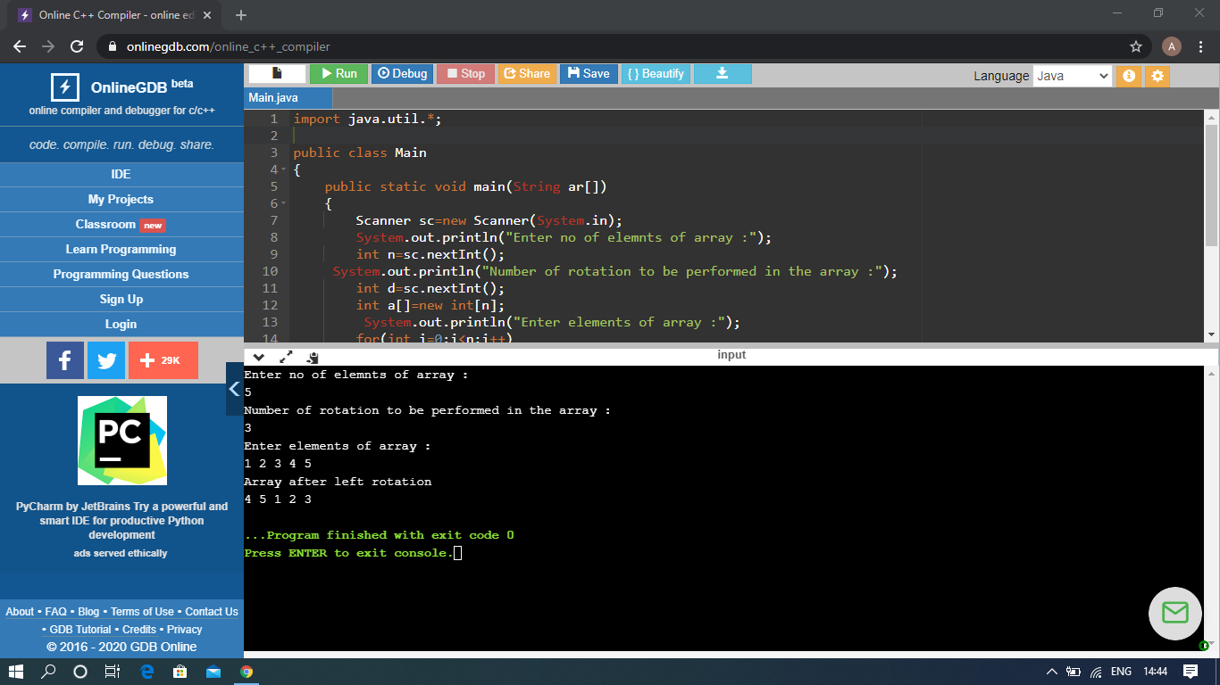

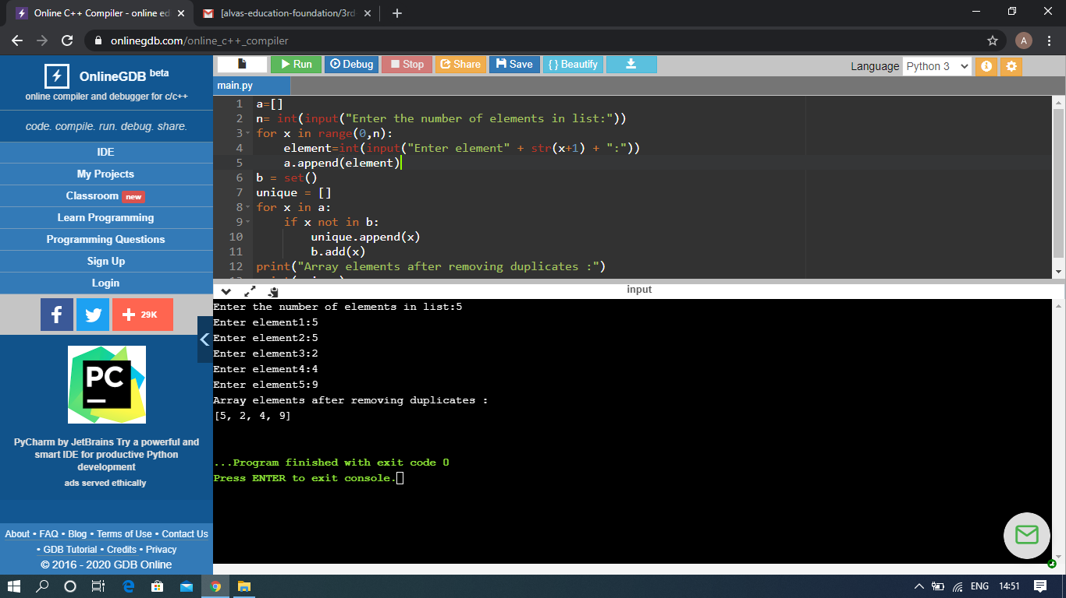

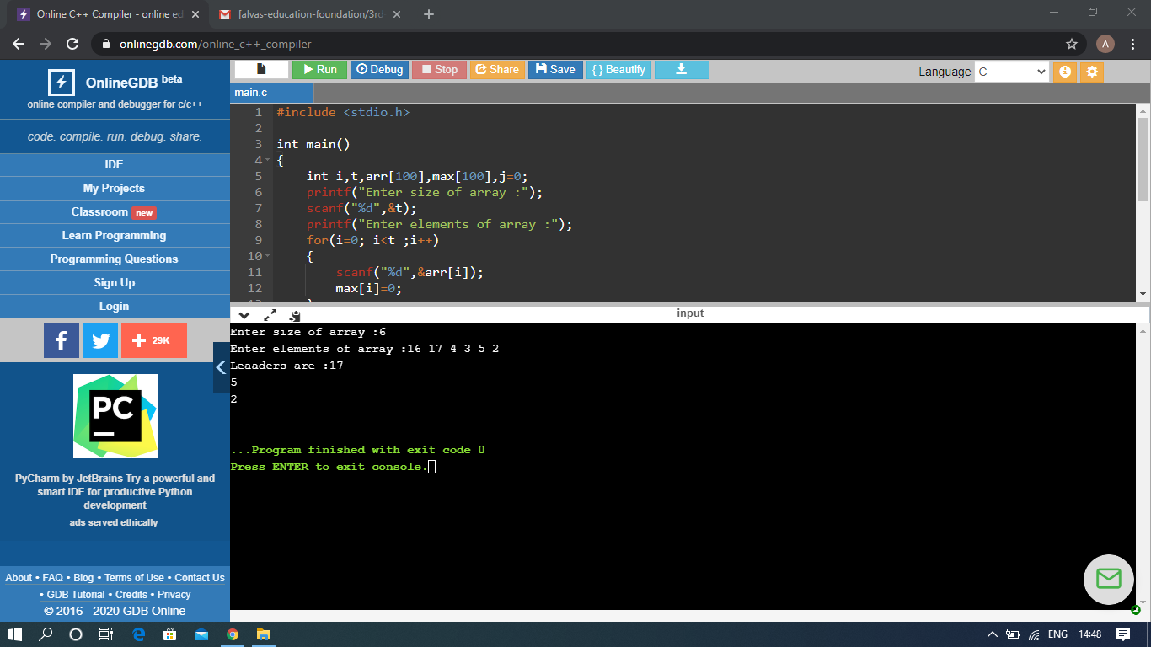

The above Programs were written and executed and the output of the same is displayed above. The code for those 3 programs have been uploaded to the github repository and the link to the same is provided on the form.