**DAILY ONLINE ACTIVITIES SUMMARY**

|  |  |  |  |  |  |  |  |  |
| --- | --- | --- | --- | --- | --- | --- | --- | --- |
| **Date:** | **2-06-2020** | | | | | **Name:** | **John Alsten Tauro** | |
| **Sem & Sec** | **6th A** | | | | | **USN:** | **4AL17CS037** | |
| **Online Test Summary** | | | | | | | | |
| **Subject** | | **Computer graphics and visualisation(CGV)** | | | | | | |
| **Max. Marks** | | **30** | | **Score** | | | **30** | |
| **Certification Course Summary** | | | | | | | | |
| **Course** | **A Full Stack Web Developer – Beginner to Advanced** | | | | | | | |
| **Certificate Provider** | | | **Udemy** | | **Duration** | | | **19.5hrs** |
| **Coding Challenges** | | | | | | | | |
| **Problem Statement**: 1. .Python program to return a list containing first and last element using list slicing method.  **2.** Write a java program to check if given linked list has a loop or not.  **3.** Given an array of positive integers. Write a C Program to find inversion count of array. | | | | | | | | |
| **Status: YES, Completed all Programs** | | | | | | | | |
| **Uploaded the report in Github** | | | | | **YES** | | | |
| **If yes Repository name** | | | | | [**https://github.com/alvas-education-foundation/Alsten_Tauro**](https://github.com/alvas-education-foundation/Alsten_Tauro) | | | |
| **Uploaded the report in slack** | | | | | **YES** | | | |

Online Test Details: (Attach the snapshot and briefly write the report for the same)

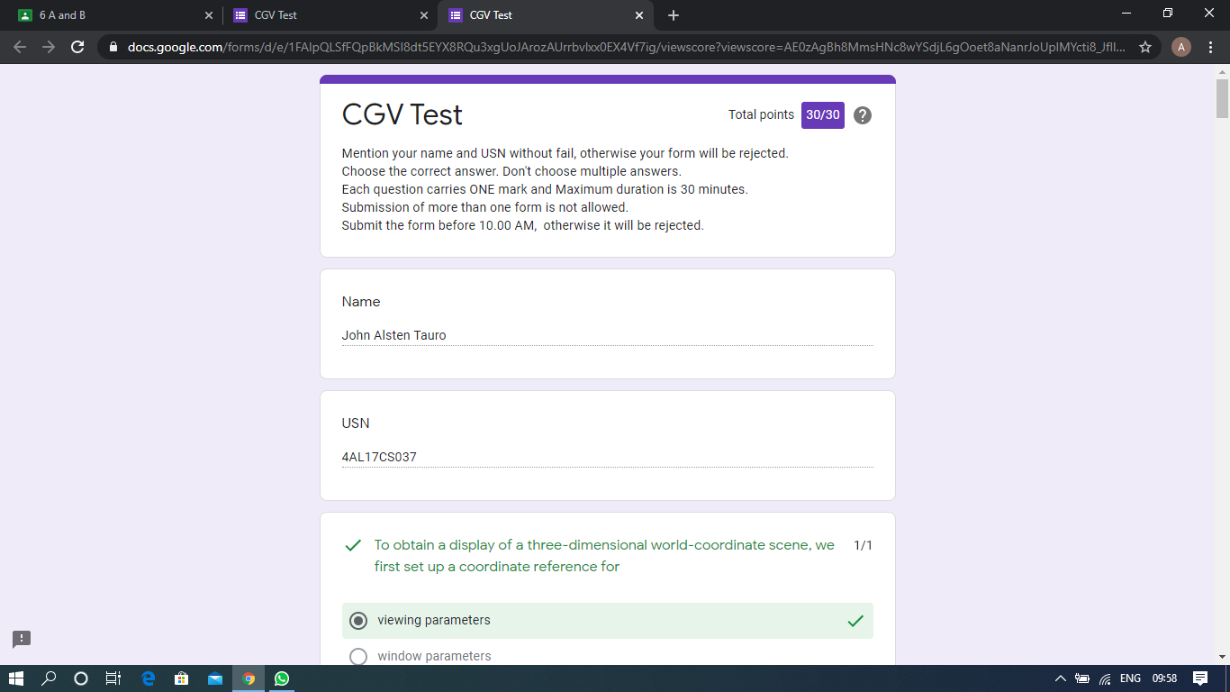

Scored 30 out of 30 in CGV test

Certification Course Details: (Attach the snapshot and briefly write the report for the same)

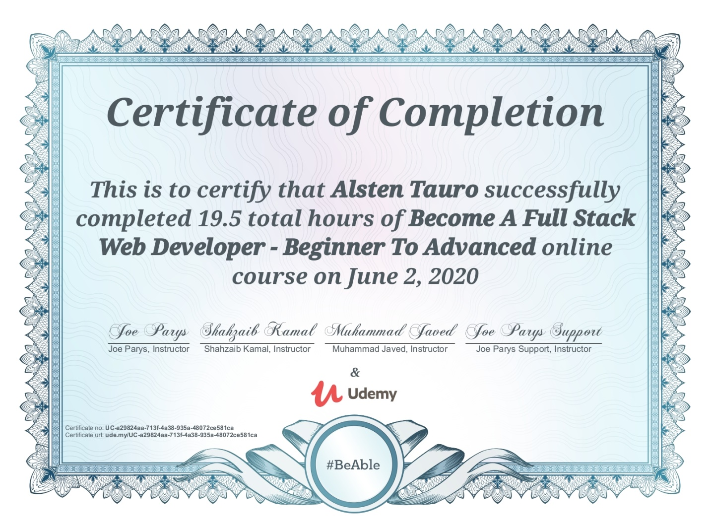

Successfully completed Become A Full Stack Web Developer – Beginner To Advanced online course on June 2, 2020.

Coding Challenges Details: (Attach the snapshot and briefly write the report for the same)

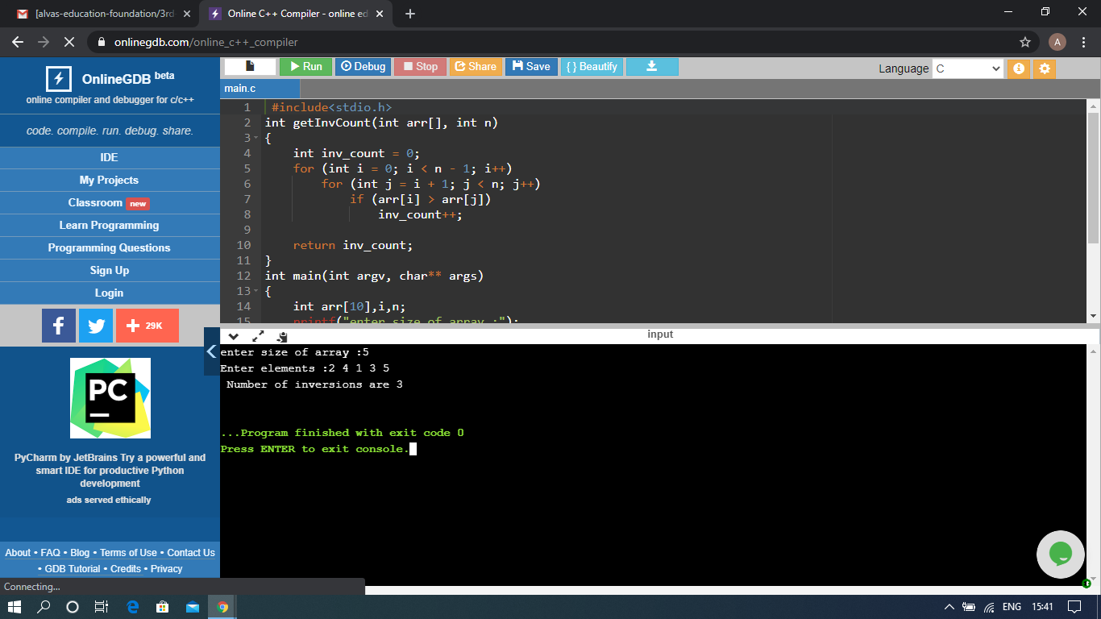

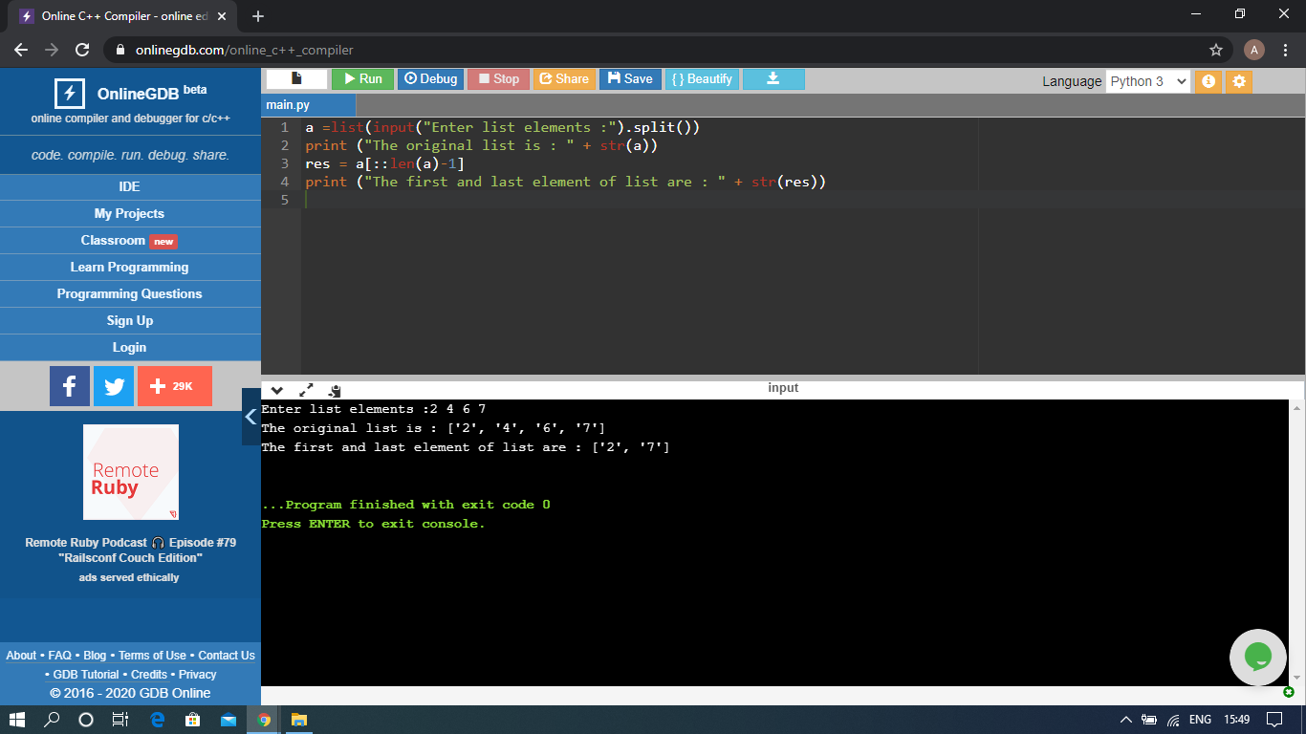

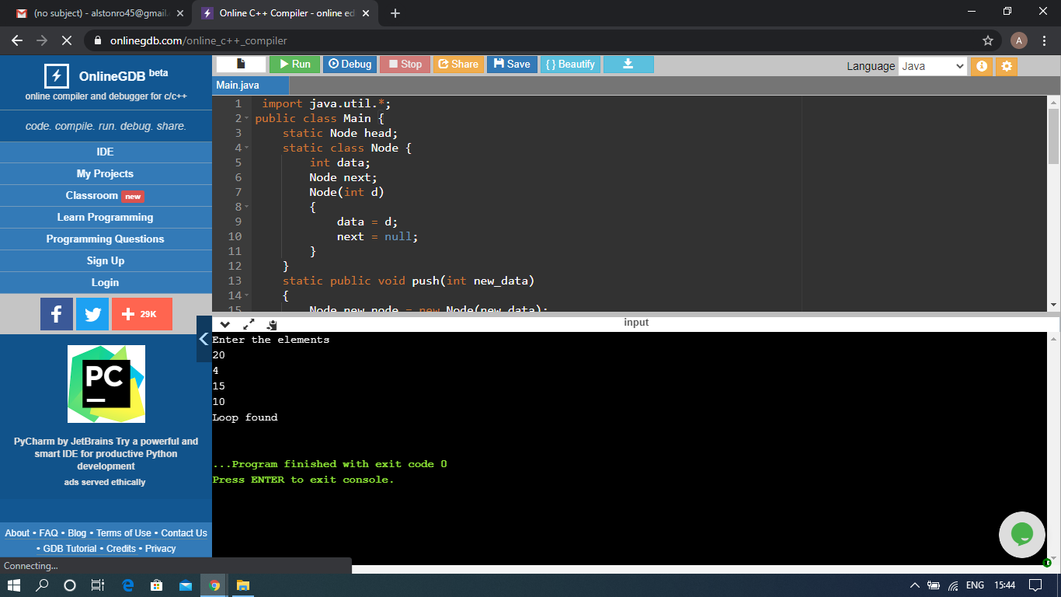

The above Programs were written and executed and the output of the same is displayed above. The code for those 3 programs have been uploaded to the github repository and the link to the same is provided on the form.