**DAILY ONLINE ACTIVITIES SUMMARY**

|  |  |  |  |  |  |  |  |  |
| --- | --- | --- | --- | --- | --- | --- | --- | --- |
| **Date:** | **2-07-2020** | | | | | **Name:** | **John Alsten Tauro** | |
| **Sem & Sec** | **6th A** | | | | | **USN:** | **4AL17CS037** | |
| **Online Test Summary** | | | | | | | | |
| **Subject** | |  | | | | | | |
| **Max. Marks** | |  | | **Score** | | |  | |
| **Pre-Placement Course Summary** | | | | | | | | |
| **Pre-placement training** |  | | | | | | | |
| **Faculty name** | | |  | | **Duration** | | |  |
| **Coding Challenges** | | | | | | | | |
| Problem Statement: 1. Write a program that will read a sequence of positive real numbers entered by the user and will print the same numbers in sorted order from smallest to largest. The user will input a zero to mark the end of the input. Assume that at most 100 positive numbers will be entered..   .  . | | | | | | | | |
| **Status: YES, Completed all Programs** | | | | | | | | |
| **Uploaded the report in Github** | | | | | **YES** | | | |
| **If yes Repository name** | | | | | [**https://github.com/alvas-education-foundation/Alsten_Tauro**](https://github.com/alvas-education-foundation/Alsten_Tauro) | | | |
| **Uploaded the report in slack** | | | | | **YES** | | | |

Coding Challenges Details: (Attach the snapshot and briefly write the report for the same)

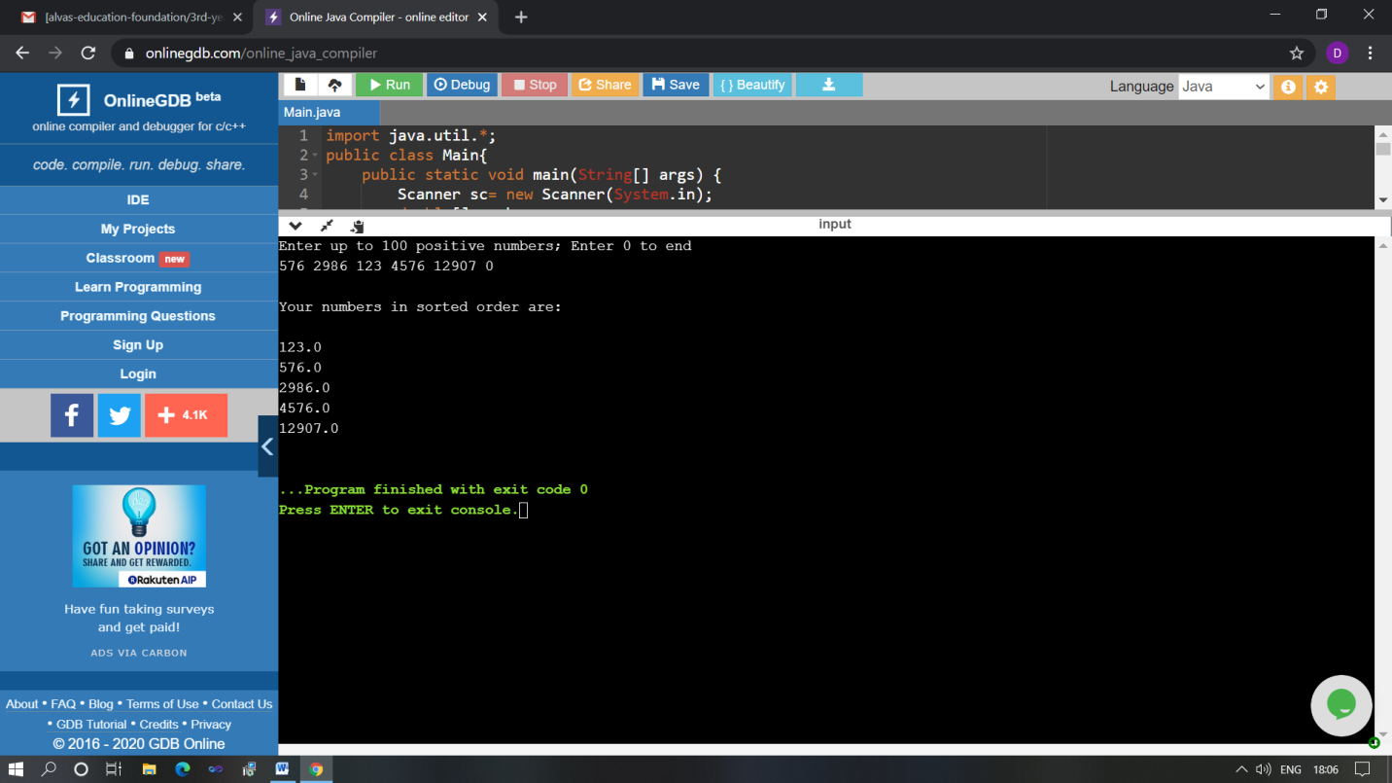

The above Programs were written and executed and the output of the same is displayed above. The code for those 1 programs have been uploaded to the github repository and the link to the same is provided on the form.