**DAILY ONLINE ACTIVITIES SUMMARY**

|  |  |  |  |  |  |  |  |  |
| --- | --- | --- | --- | --- | --- | --- | --- | --- |
| **Date:** | **3-06-2020** | | | | | **Name:** | **John Alsten Tauro** | |
| **Sem & Sec** | **6th A** | | | | | **USN:** | **4AL17CS037** | |
| **Online Test Summary** | | | | | | | | |
| **Subject** | | **PAP** | | | | | | |
| **Max. Marks** | | **20** | | **Score** | | | **18** | |
| **Certification Course Summary** | | | | | | | | |
| **Course** | **Game development using Pygame** | | | | | | | |
| **Certificate Provider** | | | **GUVI** | | **Duration** | | | **7hrs** |
| **Coding Challenges** | | | | | | | | |
| **Problem Statement**: 1. Write a python program to generate prime number in an interval.  **2.** **Python Program to Find the Largest Number in a List without using sorting algorithm.**  3. **Python Program to Accept a Hyphen Separated Sequence of Words as Input and Print the Words in a Hyphen-Separated Sequence after Sorting them Alphabetically.**  **4.** Write a Java Program to Implement Circular Doubly Linked List.  **5.** Problem statement: Take a list of length 3 containing integers, find out which is larger, first or last one and set all the elements in the list to be that value. Print the updated list. | | | | | | | | |
| **Status: YES, Completed all Programs** | | | | | | | | |
| **Uploaded the report in Github** | | | | | **YES** | | | |
| **If yes Repository name** | | | | | [**https://github.com/alvas-education-foundation/Alsten_Tauro**](https://github.com/alvas-education-foundation/Alsten_Tauro) | | | |
| **Uploaded the report in slack** | | | | | **YES** | | | |

Online Test Details: (Attach the snapshot and briefly write the report for the same)

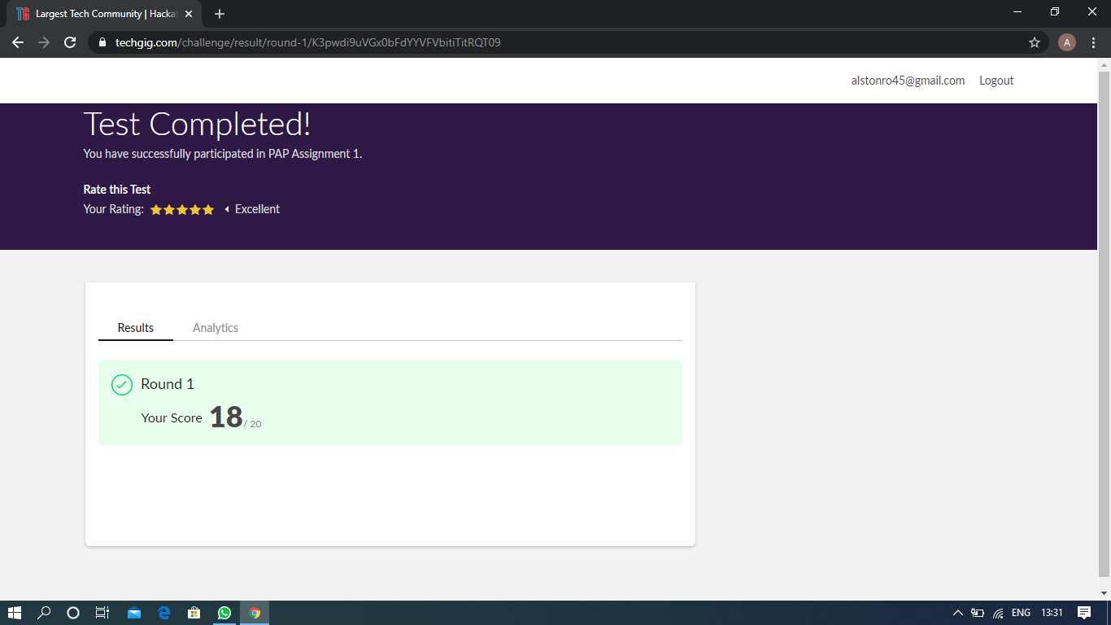

Scored 18 out of 20 in PAP assigned test

Certification Course Details: (Attach the snapshot and briefly write the report for the same)

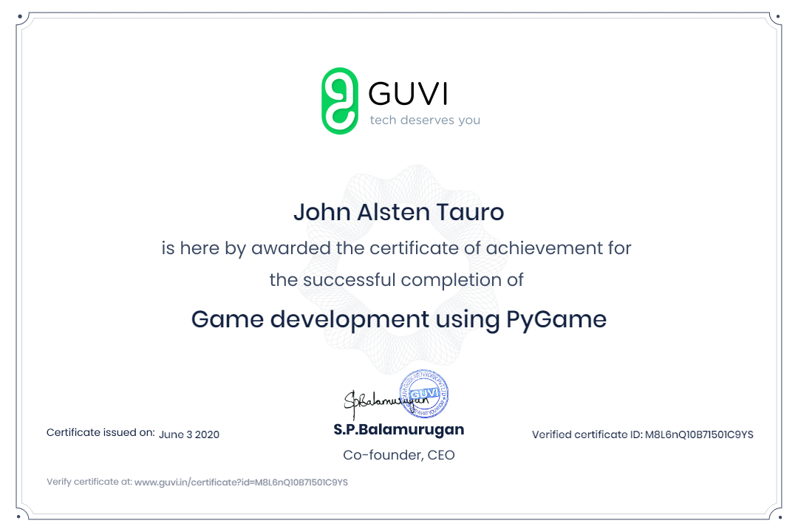

**Successfully completed Game development using Pygame in GUVI**.

Coding Challenges Details: (Attach the snapshot and briefly write the report for the same)

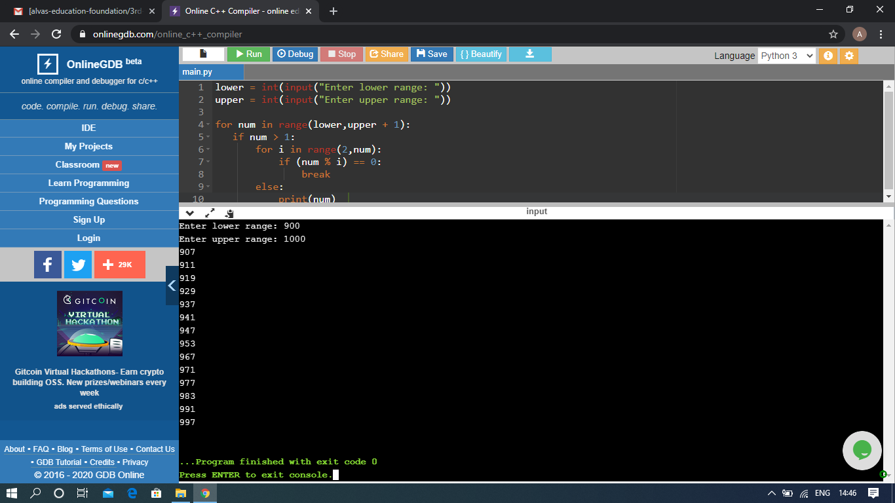

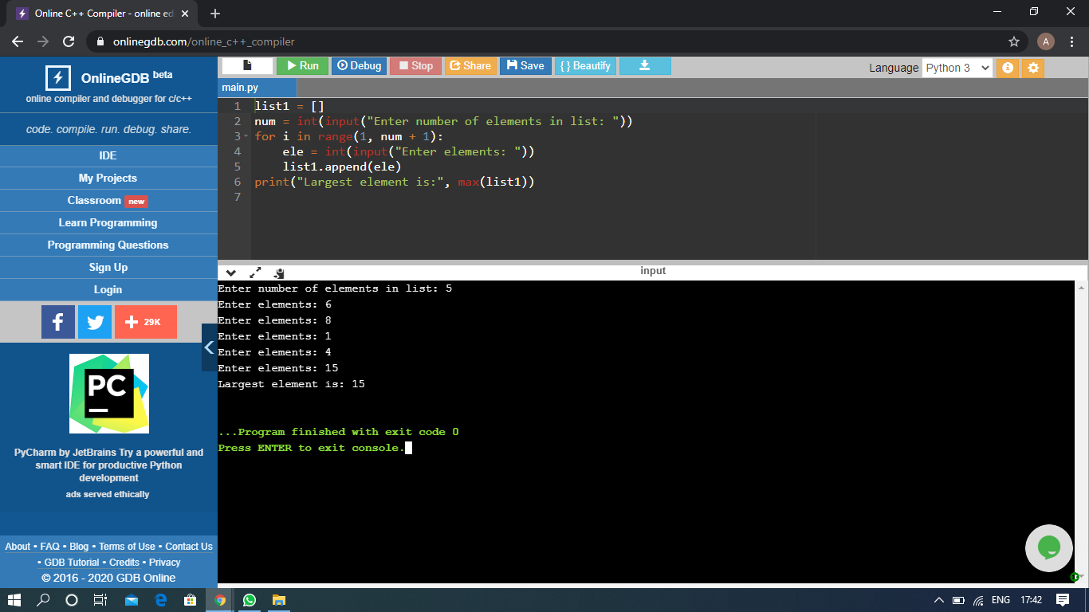

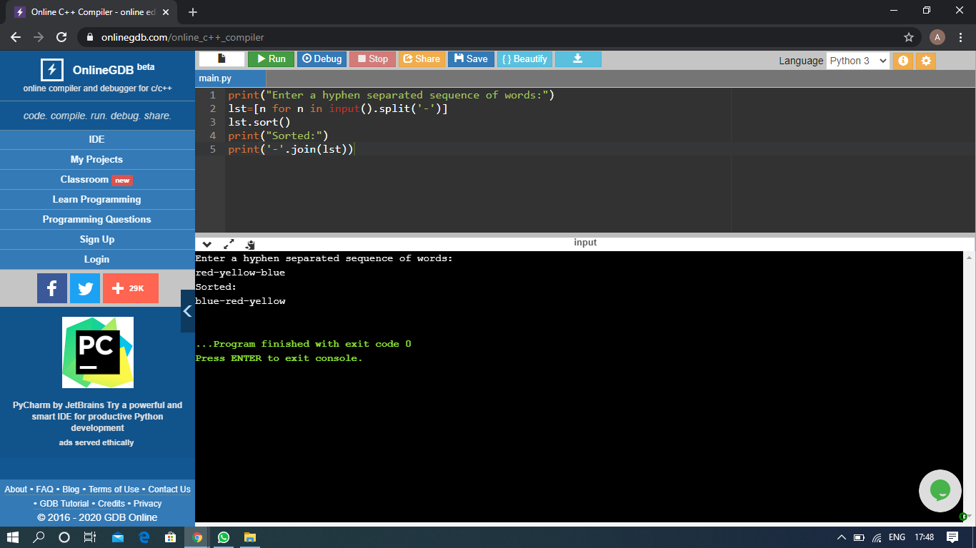

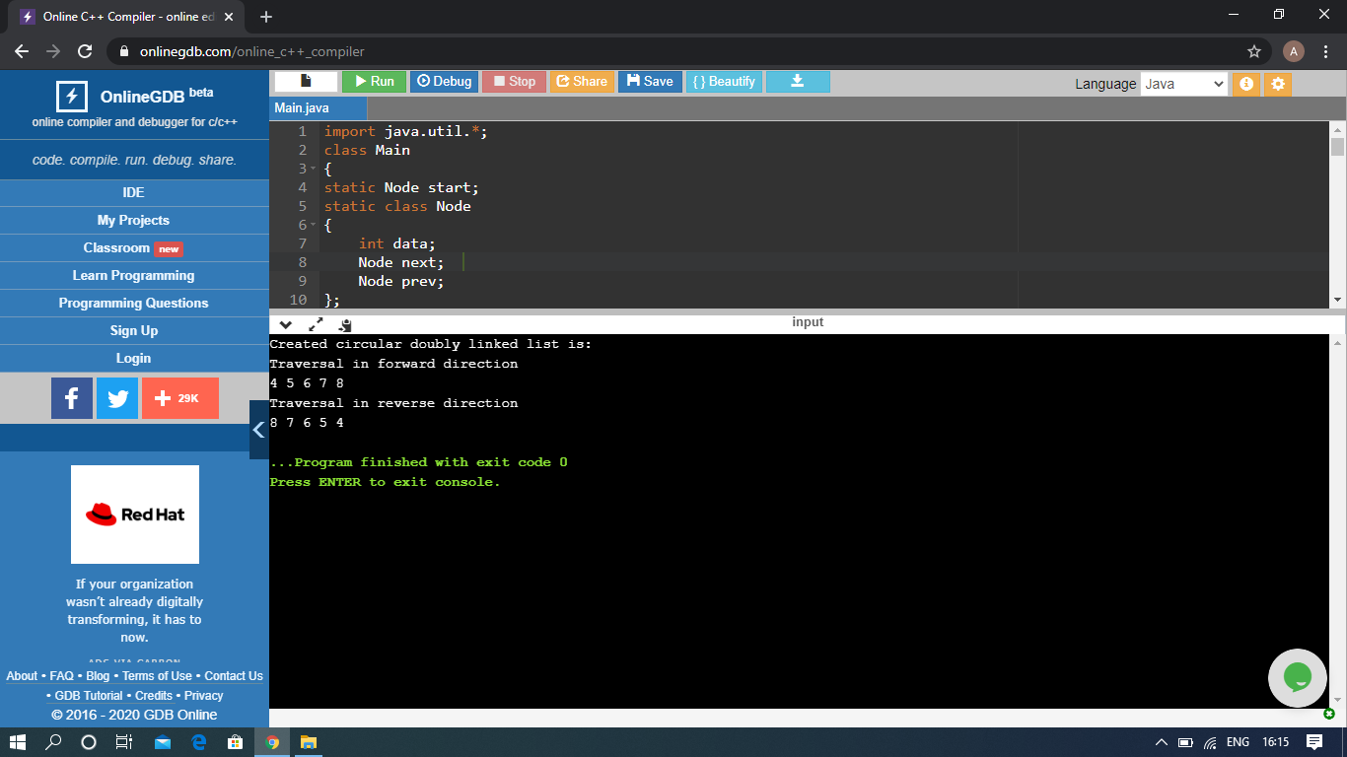

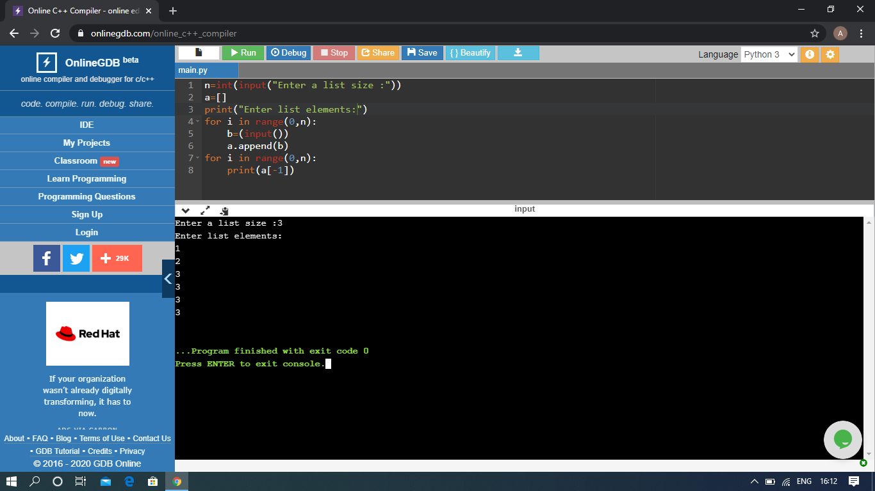

The above Programs were written and executed and the output of the same is displayed above. The code for those 5 programs have been uploaded to the github repository and the link to the same is provided on the form.