**DAILY ONLINE ACTIVITIES SUMMARY**

|  |  |  |  |  |  |  |  |  |
| --- | --- | --- | --- | --- | --- | --- | --- | --- |
| **Date:** | **4-06-2020** | | | | | **Name:** | **John Alsten Tauro** | |
| **Sem & Sec** | **6th A** | | | | | **USN:** | **4AL17CS037** | |
| **Online Test Summary** | | | | | | | | |
| **Subject** | | **Operating system(OS)** | | | | | | |
| **Max. Marks** | | **30** | | **Score** | | | **23** | |
| **Certification Course Summary** | | | | | | | | |
| **Course** | **Python for machine learning** | | | | | | | |
| **Certificate Provider** | | | **Great learning** | | **Duration** | | | **5hrs** |
| **Coding Challenges** | | | | | | | | |
| **Problem Statement**: 1. Python program to combine the strings.  **2.** Write a Java program to implement Queue Using Array And Class. | | | | | | | | |
| **Status: YES, Completed all Programs** | | | | | | | | |
| **Uploaded the report in Github** | | | | | **YES** | | | |
| **If yes Repository name** | | | | | [**https://github.com/alvas-education-foundation/Alsten_Tauro**](https://github.com/alvas-education-foundation/Alsten_Tauro) | | | |
| **Uploaded the report in slack** | | | | | **YES** | | | |

Online Test Details: (Attach the snapshot and briefly write the report for the same)

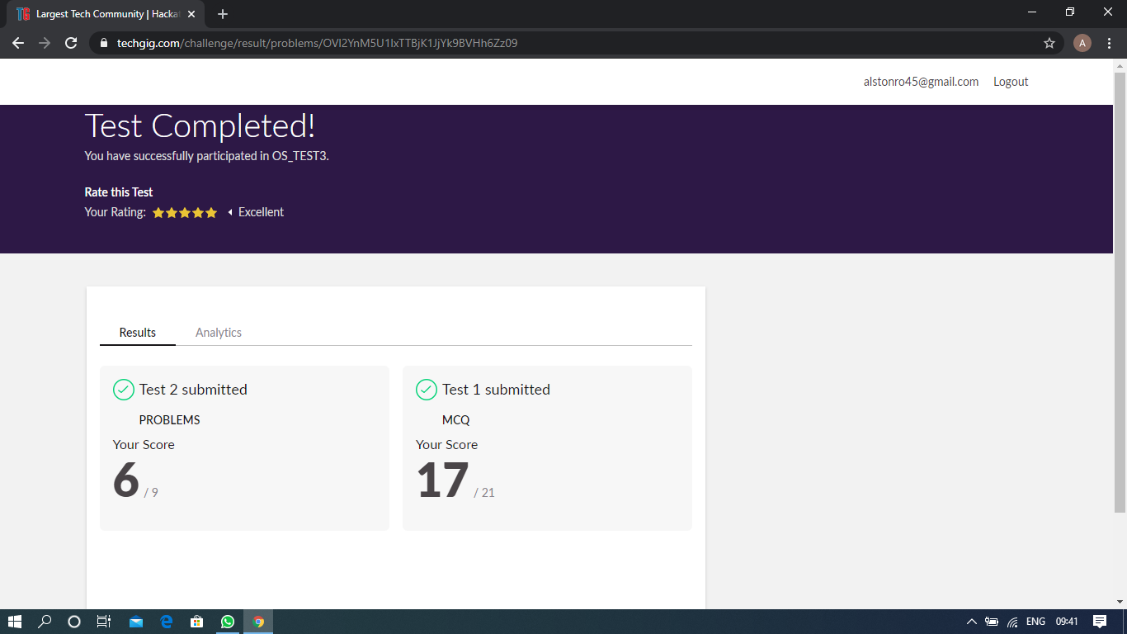

Scored 23 out of 30 in OS test

Certification Course Details: (Attach the snapshot and briefly write the report for the same)

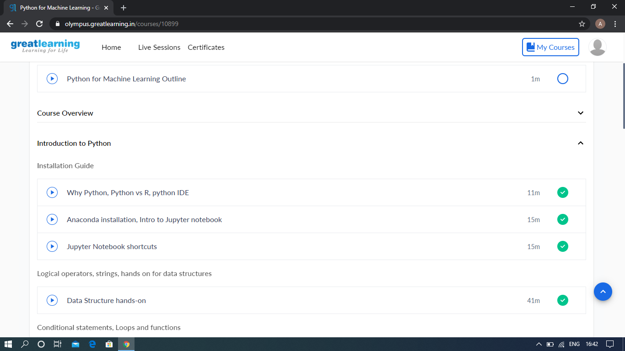

The above course is being taken up by me which is based on the Python for Machine Learning. Today in online course I studied about Introduction to python, Why python, Python vs R, Python IDE, Anaconda installation, Intro to Jupyter notebook, Jupyter Notebook shortcuts, Data structure hands-n. The details of the course and certificate provider is mentioned in the above form.

Coding Challenges Details: (Attach the snapshot and briefly write the report for the same)

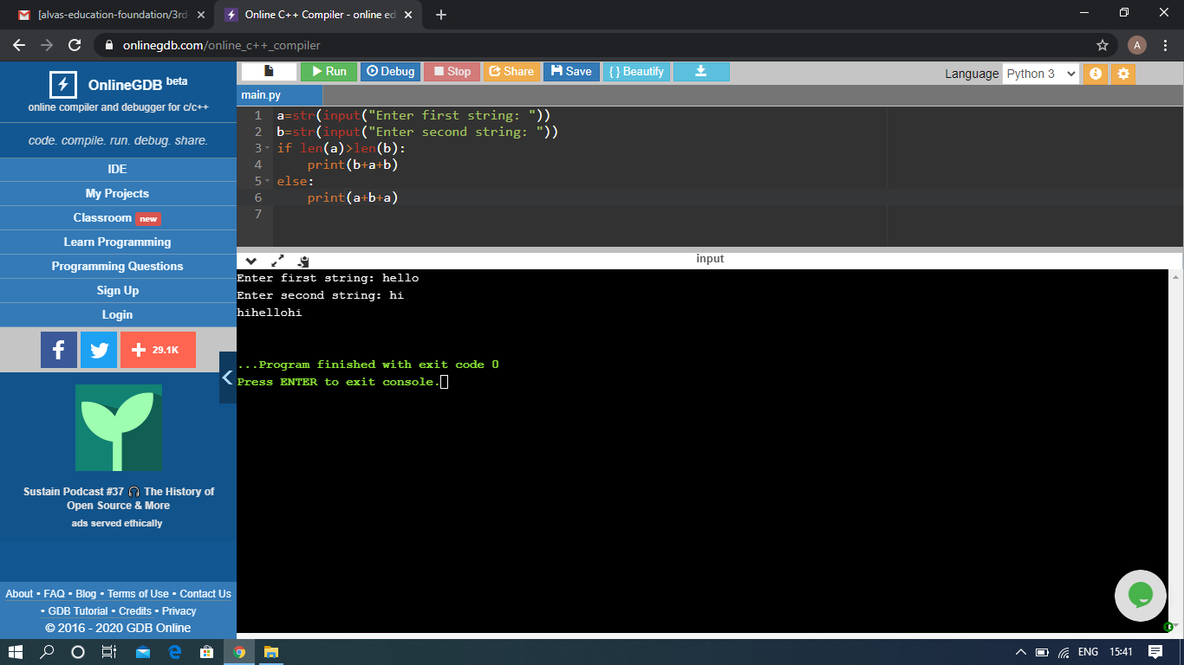

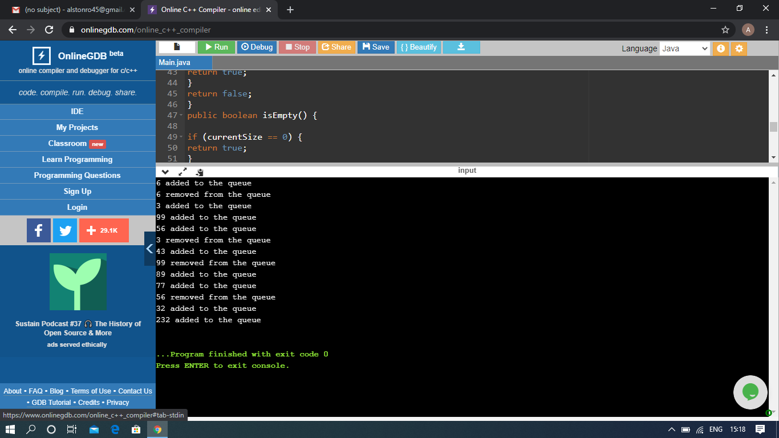

The above Programs were written and executed and the output of the same is displayed above. The code for those 2 programs have been uploaded to the github repository and the link to the same is provided on the form.