**DAILY ONLINE ACTIVITIES SUMMARY**

|  |  |  |  |  |  |  |  |  |
| --- | --- | --- | --- | --- | --- | --- | --- | --- |
| **Date:** | **5-06-2020** | | | | | **Name:** | **John Alsten Tauro** | |
| **Sem & Sec** | **6th A** | | | | | **USN:** | **4AL17CS037** | |
| **Online Test Summary** | | | | | | | | |
| **Subject** | | **Operational Research(OR) and PAP** | | | | | | |
| **Max. Marks** | | **OR:30**  **PAP:20** | | **Score** | | | **OR:30**  **PAP:15** | |
| **Certification Course Summary** | | | | | | | | |
| **Course** | **Python for machine learning** | | | | | | | |
| **Certificate Provider** | | | **Great learning** | | **Duration** | | | **5hrs** |
| **Coding Challenges** | | | | | | | | |
| **Problem Statement**: 1. Write a Java program to implement Circular Linked List Using Array And Class.  **2.** Python program to square each odd number in the list. | | | | | | | | |
| **Status: YES, Completed all Programs** | | | | | | | | |
| **Uploaded the report in Github** | | | | | **YES** | | | |
| **If yes Repository name** | | | | | [**https://github.com/alvas-education-foundation/Alsten_Tauro**](https://github.com/alvas-education-foundation/Alsten_Tauro) | | | |
| **Uploaded the report in slack** | | | | | **YES** | | | |

Online Test Details: (Attach the snapshot and briefly write the report for the same)

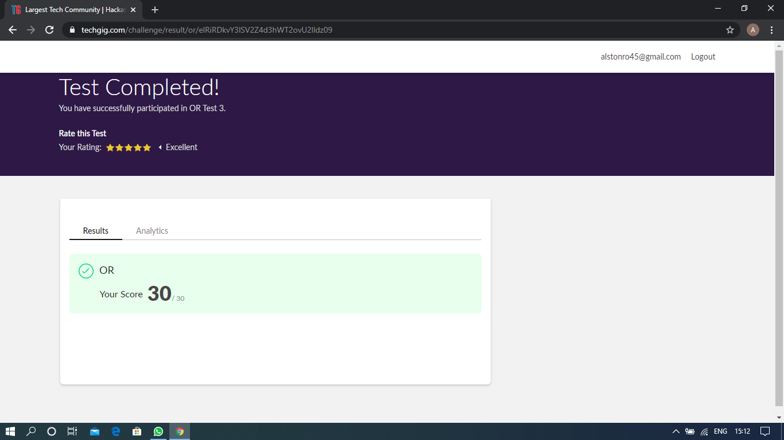

Scored 30 out of 30 in OR test

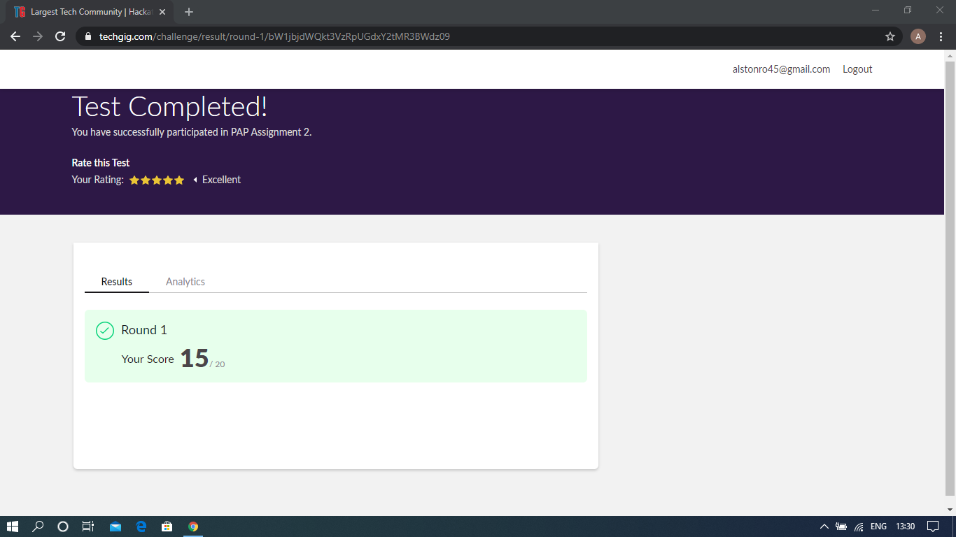

Scored 15 out of 20 in PAP assignment test

Certification Course Details: (Attach the snapshot and briefly write the report for the same)

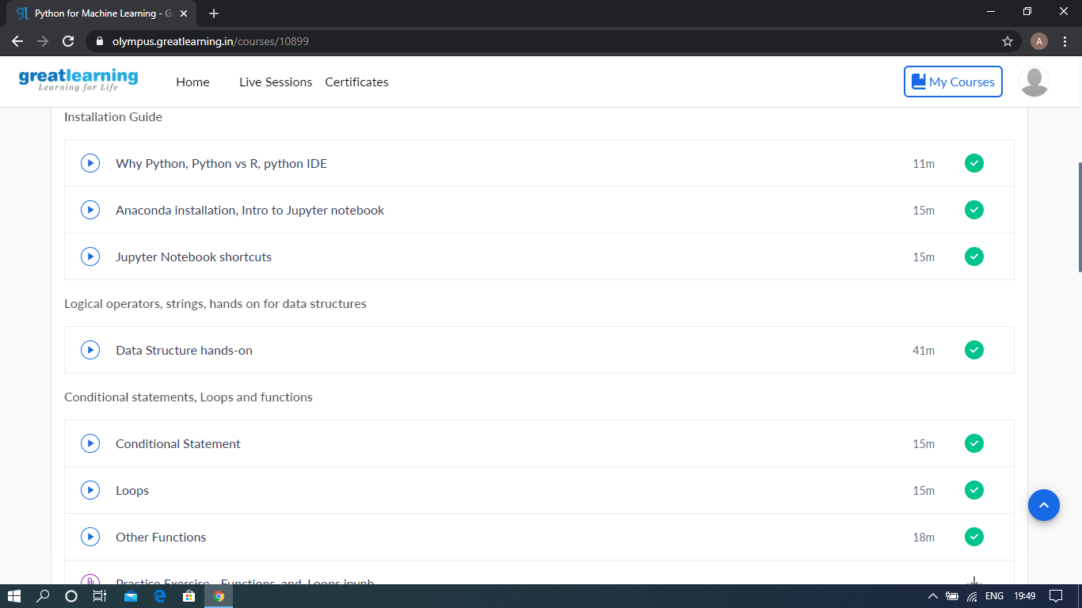

The above course is being taken up by me which is based on the Python for Machine Learning. Today in online course I studied about Conditional statements, Loops and Function, and also about NumPy and its functions. The details of the course and certificate provider is mentioned in the above form.

Coding Challenges Details: (Attach the snapshot and briefly write the report for the same)

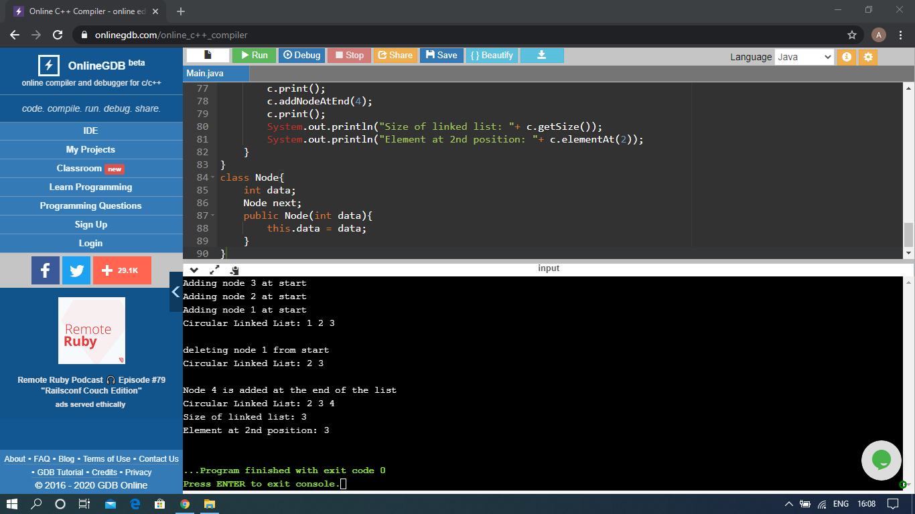

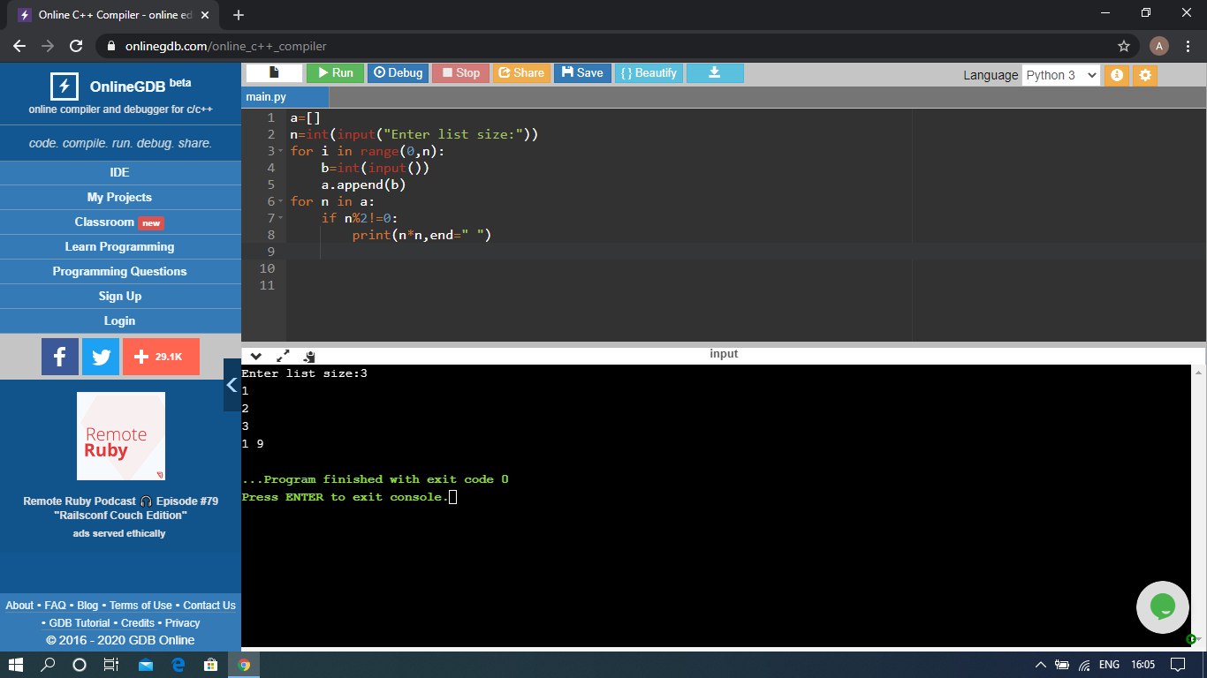

The above Programs were written and executed and the output of the same is displayed above. The code for those 2 programs have been uploaded to the github repository and the link to the same is provided on the form.