**DAILY ONLINE ACTIVITIES SUMMARY**

|  |  |  |  |  |  |  |  |  |
| --- | --- | --- | --- | --- | --- | --- | --- | --- |
| **Date:** | **6-06-2020** | | | | | **Name:** | **John Alsten Tauro** | |
| **Sem & Sec** | **6th A** | | | | | **USN:** | **4AL17CS037** | |
| **Online Test Summary** | | | | | | | | |
| **Subject** | | **PAP** | | | | | | |
| **Max. Marks** | | **30** | | **Score** | | | **25** | |
| **Certification Course Summary** | | | | | | | | |
| **Course** | **Python for machine learning** | | | | | | | |
| **Certificate Provider** | | | **Great learning** | | **Duration** | | | **5hrs** |
| **Coding Challenges** | | | | | | | | |
| **Problem Statement**: 1. .Write a program in C to rotate an array by N positions.  **2.** Write a Python program to perform Cyclic Redundancy Check.  **3.** Write a Python program to count number of strings. | | | | | | | | |
| **Status: YES, Completed all Programs** | | | | | | | | |
| **Uploaded the report in Github** | | | | | **YES** | | | |
| **If yes Repository name** | | | | | [**https://github.com/alvas-education-foundation/Alsten_Tauro**](https://github.com/alvas-education-foundation/Alsten_Tauro) | | | |
| **Uploaded the report in slack** | | | | | **YES** | | | |

Online Test Details: (Attach the snapshot and briefly write the report for the same)

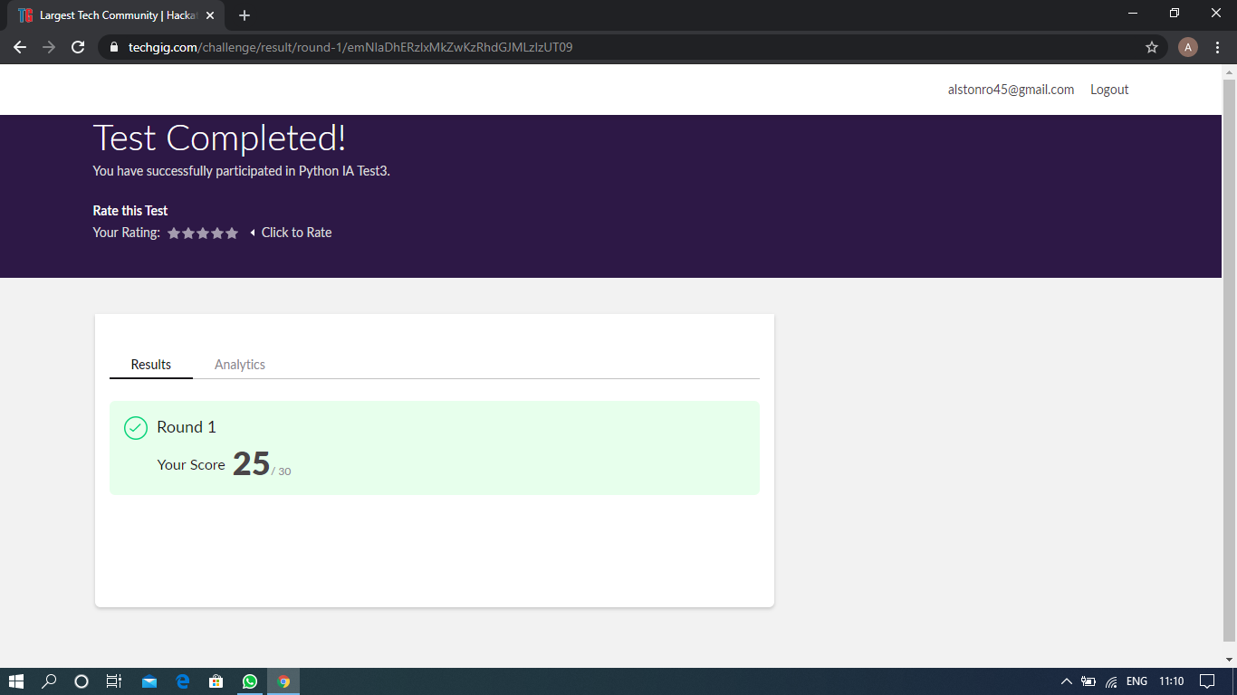

Scored 25 out of 30 in PAP test

Certification Course Details: (Attach the snapshot and briefly write the report for the same) 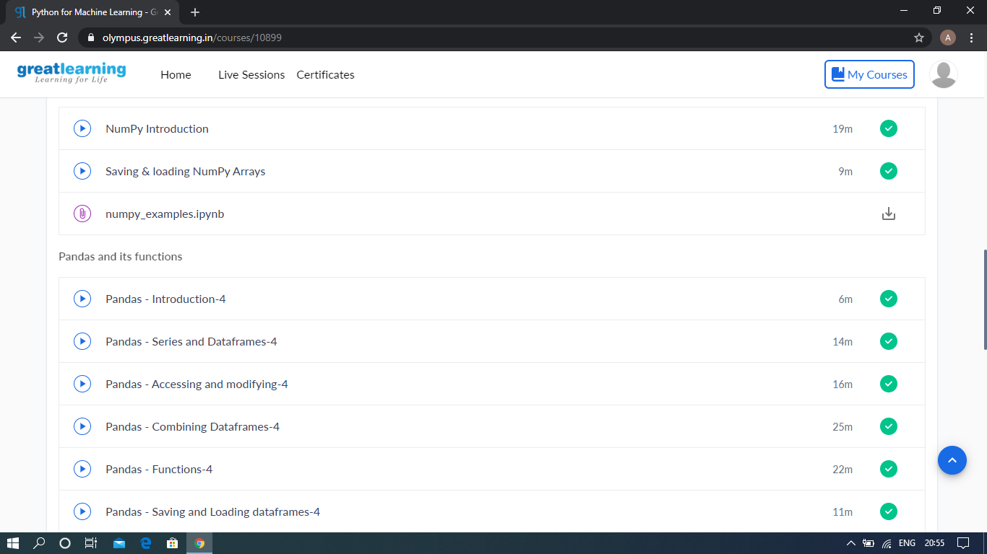

The above course is being taken up by me which is based on the Python for Machine Learning. Today in online course I studied about Pandas and it functions it includes Pandas introduction, Pandas series and data frames, Pandas accessing and modifying, Pandas combining data frames, Pandas functions, Pandas saving and loading data frame. The details of the course and certificate provider is mentioned in the above form.

Coding Challenges Details: (Attach the snapshot and briefly write the report for the same)

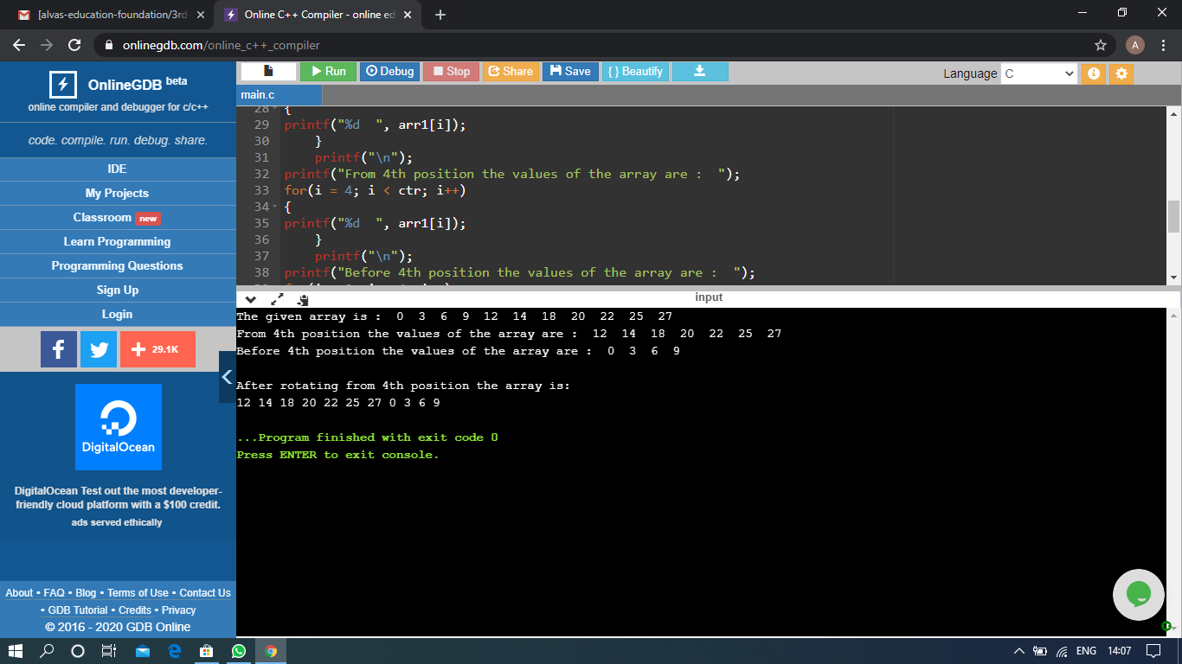

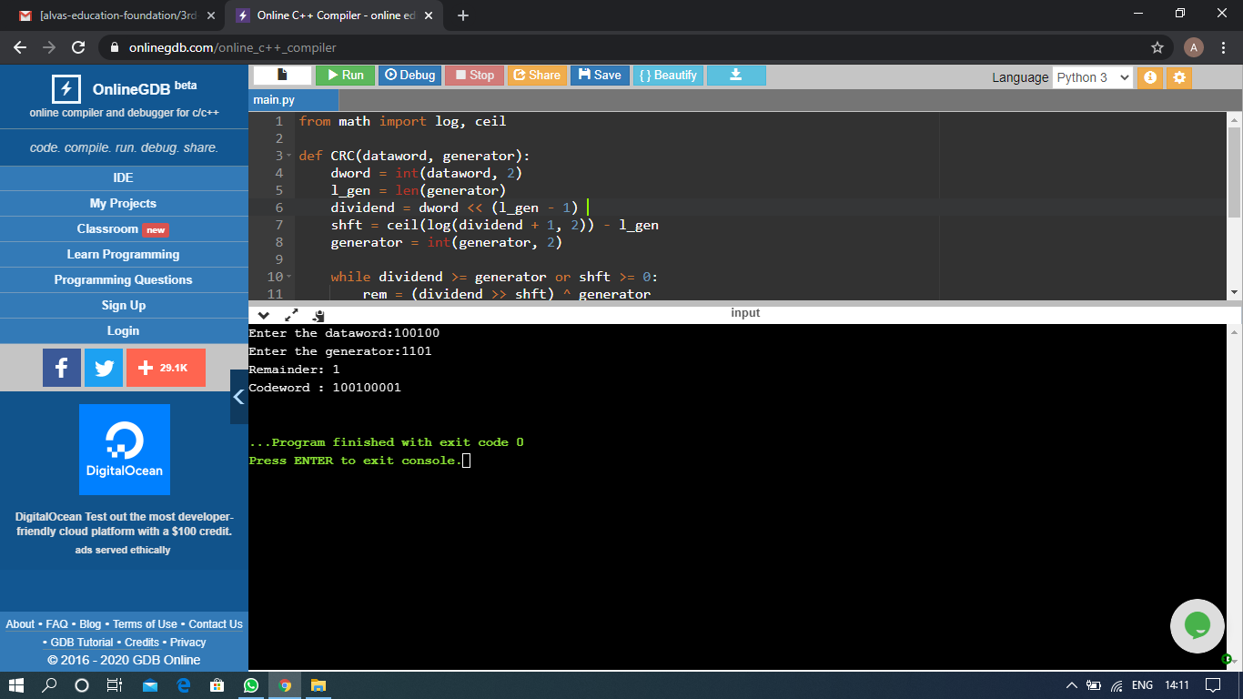

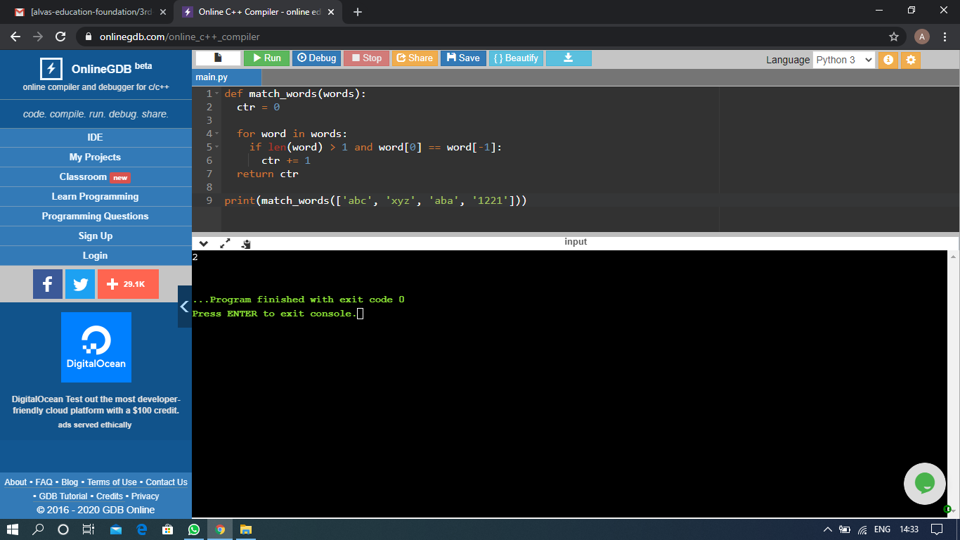

The above Programs were written and executed and the output of the same is displayed above. The code for those 3 programs have been uploaded to the github repository and the link to the same is provided on the form.