**DAILY ONLINE ACTIVITIES SUMMARY**

|  |  |  |  |  |  |  |  |  |
| --- | --- | --- | --- | --- | --- | --- | --- | --- |
| **Date:** | **8-06-2020** | | | | | **Name:** | **John Alsten Tauro** | |
| **Sem & Sec** | **6th A** | | | | | **USN:** | **4AL17CS037** | |
| **Online Test Summary** | | | | | | | | |
| **Subject** | | **Cryptography network security and cyber law(CNSC)** | | | | | | |
| **Max. Marks** | | **60** | | **Score** | | | **34** | |
| **Certification Course Summary** | | | | | | | | |
| **Course** | **Python for machine learning** | | | | | | | |
| **Certificate Provider** | | | **Great learning** | | **Duration** | | | **5hrs** |
| **Coding Challenges** | | | | | | | | |
| **Problem Statement**: 1. Write a Python program to find whether a string is a palindrome or not.  **2.** Java program to delete a node from the middle of the singly linked list.  **3.** C Program to Generate All the Set Partitions of n Numbers Beginning from 1 and so on.  **4.** Write C++ program to Check whether a number can be represented as difference of two squares. | | | | | | | | |
| **Status: YES, Completed all Programs** | | | | | | | | |
| **Uploaded the report in Github** | | | | | **YES** | | | |
| **If yes Repository name** | | | | | [**https://github.com/alvas-education-foundation/Alsten_Tauro**](https://github.com/alvas-education-foundation/Alsten_Tauro) | | | |
| **Uploaded the report in slack** | | | | | **YES** | | | |

Online Test Details: (Attach the snapshot and briefly write the report for the same)

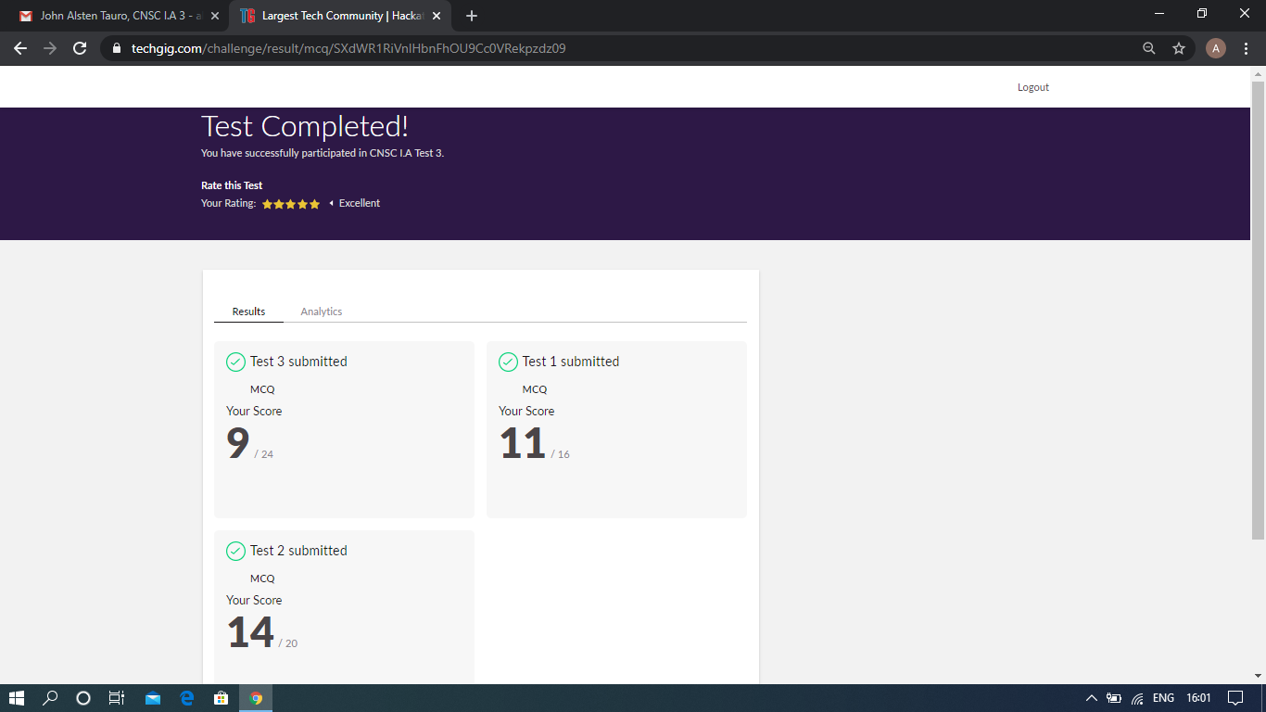

Scored 34 out of 60 in CNSC test

Certification Course Details: (Attach the snapshot and briefly write the report for the same)

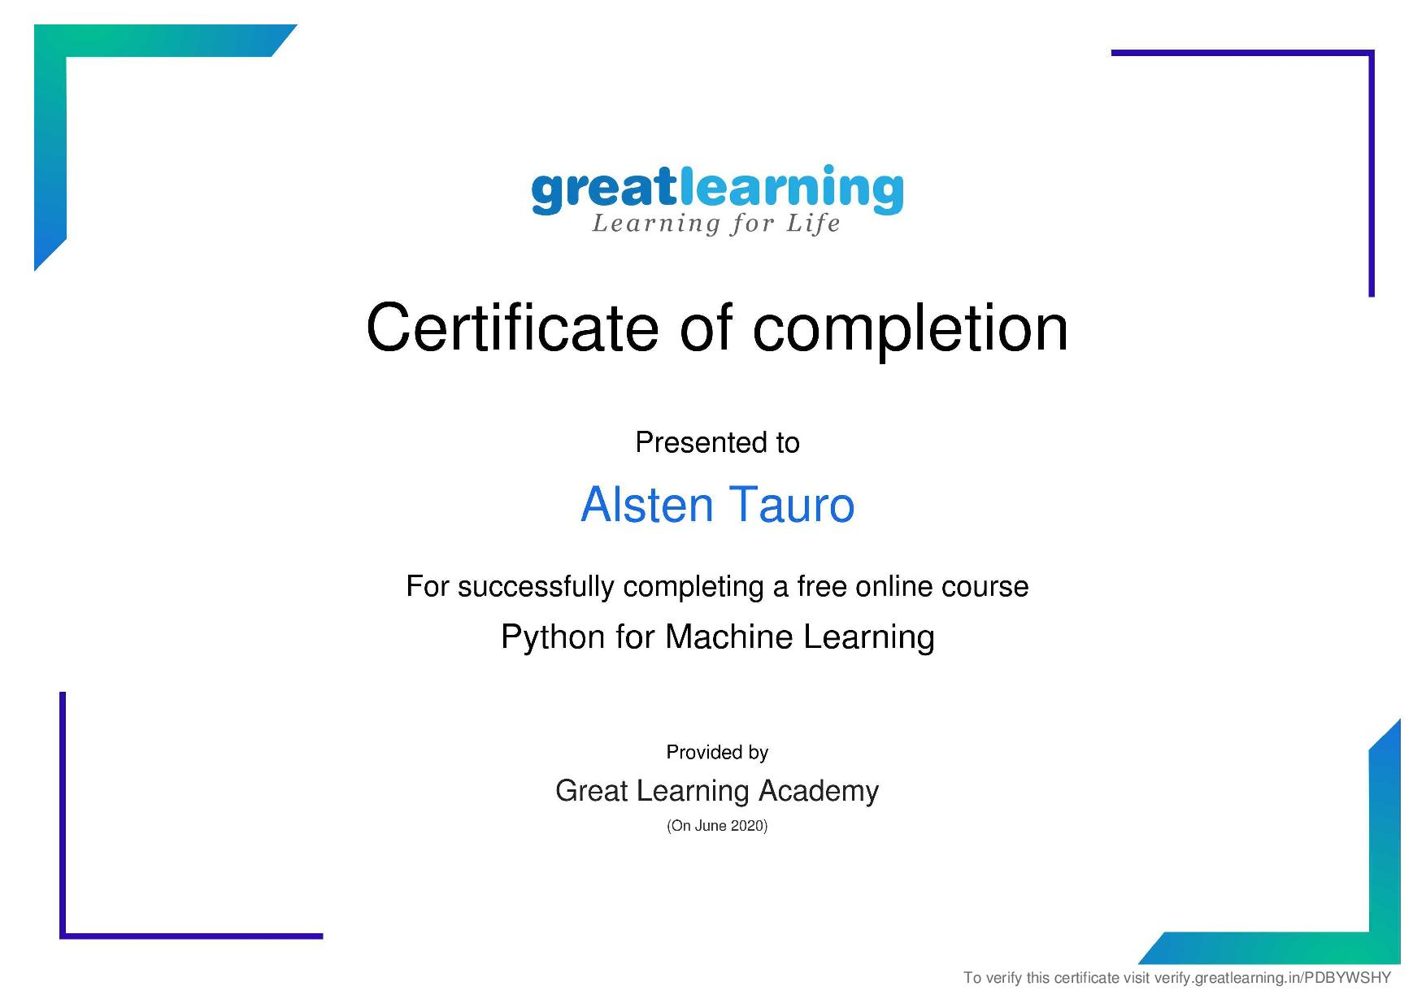

Successfully completed Python for machine learning online certification course

Coding Challenges Details: (Attach the snapshot and briefly write the report for the same)

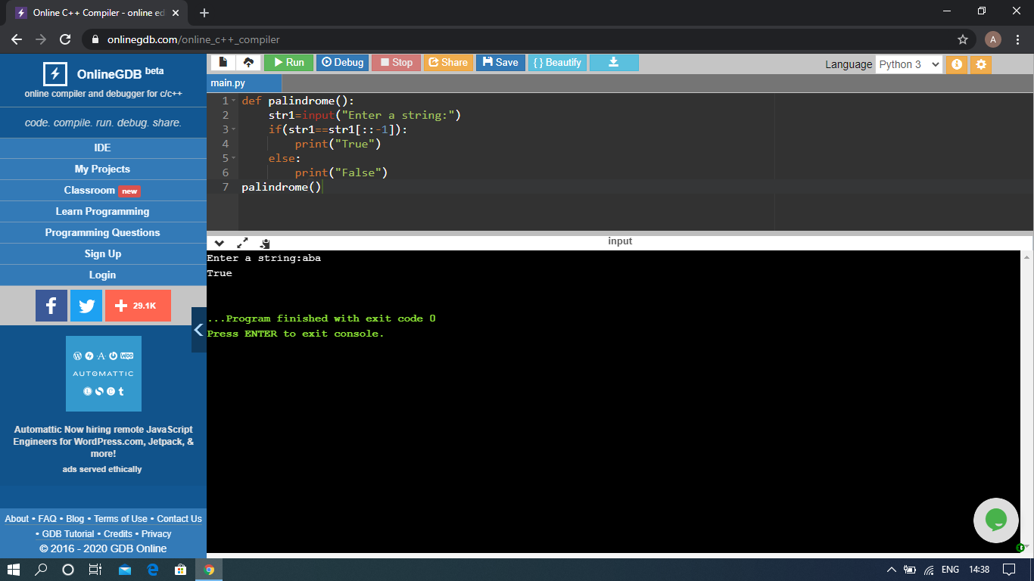

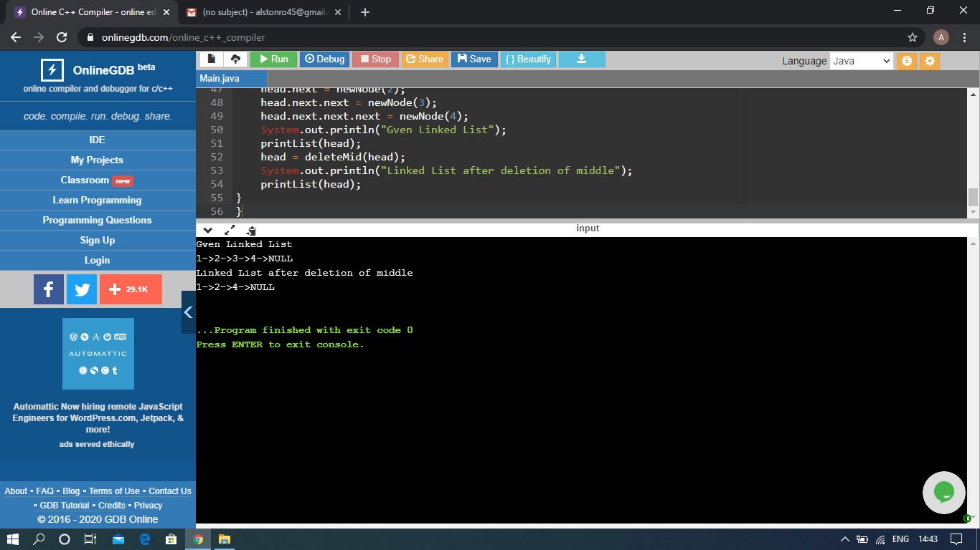

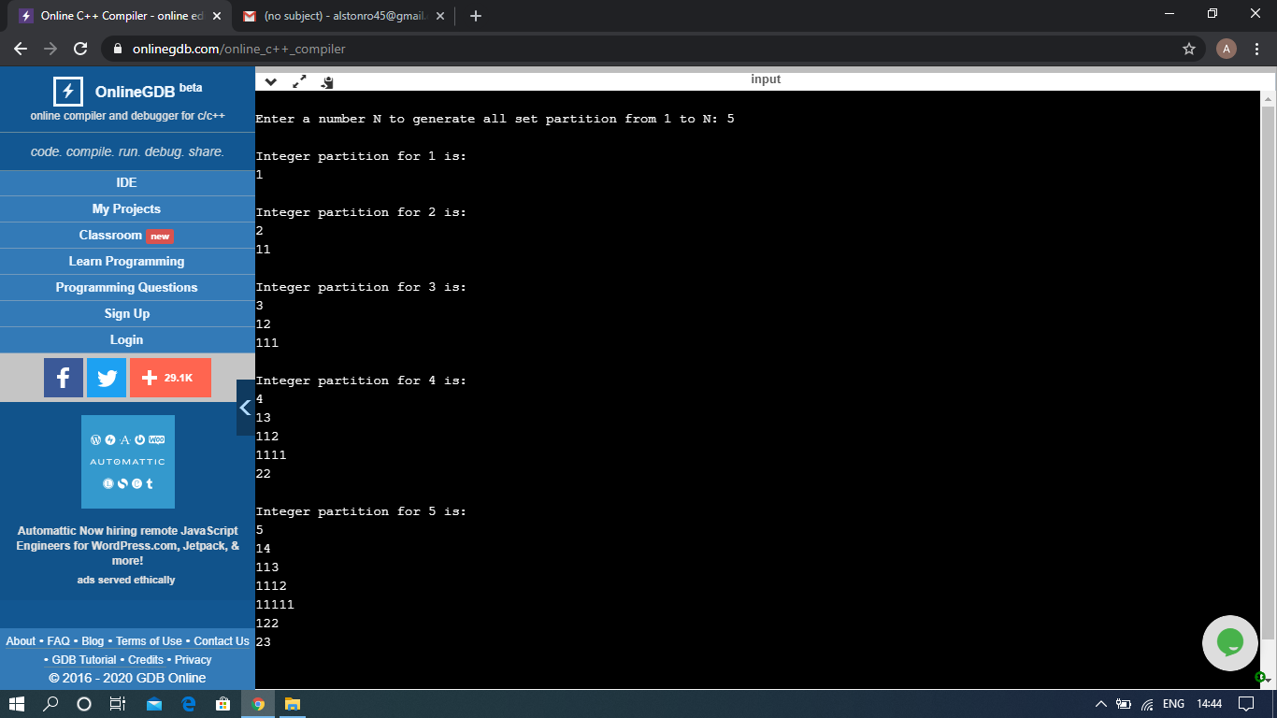

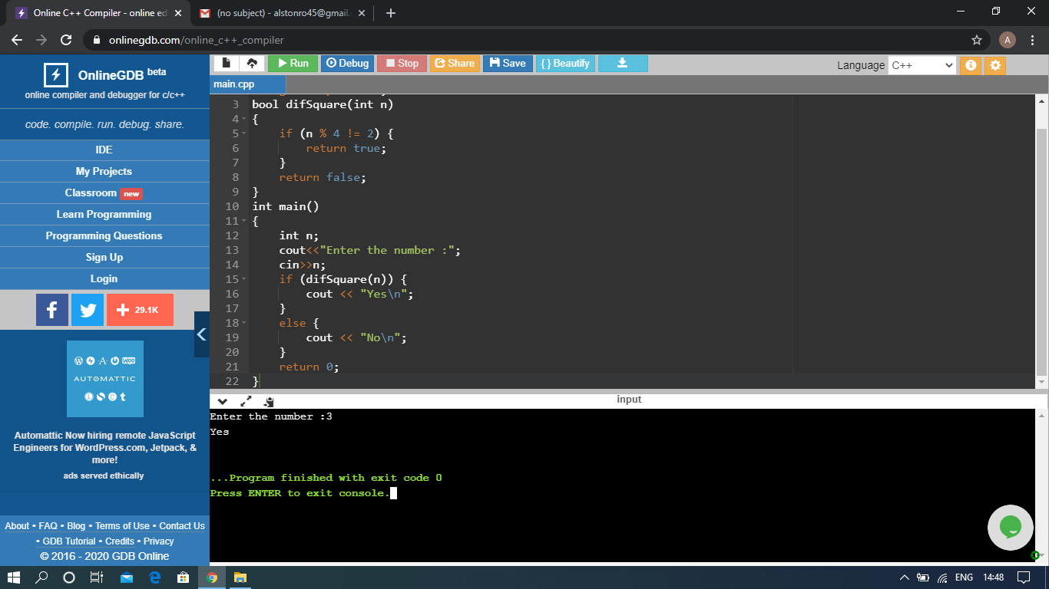

The above Programs were written and executed and the output of the same is displayed above. The code for those 4 programs have been uploaded to the github repository and the link to the same is provided on the form.