**DAILY ONLINE ACTIVITIES SUMMARY**

|  |  |  |  |  |  |  |  |  |
| --- | --- | --- | --- | --- | --- | --- | --- | --- |
| **Date:** | **8-07-2020** | | | | | **Name:** | **John Alsten Tauro** | |
| **Sem & Sec** | **6th A** | | | | | **USN:** | **4AL17CS037** | |
| **Online Test Summary** | | | | | | | | |
| **Subject** | |  | | | | | | |
| **Max. Marks** | |  | | **Score** | | |  | |
| **Pre-Placement Course Summary** | | | | | | | | |
| **Pre-placement training** | **Cloud computing** | | | | | | | |
| **Faculty name** | | | **Manjunath kotari** | | **Duration** | | | **2hr** |
| **Coding Challenges** | | | | | | | | |
| Problem Statement: 1. Python Program for Find largest prime factor of a number..   .  . | | | | | | | | |
| **Status: YES, Completed all Programs** | | | | | | | | |
| **Uploaded the report in Github** | | | | | **YES** | | | |
| **If yes Repository name** | | | | | [**https://github.com/alvas-education-foundation/Alsten_Tauro**](https://github.com/alvas-education-foundation/Alsten_Tauro) | | | |
| **Uploaded the report in slack** | | | | | **YES** | | | |

Pre-Placement training Details: (Attach the snapshot and briefly write the report for the same)

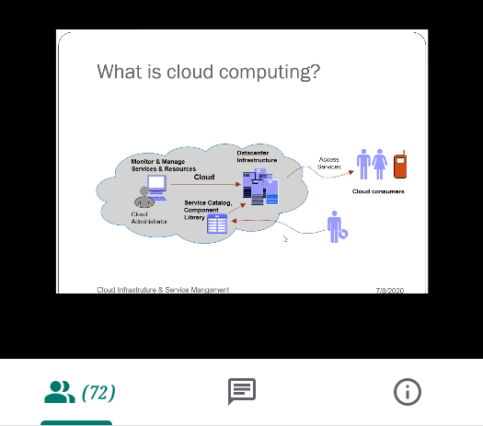

Today in this session I studied about basics of cloud computing. I also attended 2 quiz in the middle of the session.

Coding Challenges Details: (Attach the snapshot and briefly write the report for the same)

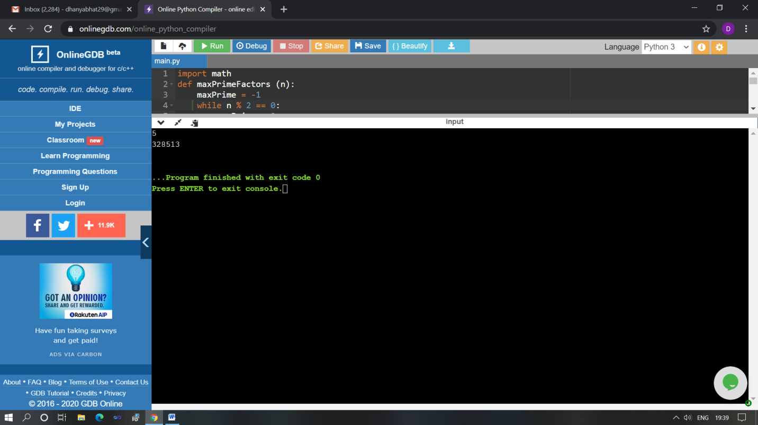

The above Programs were written and executed and the output of the same is displayed above. The code for those 1 programs have been uploaded to the github repository and the link to the same is provided on the form.