**DAILY ONLINE ACTIVITIES SUMMARY**

|  |  |  |  |  |  |  |  |  |
| --- | --- | --- | --- | --- | --- | --- | --- | --- |
| **Date:** | **9-06-2020** | | | | | **Name:** | **John Alsten Tauro** | |
| **Sem & Sec** | **6th A** | | | | | **USN:** | **4AL17CS037** | |
| **Online Test Summary** | | | | | | | | |
| **Subject** | | **Cryptography network security and cyber law(CNSC) and Computer graphics and visualization(CGV)** | | | | | | |
| **Max. Marks** | | **CNSC:60**  **CGV:30** | | **Score** | | | **CNSC:29**  **CGV:29** | |
| **Certification Course Summary** | | | | | | | | |
| **Course** | **Ethical hacking creating a keylogger** | | | | | | | |
| **Certificate Provider** | | | **Udemy** | | **Duration** | | | **1hrs** |
| **Coding Challenges** | | | | | | | | |
| **Problem Statement**: 1. Write a Python program to implement Perfect Sum problem.  2. Write a Java Program to print smallest and biggest possible palindrome word in a given string.  3. Python Program to count even and odd numbers.  4. Write a Java Program to remove all white spaces from a string without using replace().  5. Write a C Program to rotate the matrix by K times. | | | | | | | | |
| **Status: YES, Completed all Programs** | | | | | | | | |
| **Uploaded the report in Github** | | | | | **YES** | | | |
| **If yes Repository name** | | | | | [**https://github.com/alvas-education-foundation/Alsten_Tauro**](https://github.com/alvas-education-foundation/Alsten_Tauro) | | | |
| **Uploaded the report in slack** | | | | | **YES** | | | |

Online Test Details: (Attach the snapshot and briefly write the report for the same)

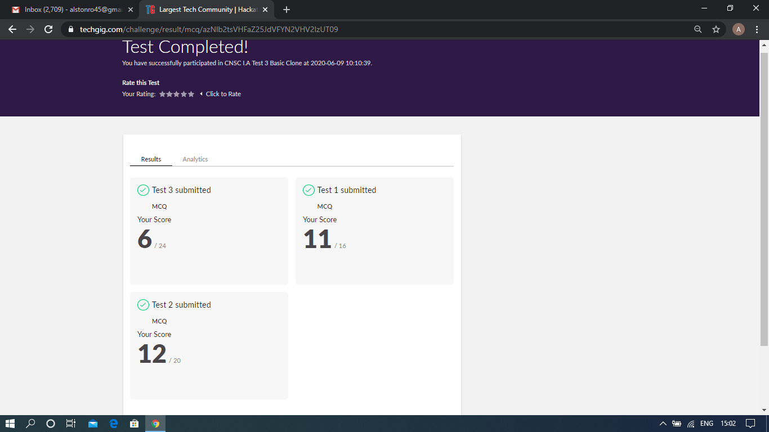

Scored 29 out of 60 in CNSC test

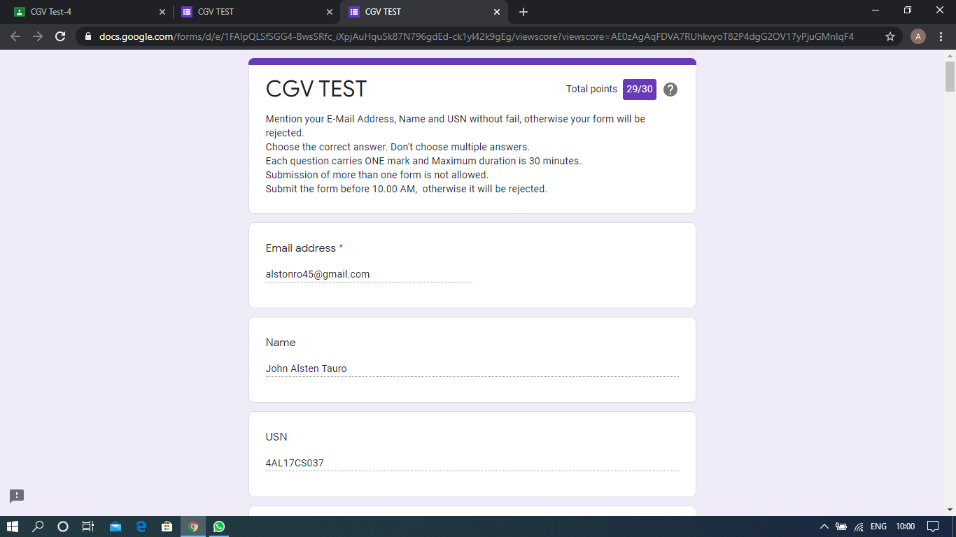

Scored 29 out of 30 in CGV test

Certification Course Details: (Attach the snapshot and briefly write the report for the same)

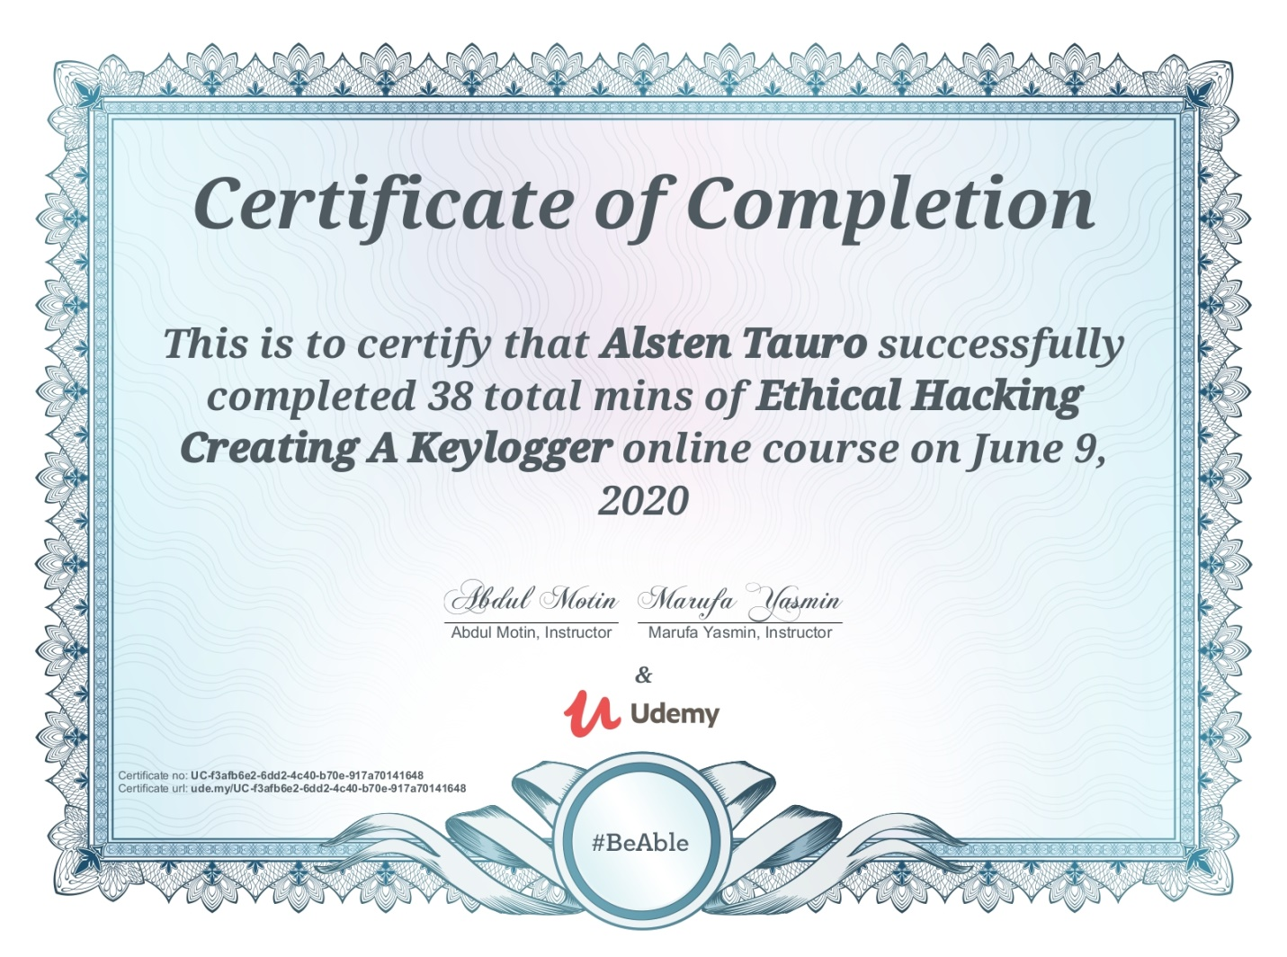

Successfully completed Ethical hacking creating a keylogger online certification course

Coding Challenges Details: (Attach the snapshot and briefly write the report for the same)

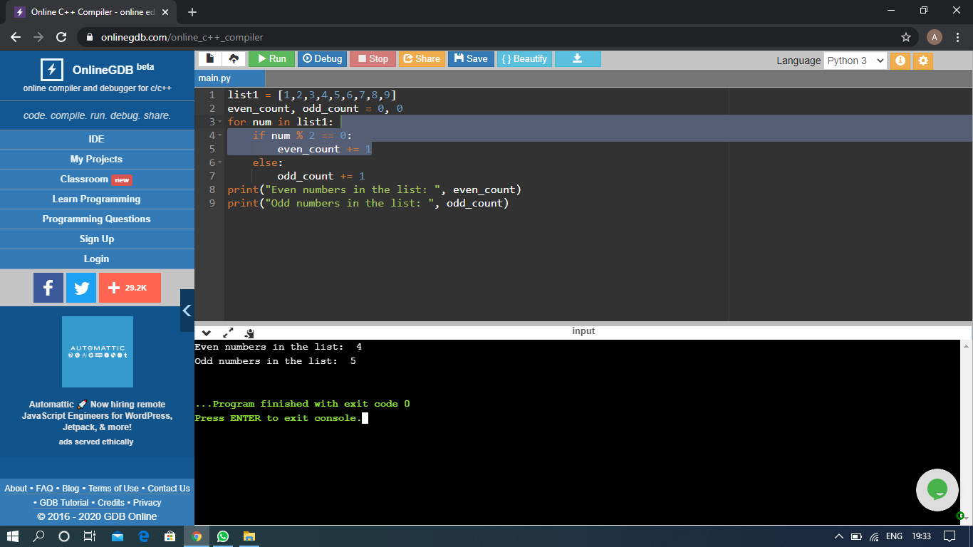

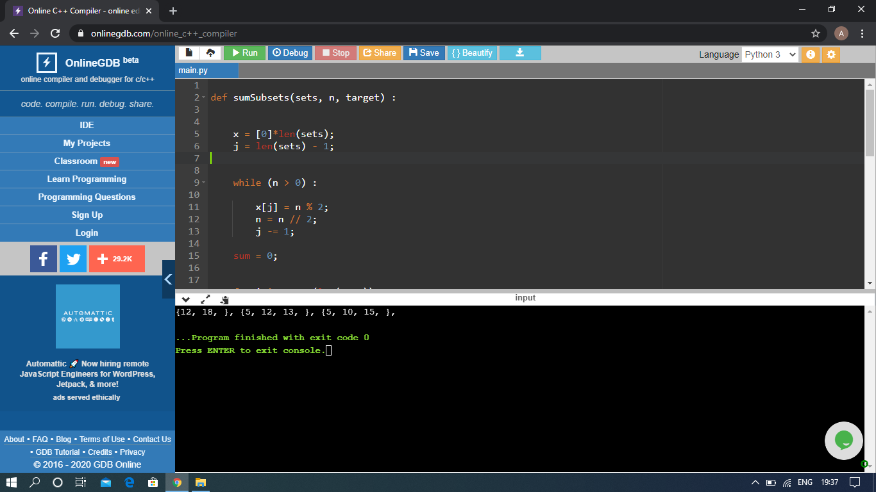

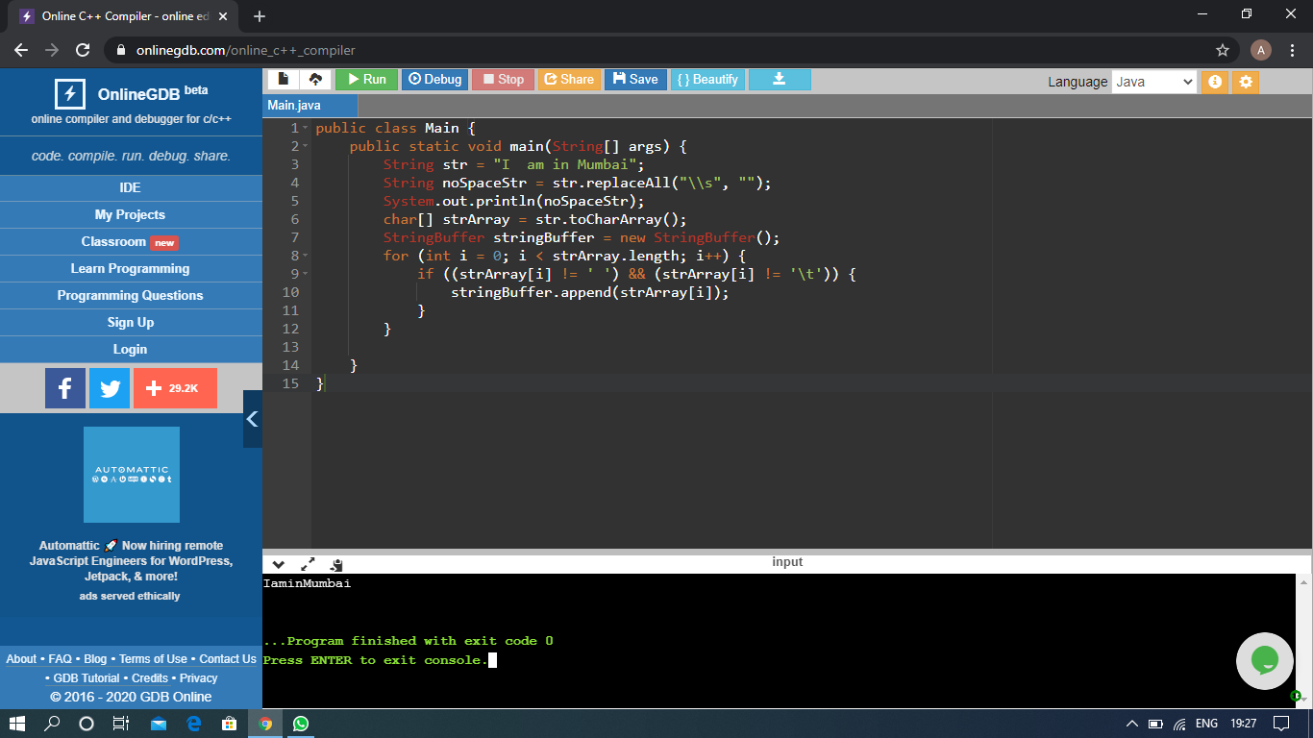

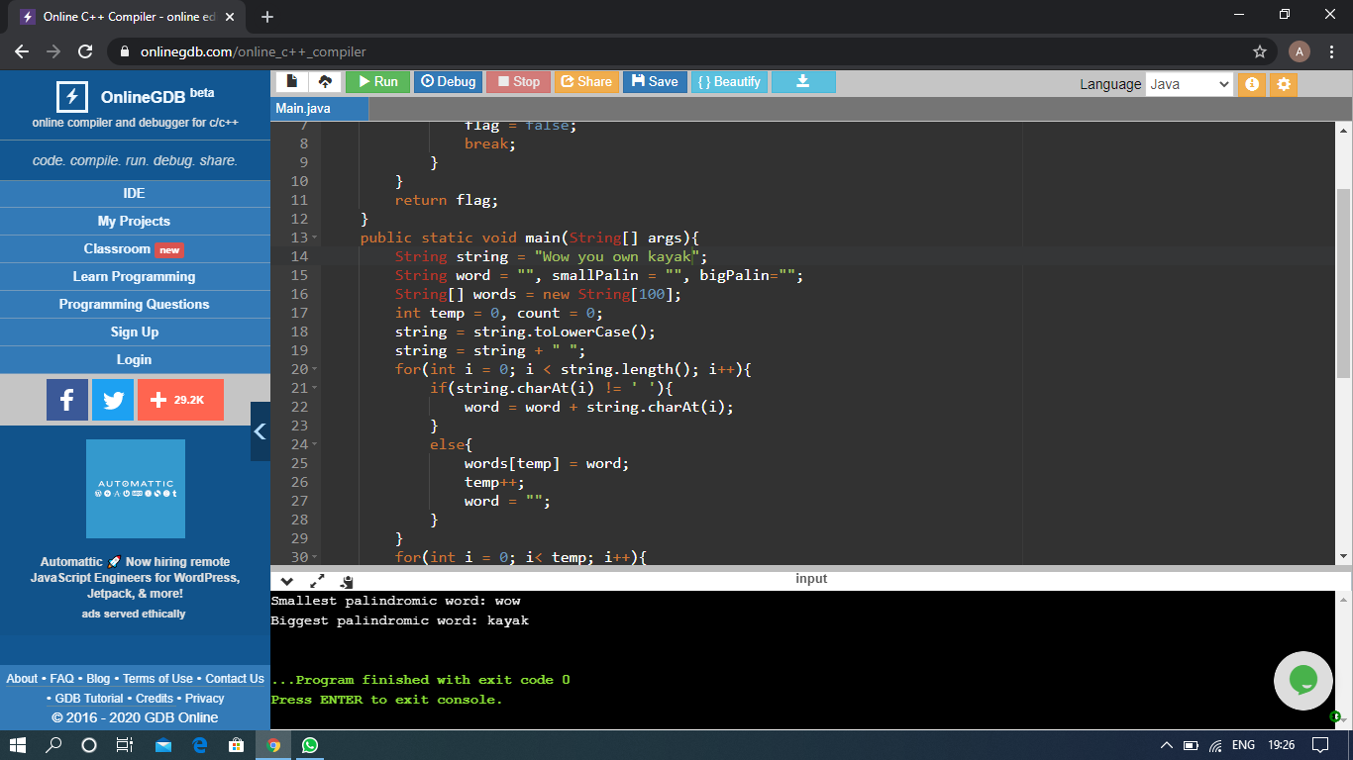

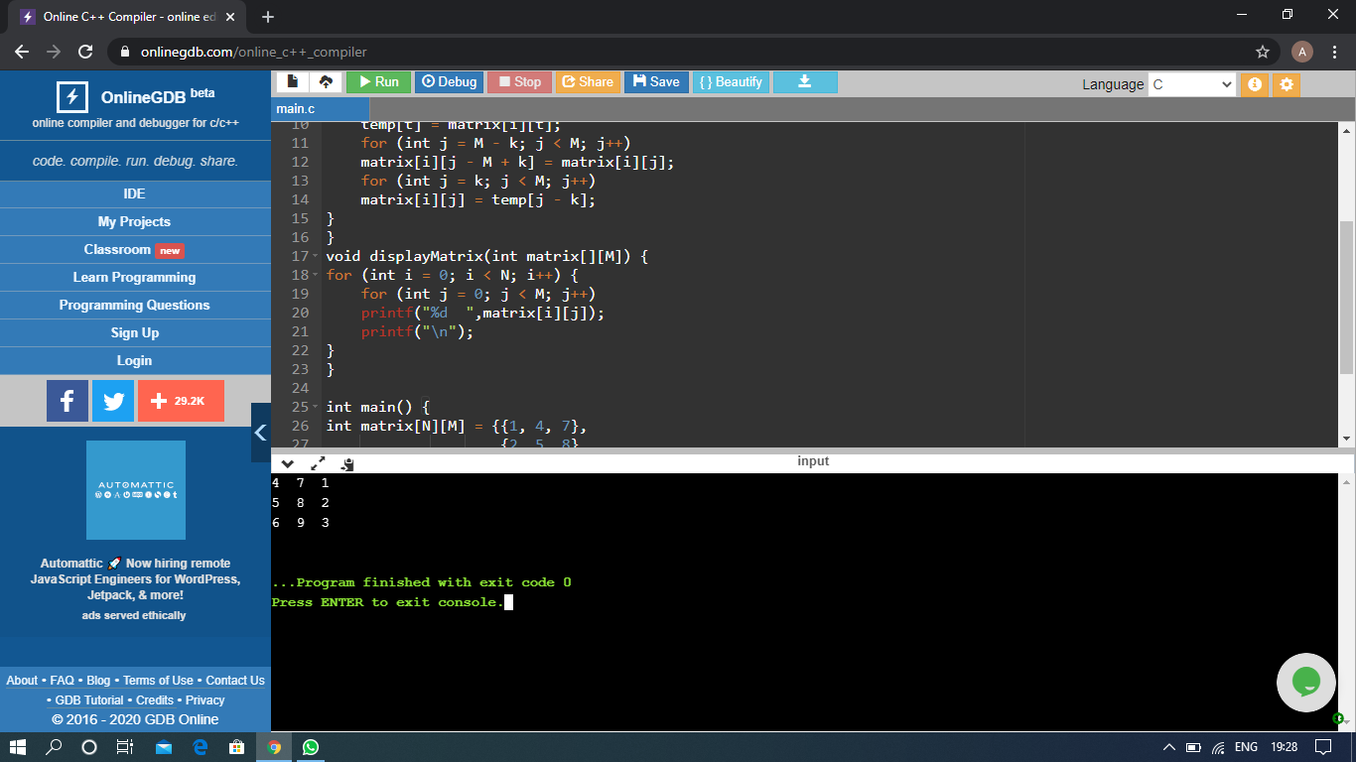

The above Programs were written and executed and the output of the same is displayed above. The code for those 5 programs have been uploaded to the github repository and the link to the same is provided on the form.