**DAILY ONLINE ACTIVITIES SUMMARY**

|  |  |  |  |  |  |  |  |  |
| --- | --- | --- | --- | --- | --- | --- | --- | --- |
| **Date:** | **10-06-2020** | | | | | **Name:** | **John Alsten Tauro** | |
| **Sem & Sec** | **6th A** | | | | | **USN:** | **4AL17CS037** | |
| **Online Test Summary** | | | | | | | | |
| **Subject** | | **System software and compiler design(SSCD)** | | | | | | |
| **Max. Marks** | | **30** | | **Score** | | | **29** | |
| **Certification Course Summary** | | | | | | | | |
| **Course** | **The Complete PHP 7 Guide for Web Developers** | | | | | | | |
| **Certificate Provider** | | | **Eduonix** | | **Duration** | | | **4hrs** |
| **Coding Challenges** | | | | | | | | |
| **Problem Statement**: 1. Write a Java program to find the maximum and minimum value node from a circular linked list.  **2.** Write a C Program to print the sum of boundary elements of a matrix.  **3.** Python Program to check whether a given number is a fibonacci number or not. | | | | | | | | |
| **Status: YES, Completed all Programs** | | | | | | | | |
| **Uploaded the report in Github** | | | | | **YES** | | | |
| **If yes Repository name** | | | | | [**https://github.com/alvas-education-foundation/Alsten_Tauro**](https://github.com/alvas-education-foundation/Alsten_Tauro) | | | |
| **Uploaded the report in slack** | | | | | **YES** | | | |

Online Test Details: (Attach the snapshot and briefly write the report for the same)

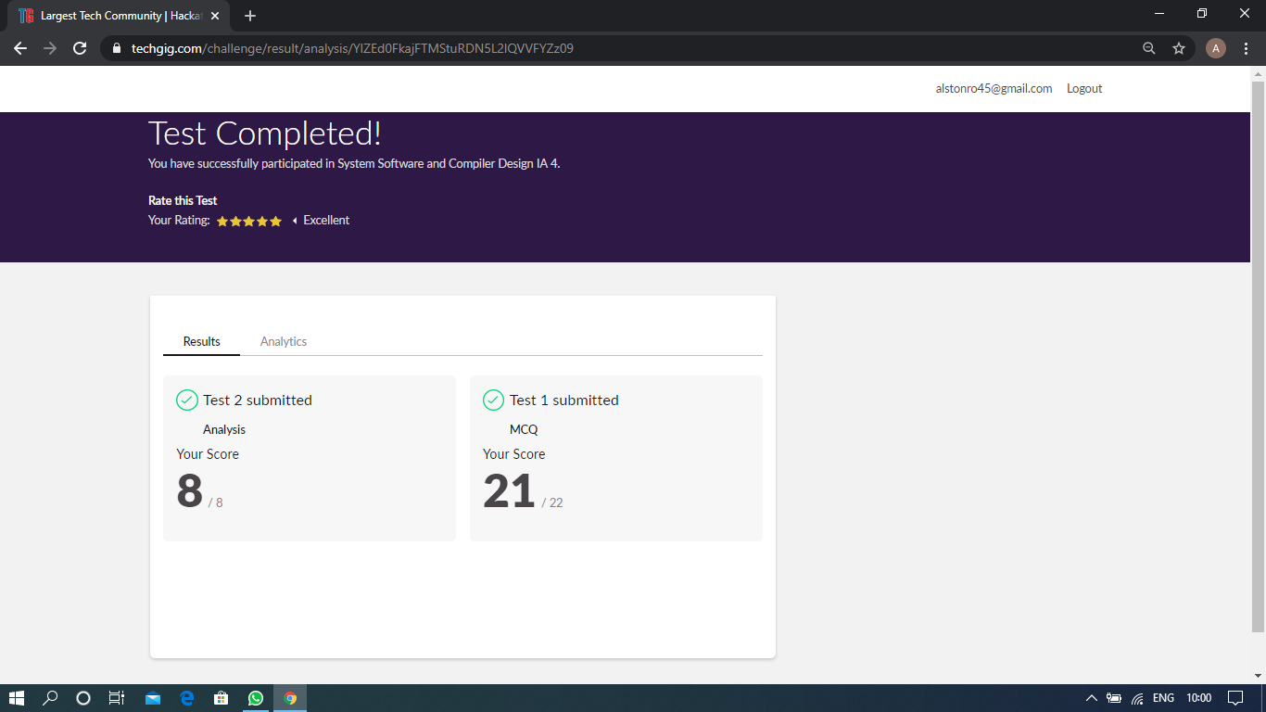

Scored 29 out of 30 in SSCD test

Certification Course Details: (Attach the snapshot and briefly write the report for the same)

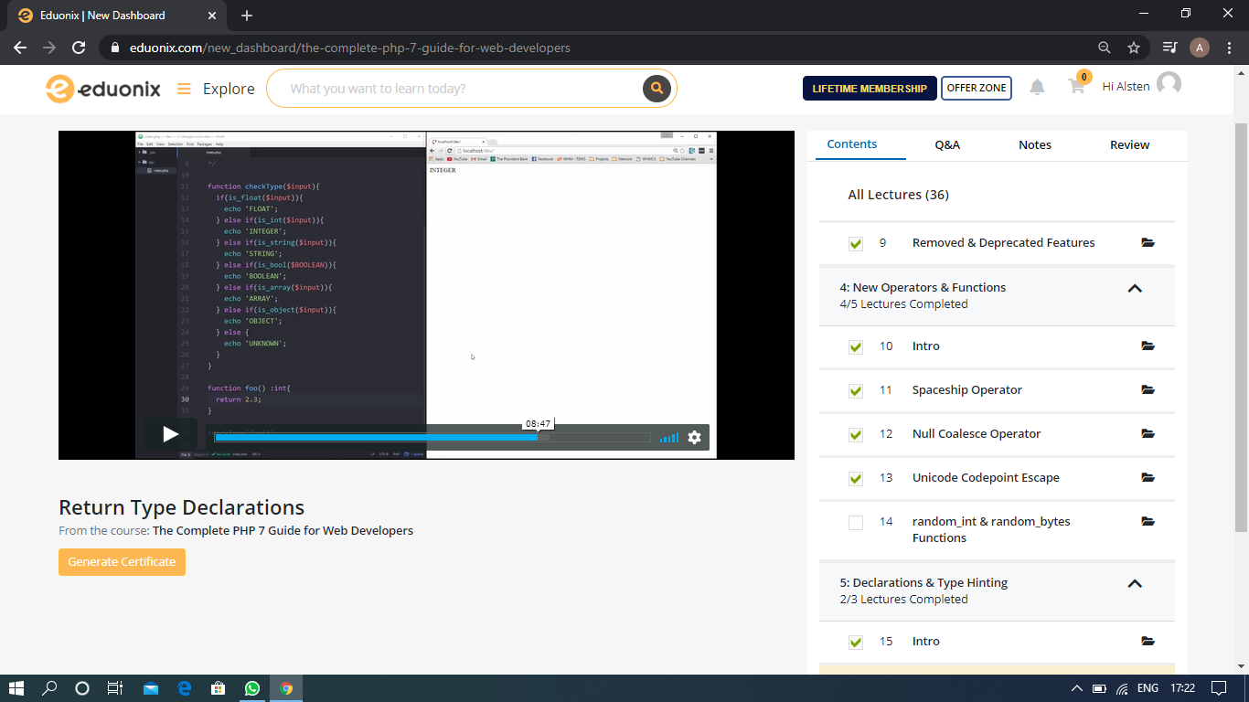

The above course is being taken up by me which is based on the Complete PHP 7 Guide for web developer. It started with the Course intro, Getting started with PHP which includes PHP language overview, Environmental setup, PHP fundamentals by example and New operators and functions.. The details of the course and certificate provider is mentioned in the above form.

Coding Challenges Details: (Attach the snapshot and briefly write the report for the same)

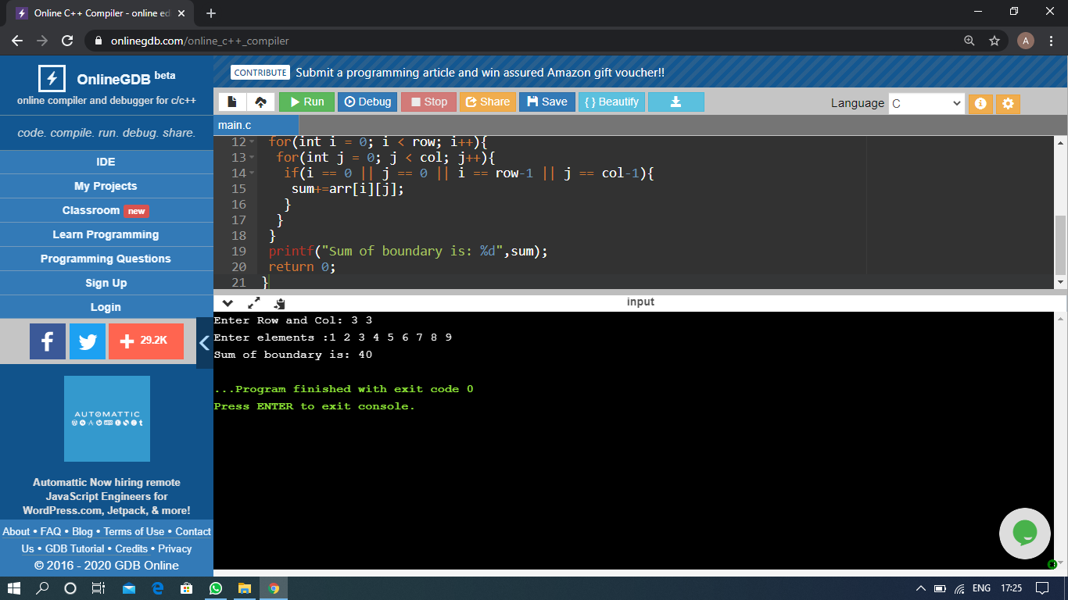

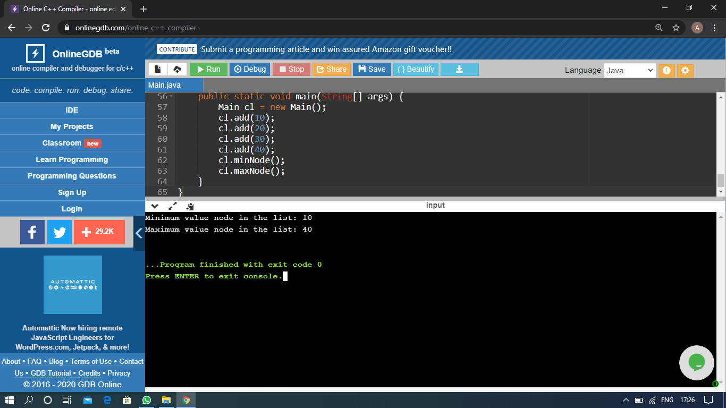

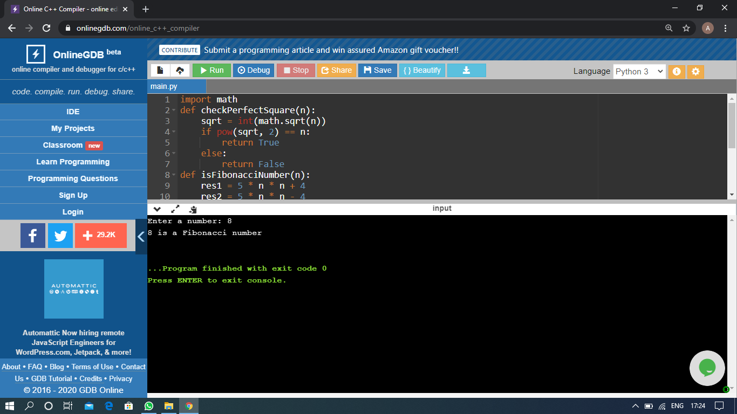

The above Programs were written and executed and the output of the same is displayed above. The code for those 3 programs have been uploaded to the github repository and the link to the same is provided on the form.