**DAILY ONLINE ACTIVITIES SUMMARY**

|  |  |  |  |  |  |  |  |  |
| --- | --- | --- | --- | --- | --- | --- | --- | --- |
| **Date:** | **14-06-2020** | | | | | **Name:** | **John Alsten Tauro** | |
| **Sem & Sec** | **6th A** | | | | | **USN:** | **4AL17CS037** | |
| **Online Test Summary** | | | | | | | | |
| **Subject** | | **-** | | | | | | |
| **Max. Marks** | | **-** | | **Score** | | | **-** | |
| **Certification Course Summary** | | | | | | | | |
| **Course** | **The Complete PHP 7 Guide for Web Developers** | | | | | | | |
| **Certificate Provider** | | | **Eduonix** | | **Duration** | | | **4hrs** |
| **Coding Challenges** | | | | | | | | |
| **Problem Statement**: 1. Write a java program to remove specific characters in the String.  **2.** Write a C Program to implement the Binary Reversal.  . | | | | | | | | |
| **Status: YES, Completed all Programs** | | | | | | | | |
| **Uploaded the report in Github** | | | | | **YES** | | | |
| **If yes Repository name** | | | | | [**https://github.com/alvas-education-foundation/Alsten_Tauro**](https://github.com/alvas-education-foundation/Alsten_Tauro) | | | |
| **Uploaded the report in slack** | | | | | **YES** | | | |

Certification Course Details: (Attach the snapshot and briefly write the report for the same)

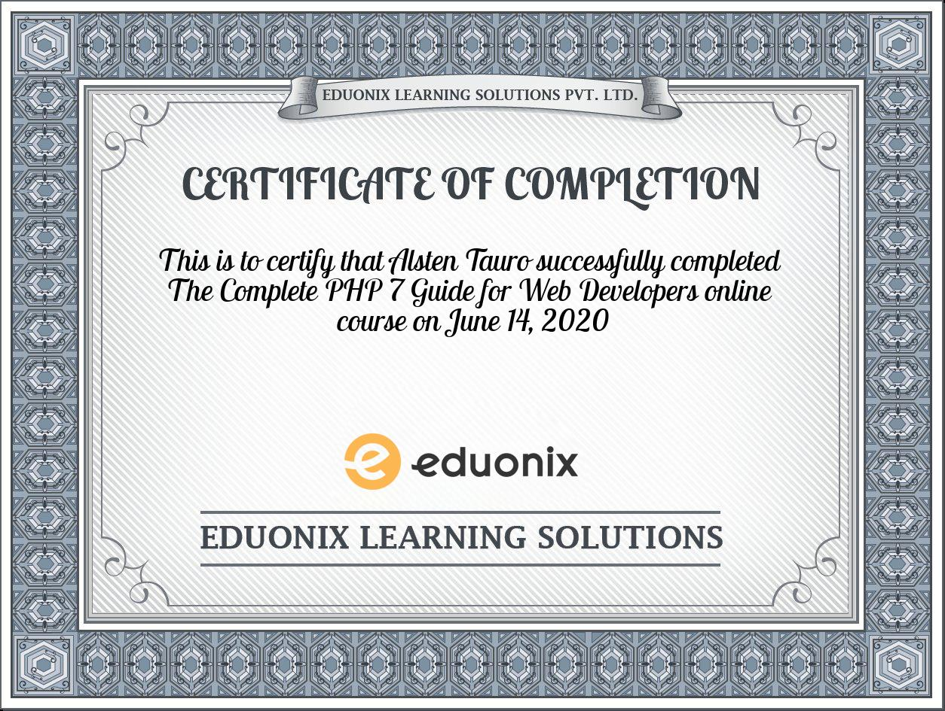

Successfully completed The Complete PHP 7 Guide for Web Developers Online course

Coding Challenges Details: (Attach the snapshot and briefly write the report for the same)

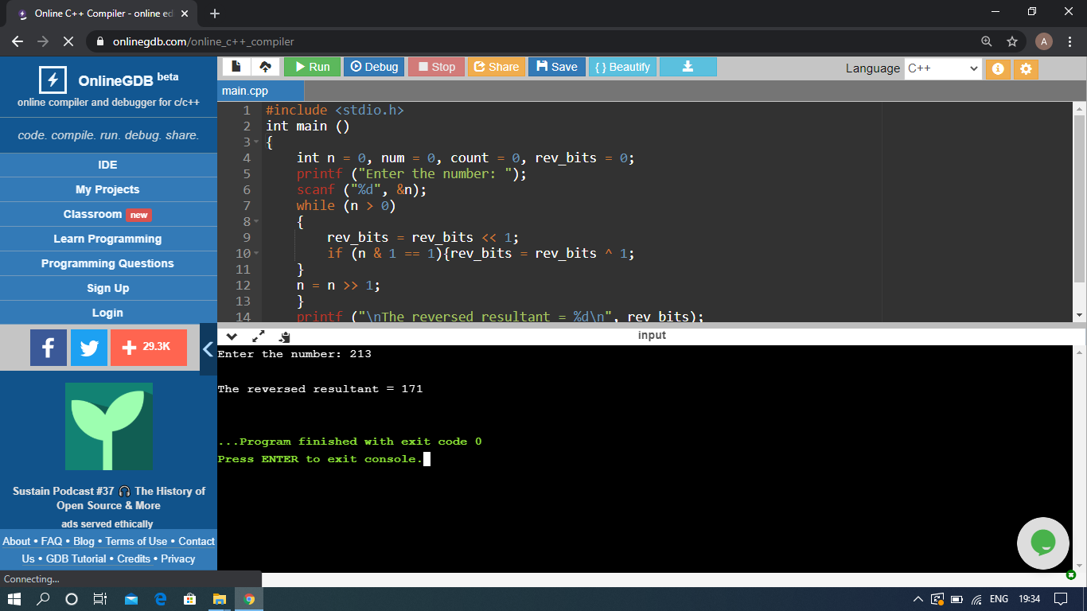

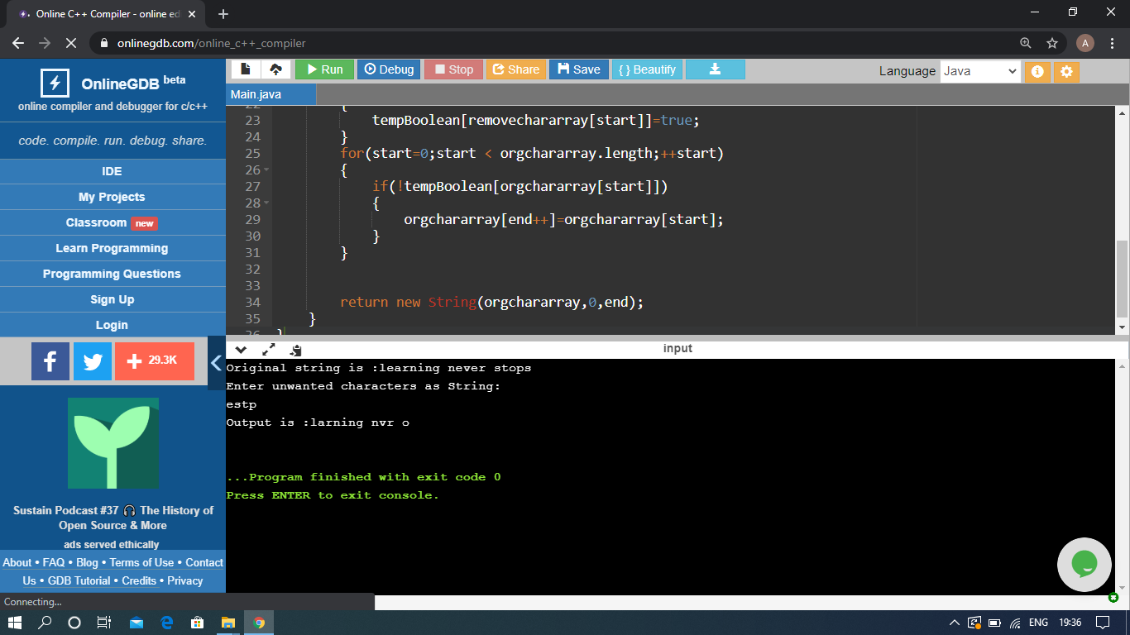

The above Programs were written and executed and the output of the same is displayed above. The code for those 2 programs have been uploaded to the github repository and the link to the same is provided on the form.