**DAILY ONLINE ACTIVITIES SUMMARY**

|  |  |  |  |  |  |  |  |  |
| --- | --- | --- | --- | --- | --- | --- | --- | --- |
| **Date:** | **14-07-2020** | | | | | **Name:** | **John Alsten Tauro** | |
| **Sem & Sec** | **6th A** | | | | | **USN:** | **4AL17CS037** | |
| **Online Test Summary** | | | | | | | | |
| **Subject** | | Operating system | | | | | | |
| **Max. Marks** | | **30** | | **Score** | | | **-** | |
| **Online Course Summary** | | | | | | | | |
| **Online course name** | **Python data structure** | | | | | | | |
| **Certificate provider** | | | **Coursera** | | **Duration** | | | **19hrs** |
| **Coding Challenges** | | | | | | | | |
| Problem Statement: 1. Python Program to find cube of first n numbers..   .  . | | | | | | | | |
| **Status: YES, Completed all Programs** | | | | | | | | |
| **Uploaded the report in Github** | | | | | **YES** | | | |
| **If yes Repository name** | | | | | [**https://github.com/alvas-education-foundation/Alsten_Tauro**](https://github.com/alvas-education-foundation/Alsten_Tauro) | | | |
| **Uploaded the report in slack** | | | | | **YES** | | | |

Online course Details: (Attach the snapshot and briefly write the report for the same)

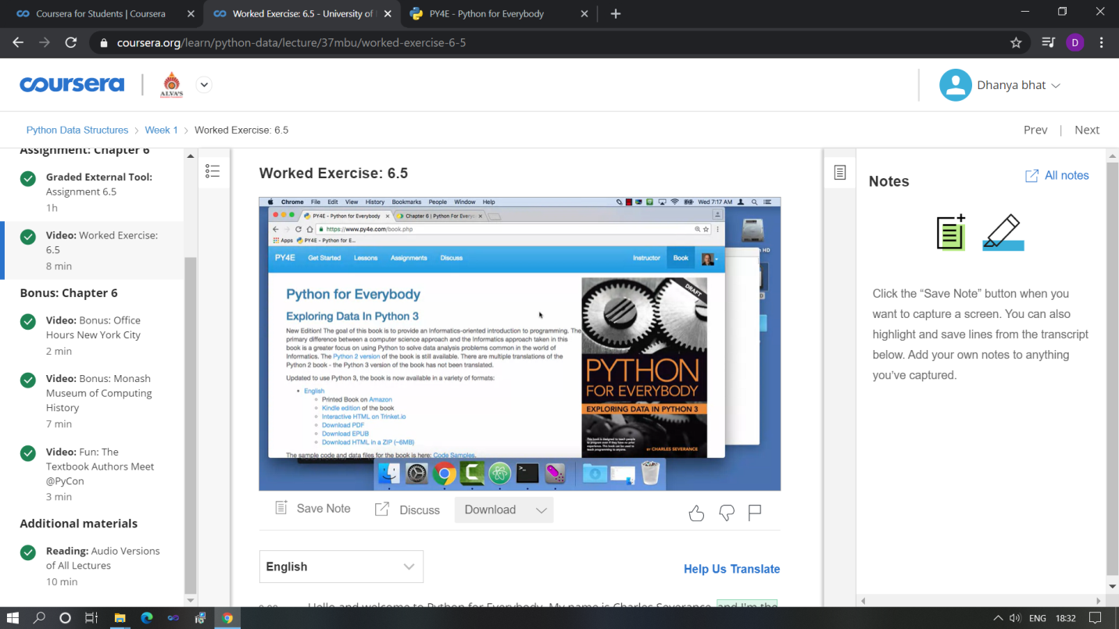

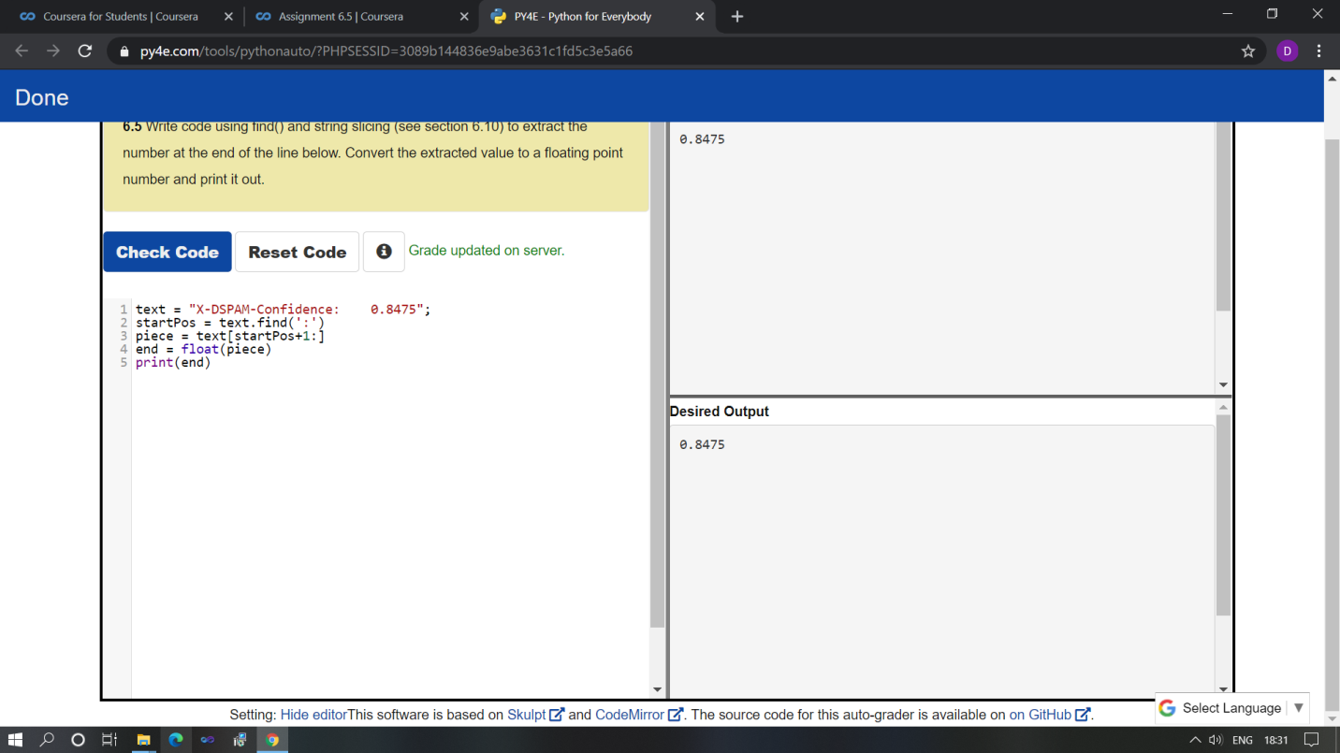

Started a online course Python data structure in coursera. Today in online course I studied some concepts of python and also completed the quiz.

Coding Challenges Details: (Attach the snapshot and briefly write the report for the same)

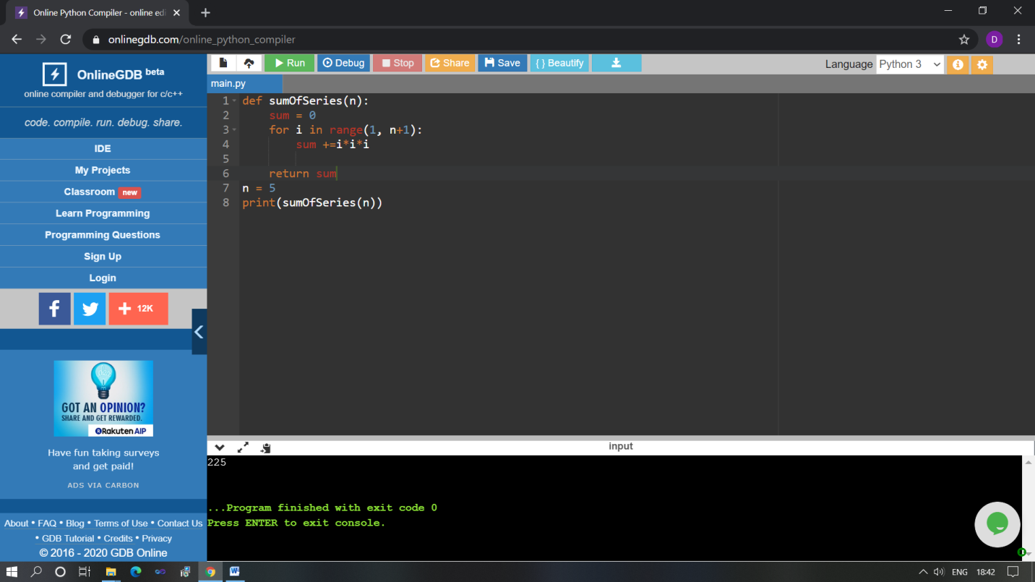

The above Programs were written and executed and the output of the same is displayed above. The code for those 1 programs have been uploaded to the github repository and the link to the same is provided on the form.