**DAILY ONLINE ACTIVITIES SUMMARY**

|  |  |  |  |  |  |  |  |  |
| --- | --- | --- | --- | --- | --- | --- | --- | --- |
| **Date:** | **17-06-2020** | | | | | **Name:** | **John Alsten Tauro** | |
| **Sem & Sec** | **6th A** | | | | | **USN:** | **4AL17CS037** | |
| **Online Test Summary** | | | | | | | | |
| **Subject** | | **C programming quiz** | | | | | | |
| **Max. Marks** | | **15** | | **Score** | | | **12** | |
| **Pre-Placement Course Summary** | | | | | | | | |
| **Pre-placement training** | 9.00-11.00:Programming in C **11.00-1.00:Applications of Python Programming in Data Analytics and Machine Learning – Research Perspective** | | | | | | | |
| **Faculty name** | | | **Vivek sharma and Dr.** Mohideen  Badusha, Dr. Mohammed javed | | **Duration** | | | **4hrs** |
| **Coding Challenges** | | | | | | | | |
| **Problem Statement**: 1. Find the smallest positive integer value that cannot be represented as sum of any subset of a given array sorted in ascending order.  **2**. Write a Java program to find the row, column position of a specified number (row, column position) in a given 2-dimensional array.  **3**. Exercise of Python Programming.  .  . | | | | | | | | |
| **Status: YES, Completed all Programs** | | | | | | | | |
| **Uploaded the report in Github** | | | | | **YES** | | | |
| **If yes Repository name** | | | | | [**https://github.com/alvas-education-foundation/Alsten_Tauro**](https://github.com/alvas-education-foundation/Alsten_Tauro) | | | |
| **Uploaded the report in slack** | | | | | **YES** | | | |

Online test Details: (Attach the snapshot and briefly write the report for the same)

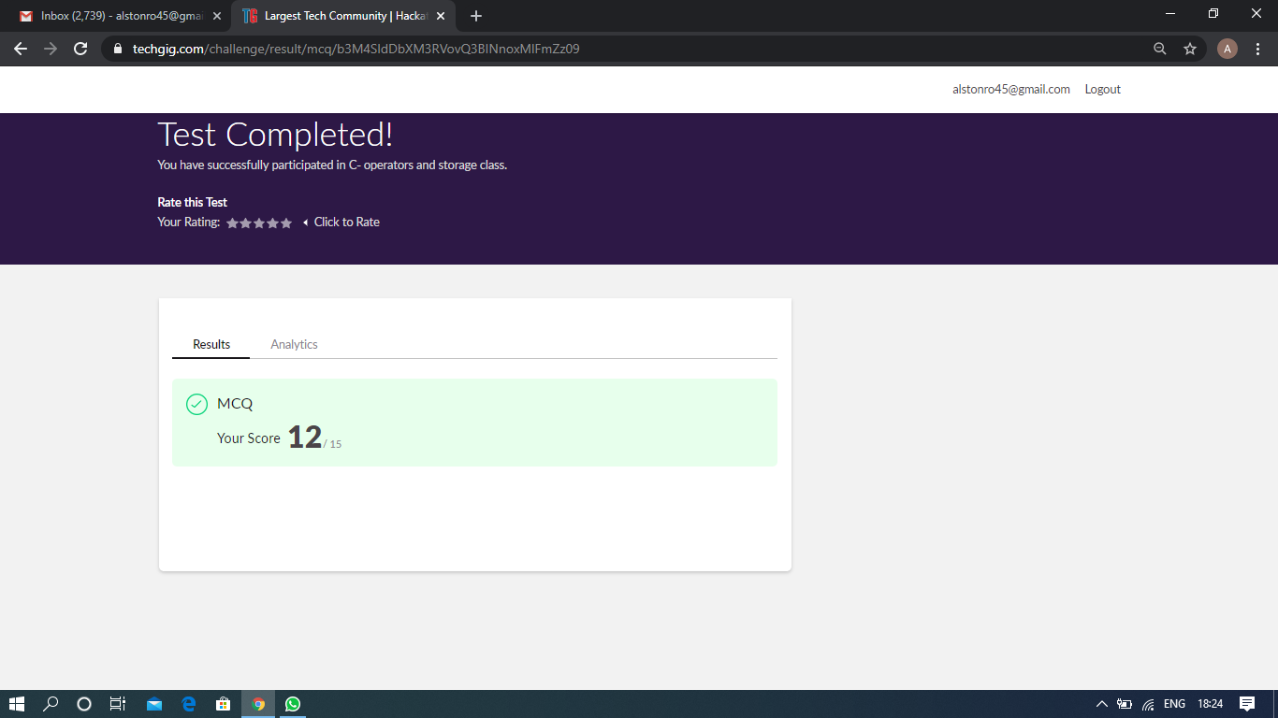

sScored 12 out of 15 in C programming quiz

Pre-Placement Course Details: (Attach the snapshot and briefly write the report for the same)

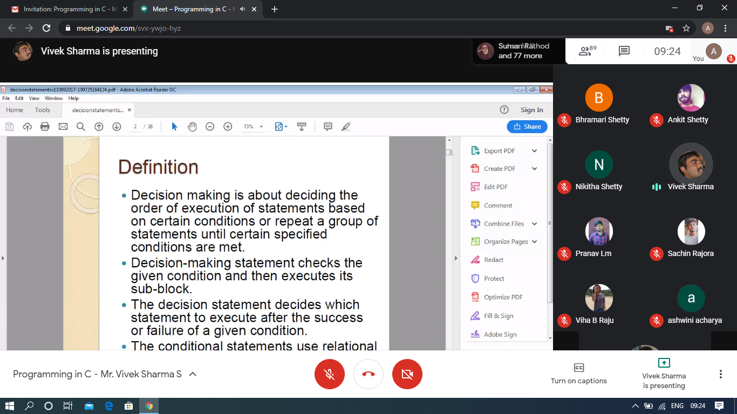

Programming in C- Mr. Vivek Sharma @Mon 15 2020 9am-11.00am

Today in this session I studies about decision making and looping statements. I also attended quiz in the middle of the session.

The exercise of the session is uploaded in the below github repository link:

<https://github.com/Alsten-Tauro/C-programming-exercises-Placement-training>

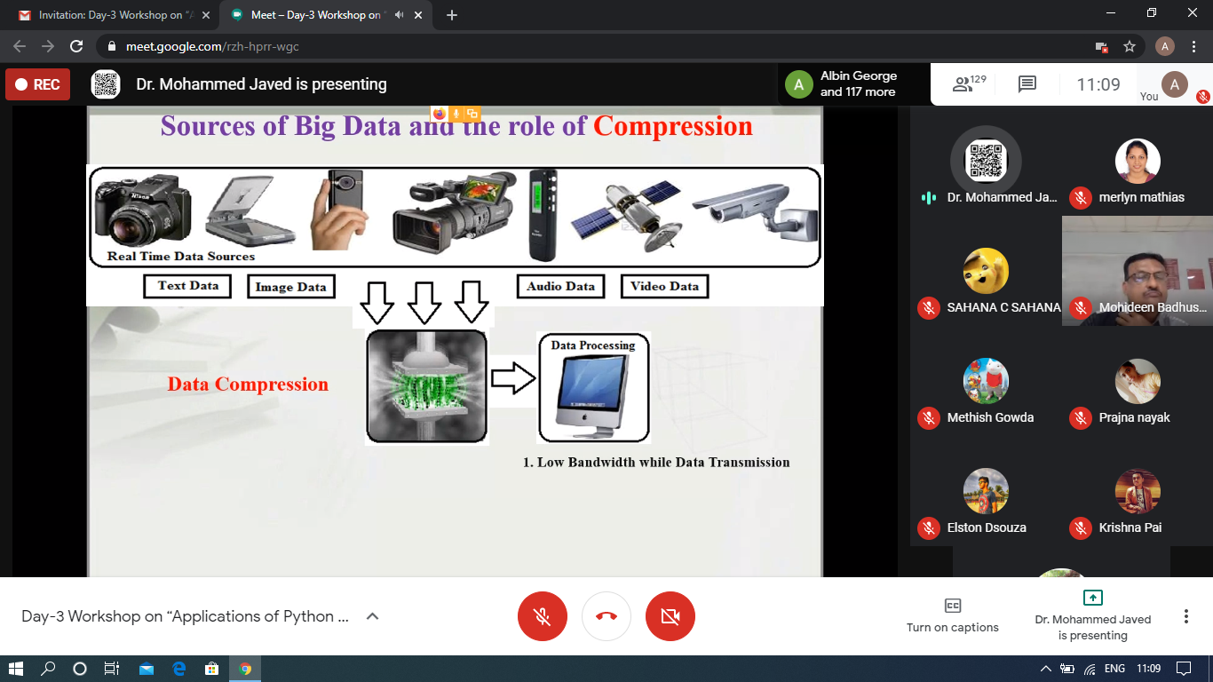

### Applications of Python Programming in Data Analytics and Machine Learning – Research Perspective- Mon 15 june 2020 11.00 to 1.00pm.

### Today in this session I studies numpy and pandas and also the worked examples with python program.

The exercise of the session is uploaded in the below github repository link

<https://github.com/Alsten-Tauro/Applications-of-Python-Programming-in-Data-Analytics-and-Machine-Learning>

Coding Challenges Details: (Attach the snapshot and briefly write the report for the same)

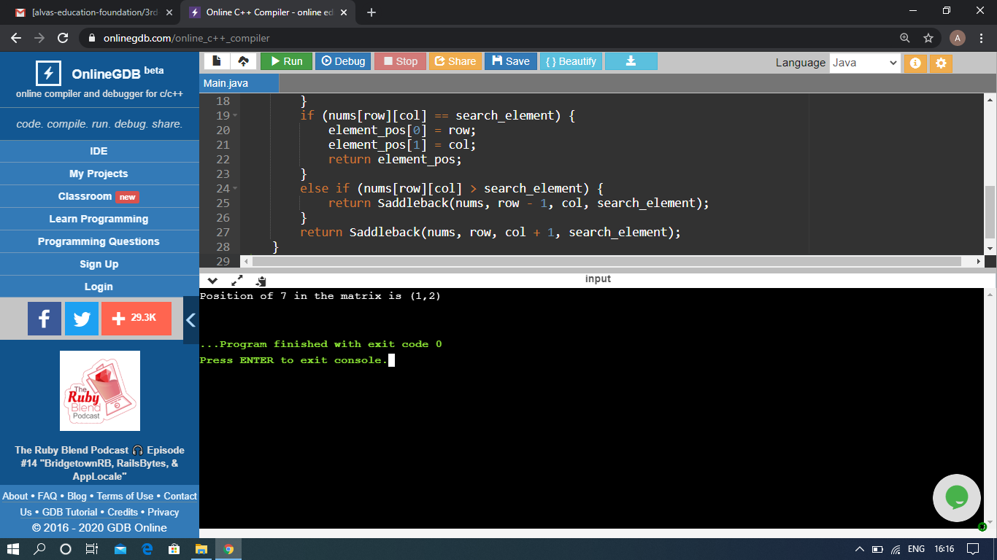

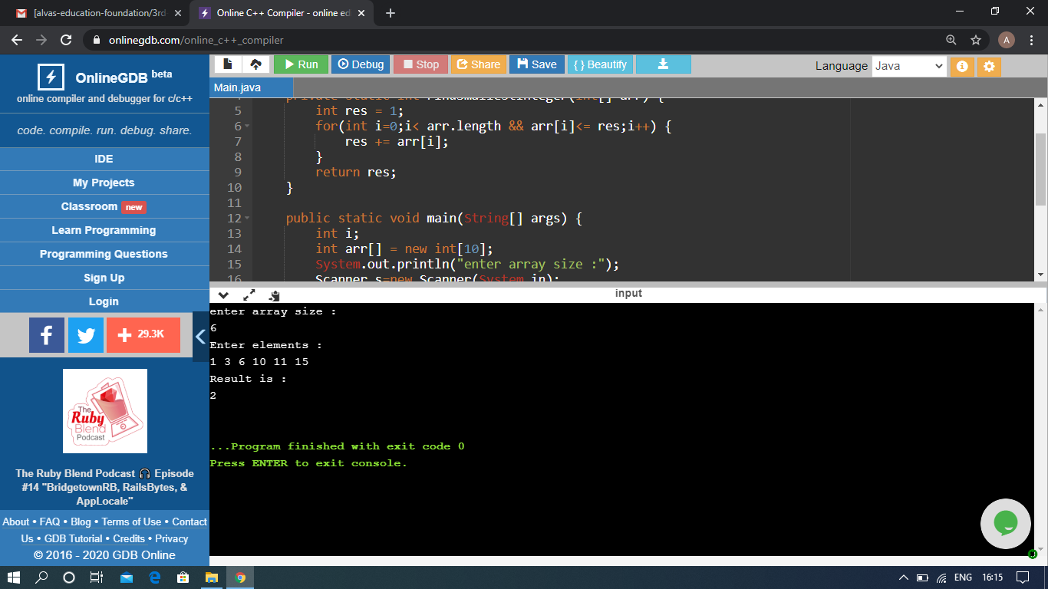

The above Programs were written and executed and the output of the same is displayed above. The code for those 2 programs have been uploaded to the github repository and the link to the same is provided on the form.