**DAILY ONLINE ACTIVITIES SUMMARY**

|  |  |  |  |  |  |  |  |  |
| --- | --- | --- | --- | --- | --- | --- | --- | --- |
| **Date:** | **19-06-2020** | | | | | **Name:** | **John Alsten Tauro** | |
| **Sem & Sec** | **6th A** | | | | | **USN:** | **4AL17CS037** | |
| **Online Test Summary** | | | | | | | | |
| **Subject** | | **C programming quiz** | | | | | | |
| **Max. Marks** | | **Quiz1-4**  **Quiz2-4** | | **Score** | | | **Quiz1-3**  **Quiz2-3** | |
| **Pre-Placement Course Summary** | | | | | | | | |
| **Pre-placement training** | 9.00-11.00:Programming in C **11.00-1.00:Applications of Python Programming in Data Analytics and Machine Learning – Research Perspective** | | | | | | | |
| **Faculty name** | | | **Shilpa gowda and Dr.** Mohideen  Badusha, Dr. Mohammed javed | | **Duration** | | | **4hrs** |
| **Coding Challenges** | | | | | | | | |
| **Problem Statement**: 1. Write a C Program for the following using pointer concept  **a.** To swap 2 numbers using pointer and function concept, return value from user defined function and print the swapped values in main() function.  **b.** Given a positive integer n, count the total number of set bits in binary representation of all numbers from 1 to n.  2. Write a Java program to create a doubly linked list of n nodes and display it in reverse order.  3. Write a C Program to rotate a Matrix by 90 Degree in Clockwise or Anticlockwise Direction. Implement (Both the rotations in single program using switch case statement).  **4**. Exercise of Python Programming.    .  . | | | | | | | | |
| **Status: YES, Completed all Programs** | | | | | | | | |
| **Uploaded the report in Github** | | | | | **YES** | | | |
| **If yes Repository name** | | | | | [**https://github.com/alvas-education-foundation/Alsten_Tauro**](https://github.com/alvas-education-foundation/Alsten_Tauro) | | | |
| **Uploaded the report in slack** | | | | | **YES** | | | |

Online test Details: (Attach the snapshot and briefly write the report for the same)

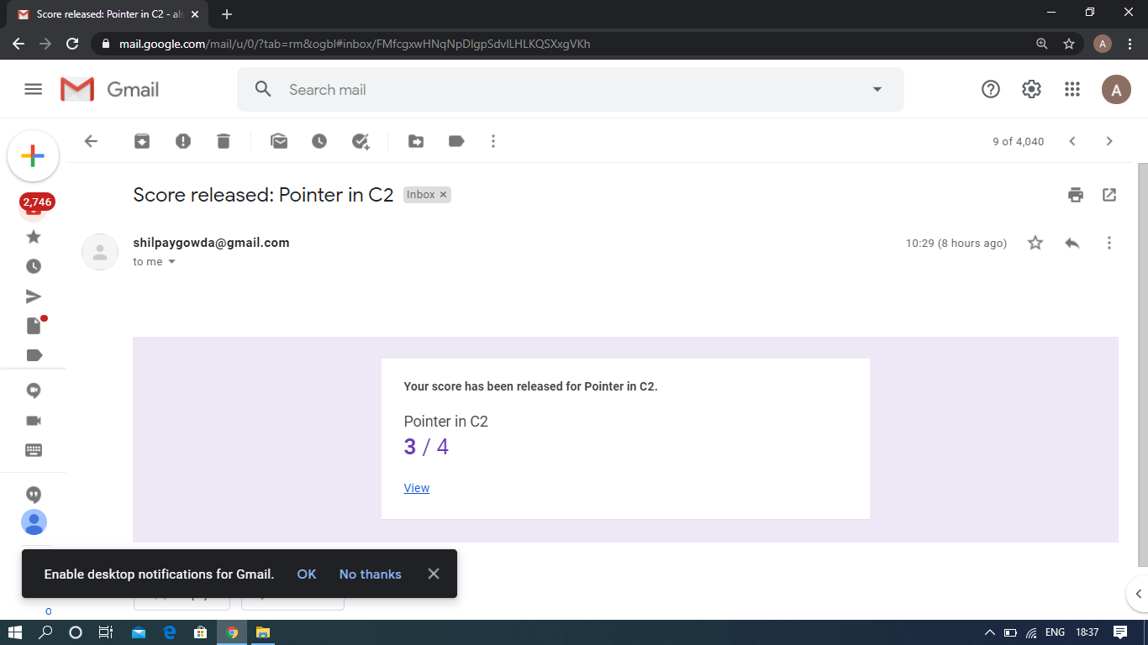

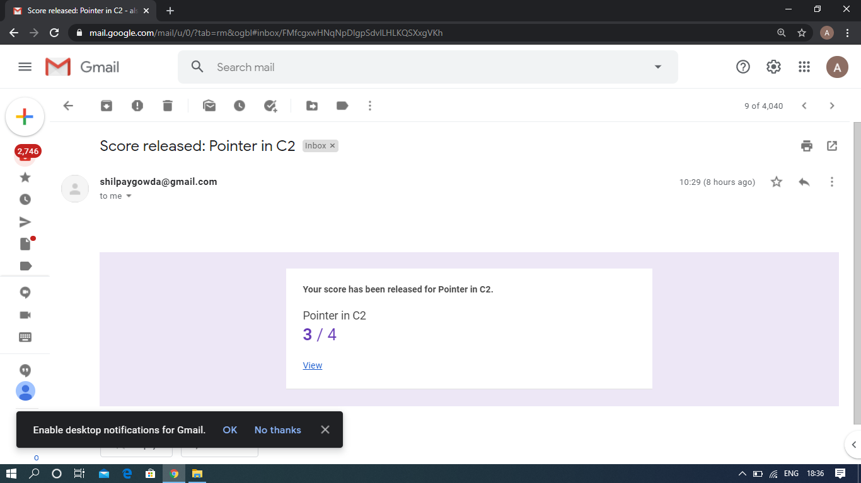

C programming quiz

Pre-Placement Course Details: (Attach the snapshot and briefly write the report for the same)

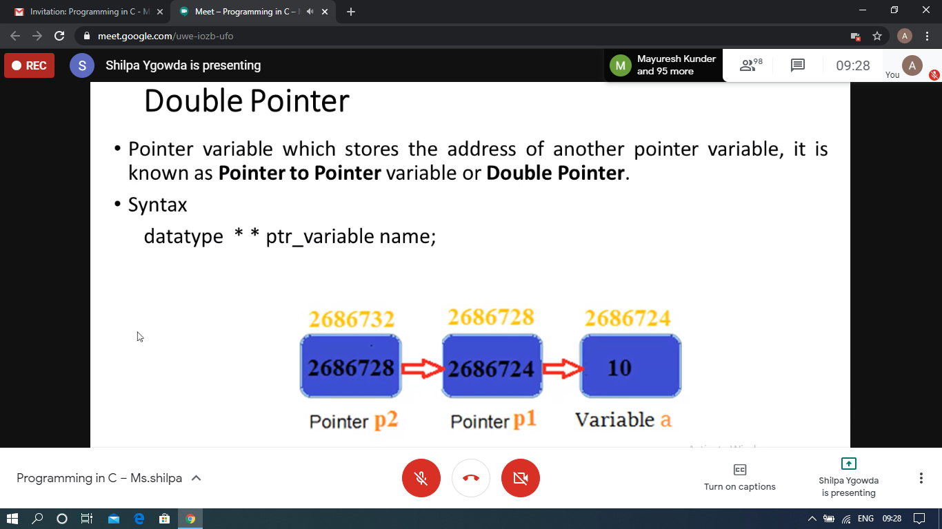

v

Programming in C

Today in this session I studies Pointers. I attended 2 quiz in the middle of the session.

The exercise of the session is uploaded in the below github repository link:

<https://github.com/Alsten-Tauro/C-programming-exercises-Placement-training>

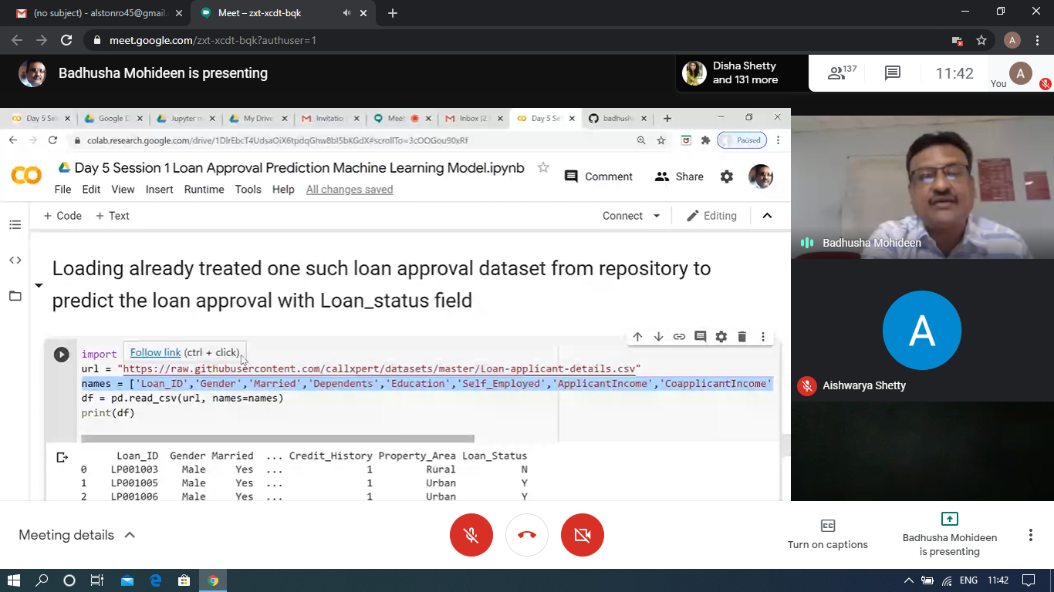

### Applications of Python Programming in Data Analytics and Machine Learning – Research PerspectiveToday in this session I studies data analytics model and also the worked examples with python program.

The exercise of the session is uploaded in the below github repository link

<https://github.com/Alsten-Tauro/Applications-of-Python-Programming-in-Data-Analytics-and-Machine-Learning>

Coding Challenges Details: (Attach the snapshot and briefly write the report for the same)

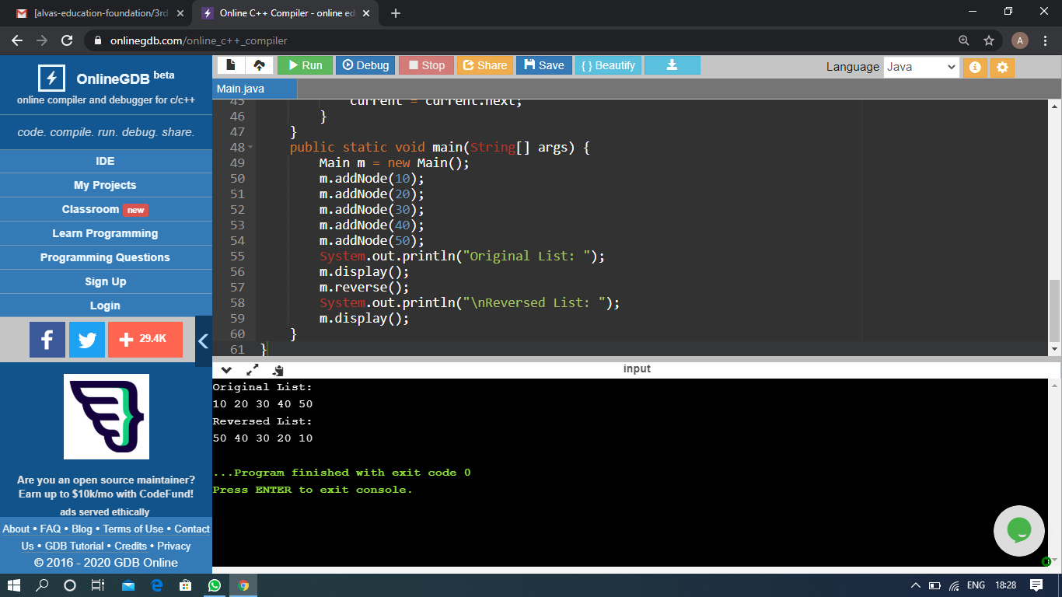

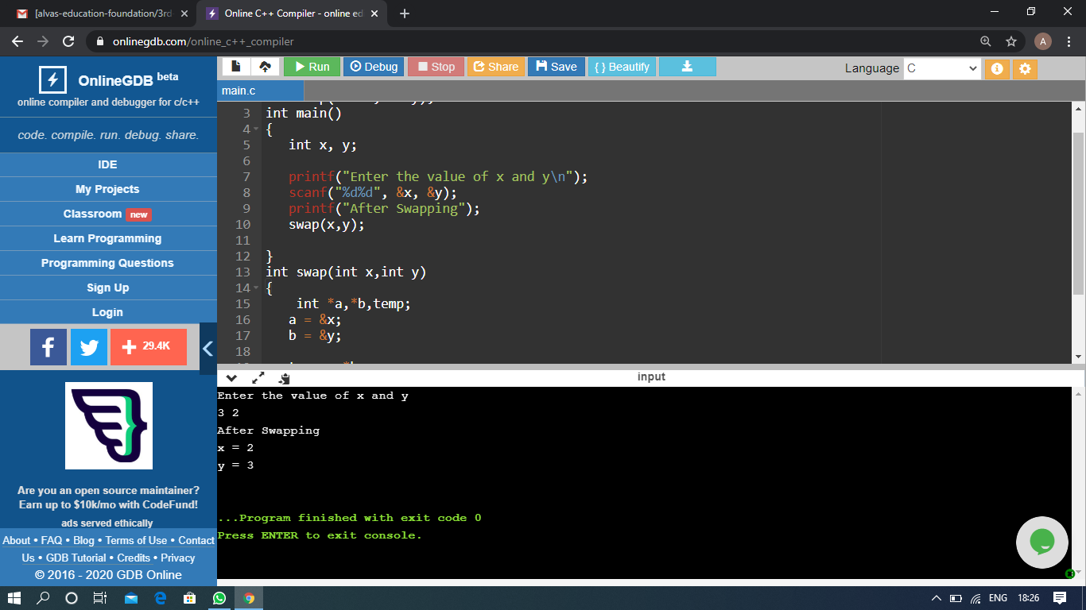

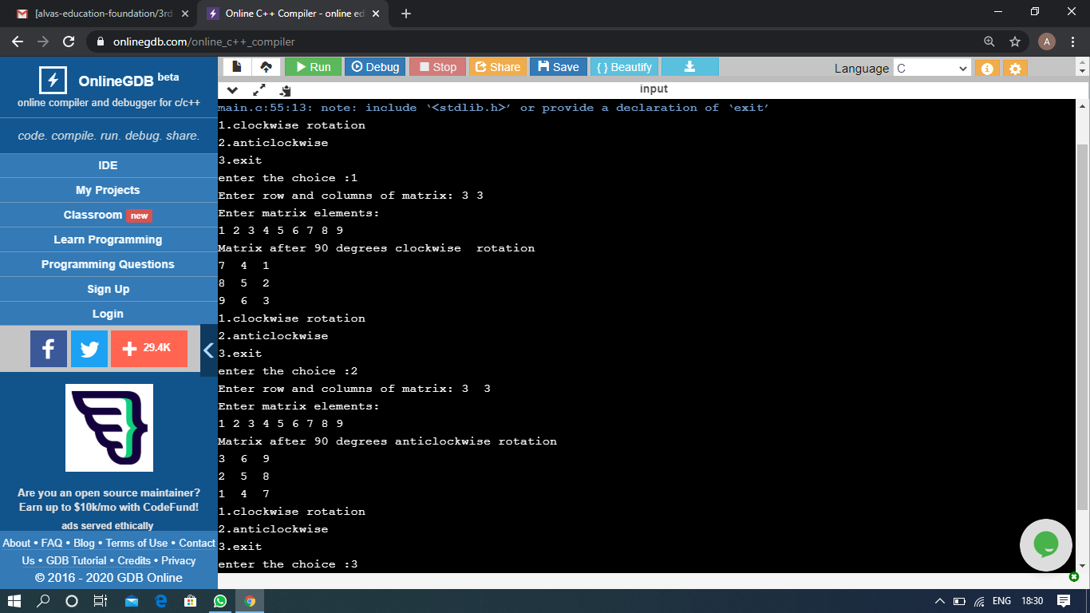

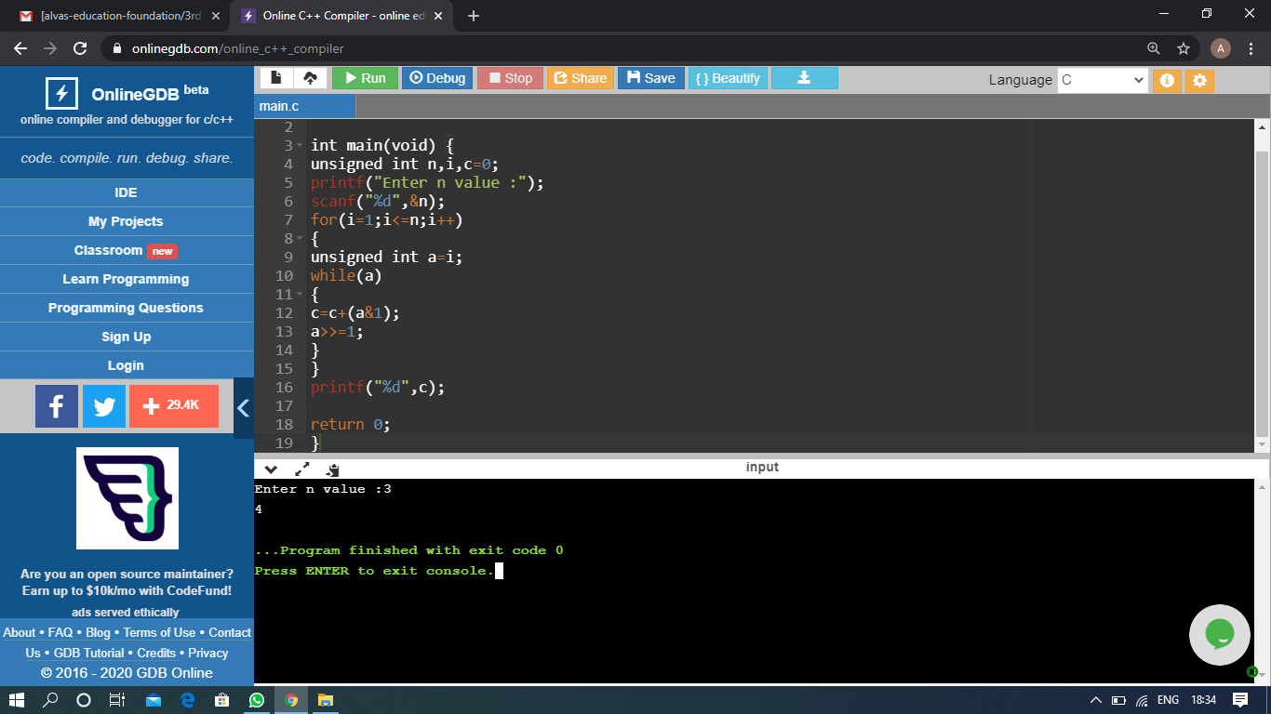

The above Programs were written and executed and the output of the same is displayed above. The code for those 4 programs have been uploaded to the github repository and the link to the same is provided on the form.