**DAILY ONLINE ACTIVITIES SUMMARY**

|  |  |  |  |  |  |  |  |  |
| --- | --- | --- | --- | --- | --- | --- | --- | --- |
| **Date:** | **20-06-2020** | | | | | **Name:** | **John Alsten Tauro** | |
| **Sem & Sec** | **6th A** | | | | | **USN:** | **4AL17CS037** | |
| **Online Test Summary** | | | | | | | | |
| **Subject** | | **C++ programming quiz** | | | | | | |
| **Max. Marks** | |  | | **Score** | | |  | |
| **Pre-Placement Course Summary** | | | | | | | | |
| **Pre-placement training** | 9.20-11.00: Programming in C++ **11.10-1.00: Programming in C++** | | | | | | | |
| **Faculty name** | | | **Ankitha shetty and Pradeep nayak** | | **Duration** | | | **4hrs** |
| **Coding Challenges** | | | | | | | | |
| **Problem Statement**: 1. Write a Java Program to find area of Square, Rectangle and Circle using Method Overloading.  **2**. Write a C Program to rotate an array by K positions.    .  . | | | | | | | | |
| **Status: YES, Completed all Programs** | | | | | | | | |
| **Uploaded the report in Github** | | | | | **YES** | | | |
| **If yes Repository name** | | | | | [**https://github.com/alvas-education-foundation/Alsten_Tauro**](https://github.com/alvas-education-foundation/Alsten_Tauro) | | | |
| **Uploaded the report in slack** | | | | | **YES** | | | |

Pre-Placement Course Details: (Attach the snapshot and briefly write the report for the same)

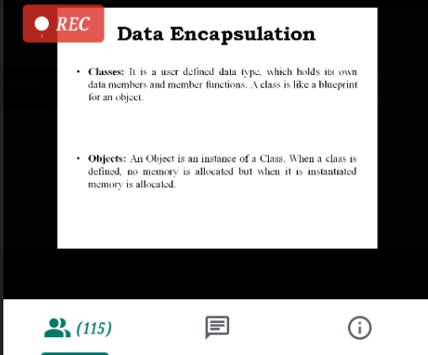

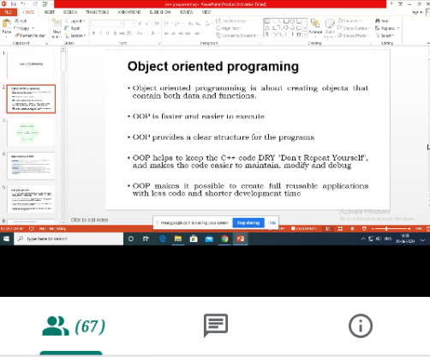

v

Programming in C++

Today in this session I studied about basics of C++ programming. I attended 2 quiz in the middle of the session.

Coding Challenges Details: (Attach the snapshot and briefly write the report for the same)

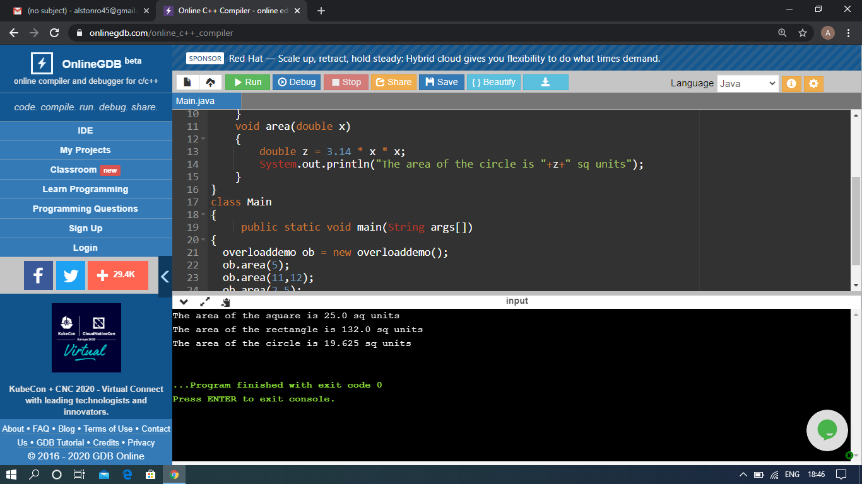

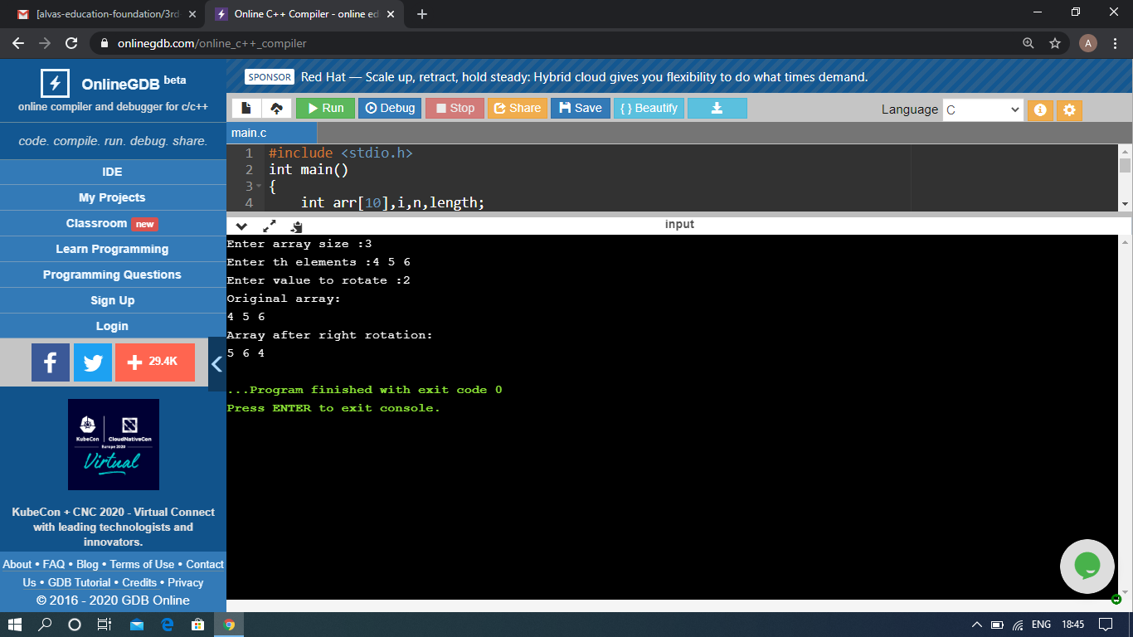

The above Programs were written and executed and the output of the same is displayed above. The code for those 2 programs have been uploaded to the github repository and the link to the same is provided on the form.