**DAILY ONLINE ACTIVITIES SUMMARY**

|  |  |  |  |  |  |  |  |  |
| --- | --- | --- | --- | --- | --- | --- | --- | --- |
| **Date:** | **21-06-2020** | | | | | **Name:** | **John Alsten Tauro** | |
| **Sem & Sec** | **6th A** | | | | | **USN:** | **4AL17CS037** | |
| **Online Test Summary** | | | | | | | | |
| **Subject** | |  | | | | | | |
| **Max. Marks** | |  | | **Score** | | |  | |
| **Pre-Placement Course Summary** | | | | | | | | |
| **Pre-placement training** |  | | | | | | | |
| **Faculty name** | | |  | | **Duration** | | | **4hrs** |
| **Coding Challenges** | | | | | | | | |
| **Problem Statement**: 1. Write a Python program to display a calendar  **2.** Python program to display all prime numbers in an interval.    .  . | | | | | | | | |
| **Status: YES, Completed all Programs** | | | | | | | | |
| **Uploaded the report in Github** | | | | | **YES** | | | |
| **If yes Repository name** | | | | | [**https://github.com/alvas-education-foundation/Alsten_Tauro**](https://github.com/alvas-education-foundation/Alsten_Tauro) | | | |
| **Uploaded the report in slack** | | | | | **YES** | | | |

Coding Challenges Details: (Attach the snapshot and briefly write the report for the same)

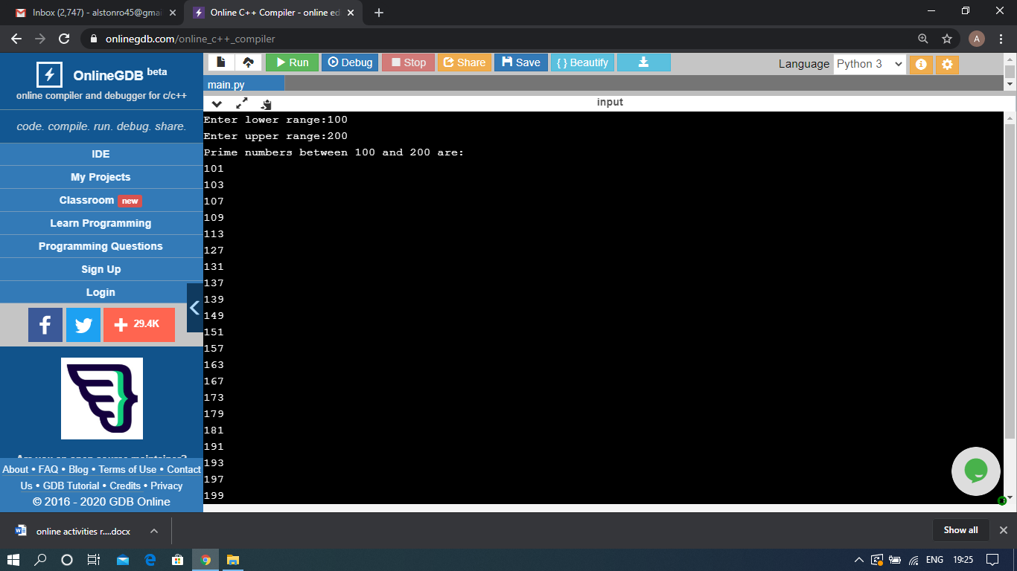

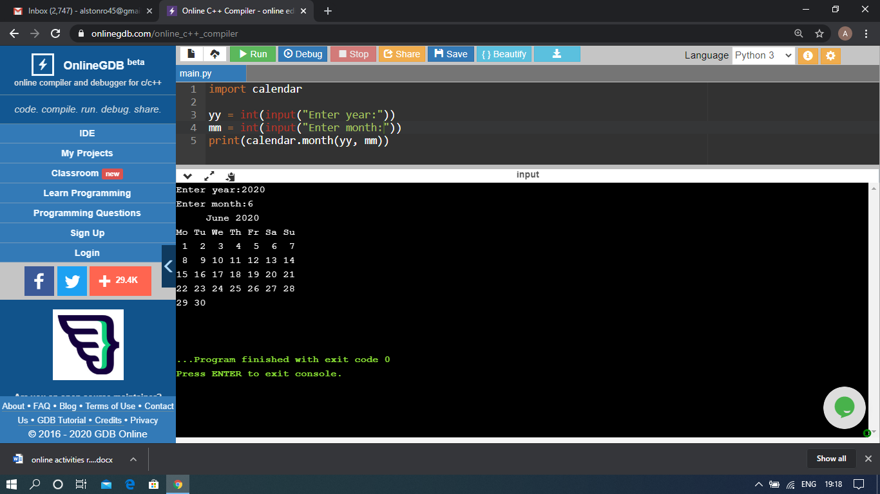

The above Programs were written and executed and the output of the same is displayed above. The code for those 2 programs have been uploaded to the github repository and the link to the same is provided on the form.