**DAILY ONLINE ACTIVITIES SUMMARY**

|  |  |  |  |  |  |  |  |  |
| --- | --- | --- | --- | --- | --- | --- | --- | --- |
| **Date:** | **22-06-2020** | | | | | **Name:** | **John Alsten Tauro** | |
| **Sem & Sec** | **6th A** | | | | | **USN:** | **4AL17CS037** | |
| **Online Test Summary** | | | | | | | | |
| **Subject** | | **C++ programming quiz** | | | | | | |
| **Max. Marks** | |  | | **Score** | | |  | |
| **Pre-Placement Course Summary** | | | | | | | | |
| **Pre-placement training** | 9.20-11.00: Programming in C++ **11.10-1.00: Programming in C++** | | | | | | | |
| **Faculty name** | | | **Ankitha shetty and shilpa** | | **Duration** | | | **4hrs** |
| **Coding Challenges** | | | | | | | | |
| **Problem Statement**: 1. Write a Java program to find maximum repeated words from a file.    .  . | | | | | | | | |
| **Status: YES, Completed all Programs** | | | | | | | | |
| **Uploaded the report in Github** | | | | | **YES** | | | |
| **If yes Repository name** | | | | | [**https://github.com/alvas-education-foundation/Alsten_Tauro**](https://github.com/alvas-education-foundation/Alsten_Tauro) | | | |
| **Uploaded the report in slack** | | | | | **YES** | | | |

Online test Details: (Attach the snapshot and briefly write the report for the same)

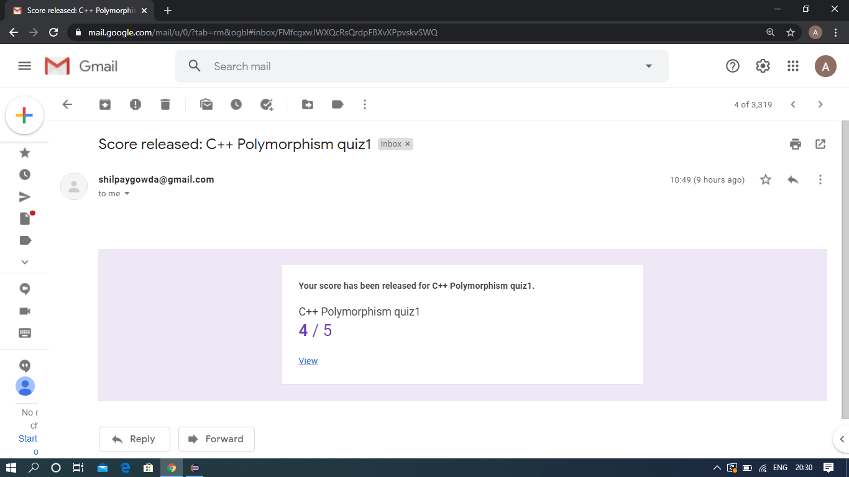

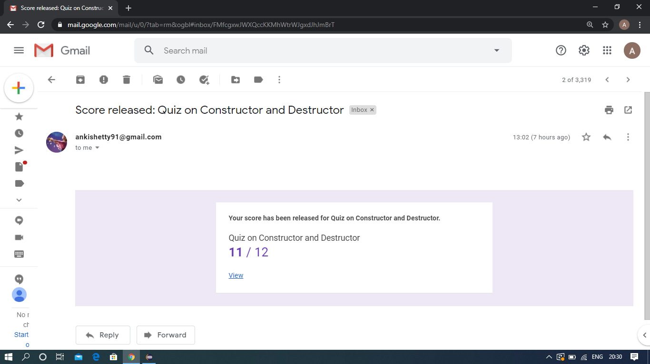

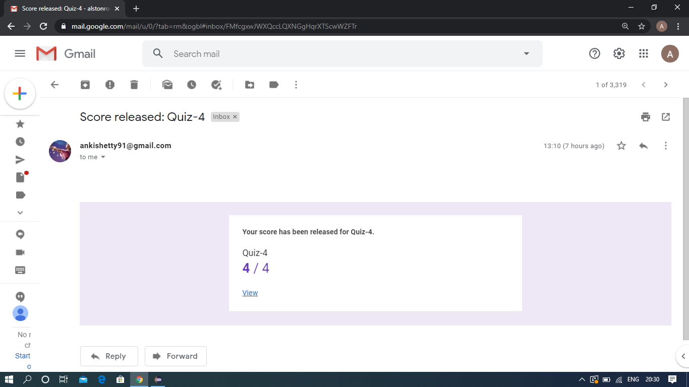

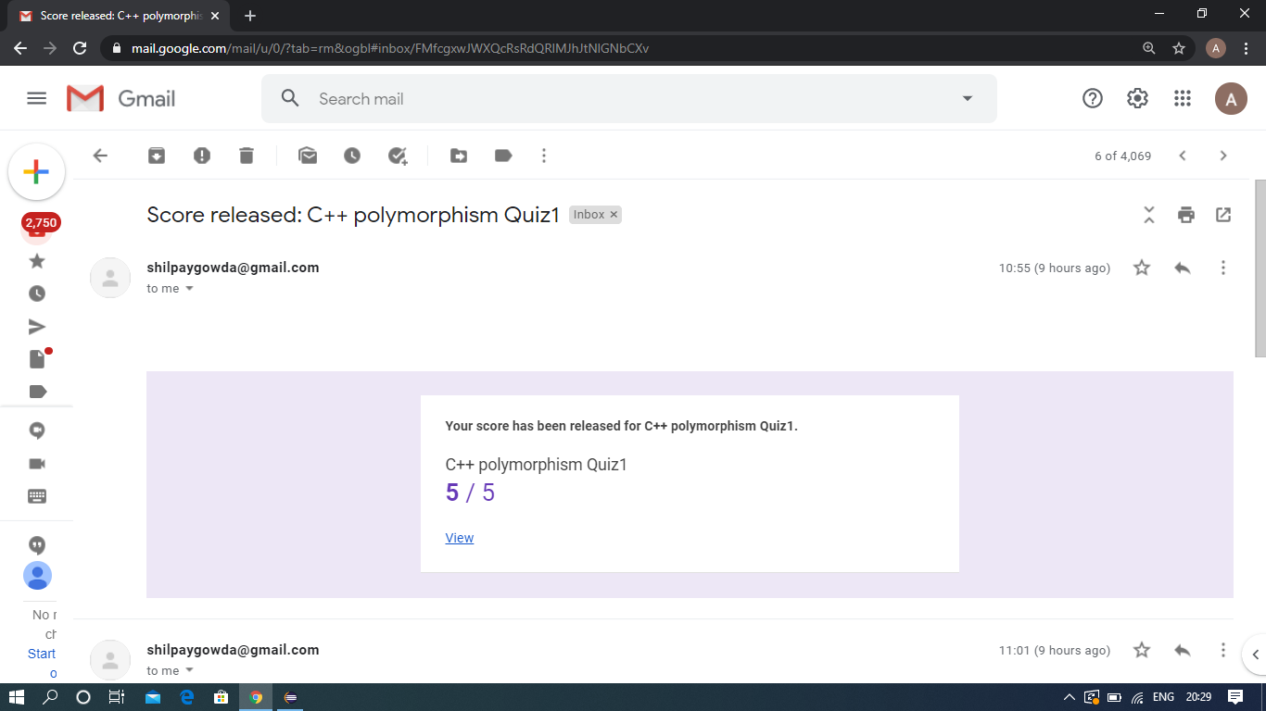

Pre-Placement Course Details: (Attach the snapshot and briefly write the report for the same)

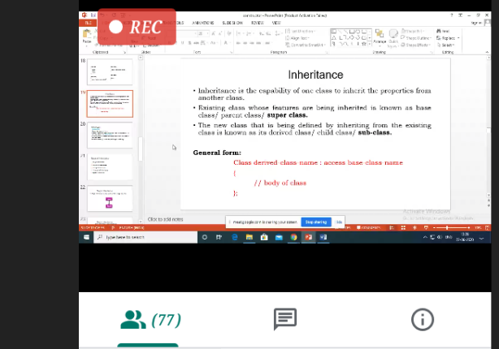

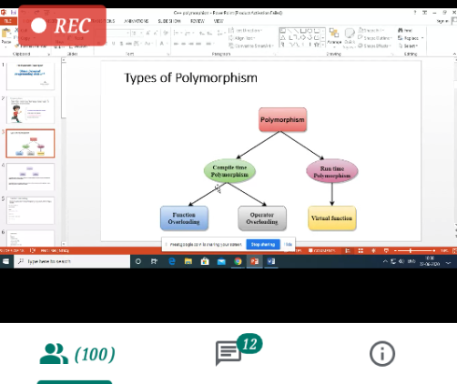

vProgramming in C++

Today in this session I studied about inheritance and polymorphism with C++ programming examples. I attended 4 quiz in the middle of the session.

Coding Challenges Details: (Attach the snapshot and briefly write the report for the same)

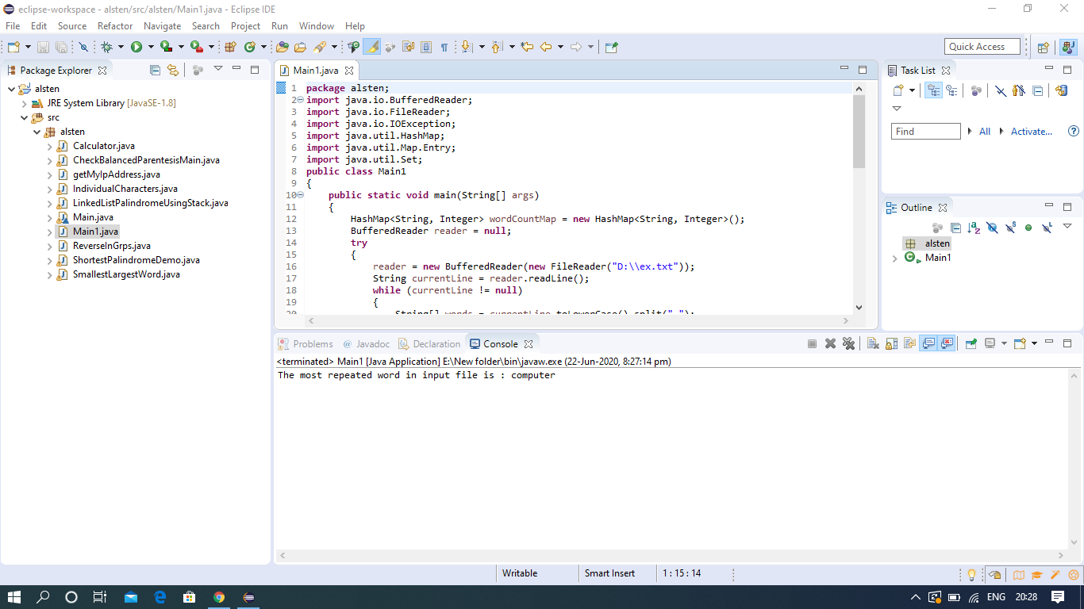

The above Programs were written and executed and the output of the same is displayed above. The code for those 1 programs have been uploaded to the github repository and the link to the same is provided on the form.