**DAILY ONLINE ACTIVITIES SUMMARY**

|  |  |  |  |  |  |  |  |  |
| --- | --- | --- | --- | --- | --- | --- | --- | --- |
| **Date:** | **23-05-2020** | | | | | **Name:** | **John Alsten Tauro** | |
| **Sem & Sec** | **6th A** | | | | | **USN:** | **4AL17CS037** | |
| **Online Test Summary** | | | | | | | | |
| **Subject** | | **PAP** | | | | | | |
| **Max. Marks** | | **30** | | **Score** | | | **18** | |
| **Certification Course Summary** | | | | | | | | |
| **Course** | **A Full Stack Web Developer – Beginner to Advanced** | | | | | | | |
| **Certificate Provider** | | | **Udemy** | | **Duration** | | | **19.5hrs** |
| **Coding Challenges** | | | | | | | | |
| **Problem Statement**: 1. . Write a C Program to Generate First N Triangular Numbers (Where N is read from the Keyboard).  2. Write a menu program in Python to find Area-Circle, Circumference-Circle, Area- Square, Circumference-Square using functions with menu choice.  3. Python program in number right angled triangle. | | | | | | | | |
| **Status: YES, Completed all Programs** | | | | | | | | |
| **Uploaded the report in Github** | | | | | **YES** | | | |
| **If yes Repository name** | | | | | [**https://github.com/alvas-education-foundation/Alsten_Tauro**](https://github.com/alvas-education-foundation/Alsten_Tauro) | | | |
| **Uploaded the report in slack** | | | | | **YES** | | | |

Online Test Details: (Attach the snapshot and briefly write the report for the same)

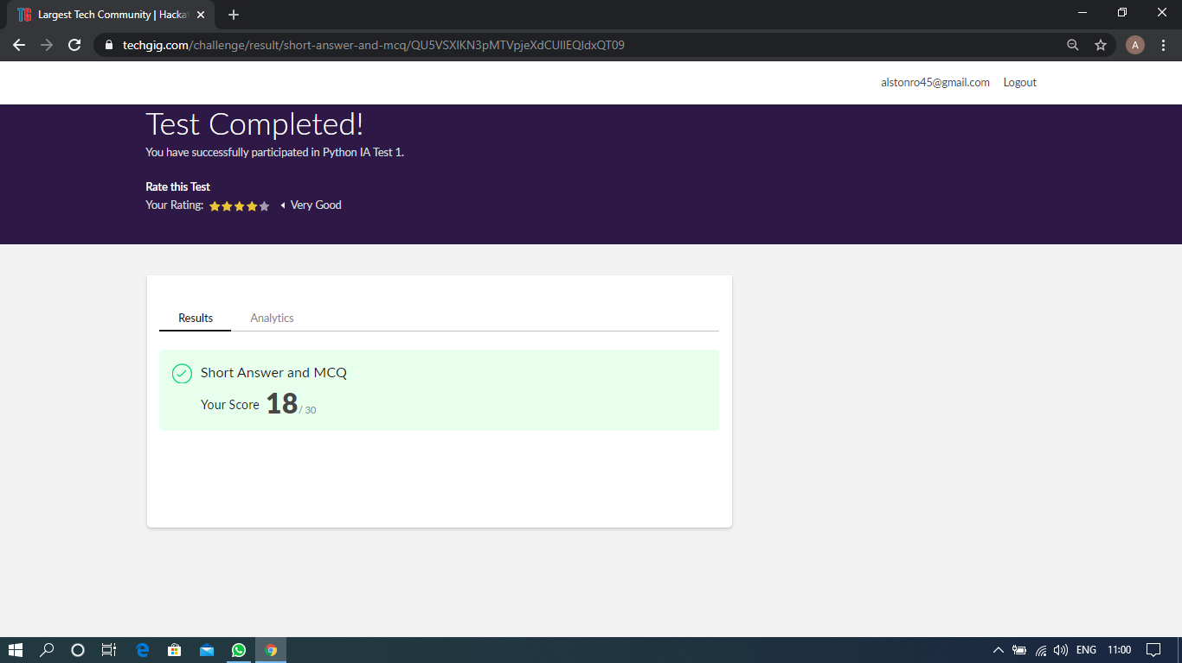

Scored 18 out of 30 in PAP 1st I.A test

Certification Course Details: (Attach the snapshot and briefly write the report for the same)

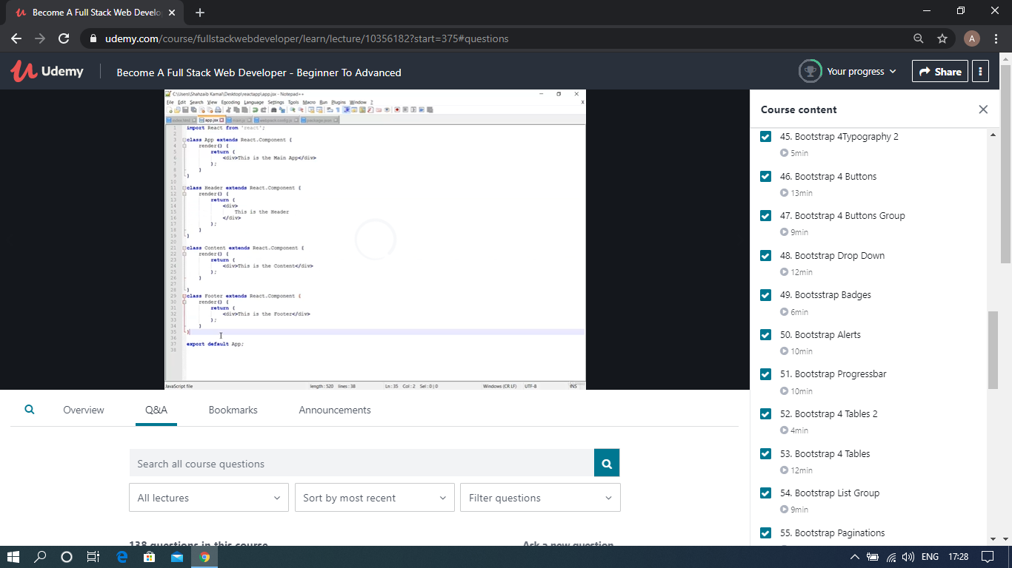

The above course is being taken up by me which is based on the full stack web development. It started with the basics of HTML, Today in Online course I studied about Bootstrap typography, Bootstrap buttons, Bootstrap button groups, Bootstrap drop down, Bootstrap badges, Bootstrap alerts, Bootstrap progress bar, Bootstrap tables. The details of the course and certificate provider is mentioned in the above form.

Coding Challenges Details: (Attach the snapshot and briefly write the report for the same)

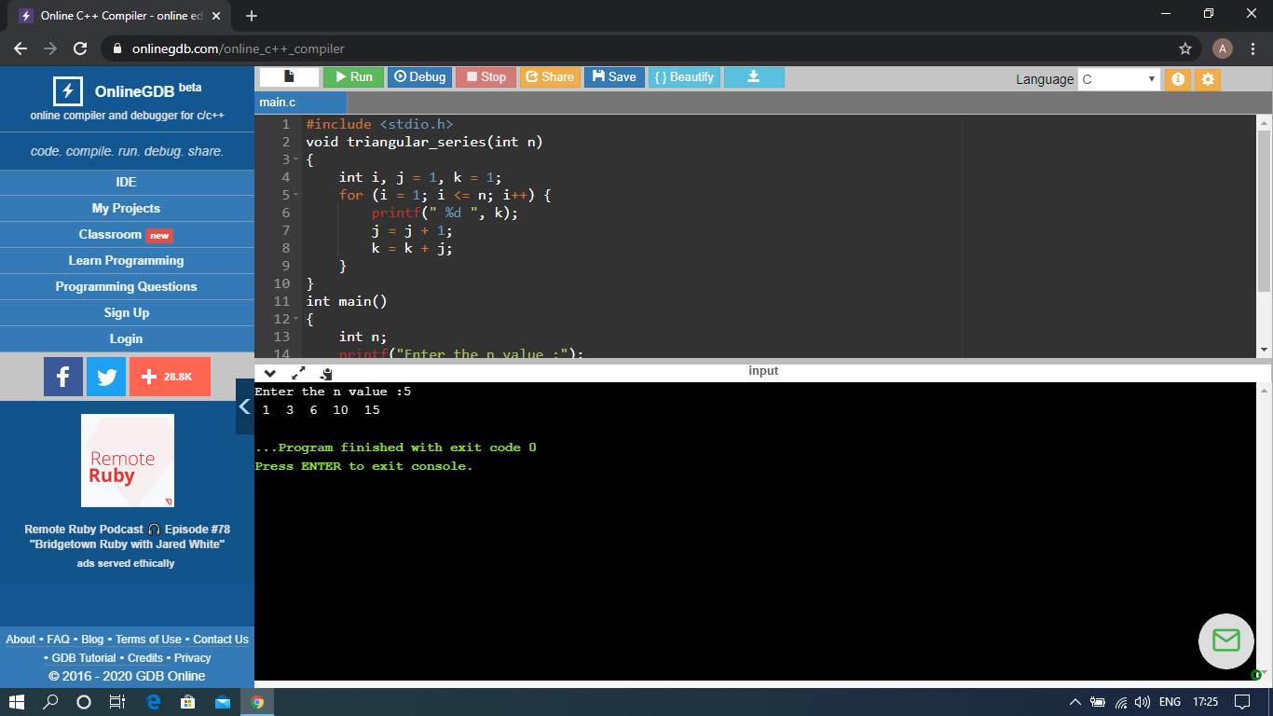

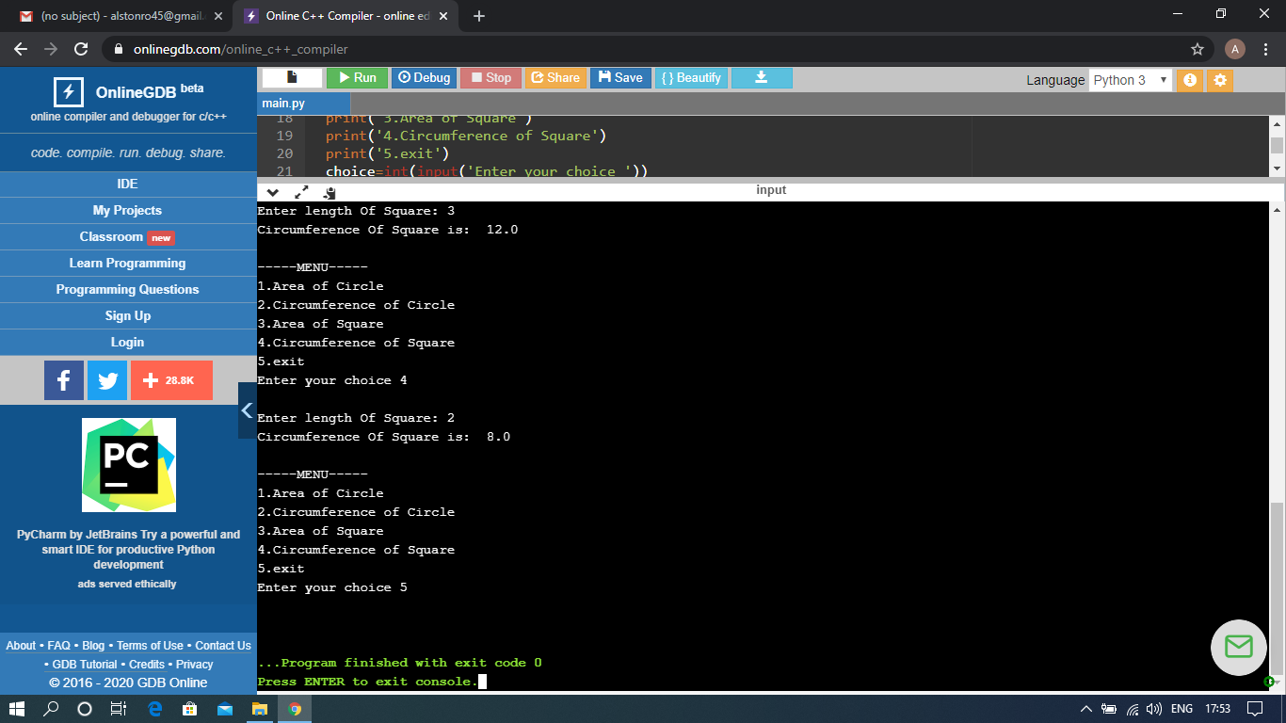

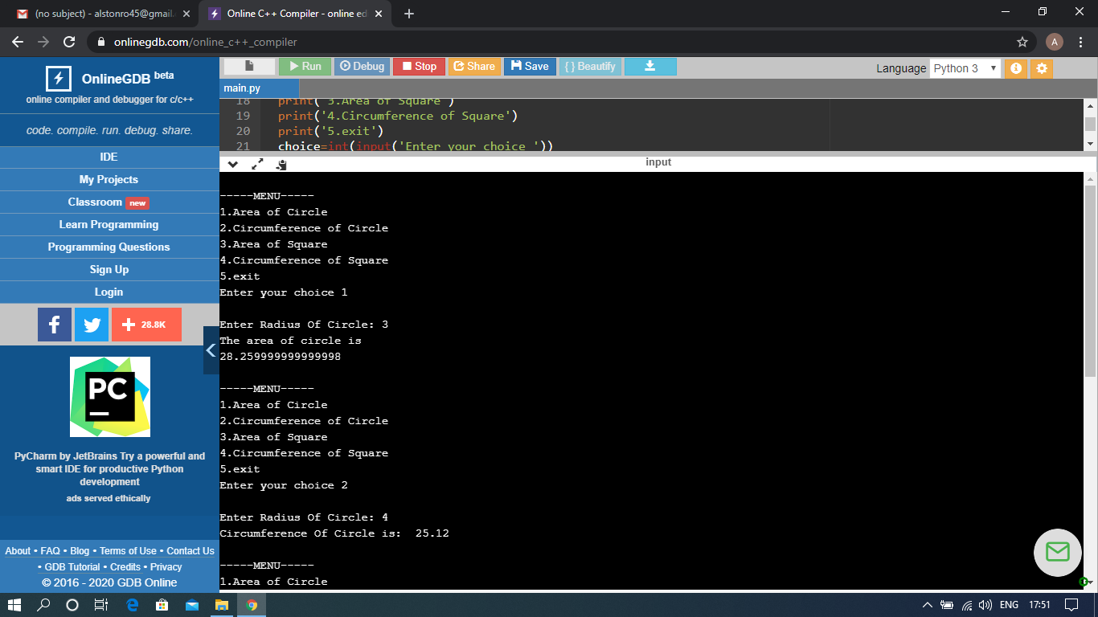

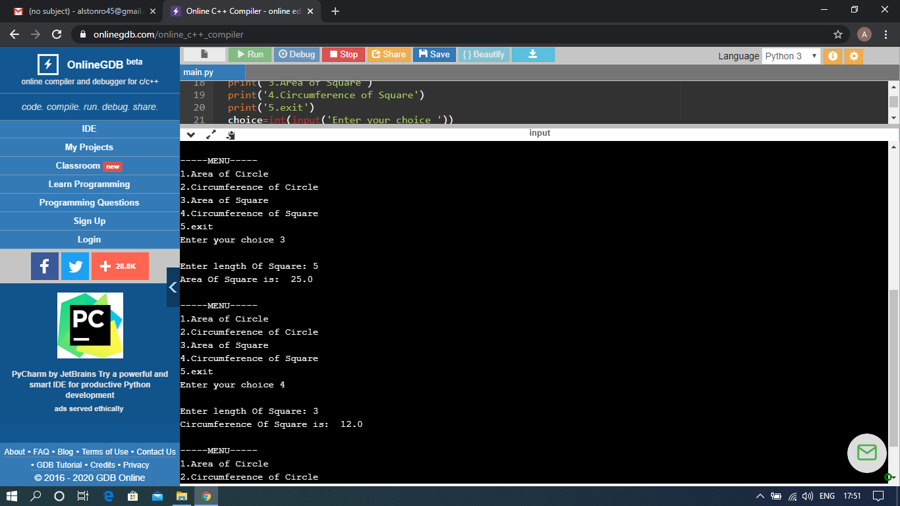

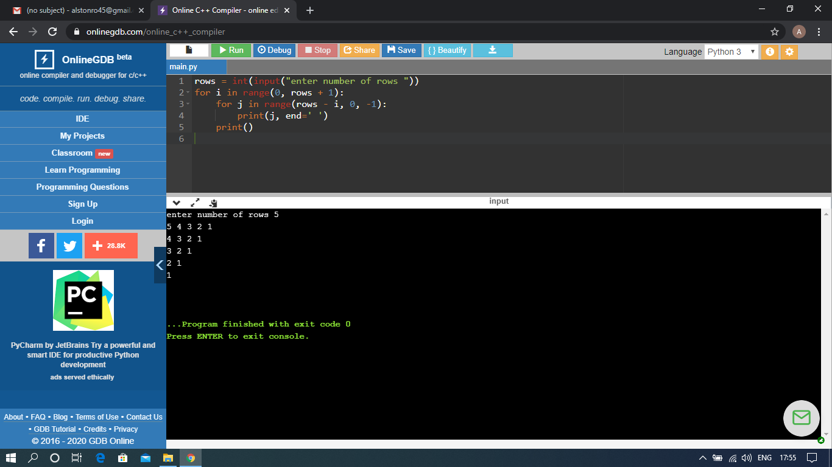

The above Programs were written and executed and the output of the same is displayed above. The code for those 3 programs have been uploaded to the github repository and the link to the same is provided on the form.