**DAILY ONLINE ACTIVITIES SUMMARY**

|  |  |  |  |  |  |  |  |  |
| --- | --- | --- | --- | --- | --- | --- | --- | --- |
| **Date:** | **23-06-2020** | | | | | **Name:** | **John Alsten Tauro** | |
| **Sem & Sec** | **6th A** | | | | | **USN:** | **4AL17CS037** | |
| **Online Test Summary** | | | | | | | | |
| **Subject** | | Java & J2EE quizPython assignment test | | | | | | |
| **Max. Marks** | | **Java:10**  **PAP:20** | | **Score** | | | **Java:9**  **PAP:17** | |
| **Pre-Placement Course Summary** | | | | | | | | |
| **Pre-placement training** | 9.20-11.00: Java & J2EE11.10-1.00: Java & J2EE | | | | | | | |
| **Faculty name** | | | **Merlyn mathias and Sharan pais** | | **Duration** | | | **4hrs** |
| **Coding Challenges** | | | | | | | | |
| **Problem Statement**: 1. Write a Java Program to traverse a binary tree using PreOrder traversal without recursion.  **2.** Write a C Program to Sort a stack using a temporary stack.    .  . | | | | | | | | |
| **Status: YES, Completed all Programs** | | | | | | | | |
| **Uploaded the report in Github** | | | | | **YES** | | | |
| **If yes Repository name** | | | | | [**https://github.com/alvas-education-foundation/Alsten_Tauro**](https://github.com/alvas-education-foundation/Alsten_Tauro) | | | |
| **Uploaded the report in slack** | | | | | **YES** | | | |

Online test Details: (Attach the snapshot and briefly write the report for the same)

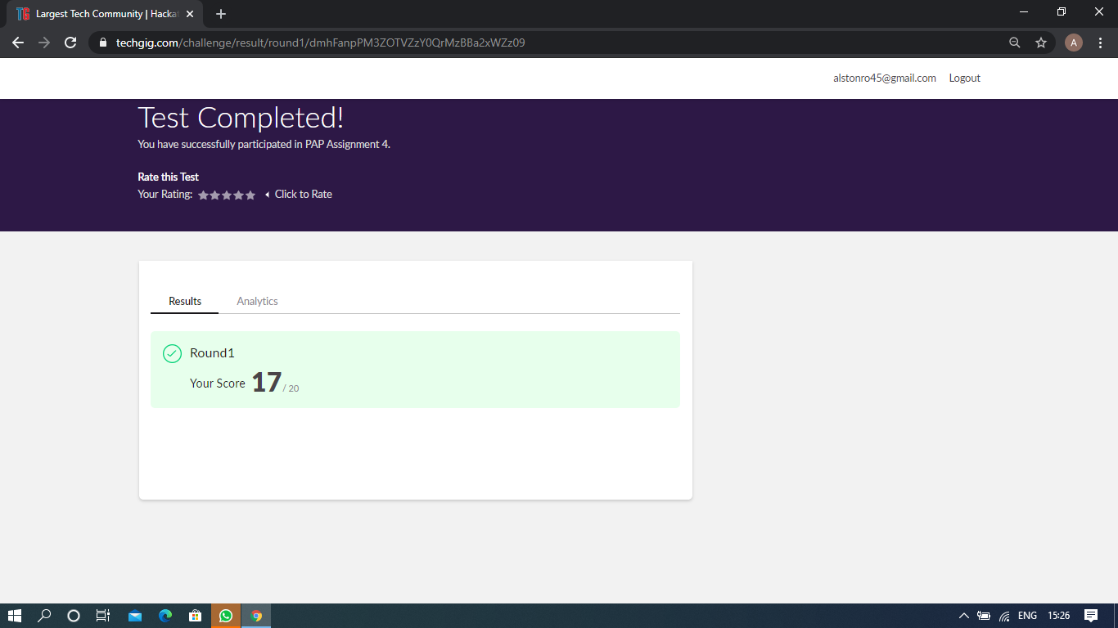

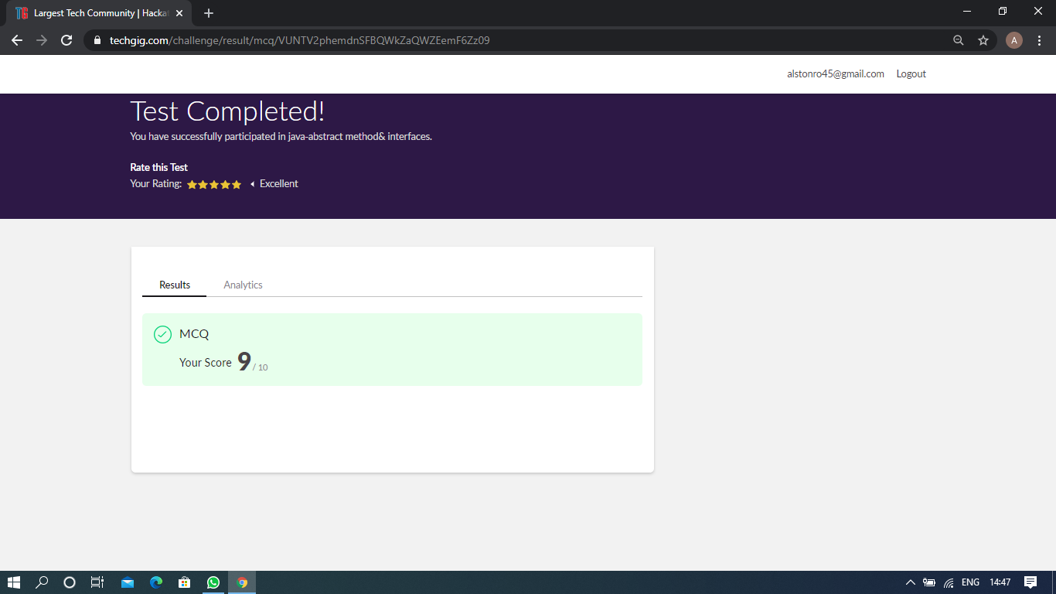

Java quiz and PAP assignment test

Pre-Placement Course Details: (Attach the snapshot and briefly write the report for the same)

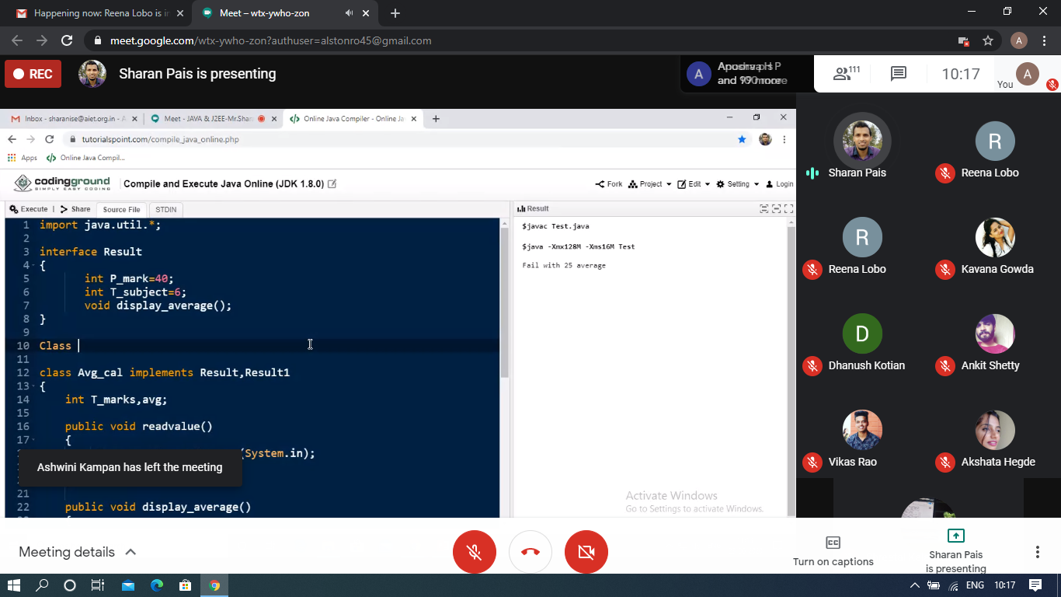

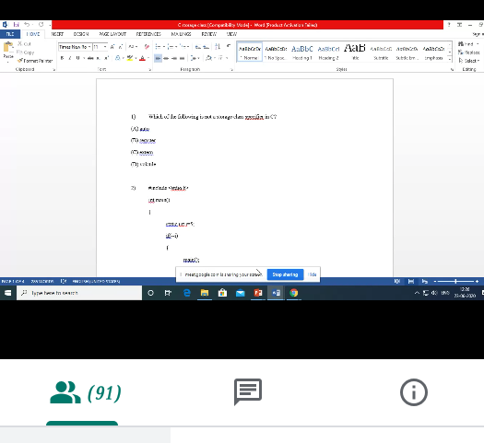

Java and J2EE

Today in this session I studied about basics of java, abstract class, inheritance with Java programming examples. I attended 4 quiz in the middle of the session.

Coding Challenges Details: (Attach the snapshot and briefly write the report for the same)

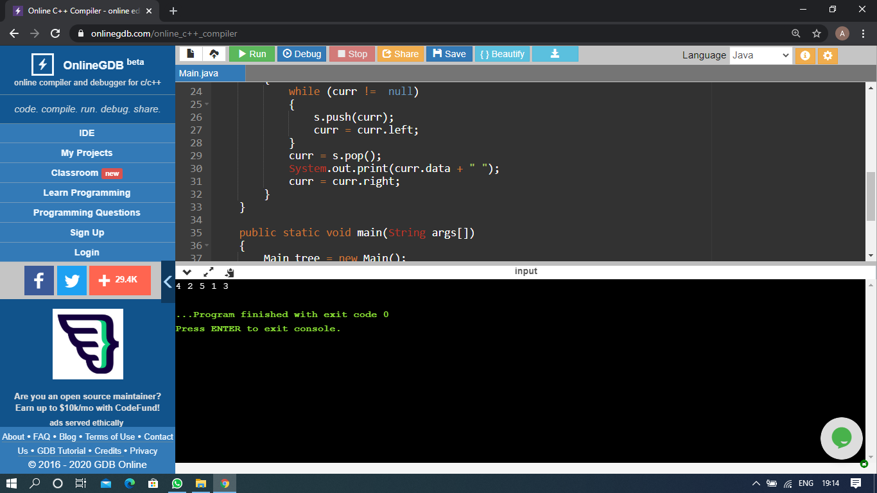

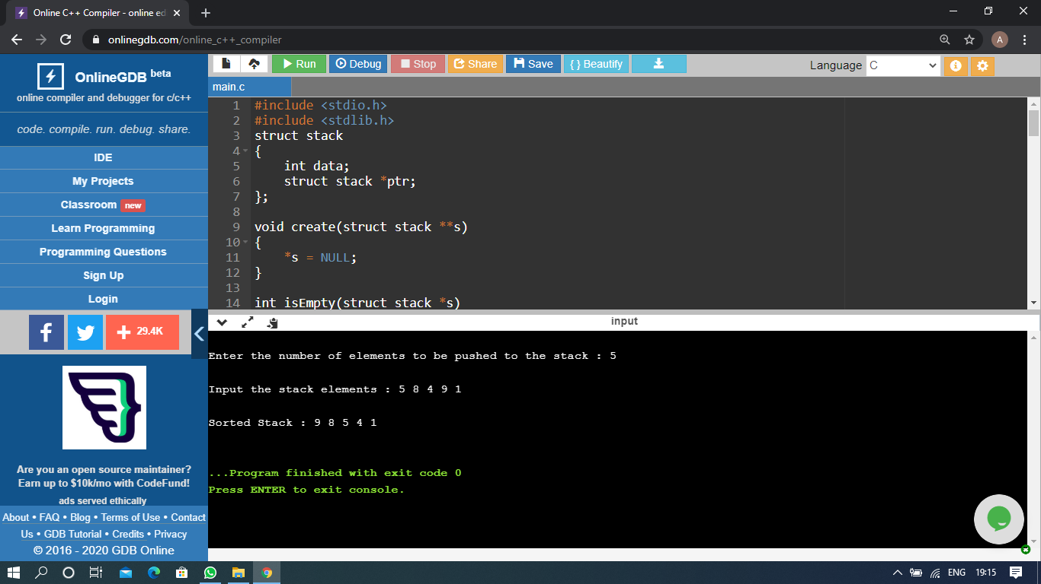

The above Programs were written and executed and the output of the same is displayed above. The code for those 2 programs have been uploaded to the github repository and the link to the same is provided on the form.