**DAILY ONLINE ACTIVITIES SUMMARY**

|  |  |  |  |  |  |  |  |  |
| --- | --- | --- | --- | --- | --- | --- | --- | --- |
| **Date:** | **24-06-2020** | | | | | **Name:** | **John Alsten Tauro** | |
| **Sem & Sec** | **6th A** | | | | | **USN:** | **4AL17CS037** | |
| **Online Test Summary** | | | | | | | | |
| **Subject** | | Java and Data structure quiz | | | | | | |
| **Max. Marks** | |  | | **Score** | | |  | |
| **Pre-Placement Course Summary** | | | | | | | | |
| **Pre-placement training** | 9.20-11.00: Java & J2EE11.10-1.00: C programming | | | | | | | |
| **Faculty name** | | | **Shilpa and venkatesh bhat** | | **Duration** | | | **4hrs** |
| **Coding Challenges** | | | | | | | | |
| **Problem Statement**: 1. Create a class named 'Shape' with a method to print "This is This is shape". Then create two other classes named 'Rectangle', 'Circle' inheriting the Shape class, both having a method to print "This is rectangular shape" and "This is circular shape" respectively. Create a subclass 'Square' of 'Rectangle' having a method to print "Square is a rectangle". Now call the method of 'Shape' and 'Rectangle' class by the object of 'Square' class.    .  . | | | | | | | | |
| **Status: YES, Completed all Programs** | | | | | | | | |
| **Uploaded the report in Github** | | | | | **YES** | | | |
| **If yes Repository name** | | | | | [**https://github.com/alvas-education-foundation/Alsten_Tauro**](https://github.com/alvas-education-foundation/Alsten_Tauro) | | | |
| **Uploaded the report in slack** | | | | | **YES** | | | |

Online test Details: (Attach the snapshot and briefly write the report for the same)

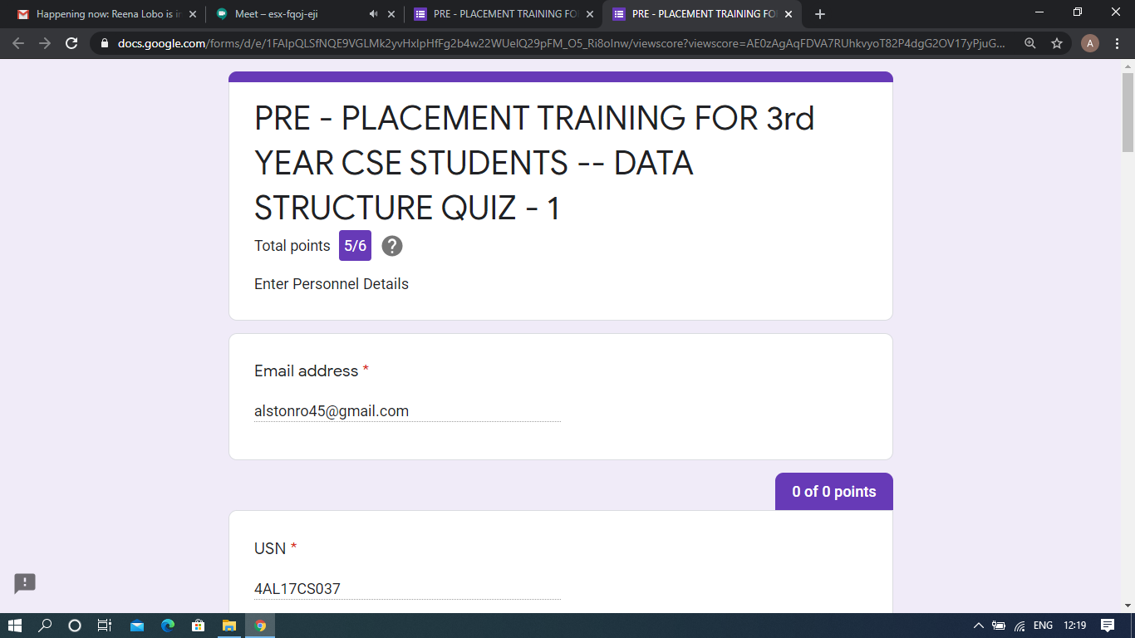

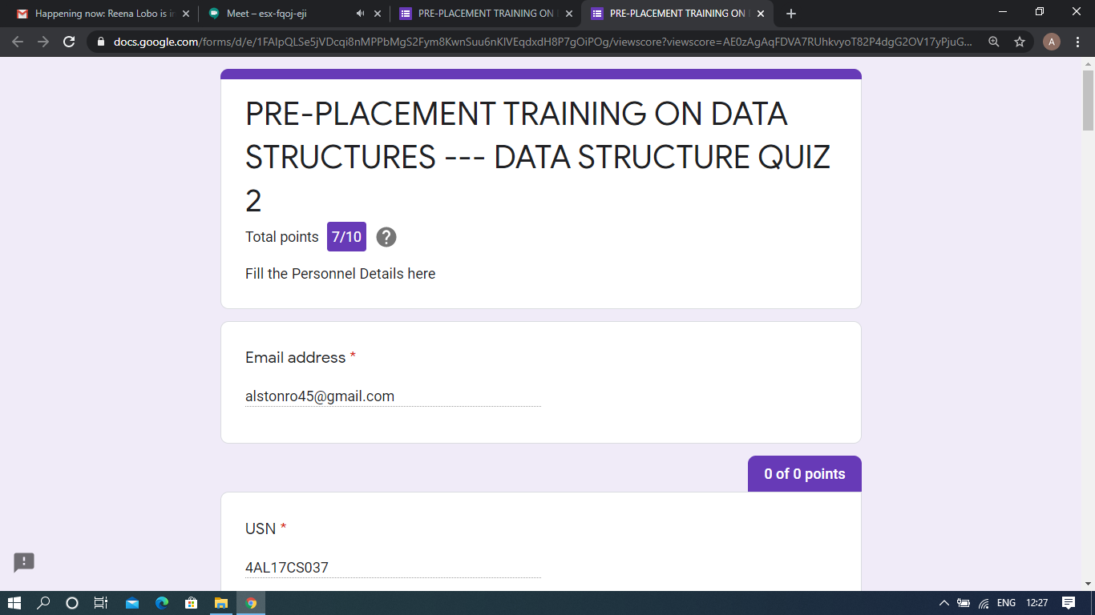

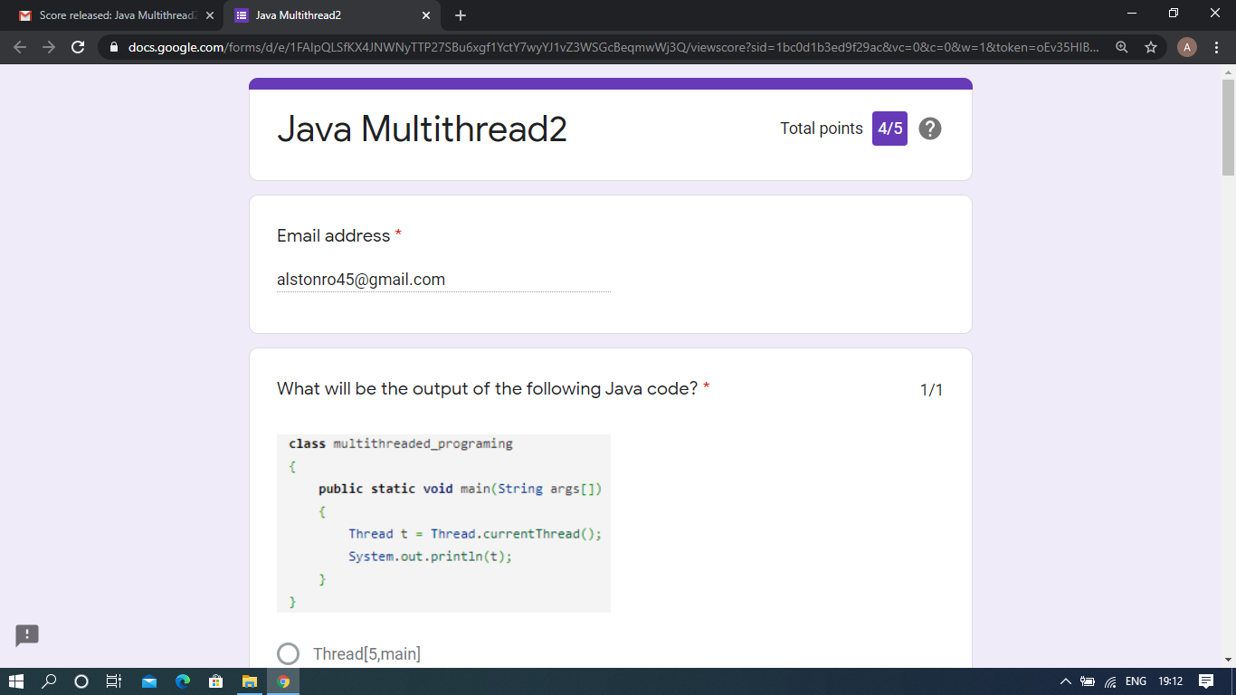

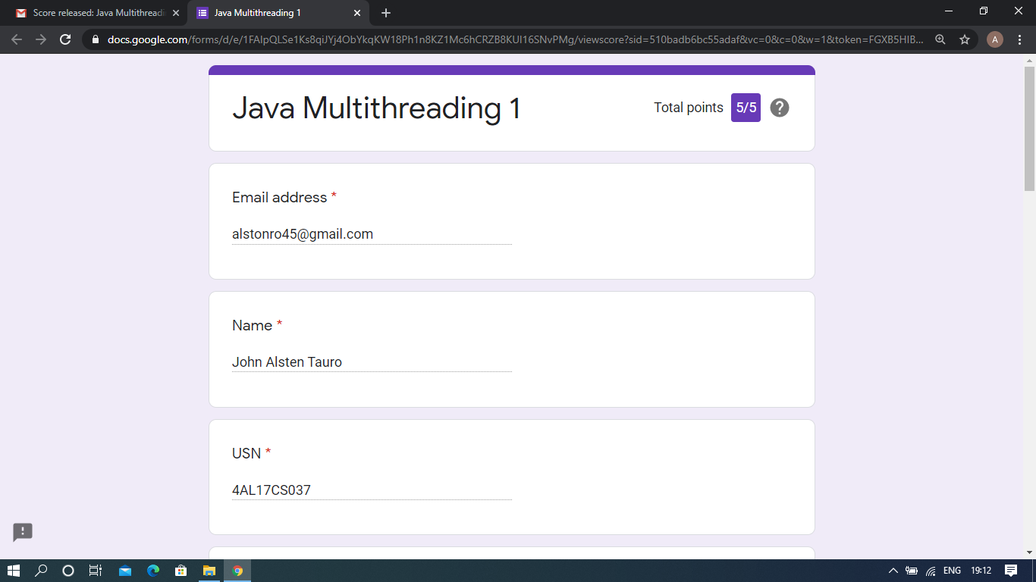

Java and data structure quiz

Pre-Placement Course Details: (Attach the snapshot and briefly write the report for the same)

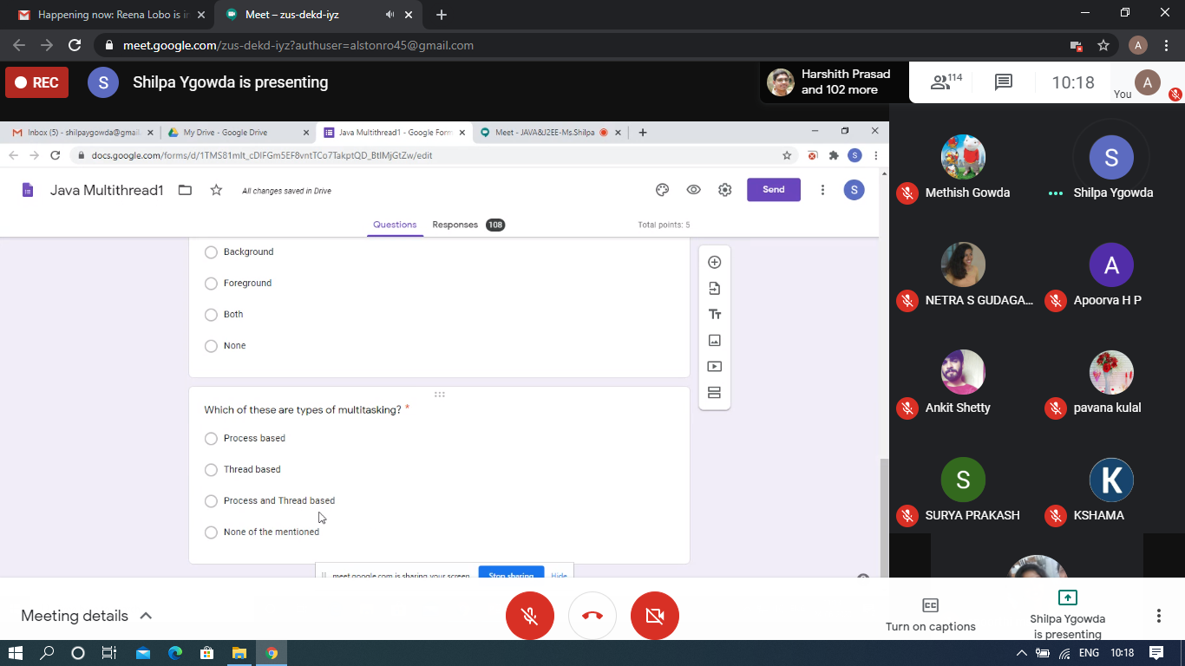

Java and J2EE

Today in this session I studied about multitasking and multithreading with Java programming examples. I attended 2 quiz in the middle of the session.

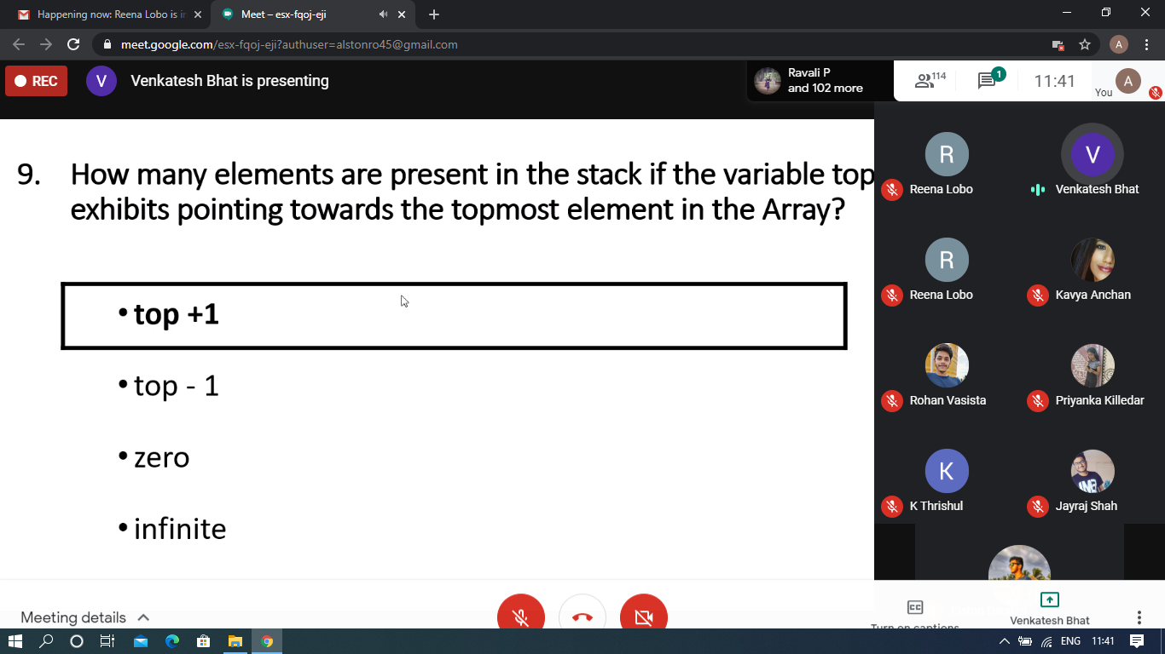

C programming

Today in this session I studied about singly linked list and stack with C programming examples. I attended 4 quiz in the middle of the session.

Coding Challenges Details: (Attach the snapshot and briefly write the report for the same)

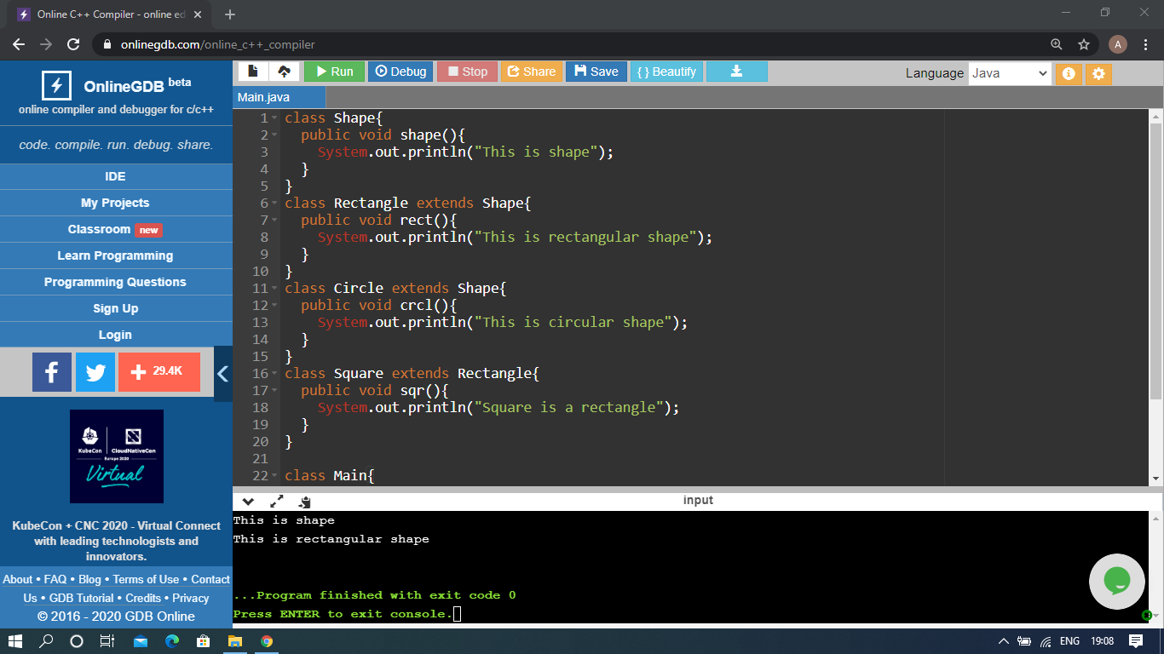

The above Programs were written and executed and the output of the same is displayed above. The code for those 1 programs have been uploaded to the github repository and the link to the same is provided on the form.