**DAILY ONLINE ACTIVITIES SUMMARY**

|  |  |  |  |  |  |  |  |  |
| --- | --- | --- | --- | --- | --- | --- | --- | --- |
| **Date:** | **25-05-2020** | | | | | **Name:** | **John Alsten Tauro** | |
| **Sem & Sec** | **6th A** | | | | | **USN:** | **4AL17CS037** | |
| **Online Test Summary** | | | | | | | | |
| **Subject** | |  | | | | | | |
| **Max. Marks** | |  | | **Score** | | |  | |
| **Certification Course Summary** | | | | | | | | |
| **Course** | **A Full Stack Web Developer – Beginner to Advanced** | | | | | | | |
| **Certificate Provider** | | | **Udemy** | | **Duration** | | | **19.5hrs** |
| **Coding Challenges** | | | | | | | | |
| **Problem Statement**: | | | | | | | | |
| **Status:** | | | | | | | | |
| **Uploaded the report in Github** | | | | | **YES** | | | |
| **If yes Repository name** | | | | | [**https://github.com/alvas-education-foundation/Alsten_Tauro**](https://github.com/alvas-education-foundation/Alsten_Tauro) | | | |
| **Uploaded the report in slack** | | | | | **YES** | | | |

Certification Course Details: (Attach the snapshot and briefly write the report for the same)

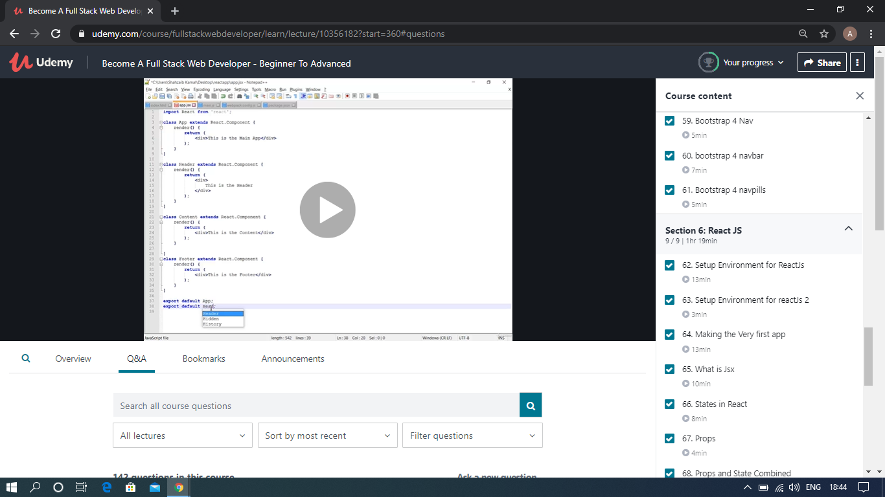

The above course is being taken up by me which is based on the full stack web development. It started with the basics of HTML, Today in Online course I studied about Bootstrap navpills, basics of ReactJS, Setup Environment and making a first page of ReactJS and also about Jsx . The details of the course and certificate provider is mentioned in the above form.