**DAILY ONLINE ACTIVITIES SUMMARY**

|  |  |  |  |  |  |  |  |  |
| --- | --- | --- | --- | --- | --- | --- | --- | --- |
| **Date:** | **25-06-2020** | | | | | **Name:** | **John Alsten Tauro** | |
| **Sem & Sec** | **6th A** | | | | | **USN:** | **4AL17CS037** | |
| **Online Test Summary** | | | | | | | | |
| **Subject** | | Java and C programming quiz | | | | | | |
| **Max. Marks** | |  | | **Score** | | |  | |
| **Pre-Placement Course Summary** | | | | | | | | |
| **Pre-placement training** | 9.20-11.00: Java & J2EE11.10-1.00: C programming | | | | | | | |
| **Faculty name** | | | **Sayeesh and venkatesh bhat** | | **Duration** | | | **4hrs** |
| **Coding Challenges** | | | | | | | | |
| **Problem Statement**: 1. Write a C program to implement a simple queue using SLL.  **2.** Write a C program to implement circular queue using SLL.  **3.** Write a C program to multiple stack operation using SLL.  **4.** Write a C program to implement operations on multiple queues    .  . | | | | | | | | |
| **Status: YES, Completed all Programs** | | | | | | | | |
| **Uploaded the report in Github** | | | | | **YES** | | | |
| **If yes Repository name** | | | | | [**https://github.com/alvas-education-foundation/Alsten_Tauro**](https://github.com/alvas-education-foundation/Alsten_Tauro) | | | |
| **Uploaded the report in slack** | | | | | **YES** | | | |

Online test Details: (Attach the snapshot and briefly write the report for the same)

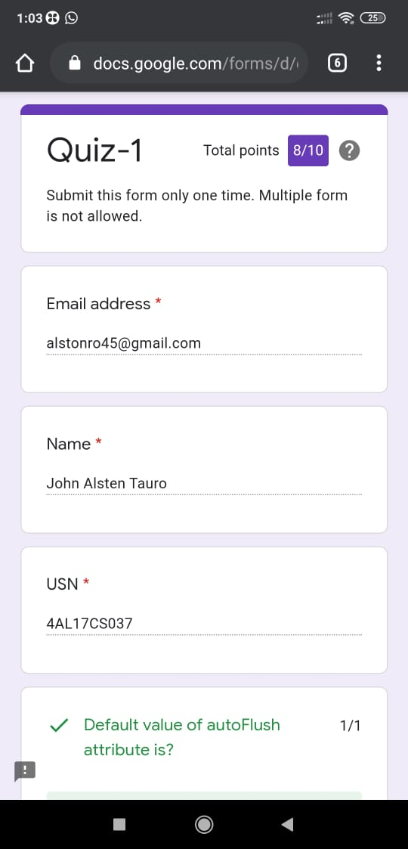

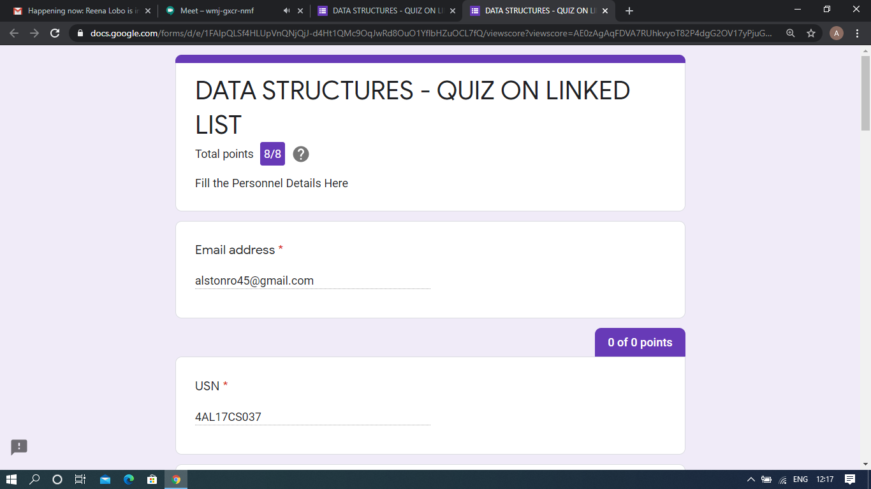

JSP and C programming quiz

Pre-Placement Course Details: (Attach the snapshot and briefly write the report for the same)

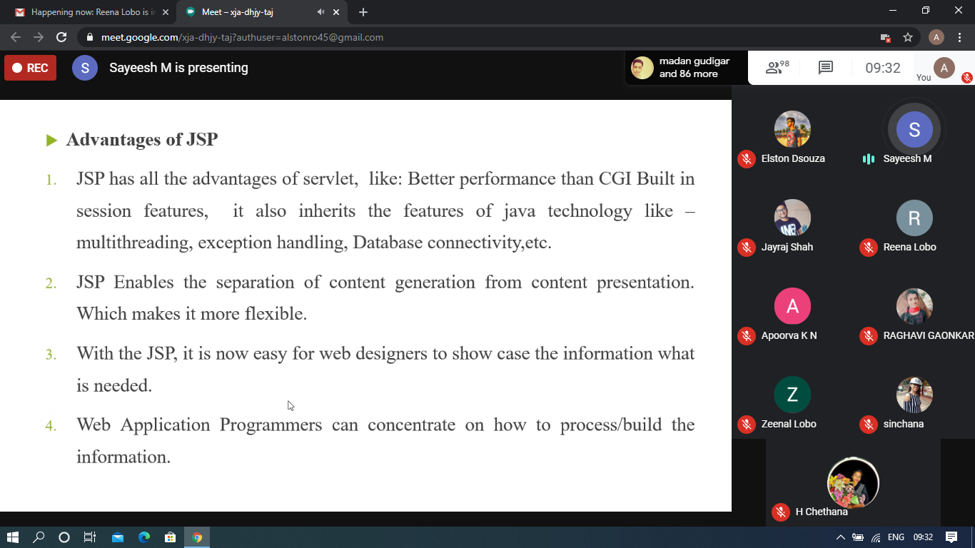

Java and J2EE

Today in this session I studied about JSP with Java programming examples. I attended 1 quiz in the middle of the session.

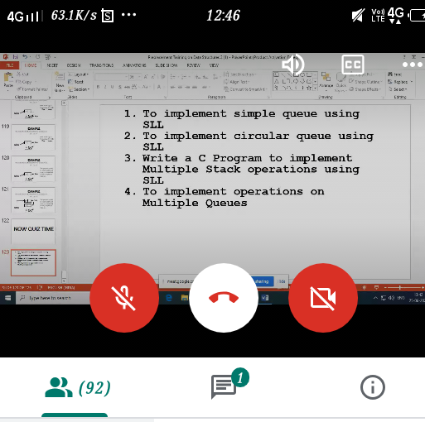

C programming

Today in this session I studied about singly linked list, Triply linked list and stack with C programming examples. I attended 2 quiz in the middle of the session.

Coding Challenges Details: (Attach the snapshot and briefly write the report for the same)

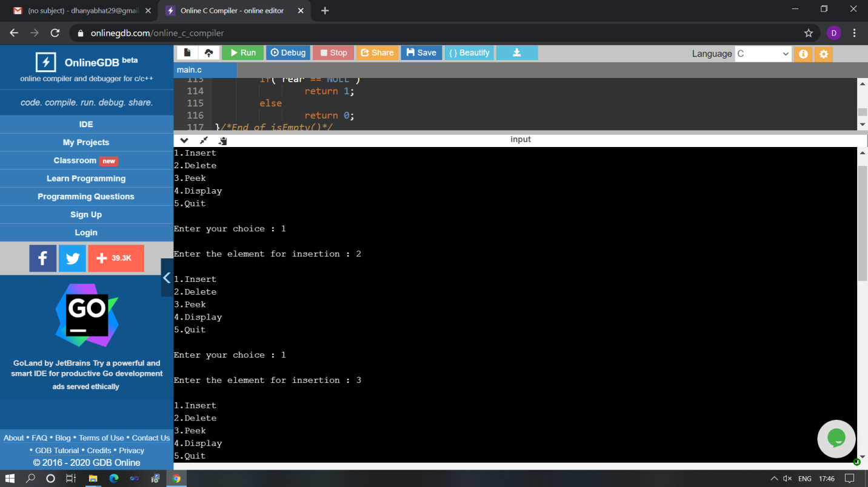

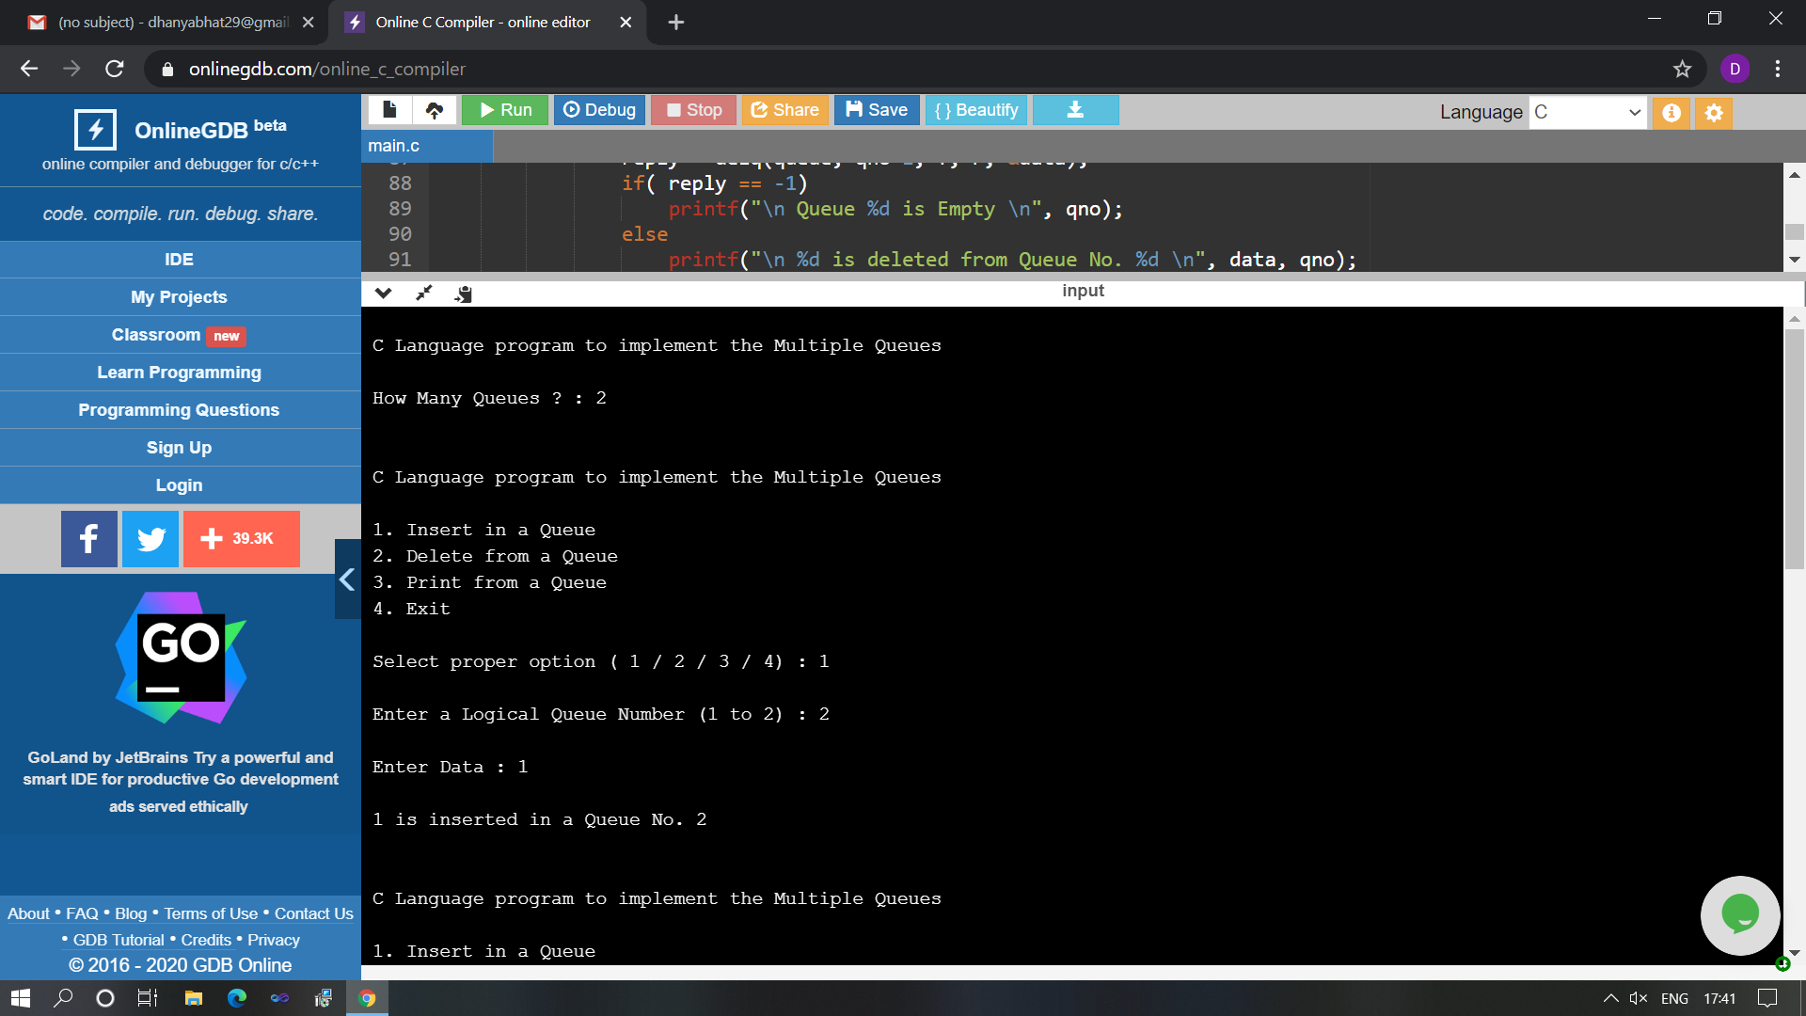

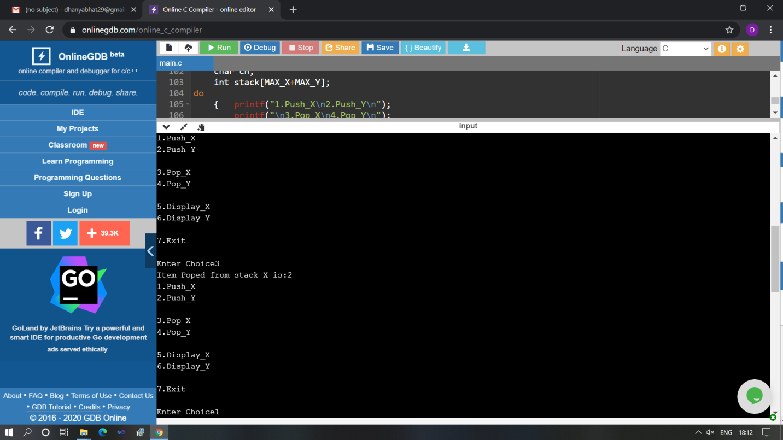

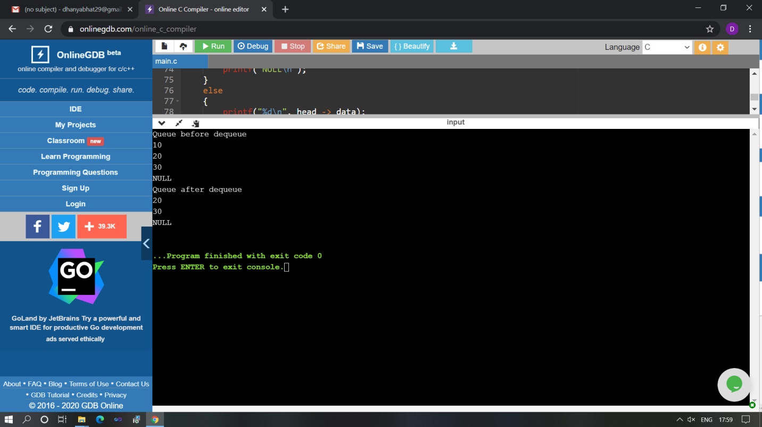

The above Programs were written and executed and the output of the same is displayed above. The code for those 4 programs have been uploaded to the github repository and the link to the same is provided on the form.