**DAILY ONLINE ACTIVITIES SUMMARY**

|  |  |  |  |  |  |  |  |  |
| --- | --- | --- | --- | --- | --- | --- | --- | --- |
| **Date:** | **26-06-2020** | | | | | **Name:** | **John Alsten Tauro** | |
| **Sem & Sec** | **6th A** | | | | | **USN:** | **4AL17CS037** | |
| **Online Test Summary** | | | | | | | | |
| **Subject** | | Cyber security and data structure quiz | | | | | | |
| **Max. Marks** | |  | | **Score** | | |  | |
| **Pre-Placement Course Summary** | | | | | | | | |
| **Pre-placement training** | 9.20-11.00: Cyber security and law11.10-1.00: C programming | | | | | | | |
| **Faculty name** | | | **Sayeesh and venkatesh bhat** | | **Duration** | | | **4hrs** |
| **Coding Challenges** | | | | | | | | |
| **Problem Statement**: 1. Write a program to print all permutations of a given string.    .  . | | | | | | | | |
| **Status: YES, Completed all Programs** | | | | | | | | |
| **Uploaded the report in Github** | | | | | **YES** | | | |
| **If yes Repository name** | | | | | [**https://github.com/alvas-education-foundation/Alsten_Tauro**](https://github.com/alvas-education-foundation/Alsten_Tauro) | | | |
| **Uploaded the report in slack** | | | | | **YES** | | | |

Online test Details: (Attach the snapshot and briefly write the report for the same)

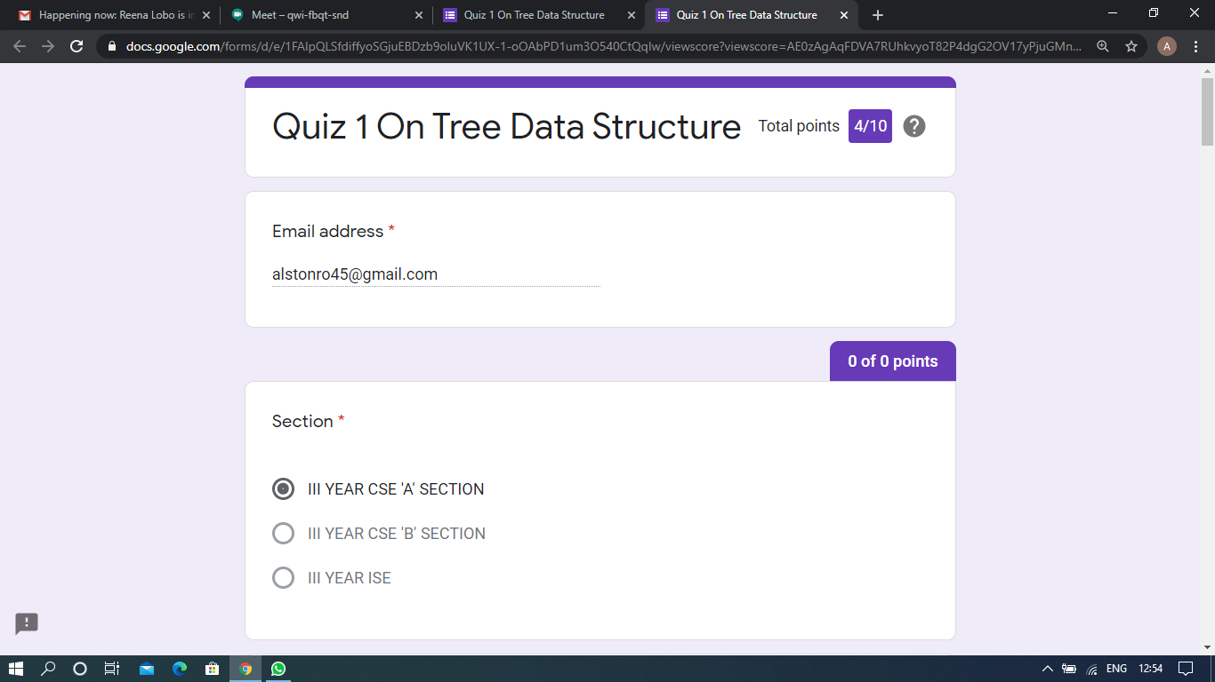

Cyber security and data structure quiz

Pre-Placement Course Details: (Attach the snapshot and briefly write the report for the same)

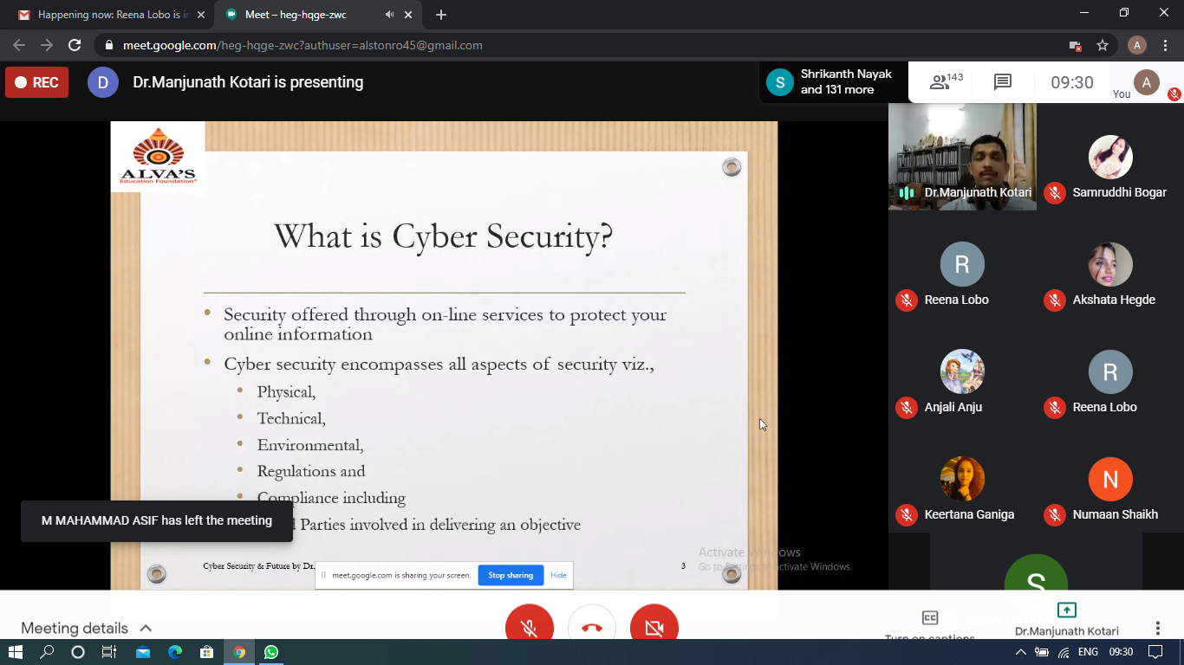

Cyber security

Today in this session I studied about Cyber security. I attended 2 quiz in the middle of the session.

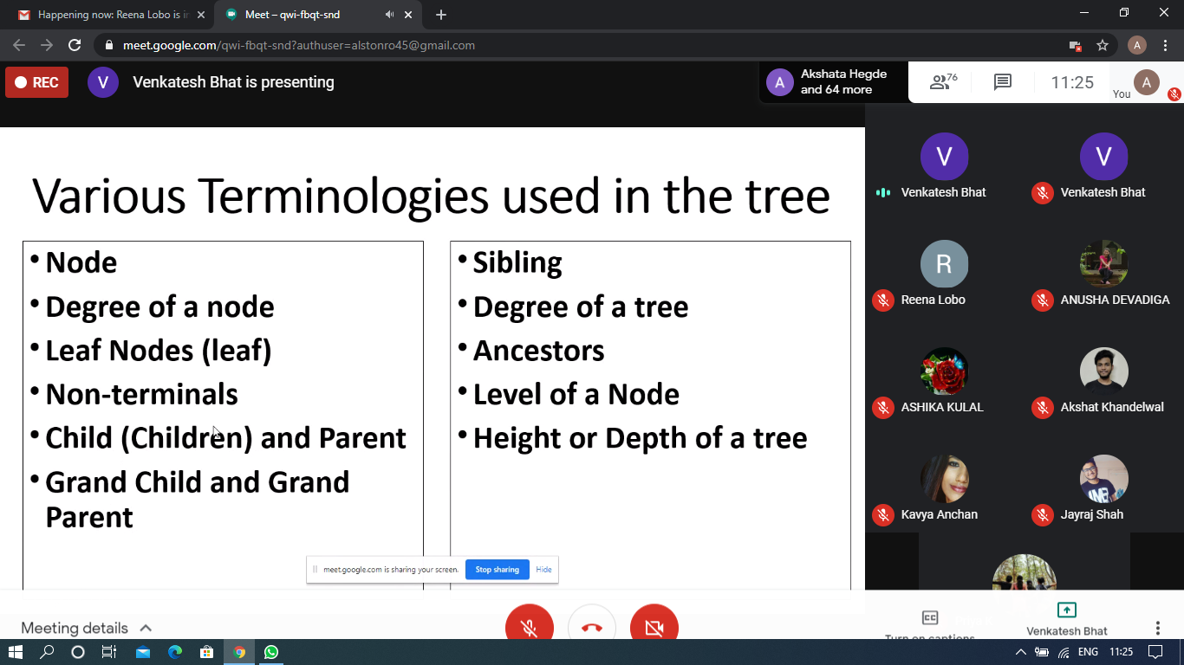

C programming

Today in this session I studied about Tree with C programming examples. I attended 2 quiz in the middle of the session.

Coding Challenges Details: (Attach the snapshot and briefly write the report for the same)

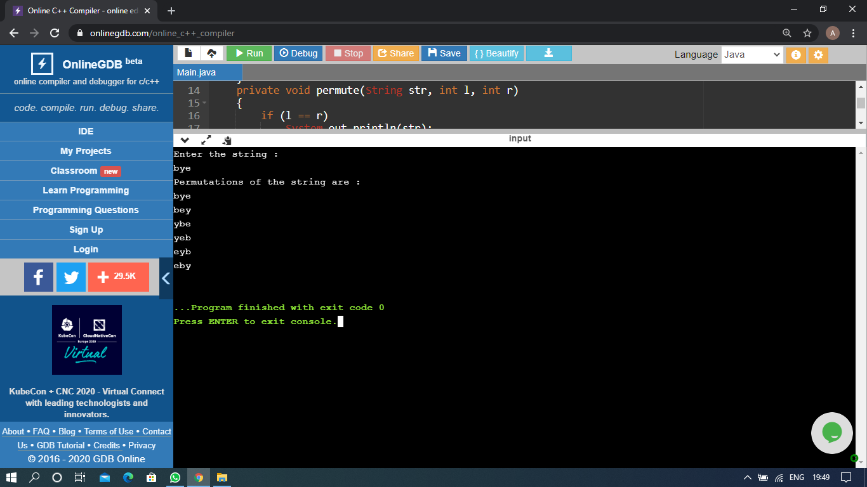

The above Programs were written and executed and the output of the same is displayed above. The code for those 1 programs have been uploaded to the github repository and the link to the same is provided on the form.