**DAILY ONLINE ACTIVITIES SUMMARY**

|  |  |  |  |  |  |  |  |  |
| --- | --- | --- | --- | --- | --- | --- | --- | --- |
| **Date:** | **27-05-2020** | | | | | **Name:** | **John Alsten Tauro** | |
| **Sem & Sec** | **6th A** | | | | | **USN:** | **4AL17CS037** | |
| **Online Test Summary** | | | | | | | | |
| **Subject** | | **System software and compiler design(SSCD)** | | | | | | |
| **Max. Marks** | | **30** | | **Score** | | | **23** | |
| **Certification Course Summary** | | | | | | | | |
| **Course** | **A Full Stack Web Developer – Beginner to Advanced** | | | | | | | |
| **Certificate Provider** | | | **Udemy** | | **Duration** | | | **19.5hrs** |
| **Coding Challenges** | | | | | | | | |
| **Problem Statement**: 1. Write a Java program to implement Binary Tree using the Linked List.  2. Given an array arr[] of the positive integers of size N, the task is to find the largest element on the left side of each index which is smaller than the element present at that index. Note: If no such element is found then print -1. 3. Write a C Program to sort an array of integers in ascending order and display the sorted array and Number of passes performed for sorting. | | | | | | | | |
| **Status: YES, Completed all Programs** | | | | | | | | |
| **Uploaded the report in Github** | | | | | **YES** | | | |
| **If yes Repository name** | | | | | [**https://github.com/alvas-education-foundation/Alsten_Tauro**](https://github.com/alvas-education-foundation/Alsten_Tauro) | | | |
| **Uploaded the report in slack** | | | | | **YES** | | | |

Online Test Details: (Attach the snapshot and briefly write the report for the same)

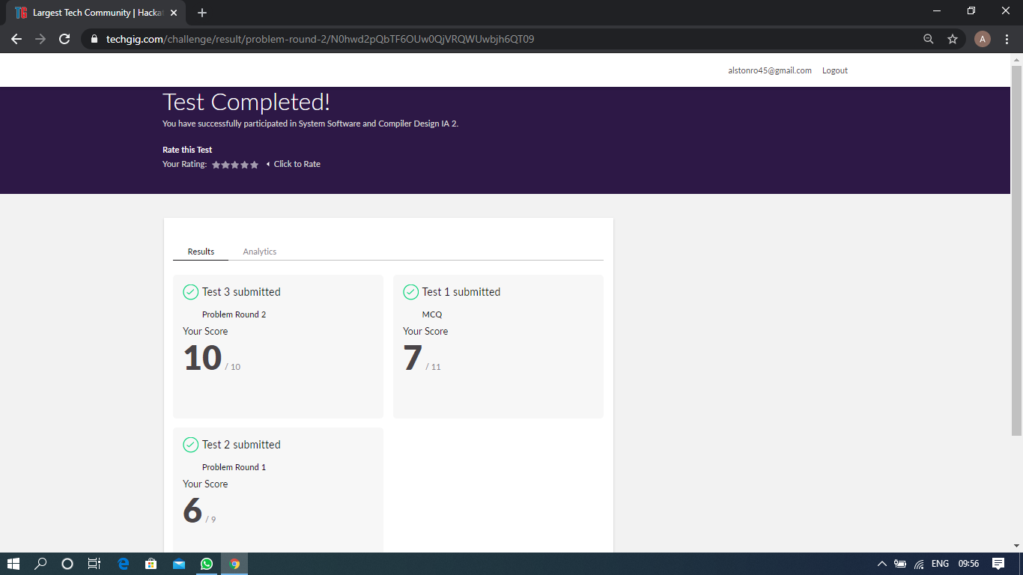

Scored 23 out of 30 in SSCD 2nd I.A test

Certification Course Details: (Attach the snapshot and briefly write the report for the same)

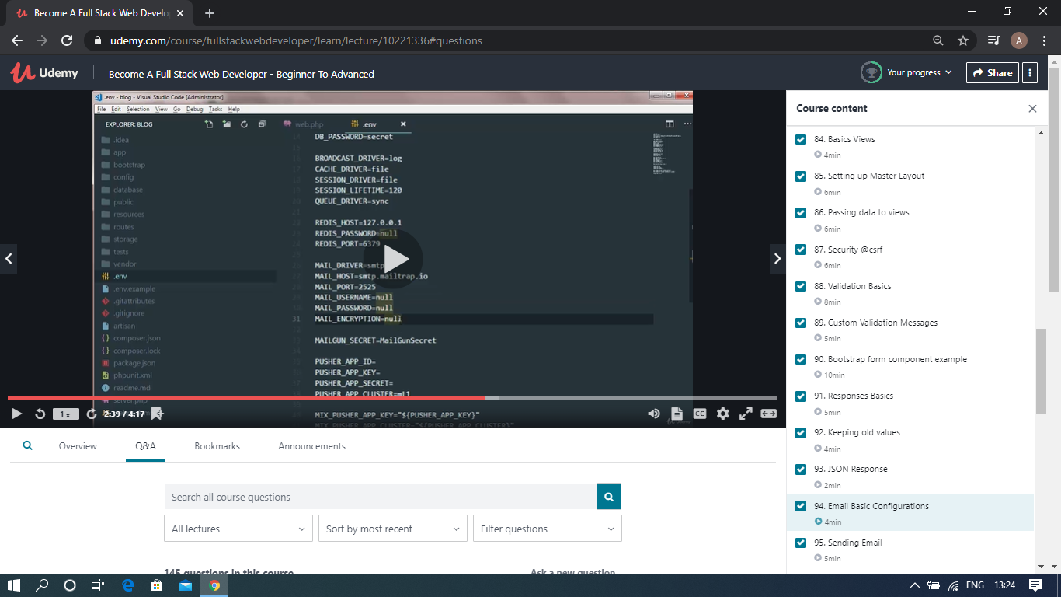

The above course is being taken up by me which is based on the full stack web development. It started with the basics of HTML, Today in Online course I studied about Validation basics, Custom validation messages, Bootstrap form component examples, Responses basics, JSON response, Sending Emails, Mark down Emails. The details of the course and certificate provider is mentioned in the above form.

Coding Challenges Details: (Attach the snapshot and briefly write the report for the same)

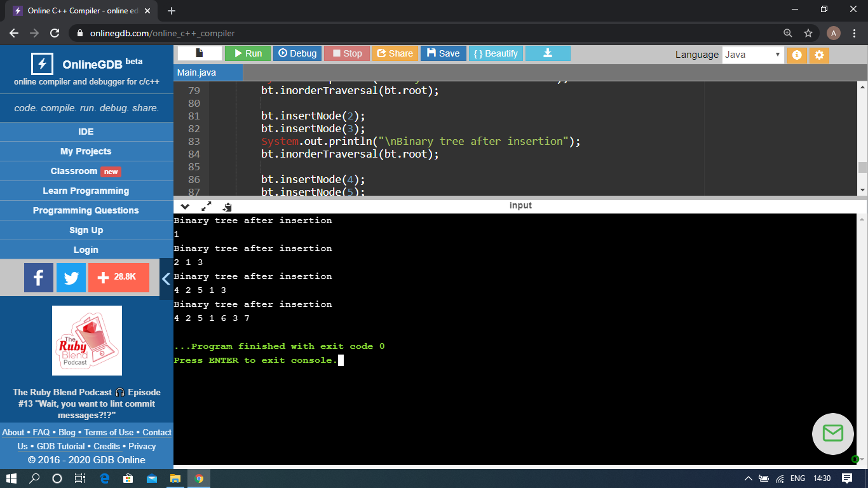

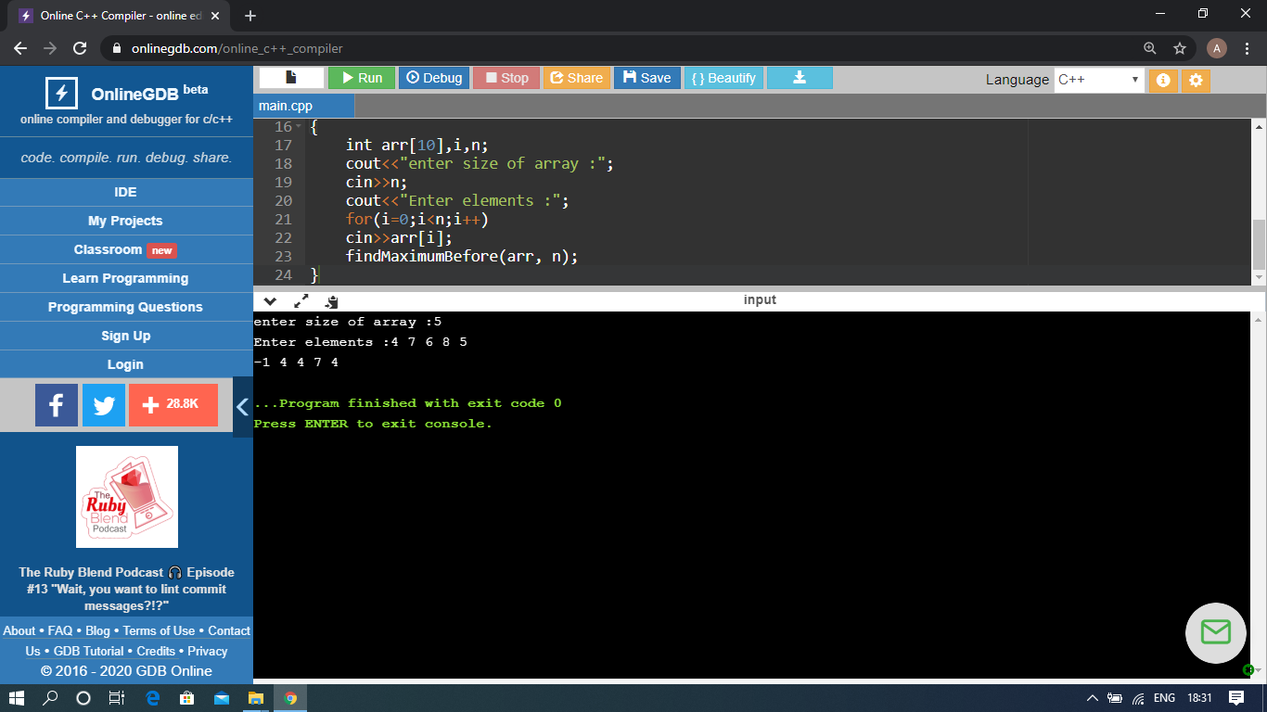

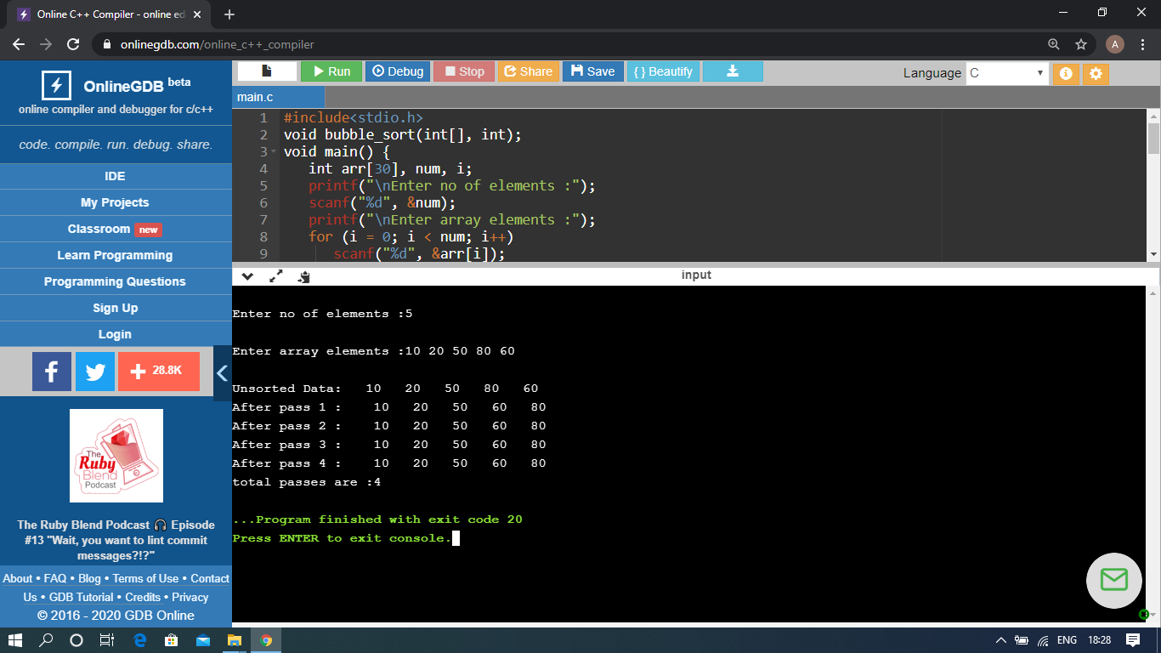

The above Programs were written and executed and the output of the same is displayed above. The code for those 3 programs have been uploaded to the github repository and the link to the same is provided on the form.