**DAILY ONLINE ACTIVITIES SUMMARY**

|  |  |  |  |  |  |  |  |  |
| --- | --- | --- | --- | --- | --- | --- | --- | --- |
| **Date:** | **28-05-2020** | | | | | **Name:** | **John Alsten Tauro** | |
| **Sem & Sec** | **6th A** | | | | | **USN:** | **4AL17CS037** | |
| **Online Test Summary** | | | | | | | | |
| **Subject** | | **Operating system(OS)** | | | | | | |
| **Max. Marks** | | **30** | | **Score** | | | **23** | |
| **Certification Course Summary** | | | | | | | | |
| **Course** | **A Full Stack Web Developer – Beginner to Advanced** | | | | | | | |
| **Certificate Provider** | | | **Udemy** | | **Duration** | | | **19.5hrs** |
| **Coding Challenges** | | | | | | | | |
| **Problem Statement**:  1. Write a Python program to find digital root of a number.  2.Write a Java program for balanced bracket.  3.Write jsp code to display today’s date and time using expression tag.  4.Write jsp script to determine how many times the visitor has loaded the page. | | | | | | | | |
| **Status: YES, Completed all Programs** | | | | | | | | |
| **Uploaded the report in Github** | | | | | **YES** | | | |
| **If yes Repository name** | | | | | [**https://github.com/alvas-education-foundation/Alsten_Tauro**](https://github.com/alvas-education-foundation/Alsten_Tauro) | | | |
| **Uploaded the report in slack** | | | | | **YES** | | | |

Online Test Details: (Attach the snapshot and briefly write the report for the same)

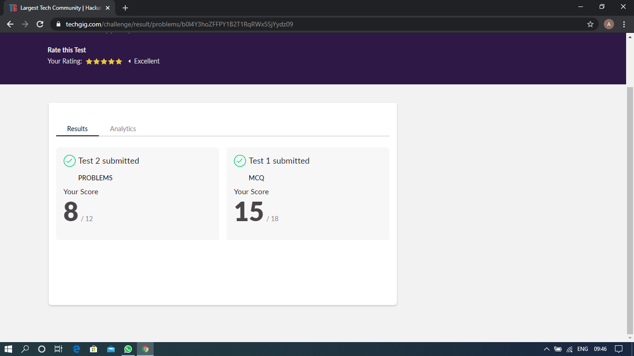

Scored 23 out of 30 in OS 2nd I.A test

Certification Course Details: (Attach the snapshot and briefly write the report for the same)

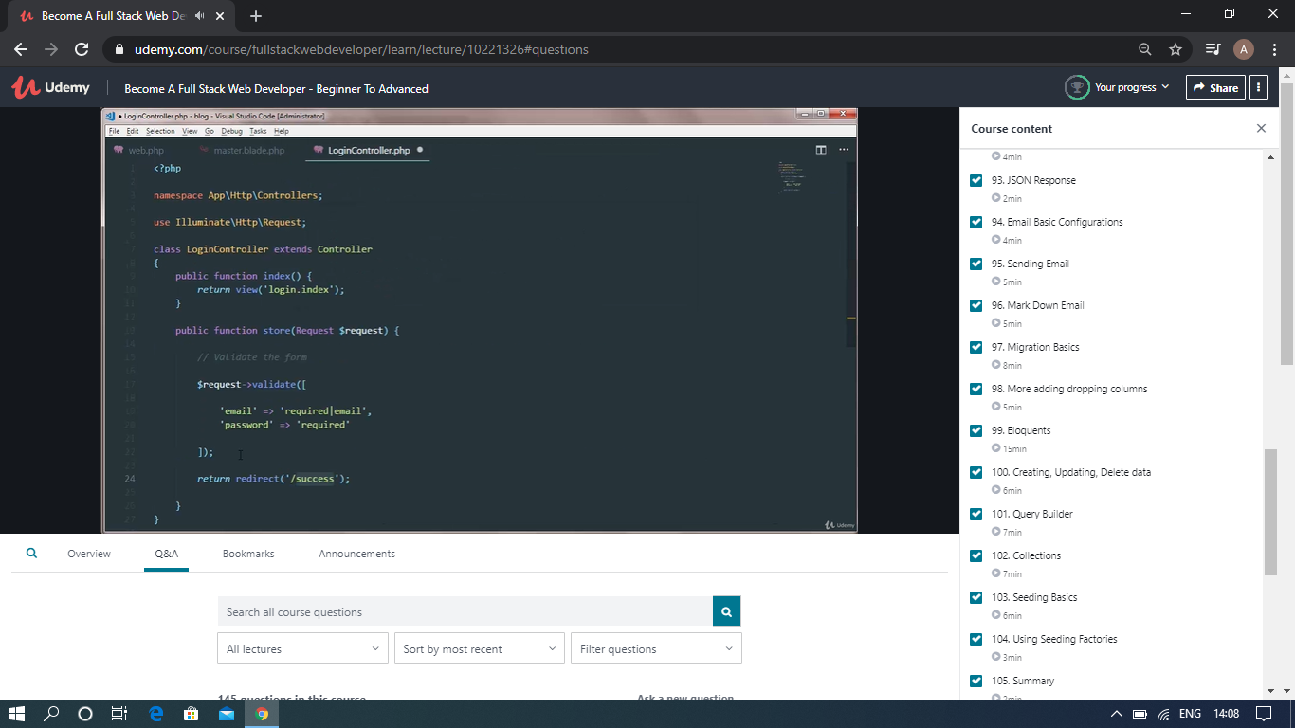

The above course is being taken up by me which is based on the full stack web development. It started with the basics of HTML, Today in Online course I studied about JSON response, Sending Emails, Mark down Emails, Seeding basics, Using seeding factories, summary. The details of the course and certificate provider is mentioned in the above form.

Coding Challenges Details: (Attach the snapshot and briefly write the report for the same)

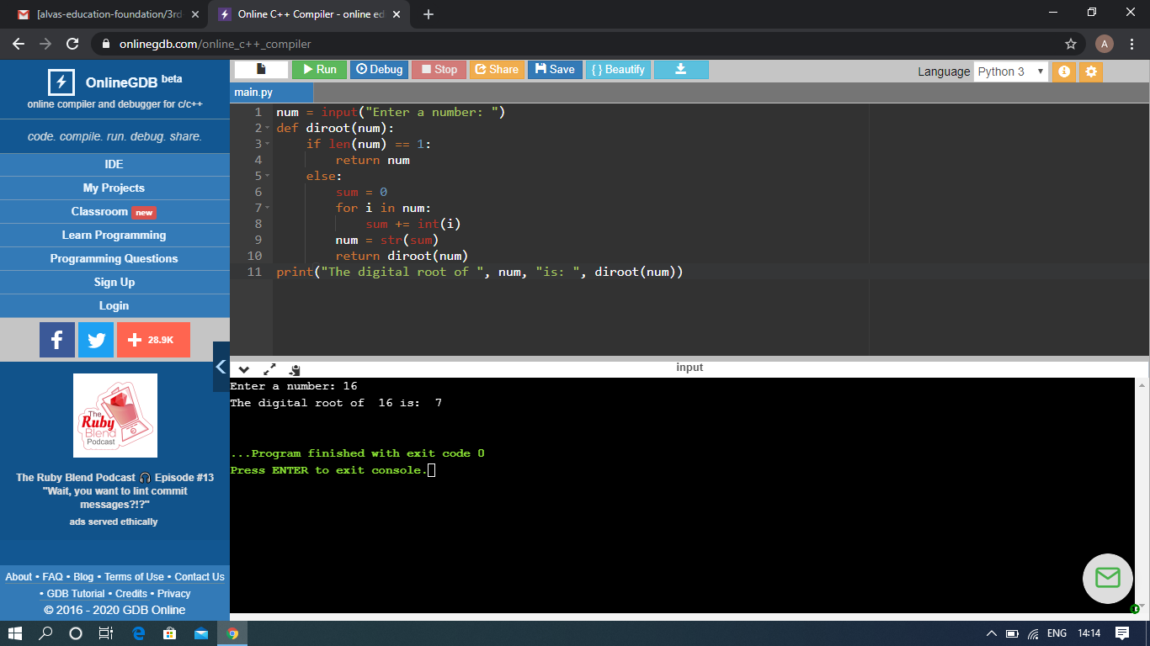

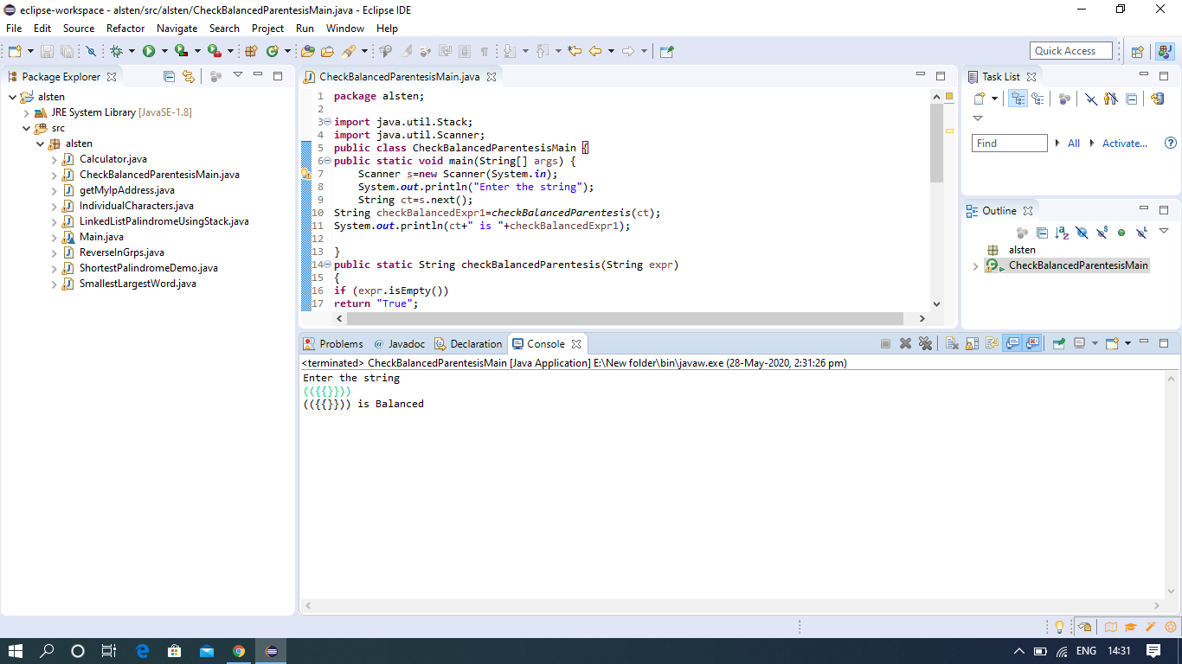

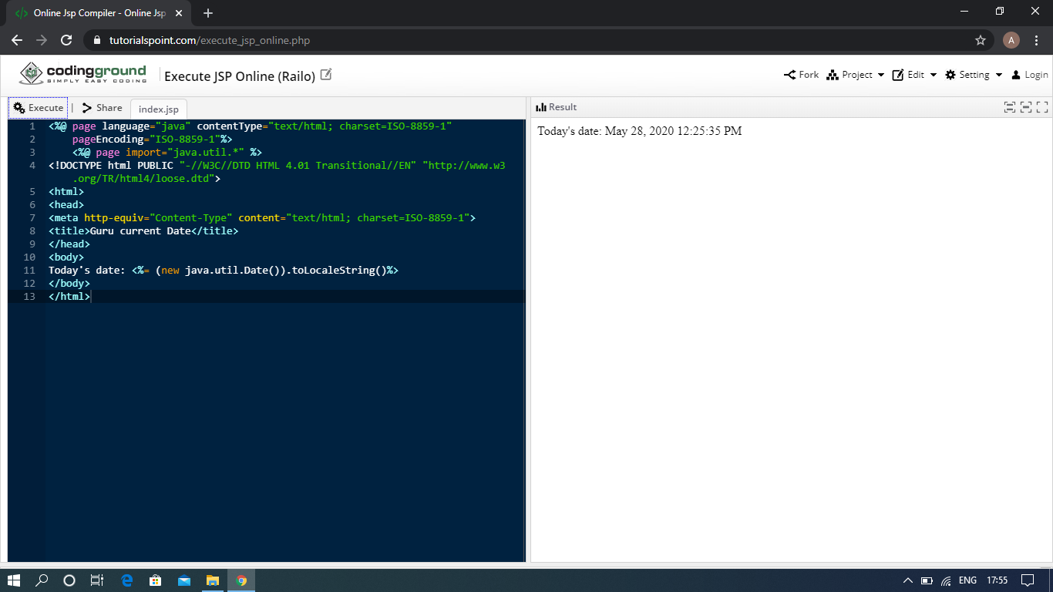

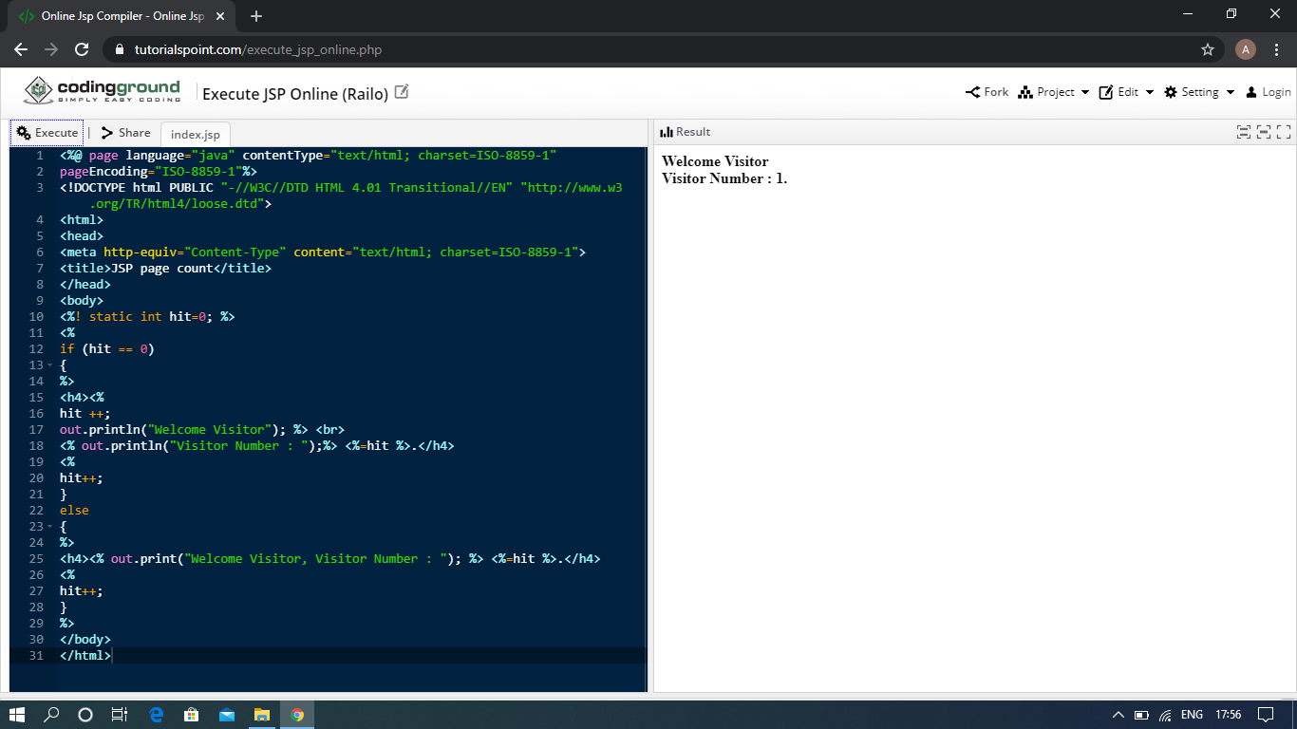

The above Programs were written and executed and the output of the same is displayed above. The code for those 2 programs have been uploaded to the github repository and the link to the same is provided on the form.