**DAILY ONLINE ACTIVITIES SUMMARY**

|  |  |  |  |  |  |  |  |  |
| --- | --- | --- | --- | --- | --- | --- | --- | --- |
| **Date:** | **28-07-2020** | | | | | **Name:** | **John Alsten Tauro** | |
| **Sem & Sec** | **6th A** | | | | | **USN:** | **4AL17CS037** | |
| **Online Test Summary** | | | | | | | | |
| **Subject** | | Operational research | | | | | | |
| **Max. Marks** | | **30** | | **Score** | | | **-** | |
| **Online Course Summary** | | | | | | | | |
| **Online course name** |  | | | | | | | |
| **Certificate provider** | | |  | | **Duration** | | |  |
| **Coding Challenges** | | | | | | | | |
| Problem Statement: 1. C program to interchange rows and columns in a matrix..   .  . | | | | | | | | |
| **Status: YES, Completed all Programs** | | | | | | | | |
| **Uploaded the report in Github** | | | | | **YES** | | | |
| **If yes Repository name** | | | | | [**https://github.com/alvas-education-foundation/Alsten_Tauro**](https://github.com/alvas-education-foundation/Alsten_Tauro) | | | |
| **Uploaded the report in slack** | | | | | **YES** | | | |

Coding Challenges Details: (Attach the snapshot and briefly write the report for the same)

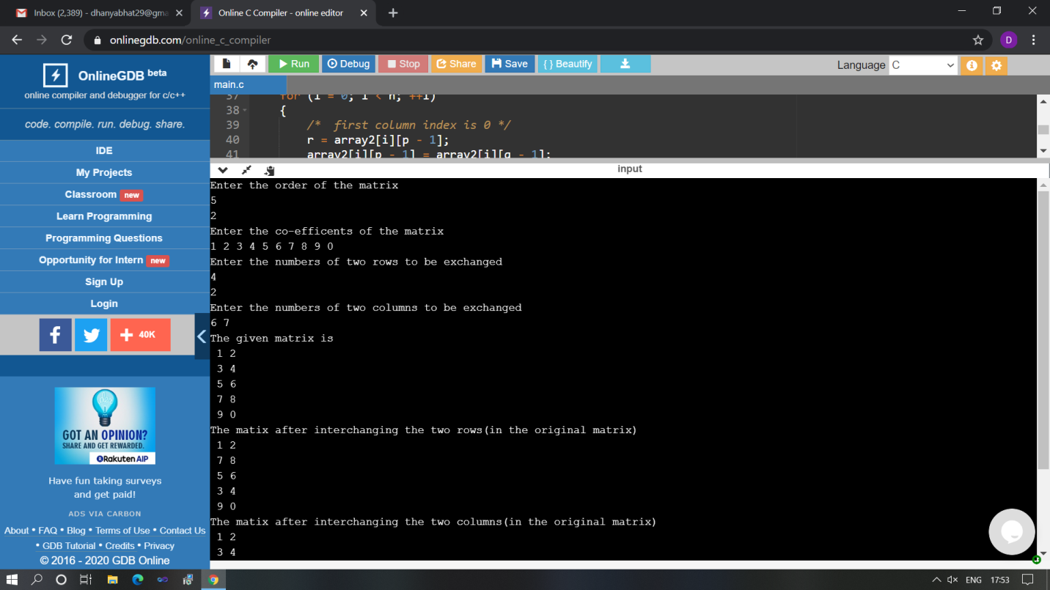

The above Programs were written and executed and the output of the same is displayed above. The code for those 1 programs have been uploaded to the github repository and the link to the same is provided on the form.