**DAILY ONLINE ACTIVITIES SUMMARY**

|  |  |  |  |  |  |  |  |  |
| --- | --- | --- | --- | --- | --- | --- | --- | --- |
| **Date:** | **29-05-2020** | | | | | **Name:** | **John Alsten Tauro** | |
| **Sem & Sec** | **6th A** | | | | | **USN:** | **4AL17CS037** | |
| **Online Test Summary** | | | | | | | | |
| **Subject** | | **Operational research(OR)** | | | | | | |
| **Max. Marks** | | **30** | | **Score** | | | **30** | |
| **Certification Course Summary** | | | | | | | | |
| **Course** | **A Full Stack Web Developer – Beginner to Advanced** | | | | | | | |
| **Certificate Provider** | | | **Udemy** | | **Duration** | | | **19.5hrs** |
| **Coding Challenges** | | | | | | | | |
| **Problem Statement**:   1. 1. Python program to calculate the number of lowercase and uppercase letters in a string. 2. We are given 3 strings: str1, str2, and str3. Str3 is said to be a shuffle of str1 and str2 if it can be formed by interleaving the characters of str1 and str2 in a way that maintains the left to right ordering of the characters from each string. For example, given str1="abc" and str2="def", str3="dabecf" is a valid shuffle since it preserves the character ordering of the two strings. So, given these 3 strings write a function that detects whether str3 is a valid shuffle of str1 and str2. 3. Write a c program to solve a system of linear congruences by applying the Chinese Remainder Theorem. 4. Write a Java Program to check whether the given number is Armstrong number or not 5. Write a Java Program to find longest substring without repeating characters in a string | | | | | | | | |
| **Status: YES, Completed all Programs** | | | | | | | | |
| **Uploaded the report in Github** | | | | | **YES** | | | |
| **If yes Repository name** | | | | | [**https://github.com/alvas-education-foundation/Alsten_Tauro**](https://github.com/alvas-education-foundation/Alsten_Tauro) | | | |
| **Uploaded the report in slack** | | | | | **YES** | | | |

Online Test Details: (Attach the snapshot and briefly write the report for the same)

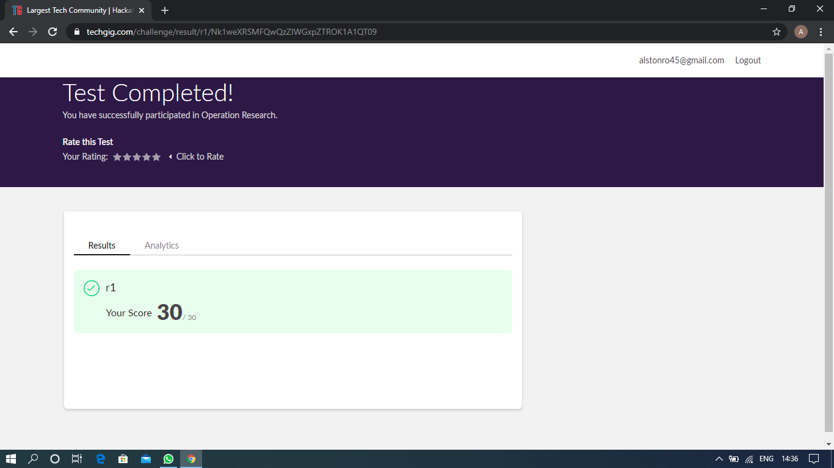

Scored 30 out of 30 in OR 2nd I.A test

Certification Course Details: (Attach the snapshot and briefly write the report for the same)

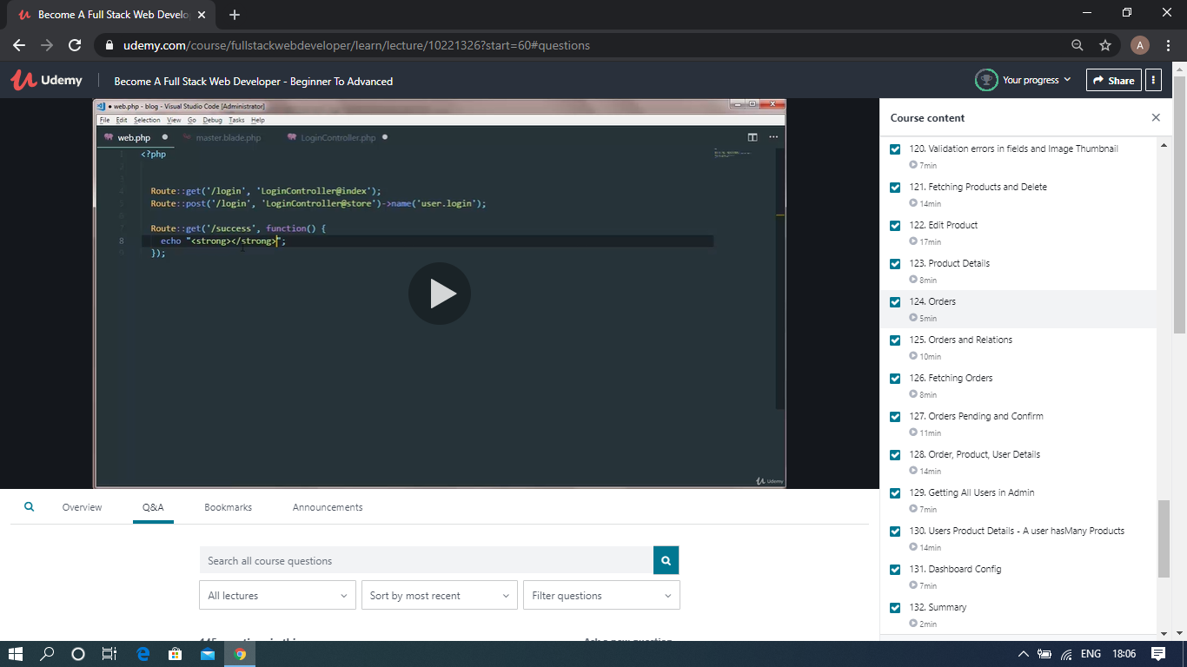

The above course is being taken up by me which is based on the full stack web development. It started with the basics of HTML, Today in Online course I studied about orders, product details, fetching orders, user product details, and the summary. The details of the course and certificate provider is mentioned in the above form.

Coding Challenges Details: (Attach the snapshot and briefly write the report for the same)

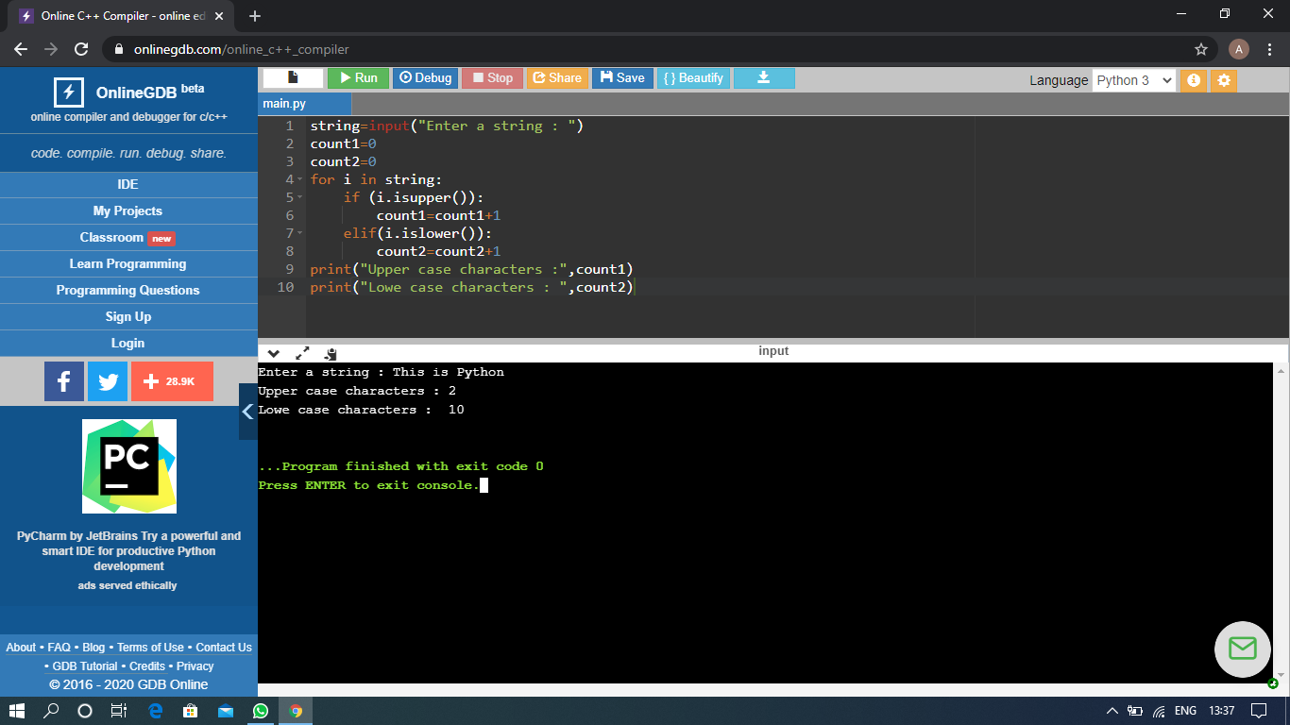

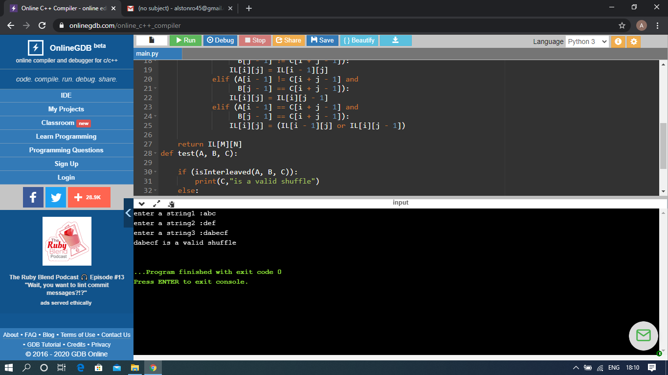

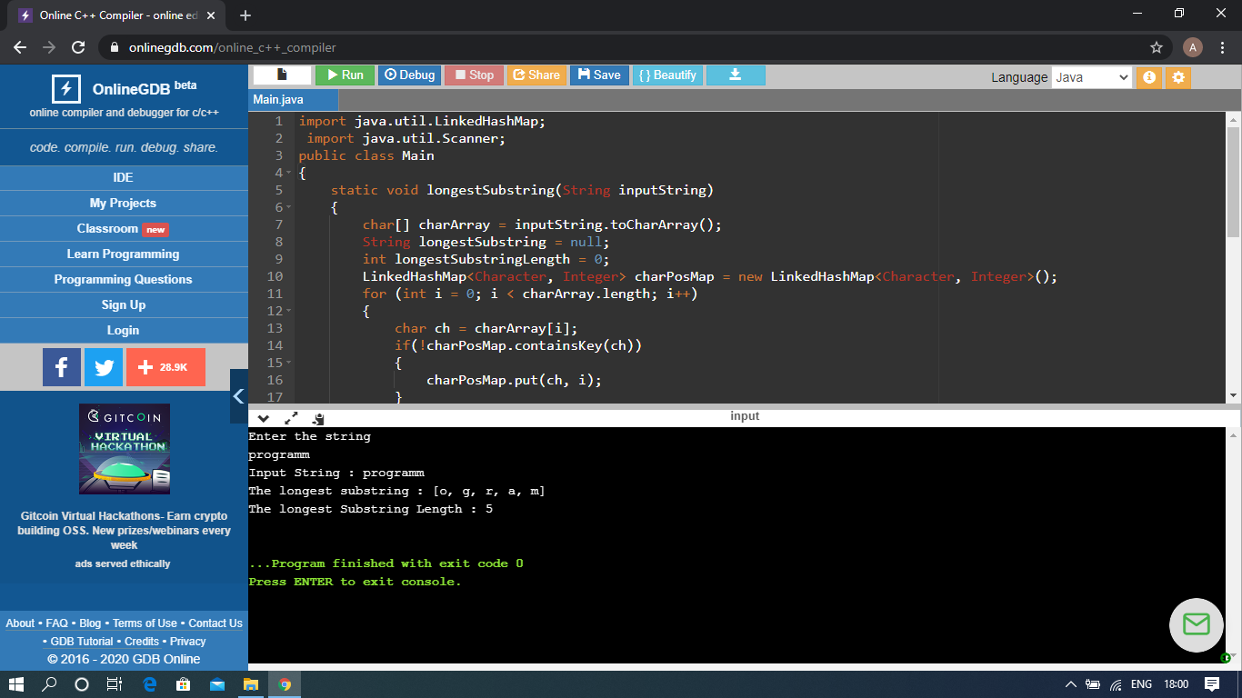

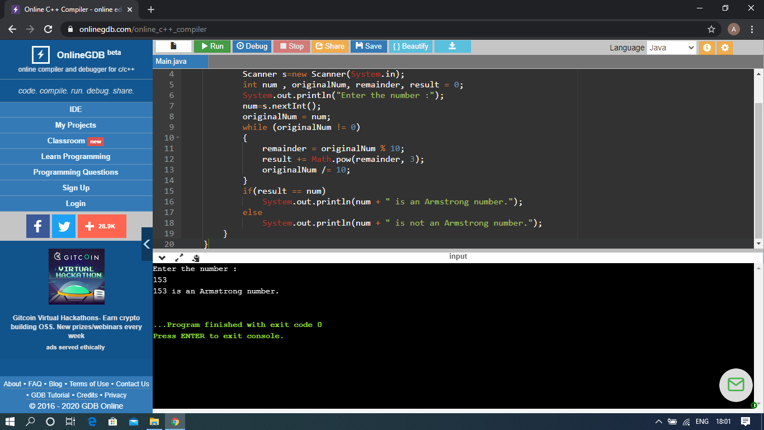

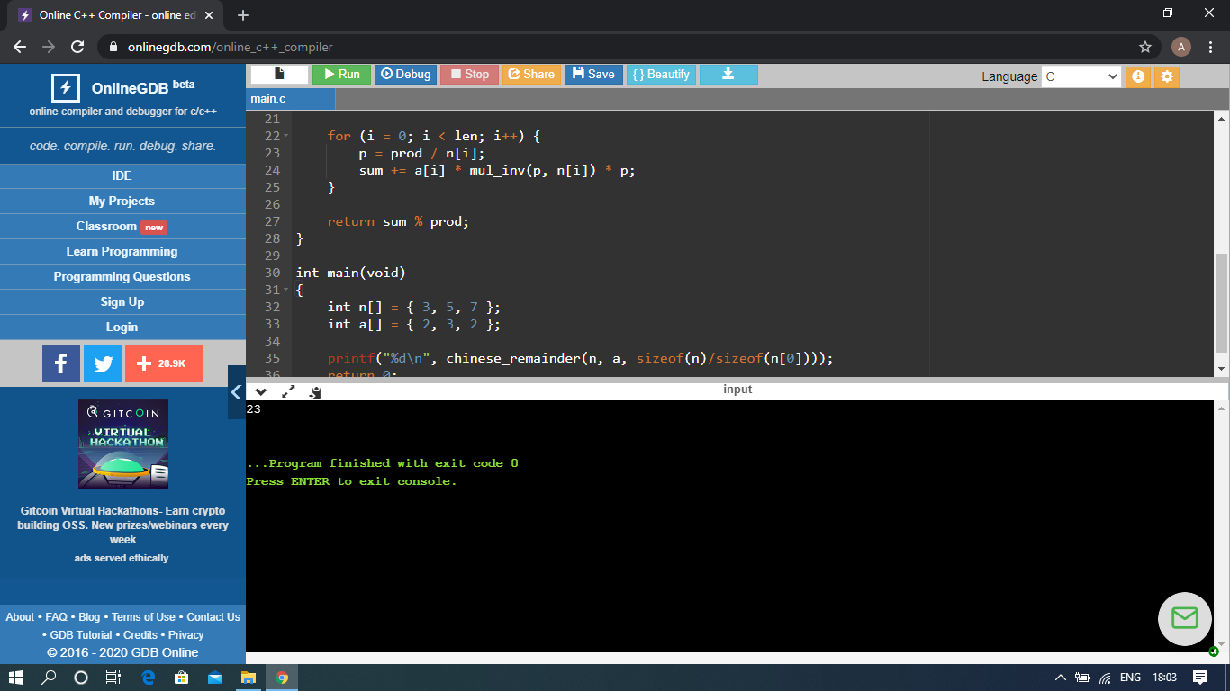

The above Programs were written and executed and the output of the same is displayed above. The code for those 5 programs have been uploaded to the github repository and the link to the same is provided on the form.