**DAILY ONLINE ACTIVITIES SUMMARY**

|  |  |  |  |  |  |  |  |  |
| --- | --- | --- | --- | --- | --- | --- | --- | --- |
| **Date:** | **29-06-2020** | | | | | **Name:** | **John Alsten Tauro** | |
| **Sem & Sec** | **6th A** | | | | | **USN:** | **4AL17CS037** | |
| **Online Test Summary** | | | | | | | | |
| **Subject** | | Cyber security and DBMS quiz | | | | | | |
| **Max. Marks** | |  | | **Score** | | |  | |
| **Pre-Placement Course Summary** | | | | | | | | |
| **Pre-placement training** | 9.20-11.00: DBMS11.10-1.00: Cyber security | | | | | | | |
| **Faculty name** | | | **Reena lobo and Manjunath kotari** | | **Duration** | | | **4hrs** |
| **Coding Challenges** | | | | | | | | |
| **Problem Statement**: 1. Write a Python program to display nth Fibonacci number.    .  . | | | | | | | | |
| **Status: YES, Completed all Programs** | | | | | | | | |
| **Uploaded the report in Github** | | | | | **YES** | | | |
| **If yes Repository name** | | | | | [**https://github.com/alvas-education-foundation/Alsten_Tauro**](https://github.com/alvas-education-foundation/Alsten_Tauro) | | | |
| **Uploaded the report in slack** | | | | | **YES** | | | |

Online test Details: (Attach the snapshot and briefly write the report for the same)

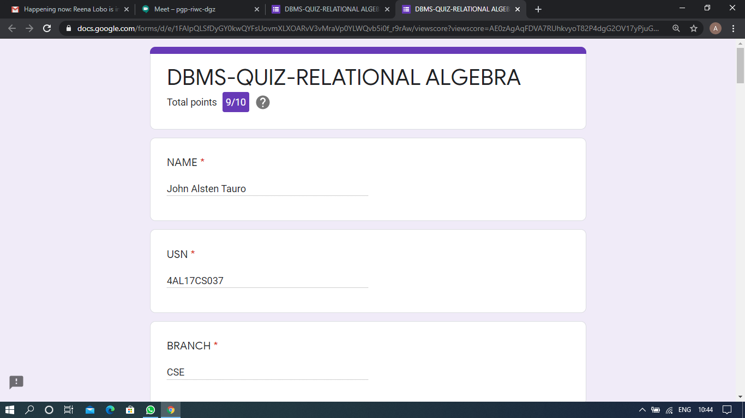

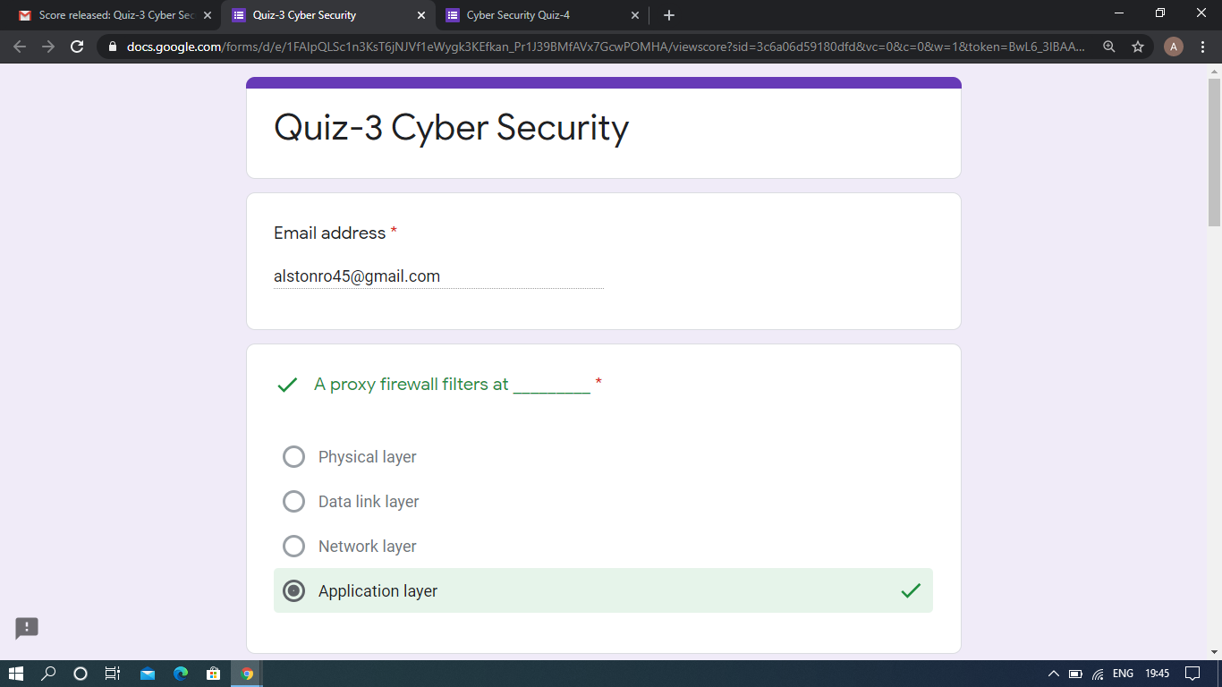

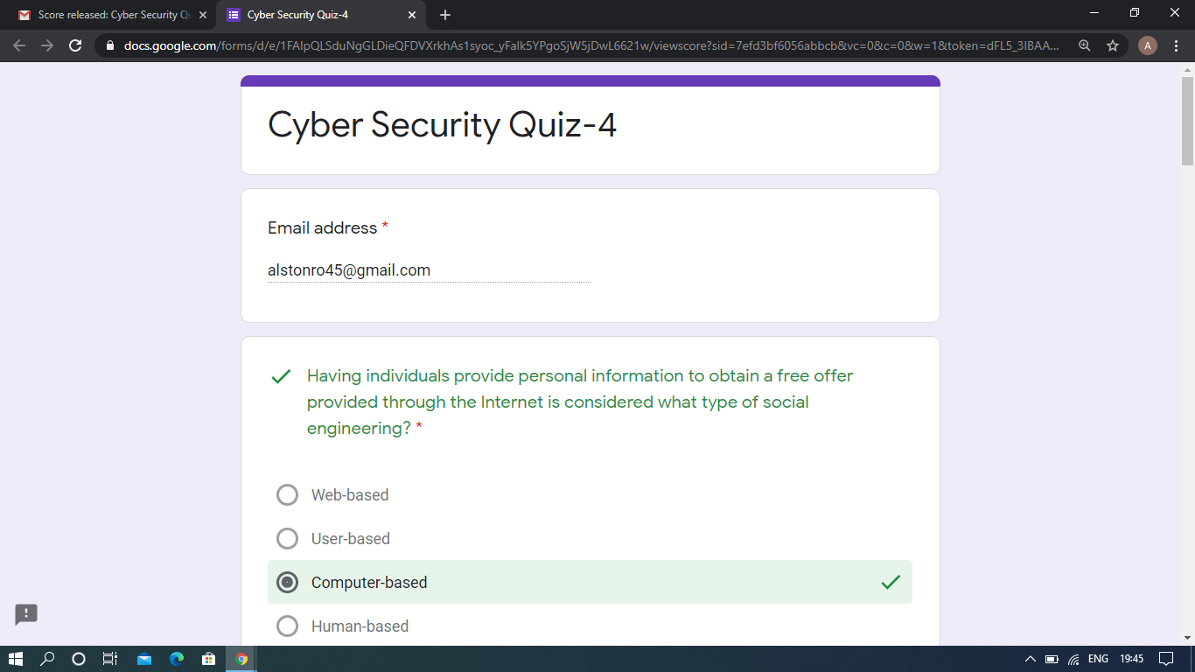

DBMS and Cyber security quiz

Pre-Placement Course Details: (Attach the snapshot and briefly write the report for the same)

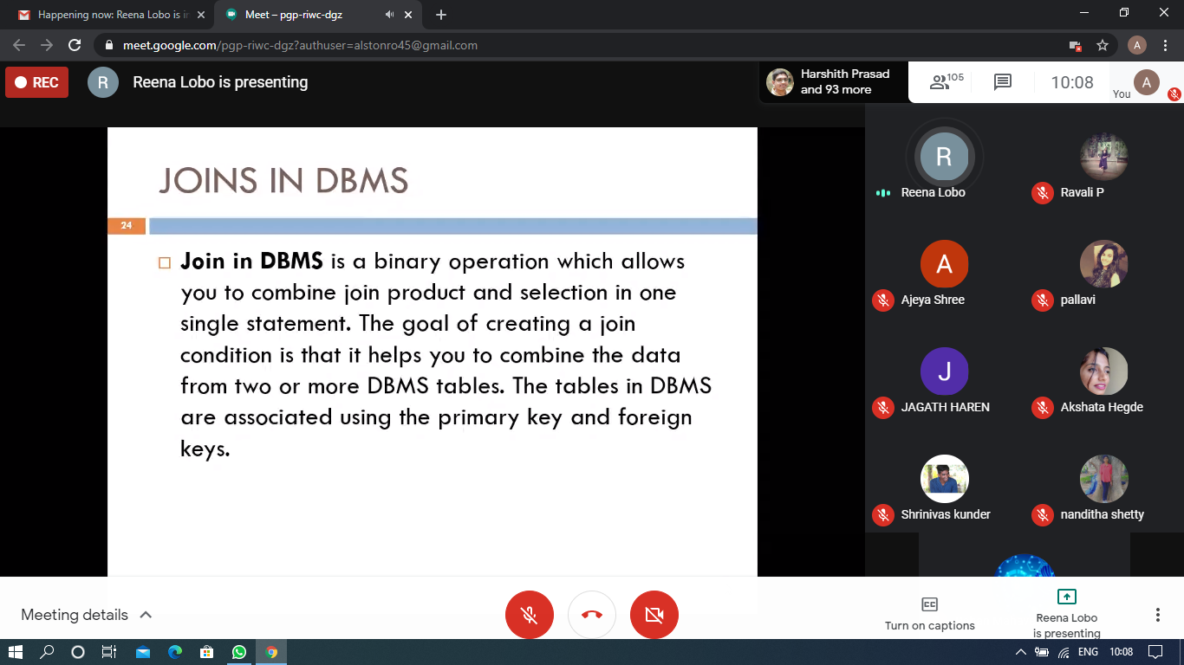

DBMS

Today in this session I studied about Relational algebra in Database management system. I attended 1 quiz in the middle of the session.

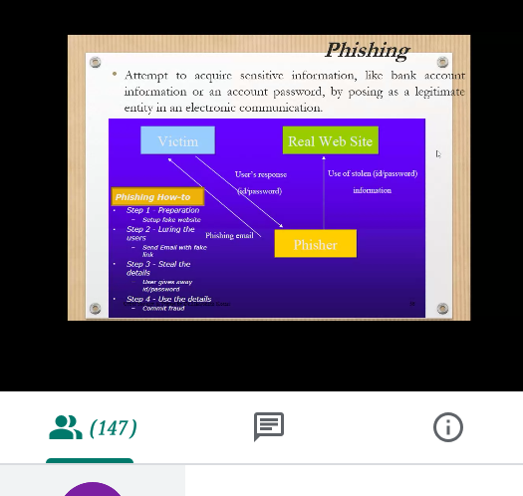

Cyber security

Today in this session I studied about Phishing and Malwares. I attended 2 quiz in the middle of the session.

Coding Challenges Details: (Attach the snapshot and briefly write the report for the same)

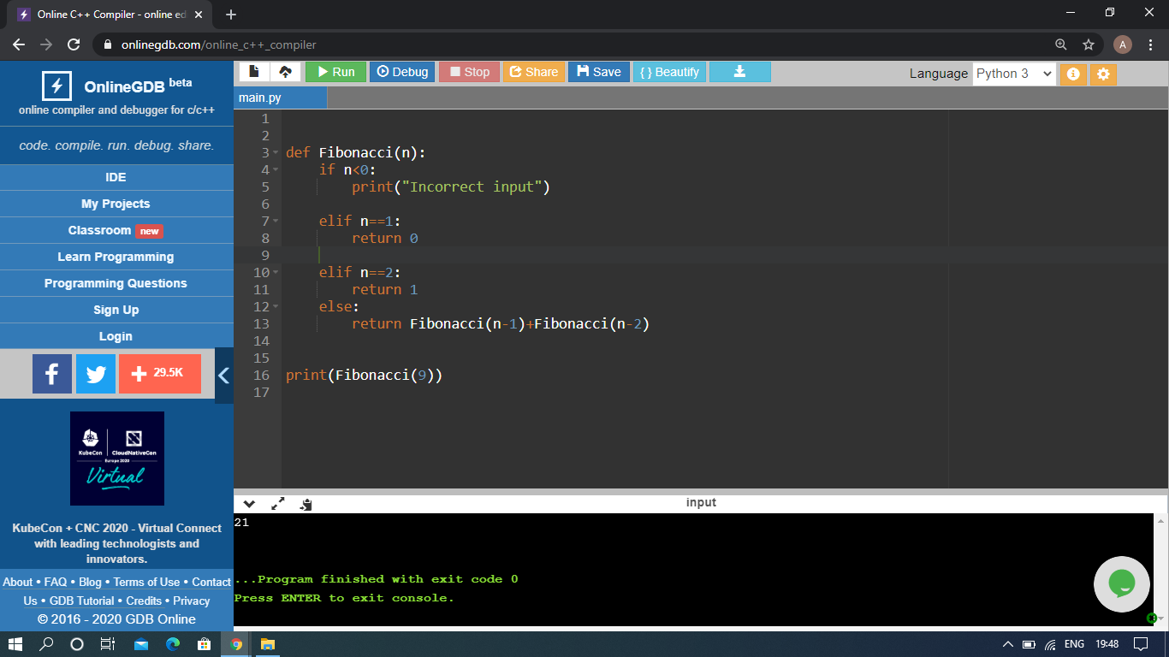

The above Programs were written and executed and the output of the same is displayed above. The code for those 1 programs have been uploaded to the github repository and the link to the same is provided on the form.