**DAILY ONLINE ACTIVITIES SUMMARY**

|  |  |  |  |  |  |  |  |  |
| --- | --- | --- | --- | --- | --- | --- | --- | --- |
| **Date:** | **31-05-2020** | | | | | **Name:** | **John Alsten Tauro** | |
| **Sem & Sec** | **6th A** | | | | | **USN:** | **4AL17CS037** | |
| **Online Test Summary** | | | | | | | | |
| **Subject** | |  | | | | | | |
| **Max. Marks** | |  | | **Score** | | |  | |
| **Certification Course Summary** | | | | | | | | |
| **Course** | **Step into Robotic Process(RPA)** | | | | | | | |
| **Certificate Provider** | | | **GUVI** | | **Duration** | | | **3hrs** |
| **Coding Challenges** | | | | | | | | |
| **Problem Statement**:   1. Write a python program to read a number n and print the natural numbers summation pattern. 2. Write a python program to find second largest number in list. | | | | | | | | |
| **Status: Yes, Completed all programs** | | | | | | | | |
| **Uploaded the report in Github** | | | | | **YES** | | | |
| **If yes Repository name** | | | | | [**https://github.com/alvas-education-foundation/Alsten_Tauro**](https://github.com/alvas-education-foundation/Alsten_Tauro) | | | |
| **Uploaded the report in slack** | | | | | **YES** | | | |

Certification Course Details: (Attach the snapshot and briefly write the report for the same)

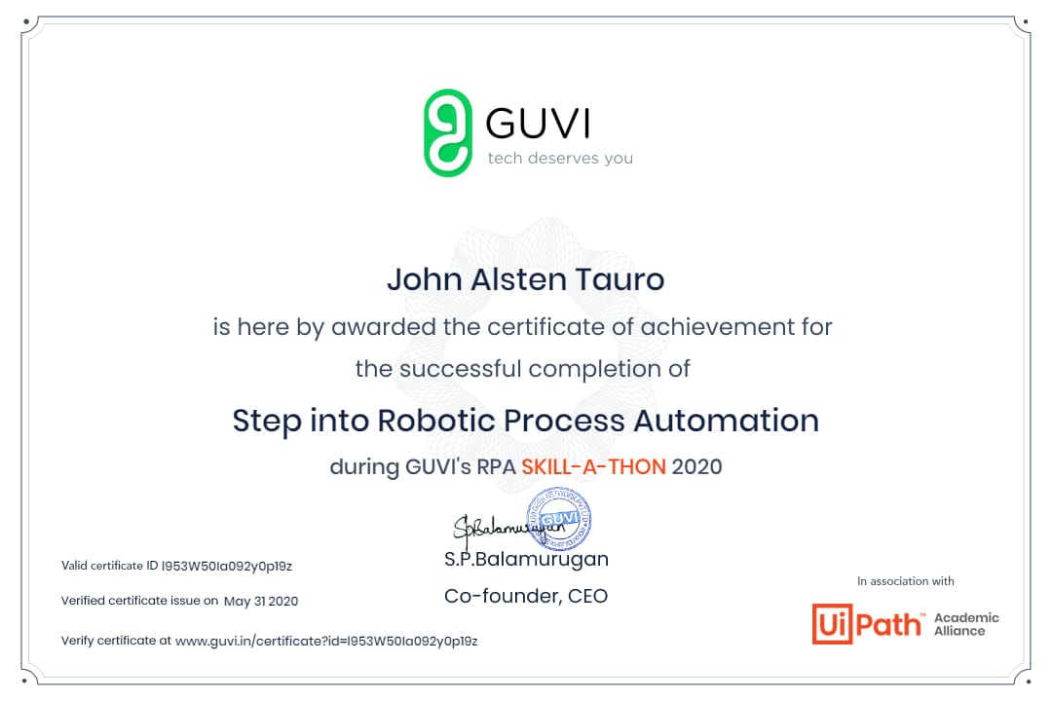

Completed Step into Robotic Process during GUVI’s RPA SKILL-A-THON 2020

Coding Challenges Details: (Attach the snapshot and briefly write the report for the same)

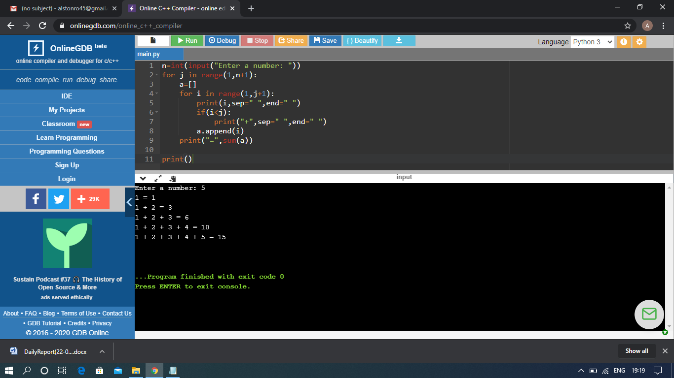

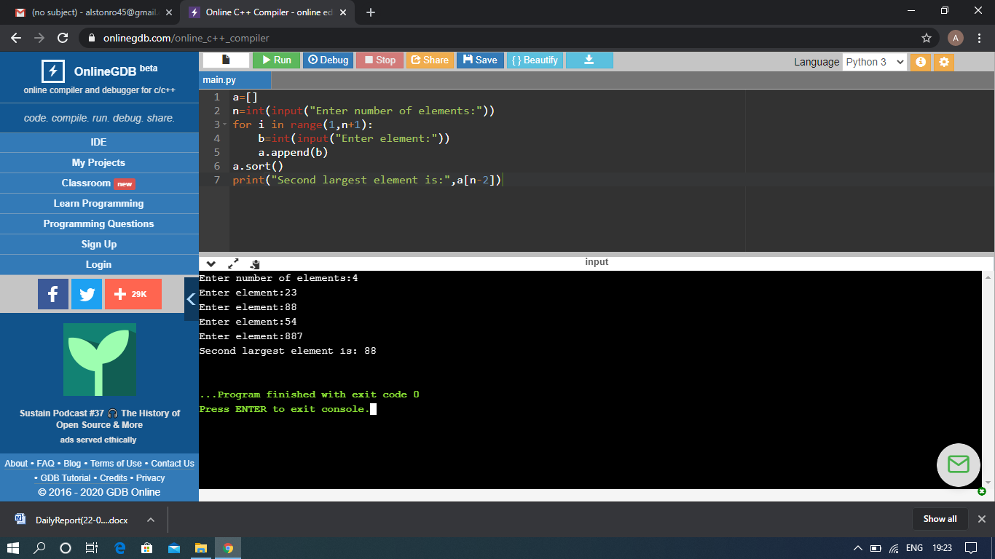

The above Programs were written and executed and the output of the same is displayed above. The code for those 2 programs have been uploaded to the github repository and the link to the same is provided on the form.