**DAILY ONLINE ACTIVITIES SUMMARY**

|  |  |  |  |  |  |  |  |  |
| --- | --- | --- | --- | --- | --- | --- | --- | --- |
| **Date:** | **08-06-2020** | | | | | **Name:** | **Anvita Keni** | |
| **Sem & Sec** | **8th sem, A sec** | | | | | **USN:** | **4AL16CS016** | |
| **Online Test Summary** | | | | | | | | |
| **Subject** | | **SMS** | | | | | | |
| **Max. Marks** | | **60** | | **Score** | | | **60** | |
| **Certification Course Summary** | | | | | | | | |
| **Course** | **Introduction to Digital Marketing** | | | | | | | |
| **Certificate Provider** | | | **Great Learning Academy** | | **Duration** | | | 3 hour |
| **Coding Challenges** | | | | | | | | |
| **Problem Statement:** Write a c program to sort an array of integers in ascending order and display the sorted array and number of passes performed for sorting.   |  | | --- | |  | |  | |  | | | | | | | | | |
| **Status:Solved** | | | | | | | | |
| **Uploaded the report in Github** | | | | | **Yes** | | | |
| **If yes Repository name** | | | | | **Anvita_Keni** | | | |
| **Uploaded the report in slack** | | | | | **Yes** | | | |

Online test details:

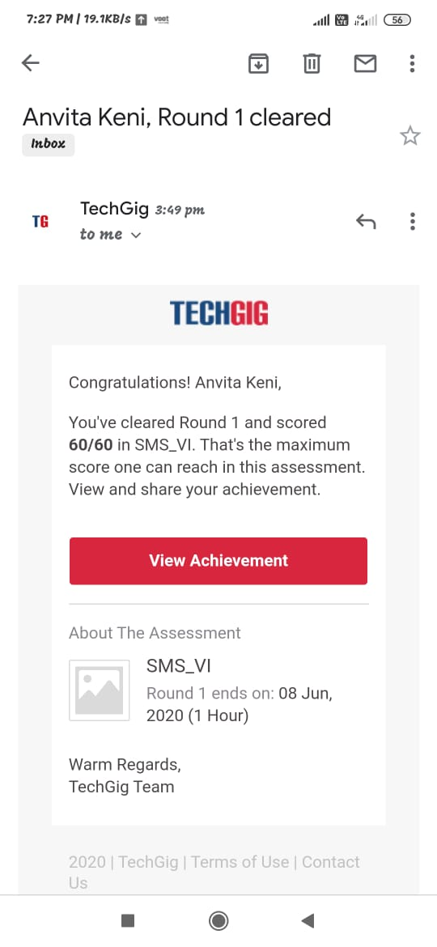

Certification Course Details:

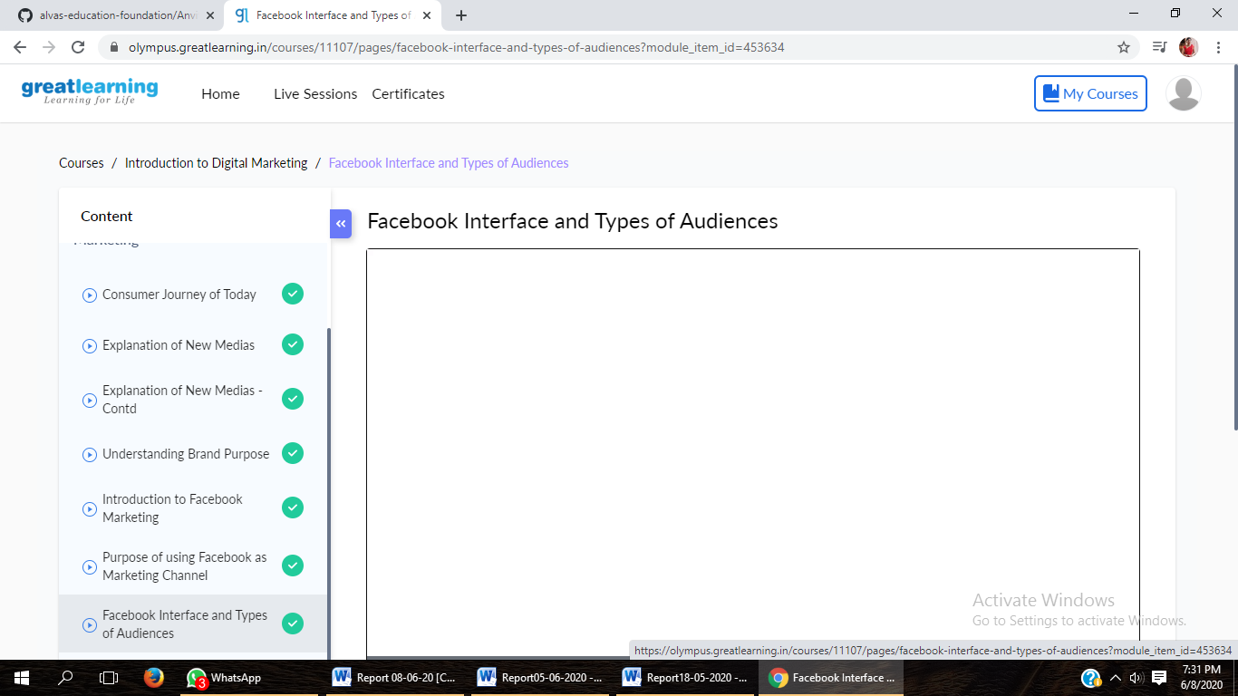

Online coding Details:

