**DAILY ASSESSMENT FORMAT**

|  |  |  |  |
| --- | --- | --- | --- |
| **Date:** | **21/05/2020** | **Name:** | **Bhuvanesh M** |
| **Course:** | **TCS ION** | **USN:** | **4AL16EC015** |
| **Topic:** | **Learn Corporate Telephone**  **Etiquette**  **Understand Accounting**  **Fundamentals**  **Gain Foundational Skills in IT** | **Semester & Section:** | **8th – A** |
| **Github Repository:** | **Bhuvan** |  |  |

|  |
| --- |
| **FORENOON SESSION DETAILS** |
| **Image of session** |

**Report –**

**Learn Corporate Telephone Etiquette**

In this online course on Learn Corporate Telephone Etiquette I learn that what we say, how much we say and how we say plays an important role in the impression we create on the listener. Through this module I learn important guidelines to be followed for effective corporate telephonic communication.

Throughout this course I learned following things –

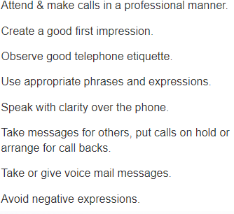

**Do’s of Telephone Etiquette**

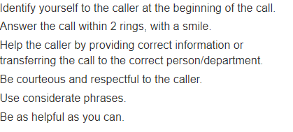

**Don’ts of Telephone Etiquette**

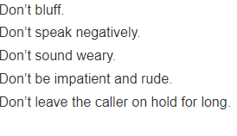

**DAILY ASSESSMENT FORMAT**

|  |  |  |  |
| --- | --- | --- | --- |
| **Date:** | **21/05/2020** | **Name:** | **Bhuvanesh M** |
| **Course:** | **java** | **USN:** | **4AL16EC015** |
| **Topic:** | **While loops** | **Semester & Section:** | **8th - A** |
| **Github Repository:** | **Bhuvan** |  |  |

|  |
| --- |
| **AFTERNOON SESSION DETAILS** |
| **Image of session** |

**Report –**

In the fourth part of the Java tutorial for beginners video series using Eclipse, we look using loops to make your code repeat statements multiple times. We also take a look at conditions.

**Code:**

**public class Application {**

**public static void main(String[] args) {**

**int value = 0;**

**while(value < 10)**

**{**

**System.out.println("Hello " + value);**

**value = value + 1;**

**}**

**}**

**}**

**Output –**

Hello 0

Hello 1

Hello 2

Hello 3

Hello 4

Hello 5

Hello 6

Hello 7

Hello 8

Hello 9