**DAILY ONLINE ACTIVITIES SUMMARY**

|  |  |  |  |  |  |  |  |  |
| --- | --- | --- | --- | --- | --- | --- | --- | --- |
| **Date:** | **18-05-2020** | | | | | **Name:** | **Pranav L M** | |
| **Sem & Sec** | **6th - B** | | | | | **USN:** | **4AL17CS062** | |
| **Online Test Summary** | | | | | | | | |
| **Subject** | | **CNSC** | | | | | | |
| **Max. Marks** | | **60** | | **Score** | | | **43** | |
| **Certification Course Summary** | | | | | | | | |
| **Course** | **Machine learning with python** | | | | | | | |
| **Certificate Provider** | | | **Congnitiveclass.ai(IBM)** | | **Duration** | | | **2/10** |
| **Coding Challenges** | | | | | | | | |
| **Problem Statement: Two java and two c-program** | | | | | | | | |
| **Status: executed** | | | | | | | | |
| **Uploaded the report in Github** | | | | | **yes** | | | |
| **If yes Repository name** | | | | | <https://github.com/pranavlm/online-coding/tree/master/18-05-20> | | | |
| **Uploaded the report in slack** | | | | | **Yes** | | | |

Online Test Details: (Attach the snapshot and briefly write the report for the same)

First I A of CNSC

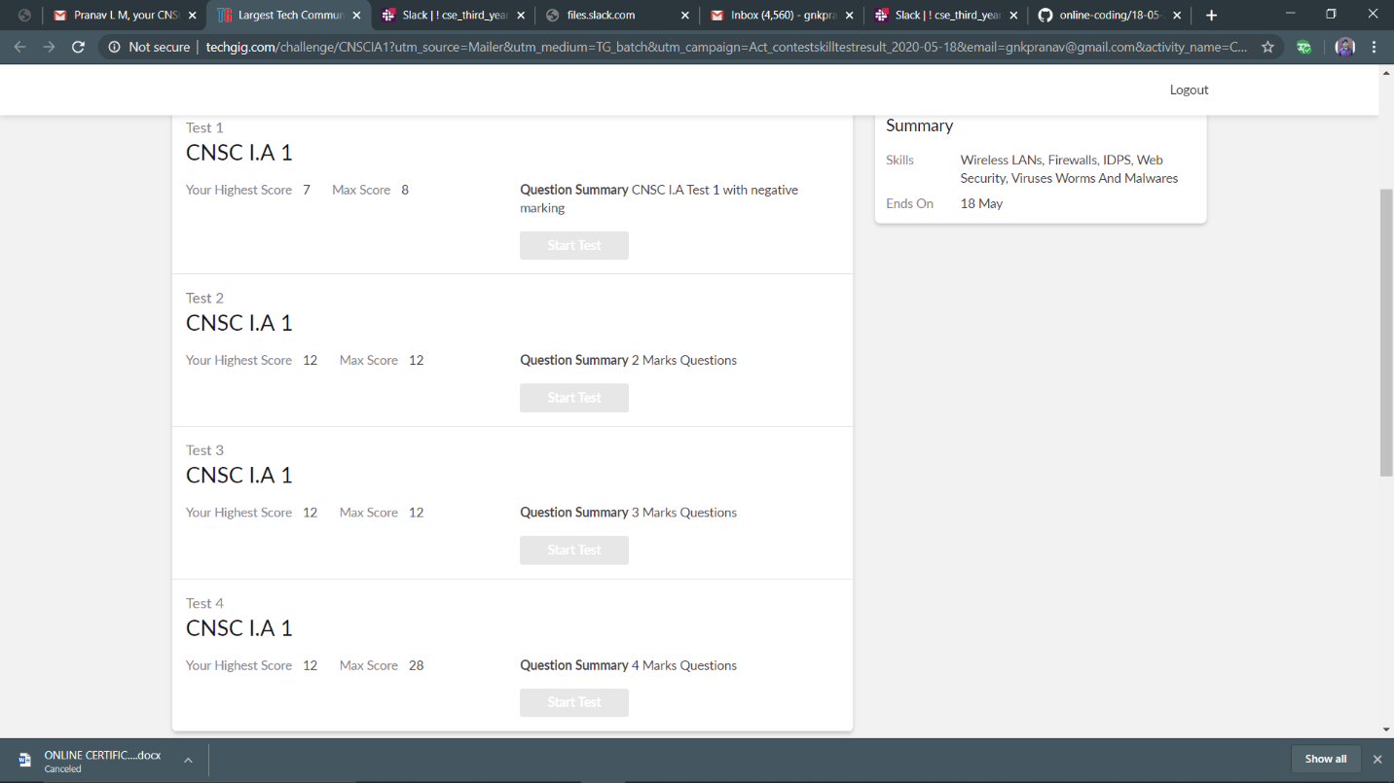

Certification Course Details: (Attach the snapshot and briefly write the report for the same)

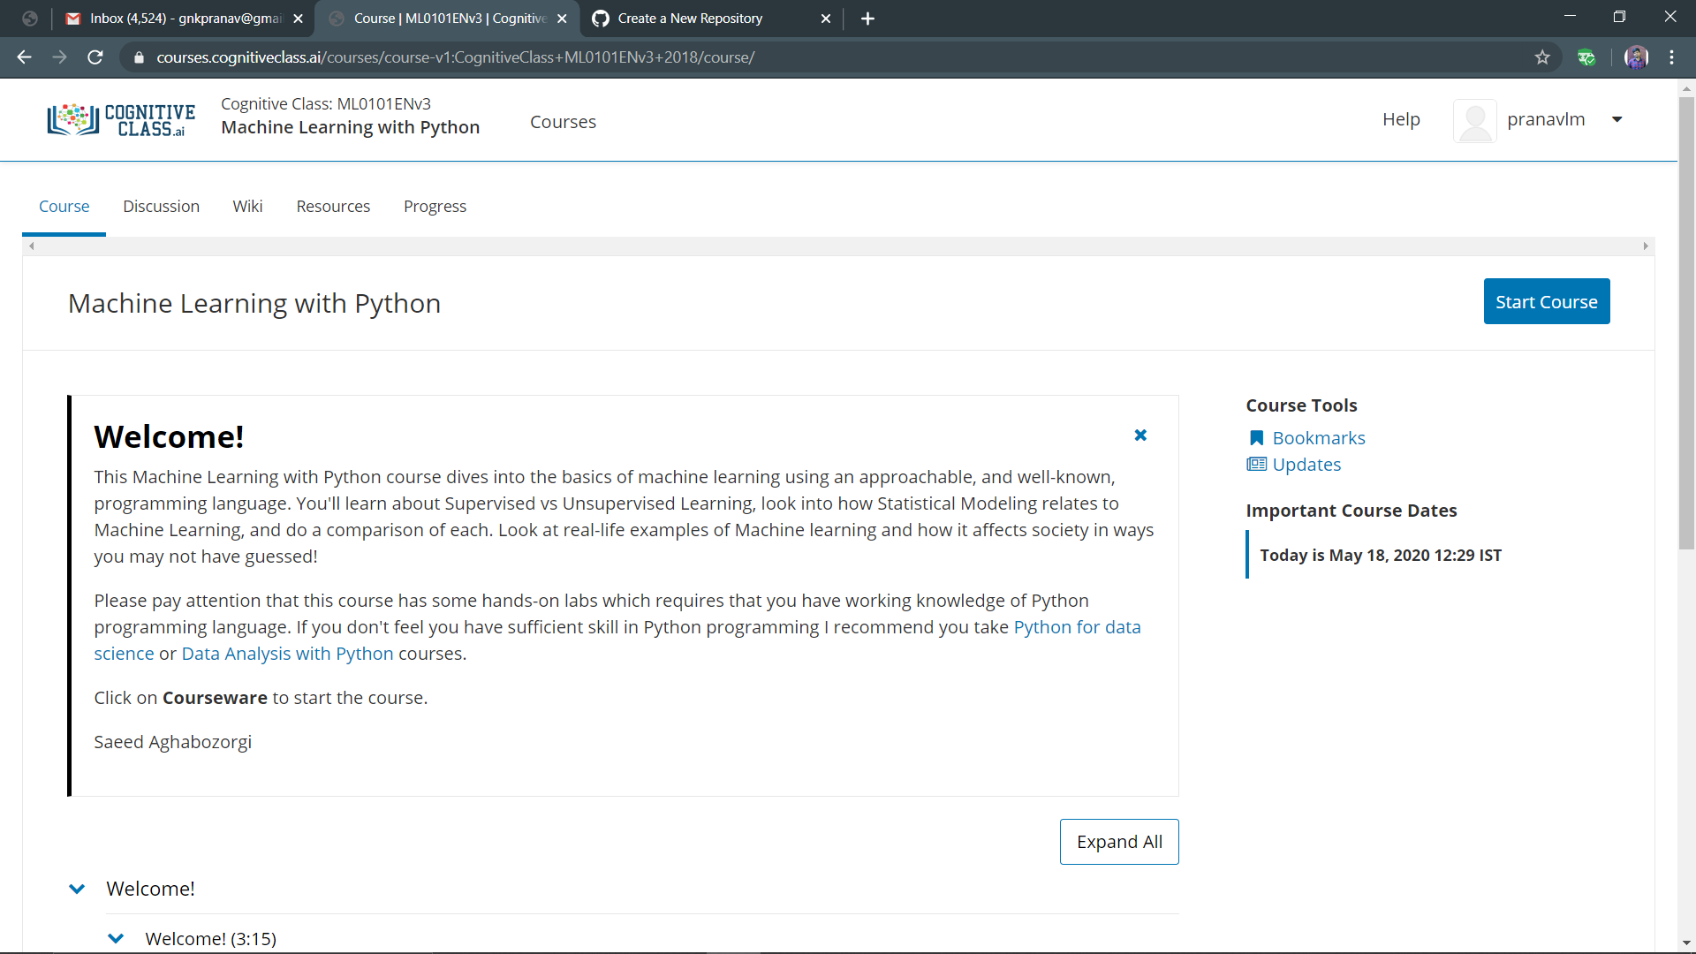

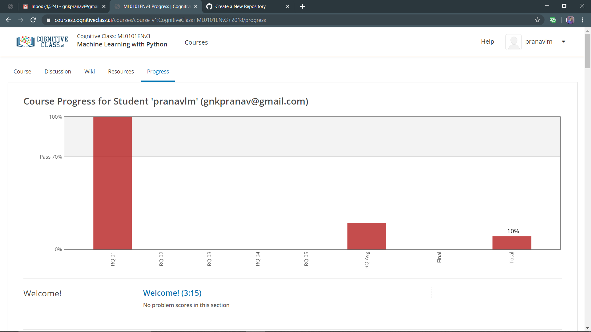

Coding Challenges Details: (Attach the snapshot and briefly write the report for the same)

Problem statements are available in the github account <https://github.com/pranavlm/online-coding/tree/master/18-05-20>

OUYPUT SCREEN-SHOTS

P-1

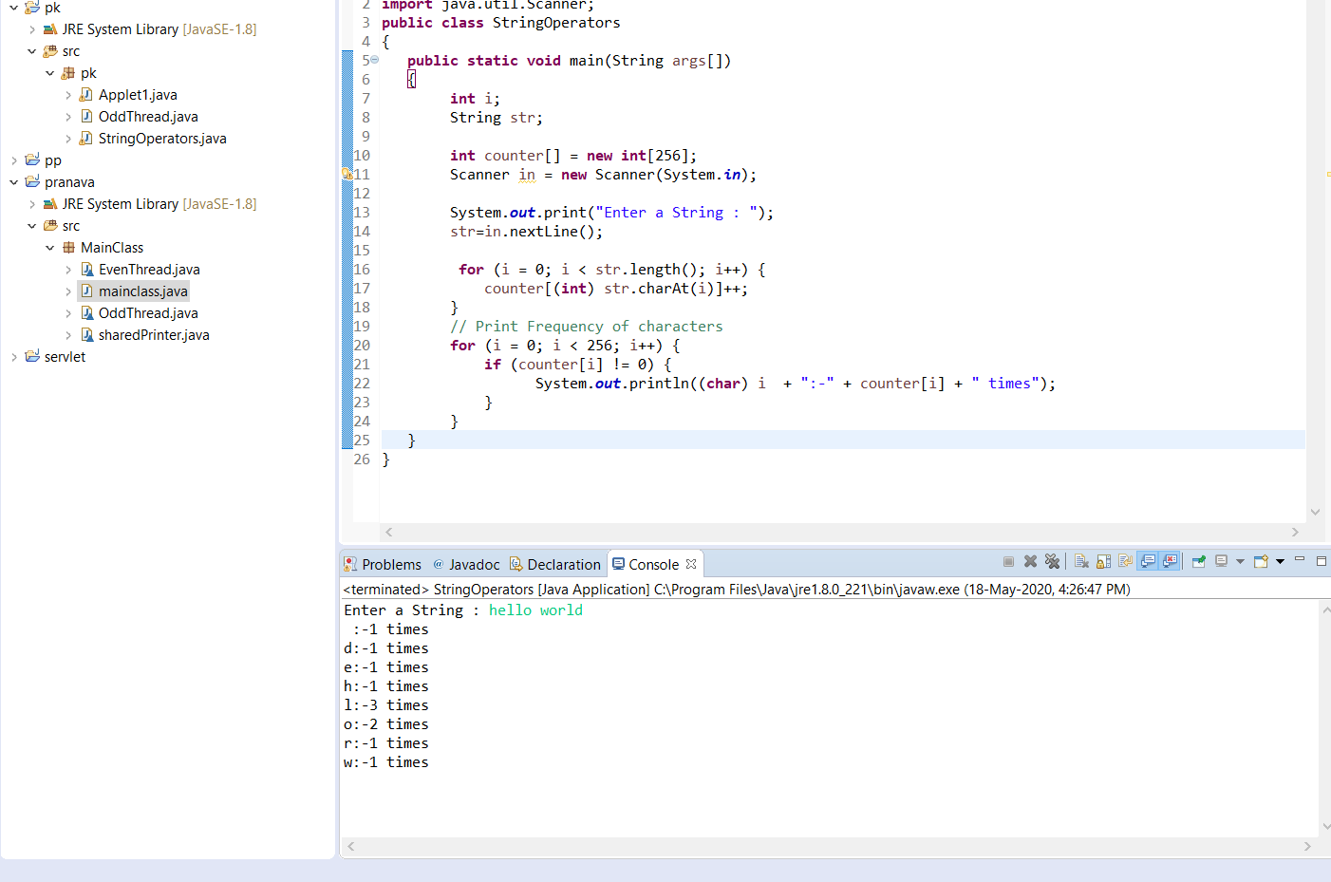

P-2

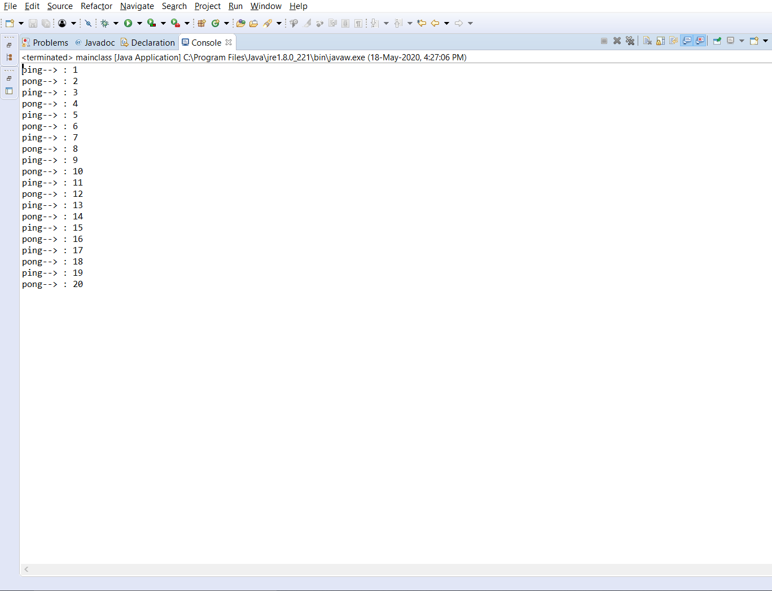

P-3

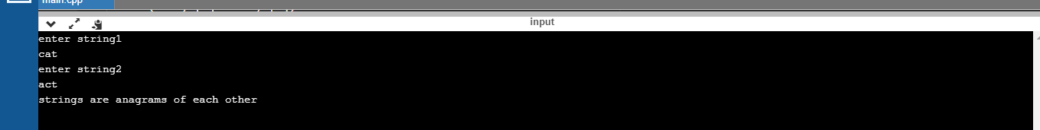

P-4

