**DAILY ONLINE ACTIVITIES SUMMARY**

|  |  |  |  |  |  |  |  |  |
| --- | --- | --- | --- | --- | --- | --- | --- | --- |
| **Date:** | **11-06-2020** | | | | | **Name:** | **Dhanya Bhat** | |
| **Sem & Sec** | **6th A** | | | | | **USN:** | **4AL17CS027** | |
| **Online Test Summary** | | | | | | | | |
| **Subject** | | **PAP** | | | | | | |
| **Max. Marks** | | **20** | | **Score** | | | **17** | |
| **Certification Course Summary** | | | | | | | | |
| **Course** | **The Complete PHP 7 Guide for Web Developers** | | | | | | | |
| **Certificate Provider** | | | **Eduonix** | | **Duration** | | | 4h**rs** |
| **Coding Challenges** | | | | | | | | |
| **Problem Statement**: 1. Write a Java program to find the nodes which are at the maximum distance in a Binary Tree.  2. Write a python function that converts a string to all uppercase, provided it contains at least 2 uppercase characters in the first 4 characters. Else print the string as it is. | | | | | | | | |
| **Status: YES, Completed all Programs.** | | | | | | | | |
| **Uploaded the report in Github** | | | | | **YES** | | | |
| **If yes Repository name** | | | | | <https://github.com/alvas-education-foundation/Dhanya-bhat-4AL17CS027> | | | |
| **Uploaded the report in slack** | | | | | **YES** | | | |

Online Test Details: (Attach the snapshot and briefly write the report for the same)

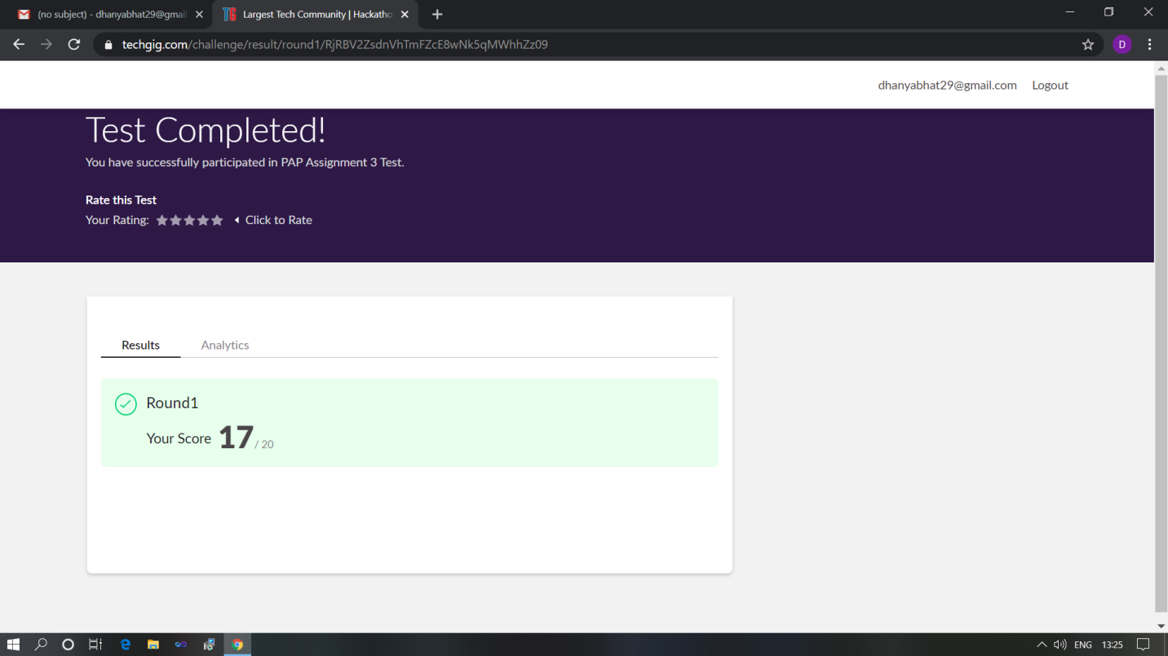

Scored 17 out of 20 in PAP assignment test

Certification Course Details: (Attach the snapshot and briefly write the report for the same)

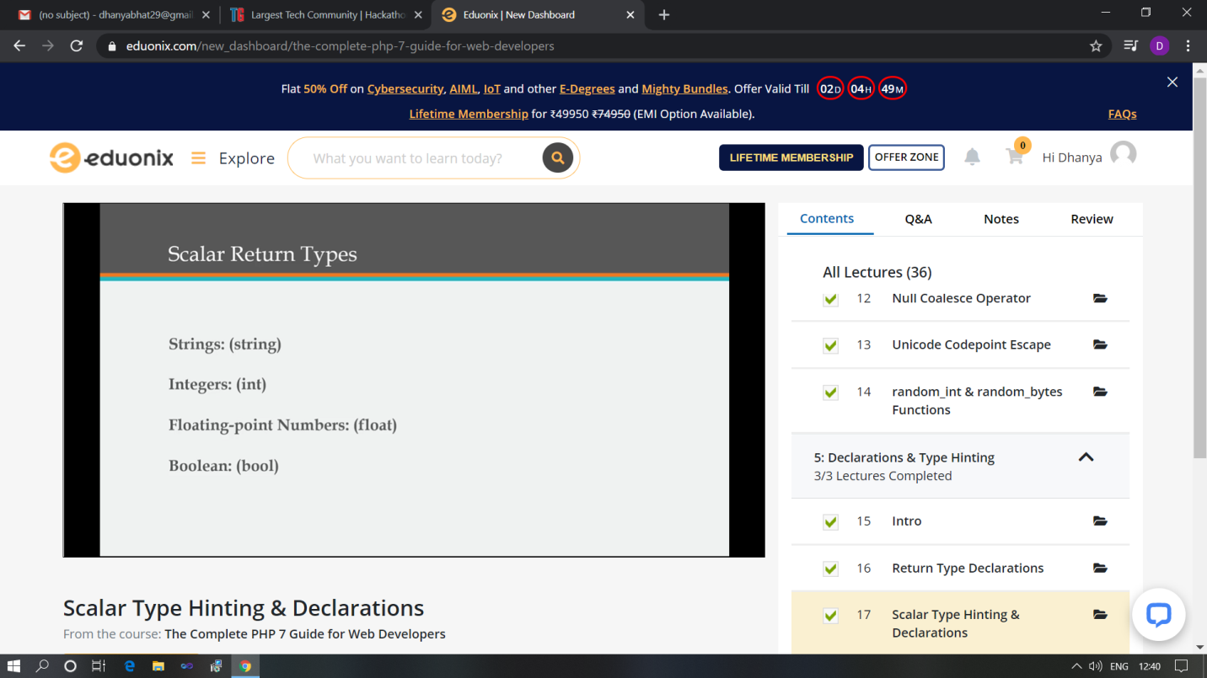

The above course is being taken up by me which is based on the Complete PHP 7 Guide for web developer. It started with the Course intro, today in online course I studies about Null coalesce operator, Unicode codepoint escape, random int & random bytes functions and also about Declaration and Type hinting. The details of the course and certificate provider is mentioned in the above form.

Coding Challenges Details: (Attach the snapshot and briefly write the report for the same)

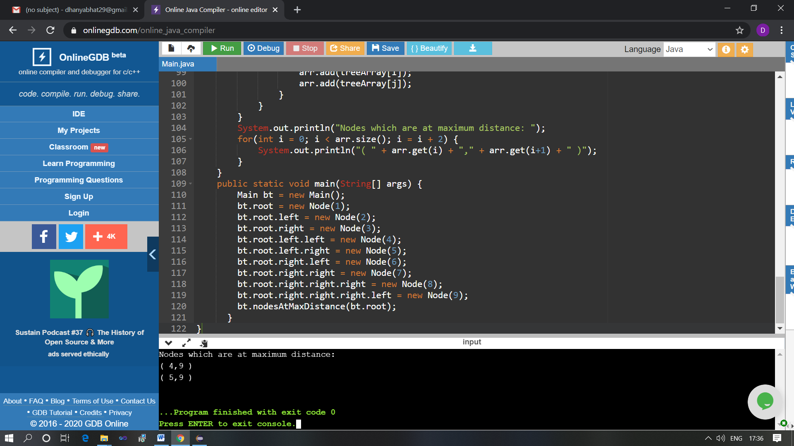

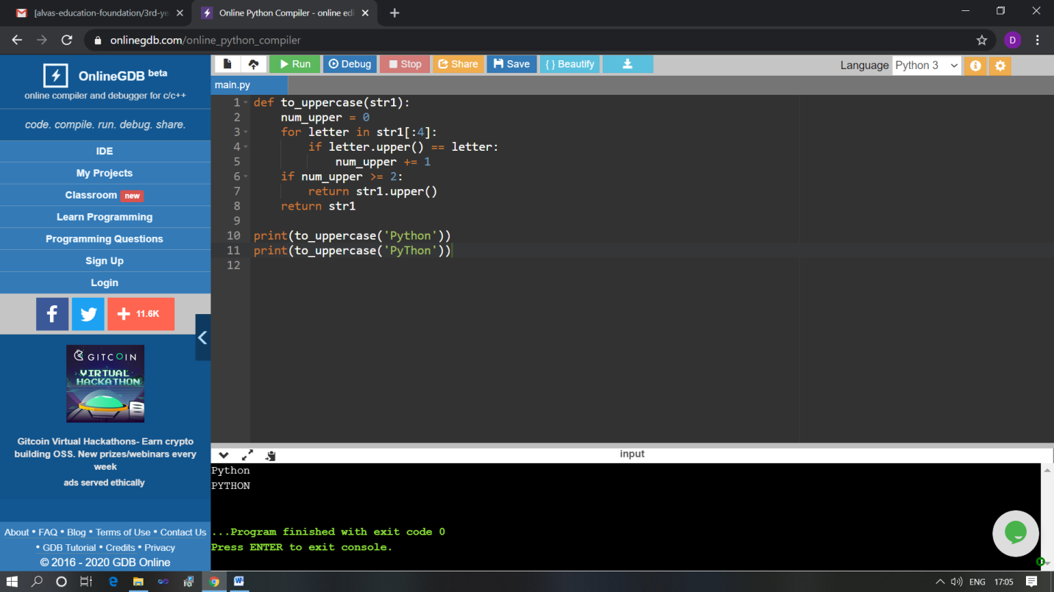

The above Programs were written and executed and the output of the same is displayed above. The code for those 2 programs have been uploaded to the github repository and the link to the same is provided on the form.