**DAILY ONLINE ACTIVITIES SUMMARY**

|  |  |  |  |  |  |  |  |  |
| --- | --- | --- | --- | --- | --- | --- | --- | --- |
| **Date:** | **11-07-2020** | | | | | **Name:** | **Dhanya Bhat** | |
| **Sem & Sec** | **6th A** | | | | | **USN:** | **4AL17CS027** | |
| **Online Test Summary** | | | | | | | | |
| **Subject** | |  | | | | | | |
| **Max. Marks** | |  | | **Score** | | |  | |
| **Online Course Summary** | | | | | | | | |
| **Online Course**  **name** | Facial Expression Recognition with keras | | | | | | | |
| **Certificate provider** | | | **Coursera** | | **Duration** | | | **2hr** |
| **Coding Challenges** | | | | | | | | |
| Problem Statement: 1. Python Program to print Fibonacci series. | | | | | | | | |
| **Status: YES, Completed all Programs.** | | | | | | | | |
| **Uploaded the report in Github** | | | | | **YES** | | | |
| **If yes Repository name** | | | | | <https://github.com/alvas-education-foundation/Dhanya-bhat-4AL17CS027> | | | |
| **Uploaded the report in slack** | | | | | **YES** | | | |

Online course Details: (Attach the snapshot and briefly write the report for the same)

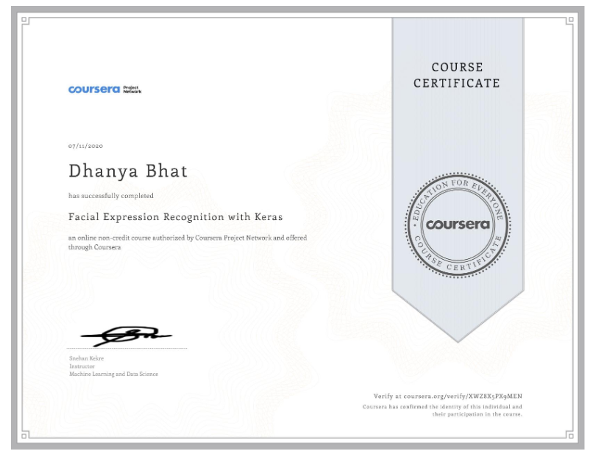

Completed Facial expression recognition with Keras online course by Coursera.

Pre-placement training Details: (Attach the snapshot and briefly write the report for the same)

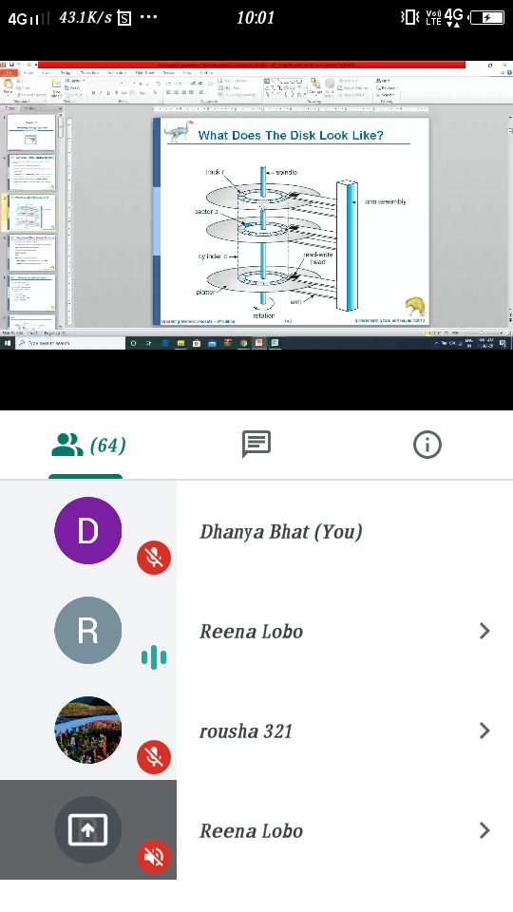

Today in this session I studied about some concepts of Operating system.

Coding Challenges Details: (Attach the snapshot and briefly write the report for the same)

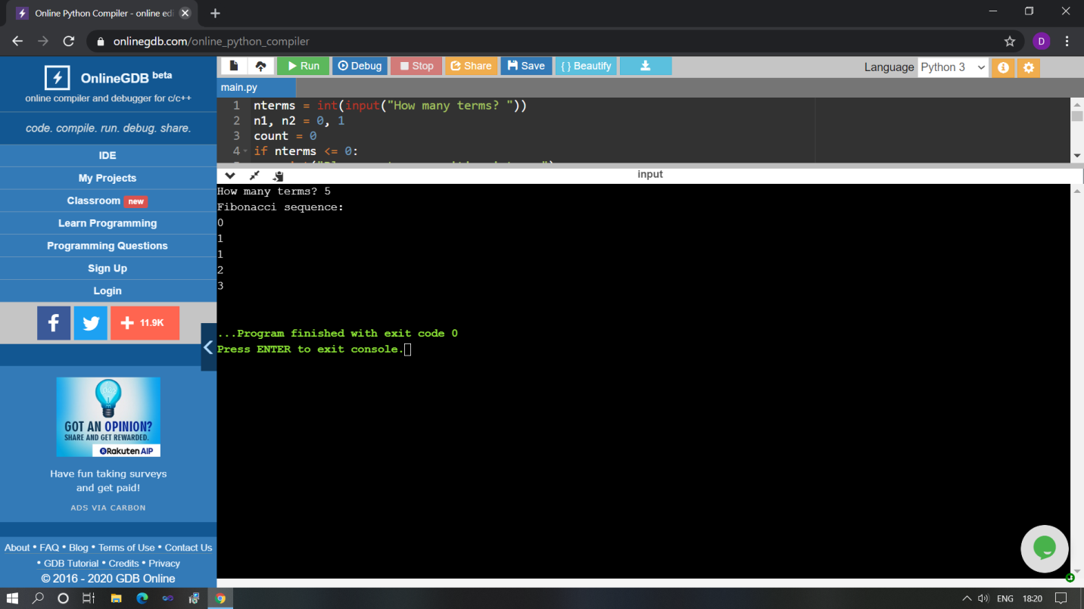

The above Programs were written and executed and the output of the same is displayed above. The code for those 1 programs have been uploaded to the github repository and the link to the same is provided on the form.