**DAILY ONLINE ACTIVITIES SUMMARY**

|  |  |  |  |  |  |  |  |  |
| --- | --- | --- | --- | --- | --- | --- | --- | --- |
| **Date:** | **12-06-2020** | | | | | **Name:** | **Dhanya Bhat** | |
| **Sem & Sec** | **6th A** | | | | | **USN:** | **4AL17CS027** | |
| **Online Test Summary** | | | | | | | | |
| **Subject** | | **-** | | | | | | |
| **Max. Marks** | | **-** | | **Score** | | | **-** | |
| **Certification Course Summary** | | | | | | | | |
| **Course** | **The Complete PHP 7 Guide for Web Developers** | | | | | | | |
| **Certificate Provider** | | | **Eduonix** | | **Duration** | | | 4h**rs** |
| **Coding Challenges** | | | | | | | | |
| **Problem Statement**: 1. Write a Python program to implement Magic Square.  **2.** Write a Python program to print the pattern. 3. Write a Java program to find maximum width of a binary tree. | | | | | | | | |
| **Status: YES, Completed all Programs.** | | | | | | | | |
| **Uploaded the report in Github** | | | | | **YES** | | | |
| **If yes Repository name** | | | | | <https://github.com/alvas-education-foundation/Dhanya-bhat-4AL17CS027> | | | |
| **Uploaded the report in slack** | | | | | **YES** | | | |

Certification Course Details: (Attach the snapshot and briefly write the report for the same)

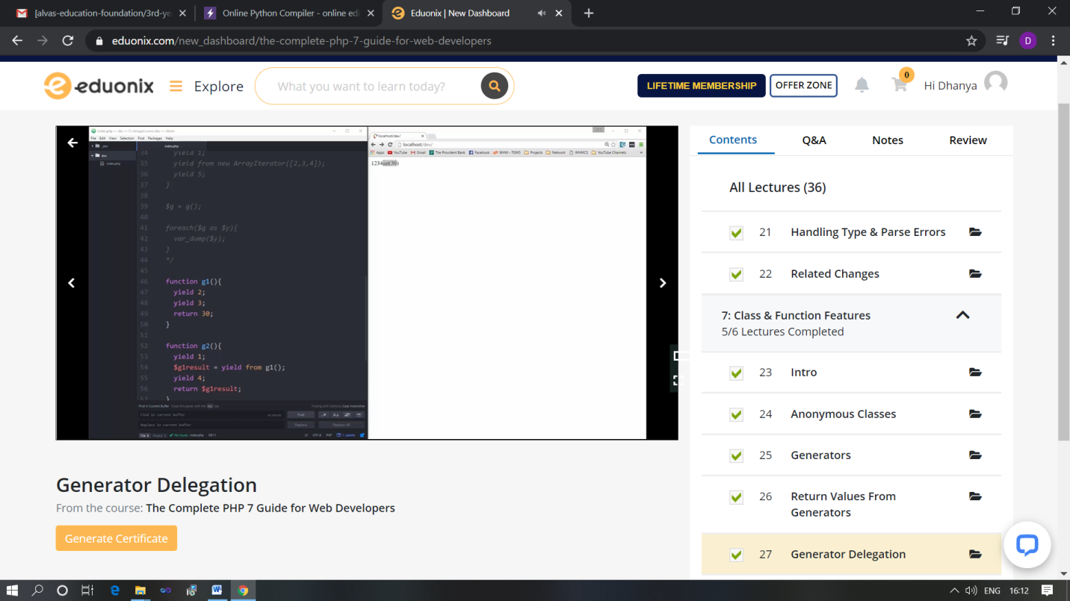

The above course is being taken up by me which is based on the Complete PHP 7 Guide for web developer. It started with the Course intro, today in online course I studied about Error handling, Class and Function features. The details of the course and certificate provider is mentioned in the above form.

Coding Challenges Details: (Attach the snapshot and briefly write the report for the same)

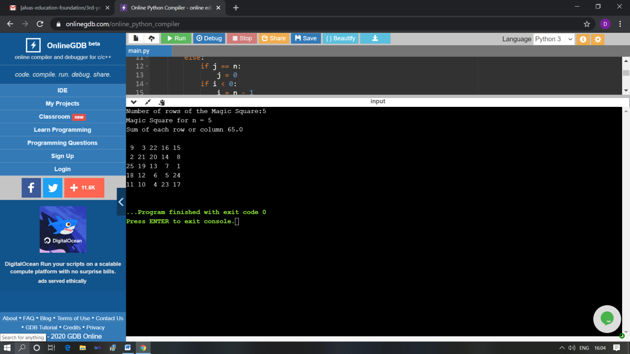

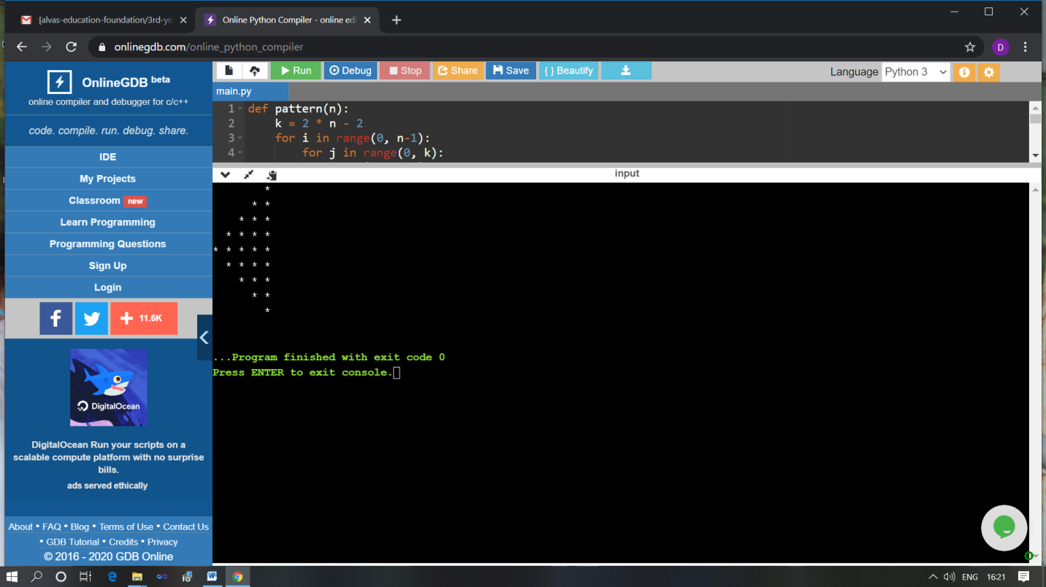

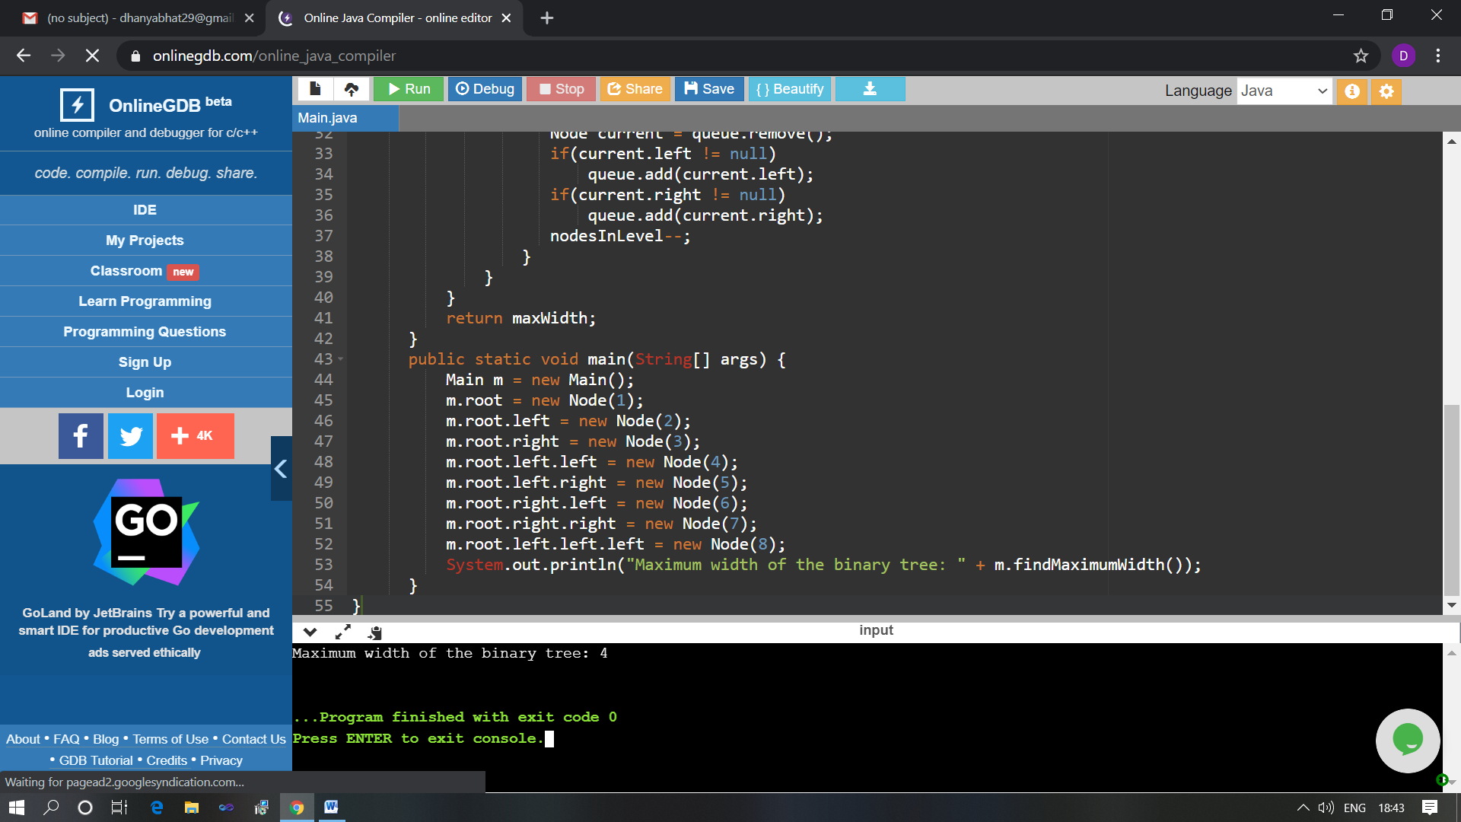

The above Programs were written and executed and the output of the same is displayed above. The code for those 3 programs have been uploaded to the github repository and the link to the same is provided on the form.