**DAILY ONLINE ACTIVITIES SUMMARY**

|  |  |  |  |  |  |  |  |  |
| --- | --- | --- | --- | --- | --- | --- | --- | --- |
| **Date:** | **16-06-2020** | | | | | **Name:** | **Dhanya Bhat** | |
| **Sem & Sec** | **6th A** | | | | | **USN:** | **4AL17CS027** | |
| **Online Test Summary** | | | | | | | | |
| **Subject** | | Python quiz | | | | | | |
| **Max. Marks** | | **20** | | **Score** | | | **13** | |
| **Pre-Placement Training Summary** | | | | | | | | |
| **Pre-Placement training** | 9.00-11.00:Programming in C11.00-1.00:Applications of Python Programming in Data Analytics and Machine Learning – Research Perspective | | | | | | | |
| **Faculty name** | | | **Merlyn mathias and Dr.** Mohideen  Badusha | | **Duration** | | | **4hrs** |
| **Coding Challenges** | | | | | | | | |
| **Problem Statement**: 1. Write a Python program to check whether a given a binary tree is a valid binary search tree (BST) or not?  **2.**. Exercise of Python Programming. | | | | | | | | |
| **Status: YES, Completed all Programs.** | | | | | | | | |
| **Uploaded the report in Github** | | | | | **YES** | | | |
| **If yes Repository name** | | | | | <https://github.com/alvas-education-foundation/Dhanya-bhat-4AL17CS027> | | | |
| **Uploaded the report in slack** | | | | | **YES** | | | |

Online test Details: (Attach the snapshot and briefly write the report for the same)

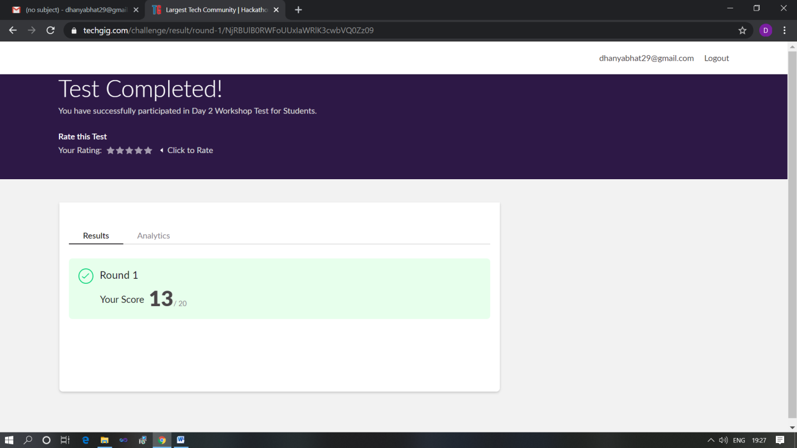

ScoeScored 13 out of 20 in Python quiz

Pre-Placement Course Details: (Attach the snapshot and briefly write the report for the same)

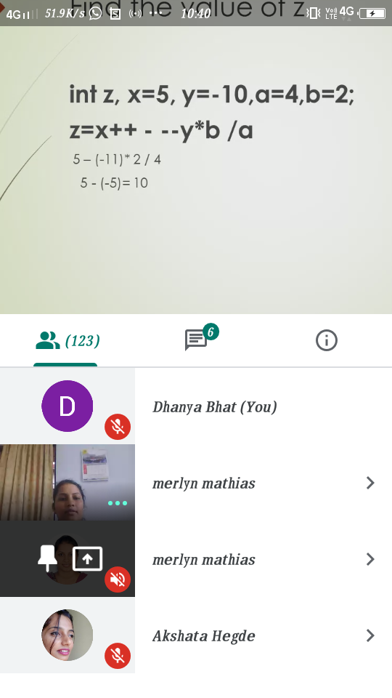

Programming in C- Merlyn mathias @Mon 15 2020 9am-11.00am

Today in this session I studies about Storage class, about static variable, increment and decrement operators, and so on. I also attended 2 quiz in the middle of the session.

The exercise of the session is uploaded in the below github repository :

<https://github.com/Dhanya-bhat/Pre_Placement_C_Programming>

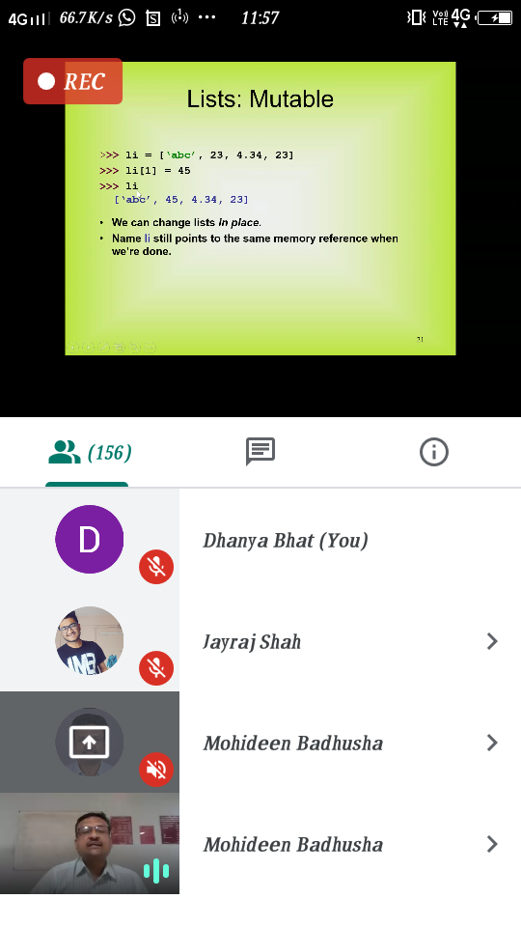

### Applications of Python Programming in Data Analytics and Machine Learning – Research Perspective- Mon 15 june 2020 11.00 to 1.00pm.

### Today in this session I studies about basics of Python programming about list, tuple, files and also the worked examples of python program.

### The exercise of the session is uploaded in the below github repository :

<https://github.com/Dhanya-bhat/Application_of_Python_Programming_in_DA_and_ML>

Coding Challenges Details: (Attach the snapshot and briefly write the report for the same)

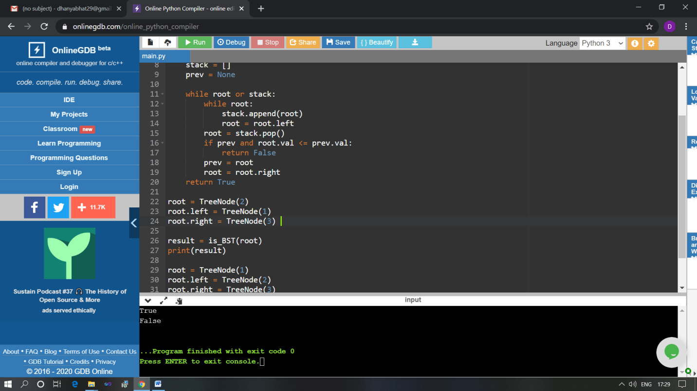

The above Programs were written and executed and the output of the same is displayed above. The code for those 1 programs have been uploaded to the github repository and the link to the same is provided on the form.