**DAILY ONLINE ACTIVITIES SUMMARY**

|  |  |  |  |  |  |  |  |  |
| --- | --- | --- | --- | --- | --- | --- | --- | --- |
| **Date:** | **17-06-2020** | | | | | **Name:** | **Dhanya Bhat** | |
| **Sem & Sec** | **6th A** | | | | | **USN:** | **4AL17CS027** | |
| **Online Test Summary** | | | | | | | | |
| **Subject** | | C programming quiz | | | | | | |
| **Max. Marks** | | **15** | | **Score** | | | **12** | |
| **Pre-Placement Training Summary** | | | | | | | | |
| **Pre-Placement training** | 9.00-11.00:Programming in C11.00-1.00:Applications of Python Programming in Data Analytics and Machine Learning – Research Perspective | | | | | | | |
| **Faculty name** | | | **Vivek sharma, Dr.** Mohideen  Badusha and Dr. Mohammed javed | | **Duration** | | | **4hrs** |
| **Coding Challenges** | | | | | | | | |
| **Problem Statement**: 1. Find the smallest positive integer value that cannot be represented as sum of any subset of a given array sorted in ascending order.  **2**. Write a Java program to find the row, column position of a specified number (row, column position) in a given 2-dimensional array.  **3**. Exercise of Python Programming. | | | | | | | | |
| **Status: YES, Completed all Programs.** | | | | | | | | |
| **Uploaded the report in Github** | | | | | **YES** | | | |
| **If yes Repository name** | | | | | <https://github.com/alvas-education-foundation/Dhanya-bhat-4AL17CS027> | | | |
| **Uploaded the report in slack** | | | | | **YES** | | | |

Online test Details: (Attach the snapshot and briefly write the report for the same)

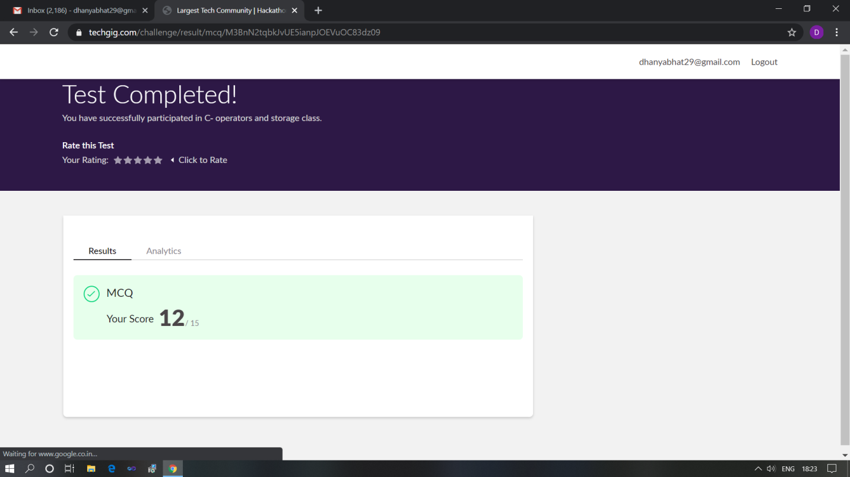

ScoeScored 12 out of 15 in C programming quiz

Pre-Placement Course Details: (Attach the snapshot and briefly write the report for the same)

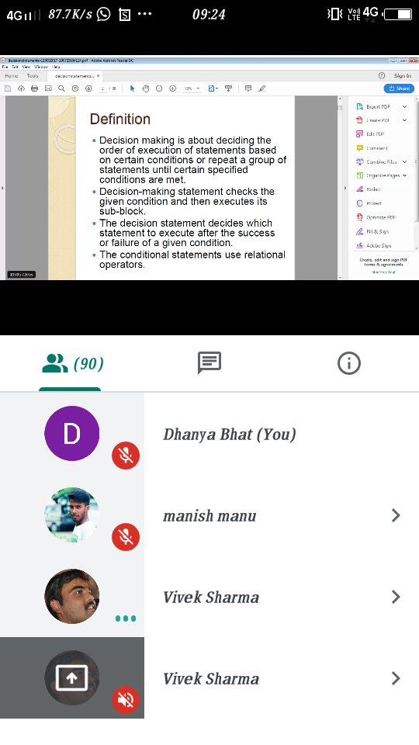

Programming in C

Today in this session I studies about Decision making and also different types of conditional loops. I also attended quiz in the middle of the session.

The exercise of the session is uploaded in the below github repository :

<https://github.com/Dhanya-bhat/Pre_Placement_C_Programming>

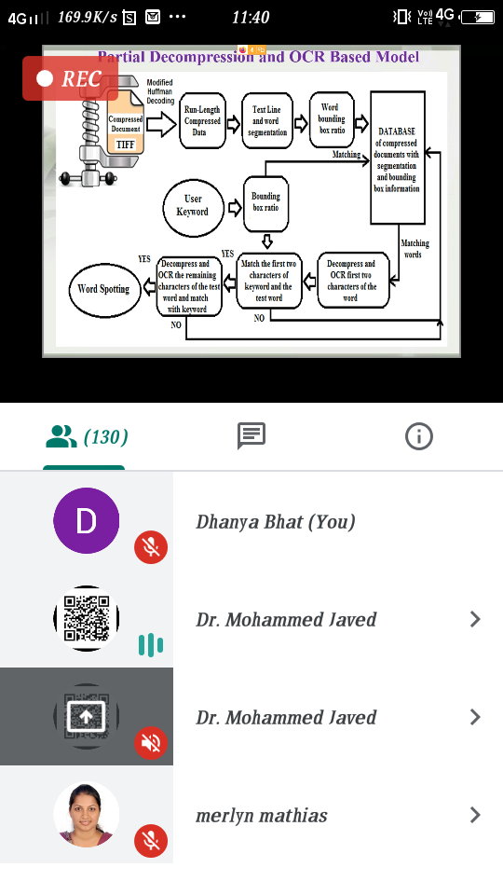

### Applications of Python Programming in Data Analytics and Machine Learning – Research Perspective

### Today in this session I studies about numpy and pandas with worked examples of python program.

### The exercise of the session is uploaded in the below github repository :

<https://github.com/Dhanya-bhat/Application_of_Python_Programming_in_DA_and_ML>

Coding Challenges Details: (Attach the snapshot and briefly write the report for the same)

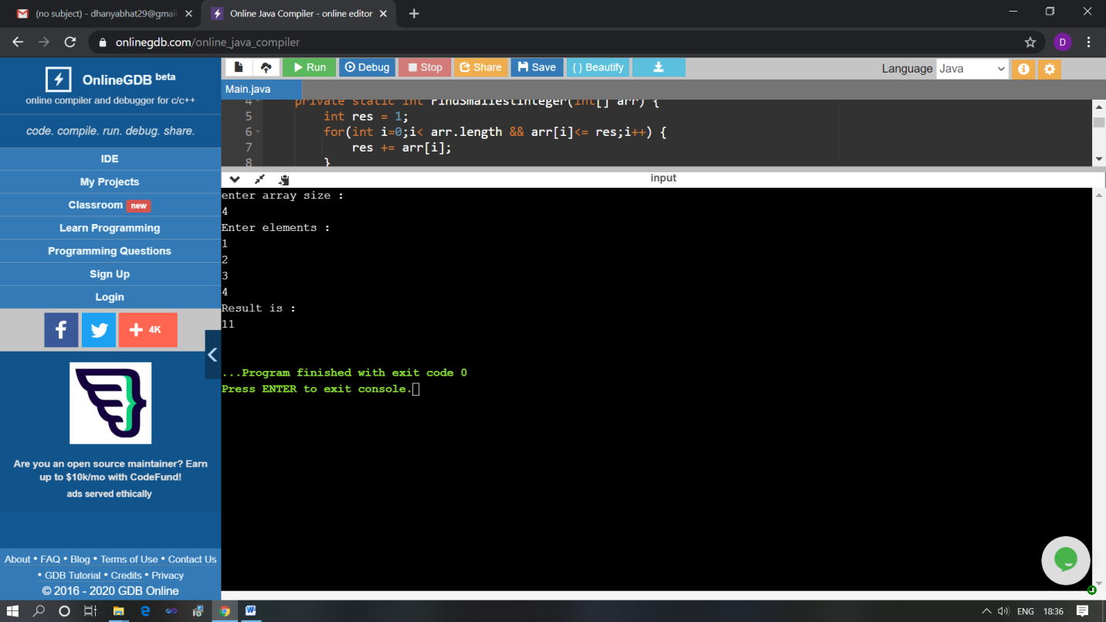

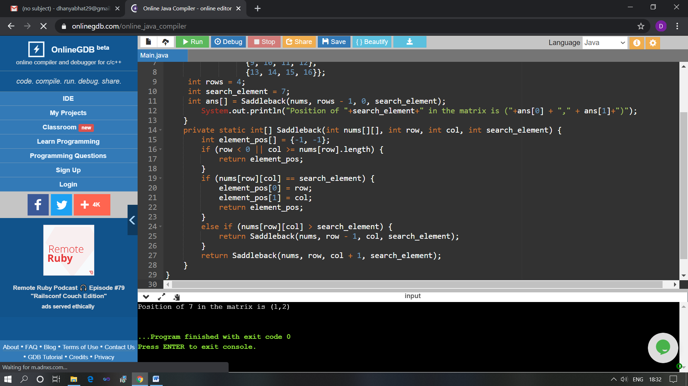

The above Programs were written and executed and the output of the same is displayed above. The code for those 2 programs have been uploaded to the github repository and the link to the same is provided on the form.