**DAILY ONLINE ACTIVITIES SUMMARY**

|  |  |  |  |  |  |  |  |  |
| --- | --- | --- | --- | --- | --- | --- | --- | --- |
| **Date:** | **18-06-2020** | | | | | **Name:** | **Dhanya Bhat** | |
| **Sem & Sec** | **6th A** | | | | | **USN:** | **4AL17CS027** | |
| **Online Test Summary** | | | | | | | | |
| **Subject** | | C programming quiz | | | | | | |
| **Max. Marks** | | **Quiz1-5**  **Quiz2-5** | | **Score** | | | **Quiz1-5**  **Quiz2-4** | |
| **Pre-Placement Training Summary** | | | | | | | | |
| **Pre-Placement training** | 9.00-11.00:Programming in C11.00-1.00:Applications of Python Programming in Data Analytics and Machine Learning – Research Perspective | | | | | | | |
| **Faculty name** | | | **Vivek sharma and Dr.** Mohideen  Badusha | | **Duration** | | | **4hrs** |
| **Coding Challenges** | | | | | | | | |
| **Problem Statement**: 1. Write a C Program to generate first N Magic Numbers.  **2**. Write a Java program to Check if a binary tree is binary search tree or not.  **3**. Exercise of Python Programming. | | | | | | | | |
| **Status: YES, Completed all Programs.** | | | | | | | | |
| **Uploaded the report in Github** | | | | | **YES** | | | |
| **If yes Repository name** | | | | | <https://github.com/alvas-education-foundation/Dhanya-bhat-4AL17CS027> | | | |
| **Uploaded the report in slack** | | | | | **YES** | | | |

Online test Details: (Attach the snapshot and briefly write the report for the same)

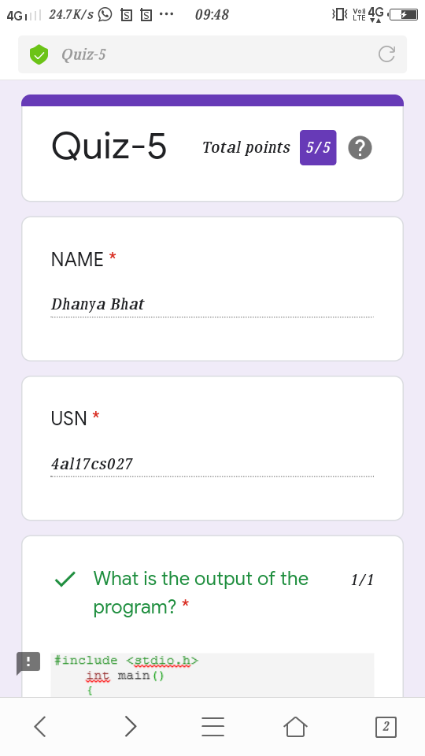

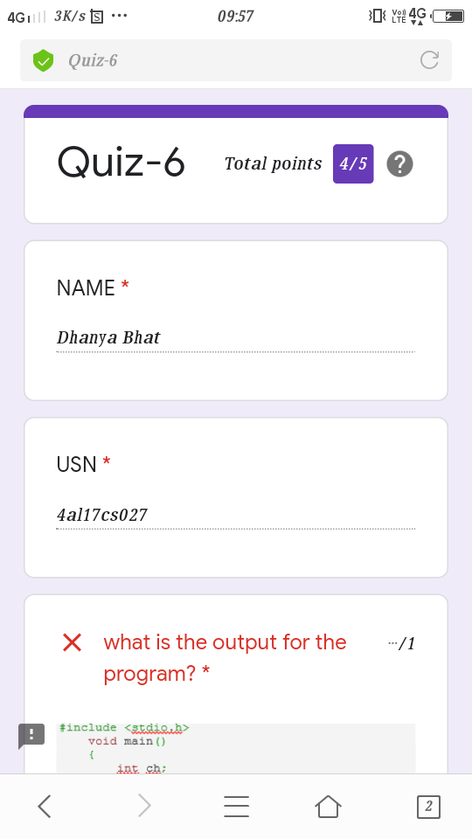

Pre-Placement Course Details: (Attach the snapshot and briefly write the report for the same)

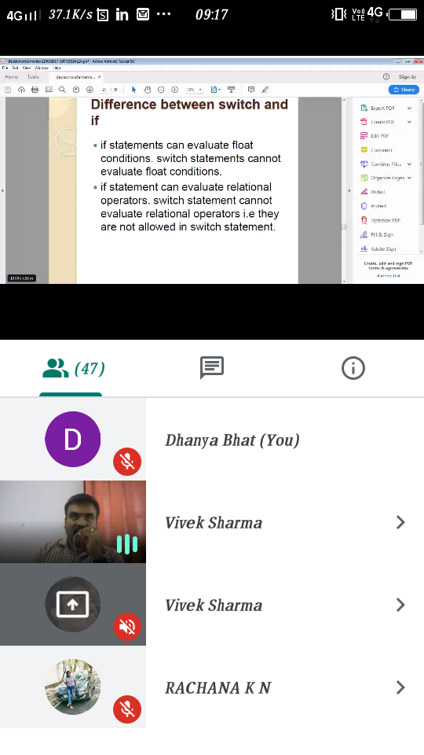

Programming in C- Merlyn mathias @Mon 15 2020 9am-11.00am

Today in this session I studies about goto, break, continue statements and about arrays . I also attended 2 quiz in the middle of the session.

The exercise of the session is uploaded in the below github repository :

<https://github.com/Dhanya-bhat/Pre_Placement_C_Programming>

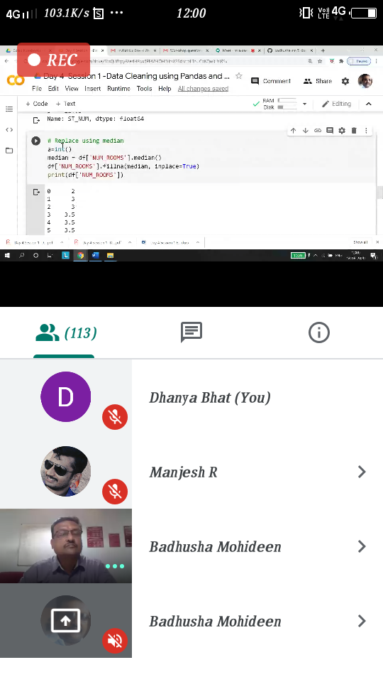

### Applications of Python Programming in Data Analytics and Machine Learning – Research Perspective- Mon 15 june 2020 11.00 to 1.00pm.

### Today in this session I studies about data analytics with worked examples of python program.

### The exercise of the session is uploaded in the below github repository :

<https://github.com/Dhanya-bhat/Application_of_Python_Programming_in_DA_and_ML>

Coding Challenges Details: (Attach the snapshot and briefly write the report for the same)

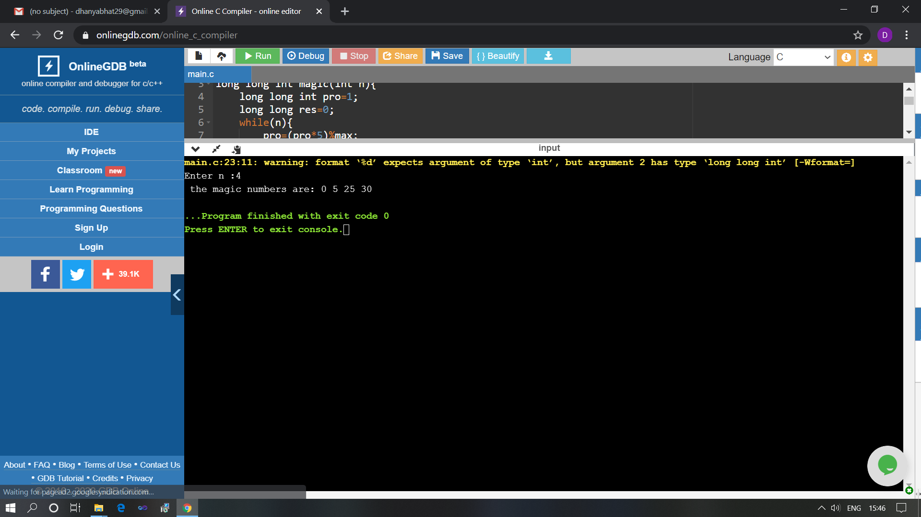

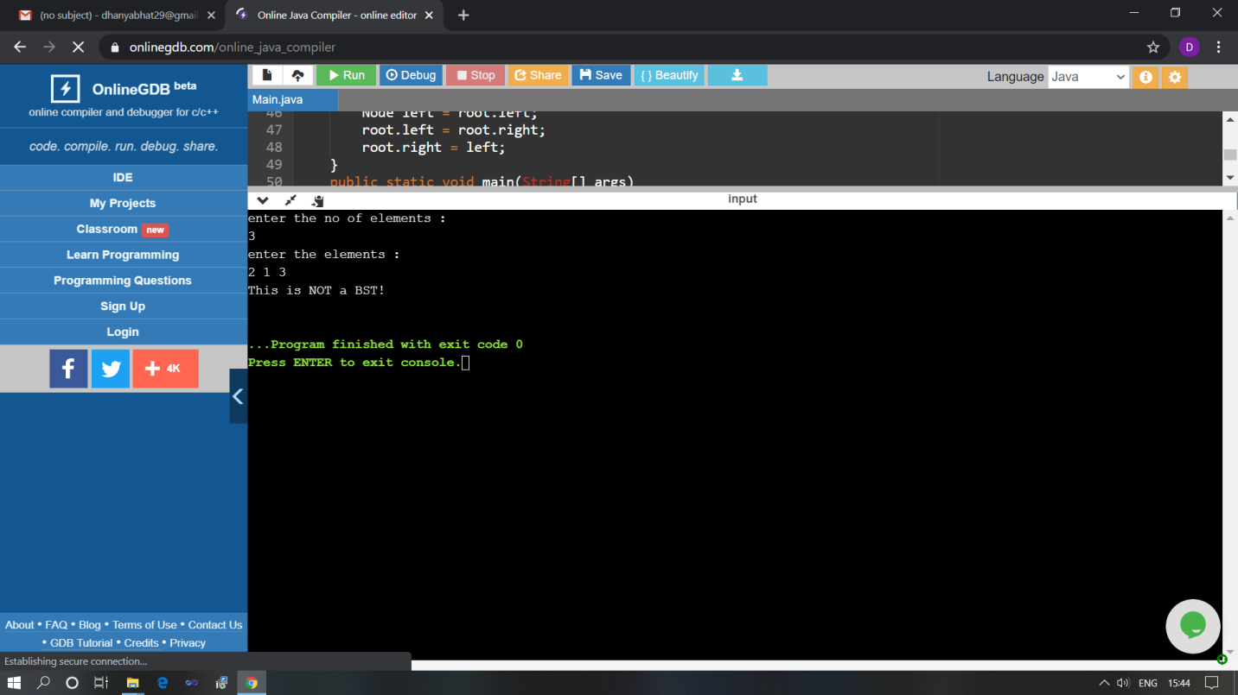

The above Programs were written and executed and the output of the same is displayed above. The code for those 2 programs have been uploaded to the github repository and the link to the same is provided on the form.