**DAILY ONLINE ACTIVITIES SUMMARY**

|  |  |  |  |  |  |  |  |  |
| --- | --- | --- | --- | --- | --- | --- | --- | --- |
| **Date:** | **19-06-2020** | | | | | **Name:** | **Dhanya Bhat** | |
| **Sem & Sec** | **6th A** | | | | | **USN:** | **4AL17CS027** | |
| **Online Test Summary** | | | | | | | | |
| **Subject** | | C programming quiz | | | | | | |
| **Max. Marks** | | **Quiz1-4**  **Quiz2-4** | | **Score** | | | **Quiz1-3**  **Quiz2-3** | |
| **Pre-Placement Training Summary** | | | | | | | | |
| **Pre-Placement training** | 9.00-11.00:Programming in C11.00-1.00:Applications of Python Programming in Data Analytics and Machine Learning – Research Perspective | | | | | | | |
| **Faculty name** | | | **Shilpa gowda and Dr.** Mohideen  Badusha | | **Duration** | | | **4hrs** |
| **Coding Challenges** | | | | | | | | |
| **Problem Statement**: 1. Write a C Program for the following using pointer concept  **a.** To swap 2 numbers using pointer and function concept, return value from user defined function and print the swapped values in main() function.  **b.** Given a positive integer n, count the total number of set bits in binary representation of all numbers from 1 to n.  2. Write a Java program to create a doubly linked list of n nodes and display it in reverse order.  3. Write a C Program to rotate a Matrix by 90 Degree in Clockwise or Anticlockwise Direction. Implement (Both the rotations in single program using switch case statement).  **4**. Exercise of Python Programming. | | | | | | | | |
| **Status: YES, Completed all Programs.** | | | | | | | | |
| **Uploaded the report in Github** | | | | | **YES** | | | |
| **If yes Repository name** | | | | | <https://github.com/alvas-education-foundation/Dhanya-bhat-4AL17CS027> | | | |
| **Uploaded the report in slack** | | | | | **YES** | | | |

Online test Details: (Attach the snapshot and briefly write the report for the same)

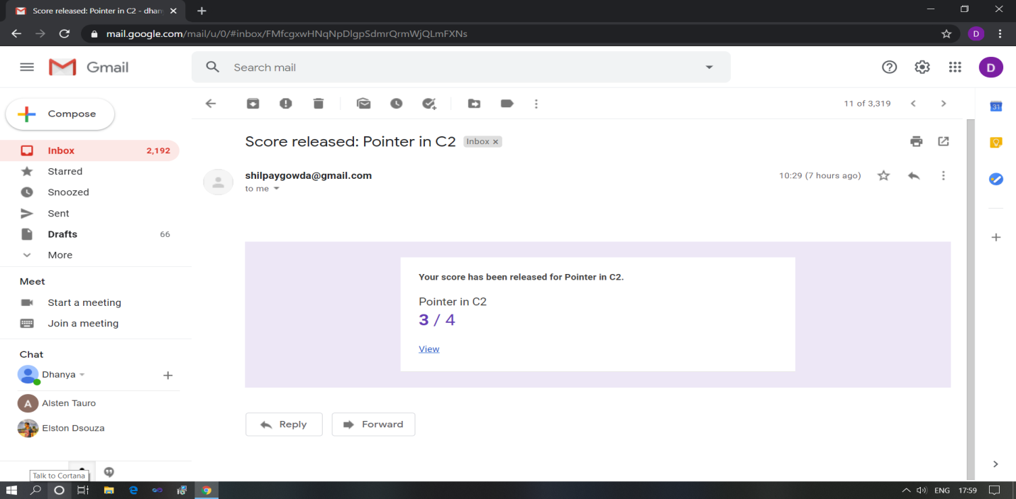

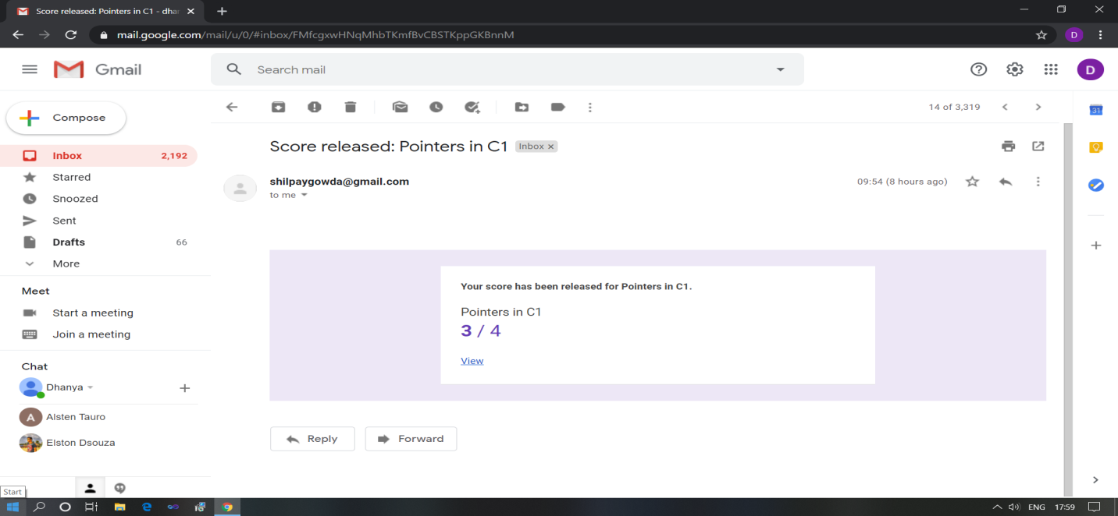

Pre-Placement Course Details: (Attach the snapshot and briefly write the report for the same)

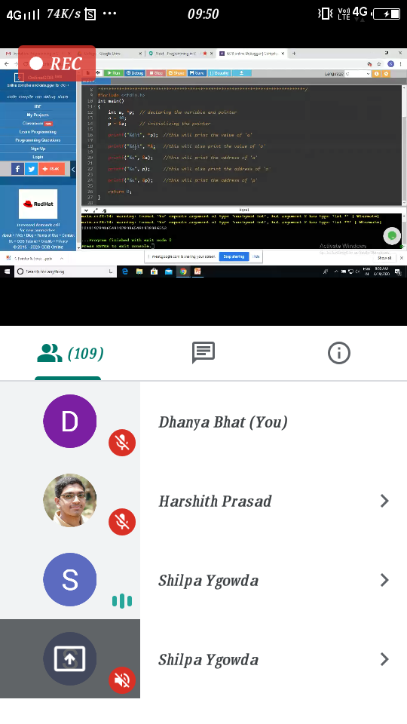

Programming in C

Today in this session I studies about Pointers with example programs. I also attended 2 quiz in the middle of the session.

The exercise of the session is uploaded in the below github repository :

<https://github.com/Dhanya-bhat/Pre_Placement_C_Programming>

### C:\Users\User\Downloads\Screenshot_20200619_121620.png

### Applications of Python Programming in Data Analytics and Machine Learning – Research Perspective

### Today in this session I studies about data analytics model with worked examples of python program

### The exercise of the session is uploaded in the below github repository :

<https://github.com/Dhanya-bhat/Application_of_Python_Programming_in_DA_and_ML>

Coding Challenges Details: (Attach the snapshot and briefly write the report for the same)

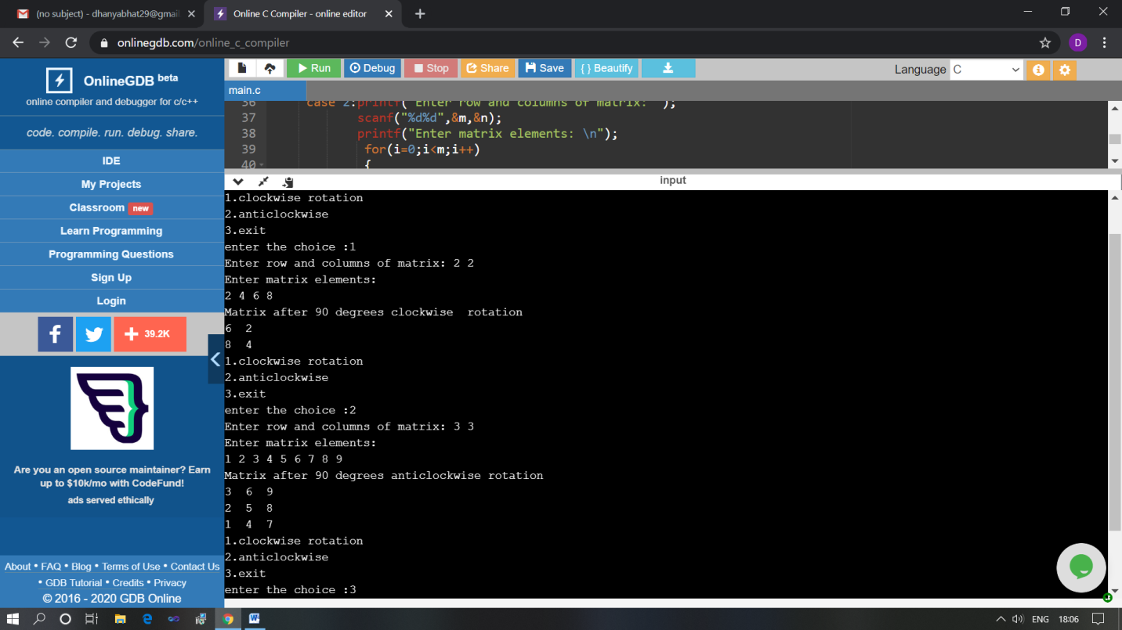

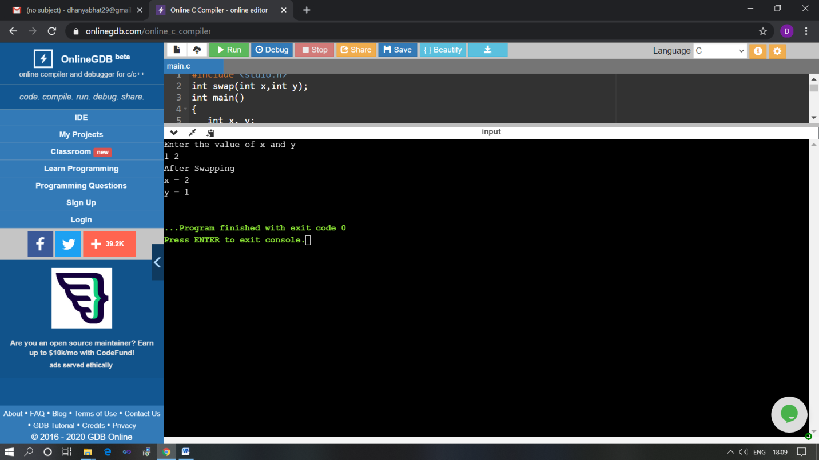

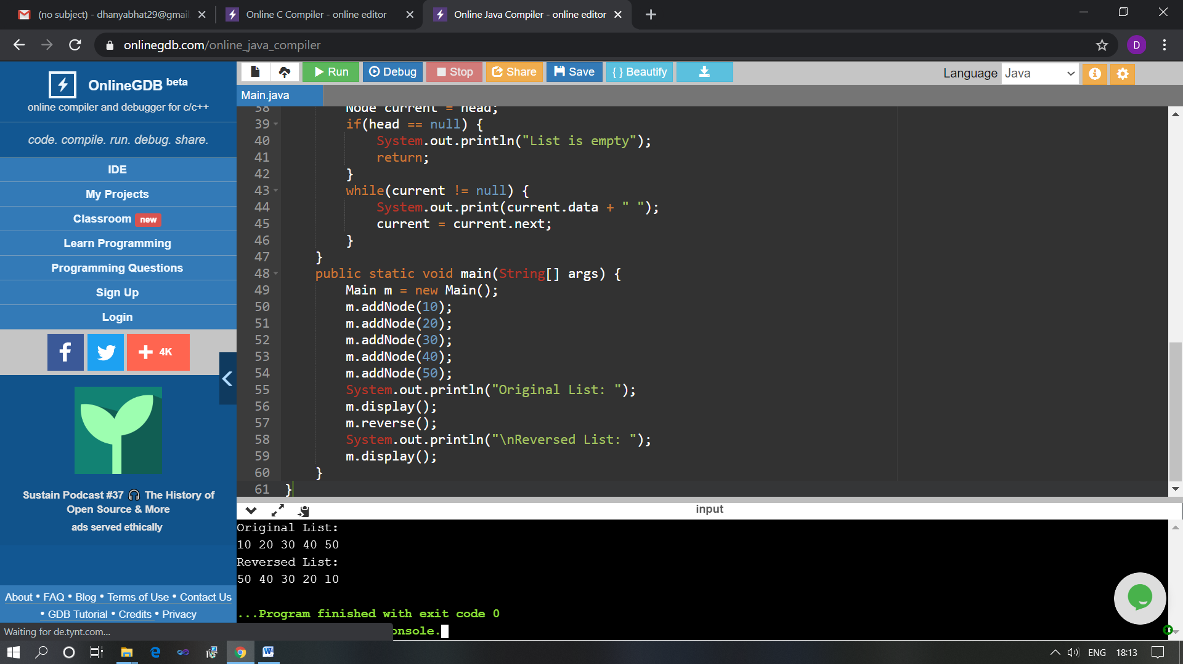

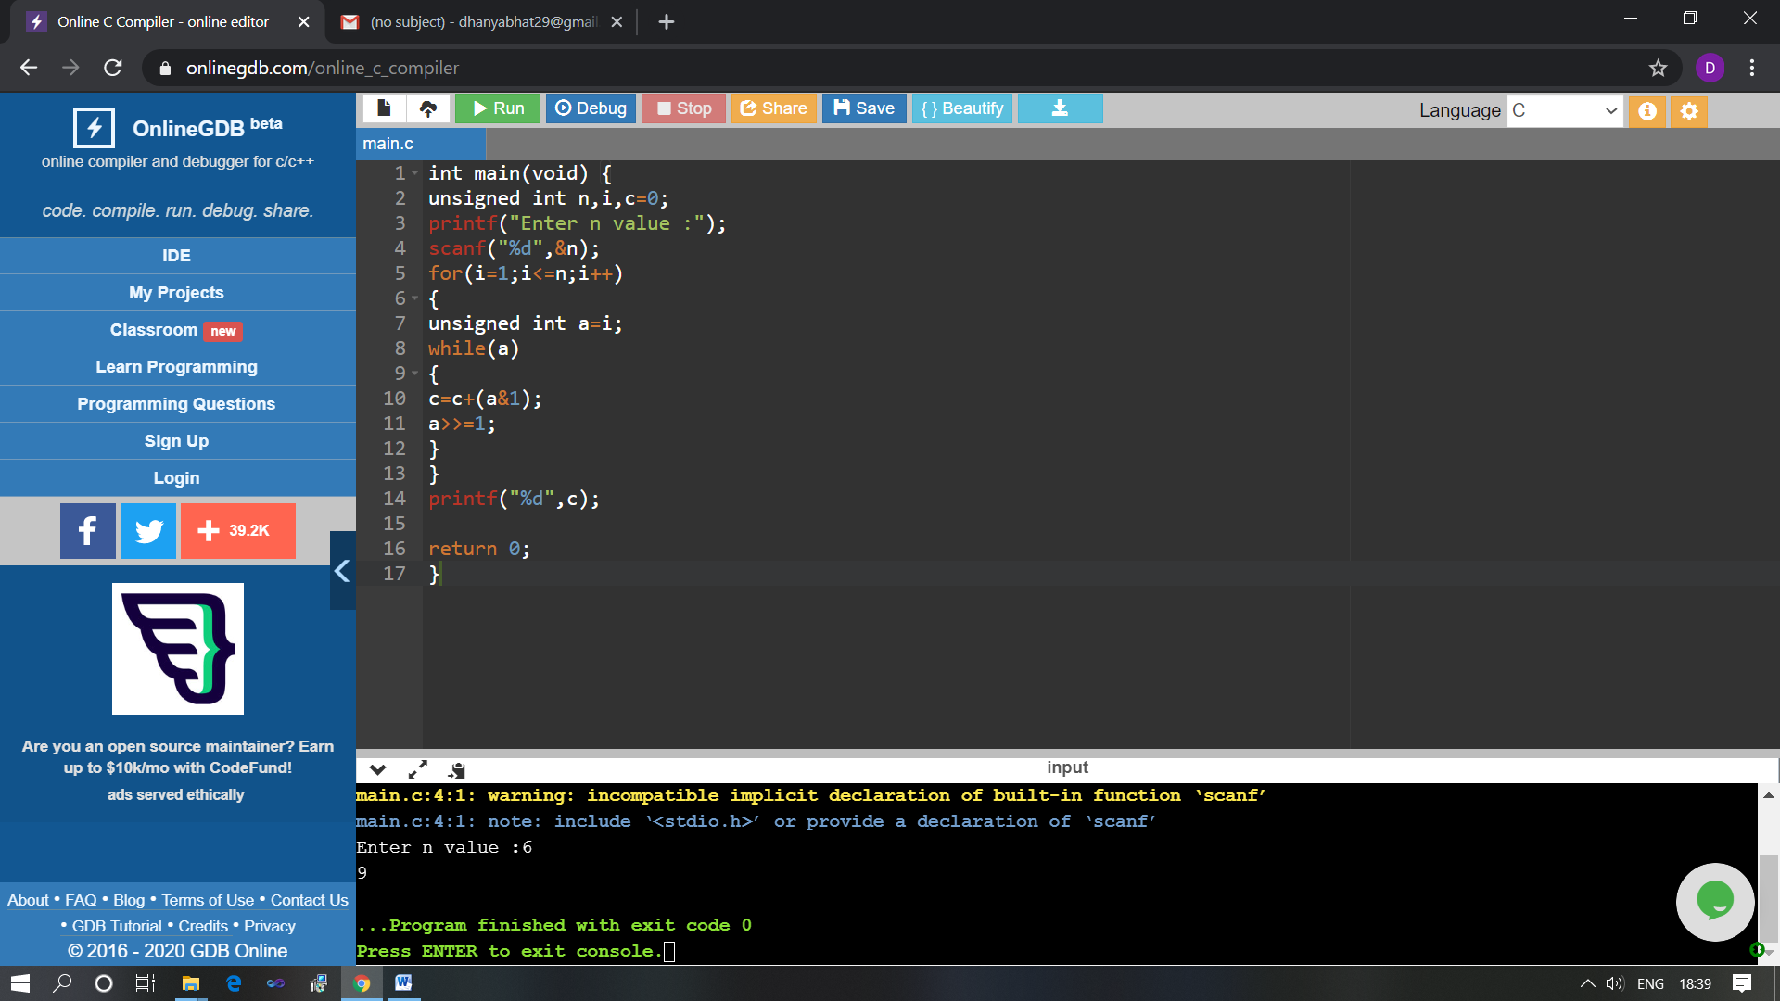

The above Programs were written and executed and the output of the same is displayed above. The code for those 4 programs have been uploaded to the github repository and the link to the same is provided on the form.