**DAILY ONLINE ACTIVITIES SUMMARY**

|  |  |  |  |  |  |  |  |  |
| --- | --- | --- | --- | --- | --- | --- | --- | --- |
| **Date:** | **21-05-2020** | | | | | **Name:** | **Dhanya Bhat** | |
| **Sem & Sec** | **6th A** | | | | | **USN:** | **4AL17CS027** | |
| **Online Test Summary** | | | | | | | | |
| **Subject** | | **Operating System(OS)** | | | | | | |
| **Max. Marks** | | **30** | | **Score** | | | **30** | |
| **Certification Course Summary** | | | | | | | | |
| **Course** | **A Full Stack Web Developer – Beginner to Advanced** | | | | | | | |
| **Certificate Provider** | | | **Udemy** | | **Duration** | | | **19.5hrs** |
| **Coding Challenges** | | | | | | | | |
| Problem Statement: 1. Write a java program to implement round robin scheduling algorithm.Calculate AVG WT AND TAT. INPUT:NO OF PROCESSES,BURST TIME AND TIME QUANTUM.  2. Write a Java Program to Demonstrate a Basic Calculator using Applet.  3. Write C Program to create Singly Liked List with n elements and reverse the elements.  4. Write a C program to construct a singly linked list by removing duplicate elements in the sorted linked list | | | | | | | | |
| Status: YES, Completed all Programs | | | | | | | | |
| **Uploaded the report in Github** | | | | | **YES** | | | |
| **If yes Repository name** | | | | | <https://github.com/alvas-education-foundation/Dhanya-bhat> | | | |
| **Uploaded the report in slack** | | | | | **YES** | | | |

Online Test Details: (Attach the snapshot and briefly write the report for the same)

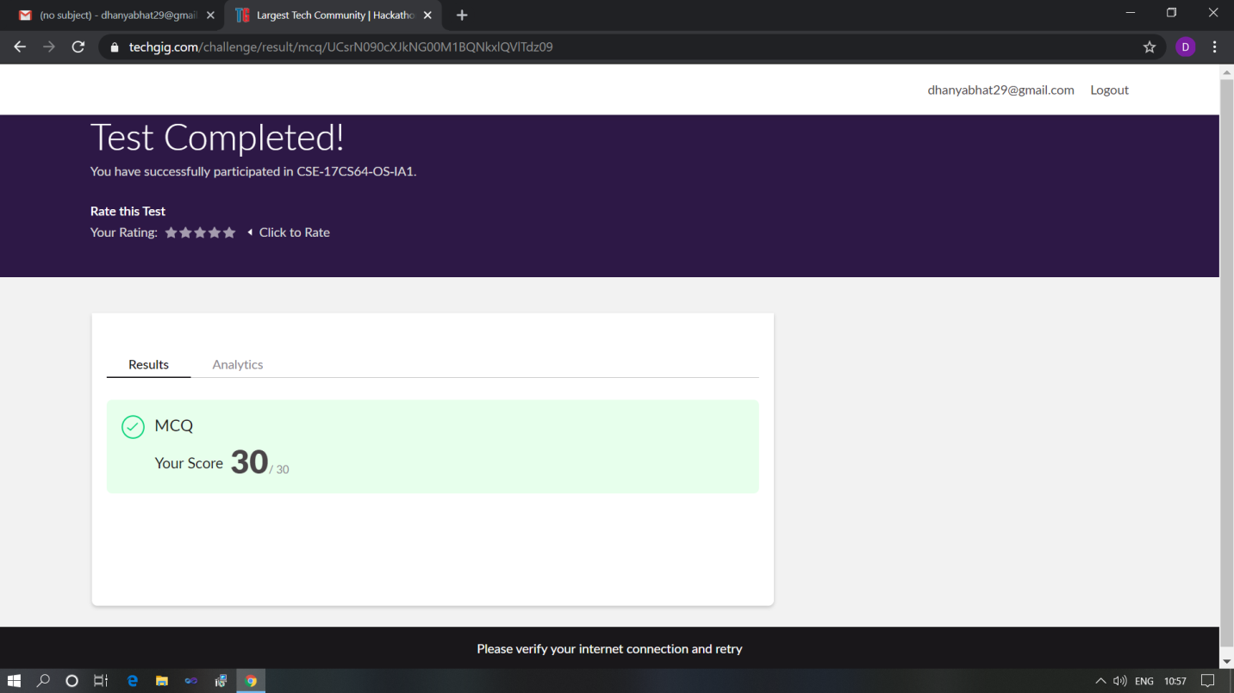

Scored 30 out of 30 in OS 1st I.A test

Certification Course Details: (Attach the snapshot and briefly write the report for the same)

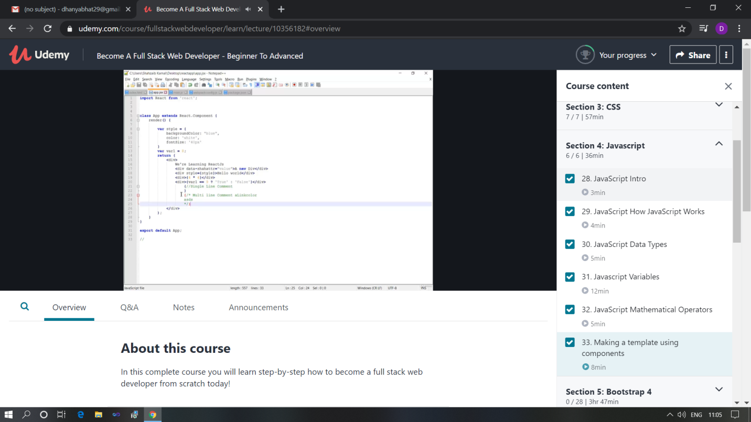

The above course is being taken up by me which is based on the full stack web development. It started with the basics of HTML, Today in Online course I studied about JavaScript intro, how JavaScript works, JavaScript data types, JavaScript variables, JavaScript mathematical operators, making a template using components. The details of the course and certificate provider is mentioned in the above form.

Coding Challenges Details: (Attach the snapshot and briefly write the report for the same)

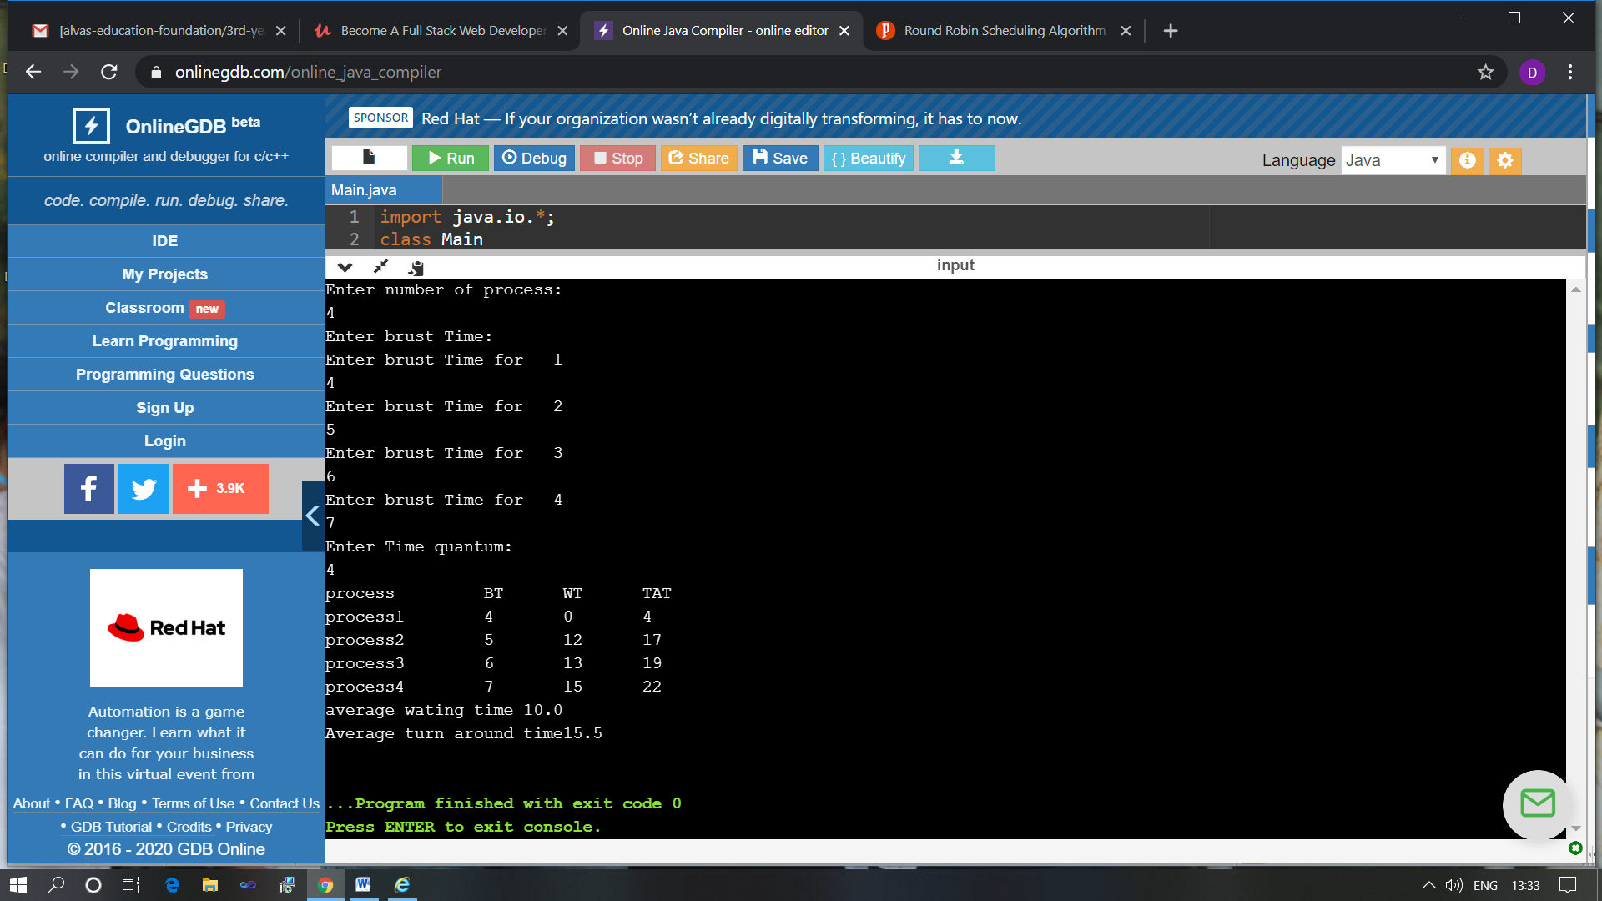

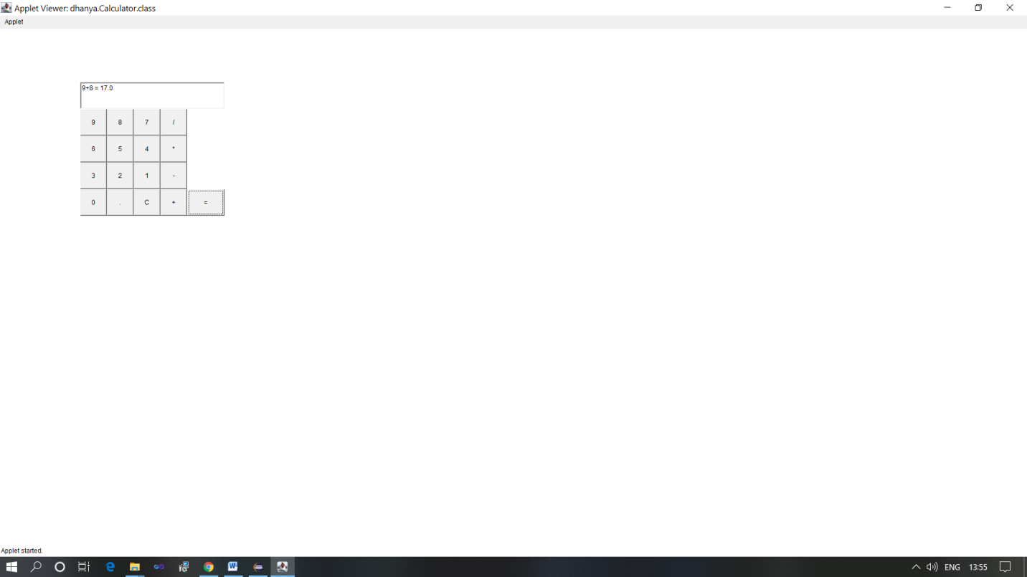

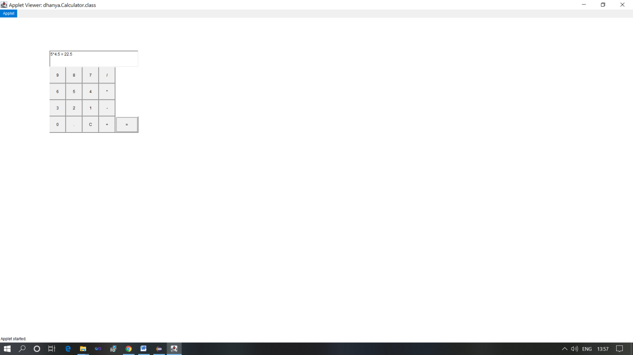

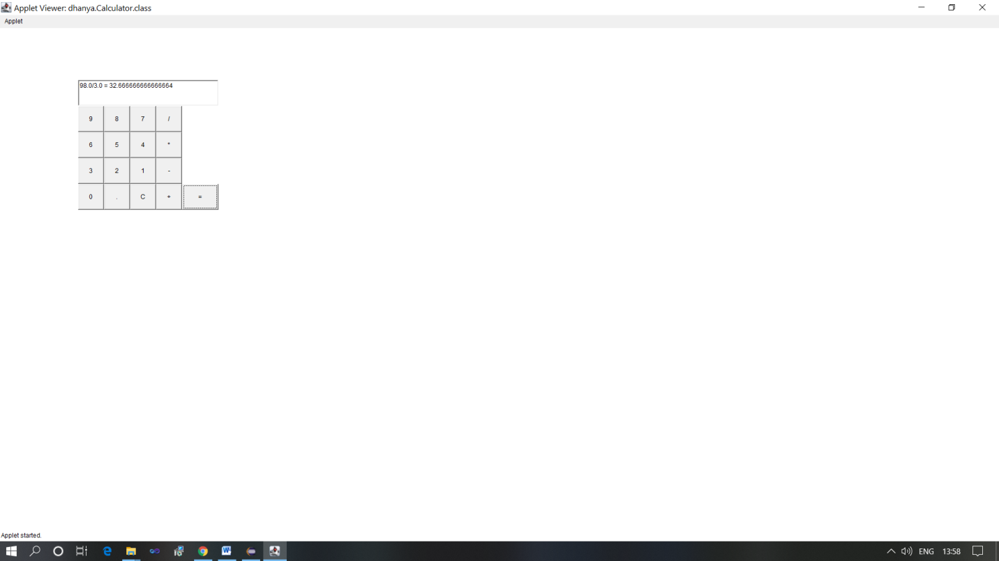

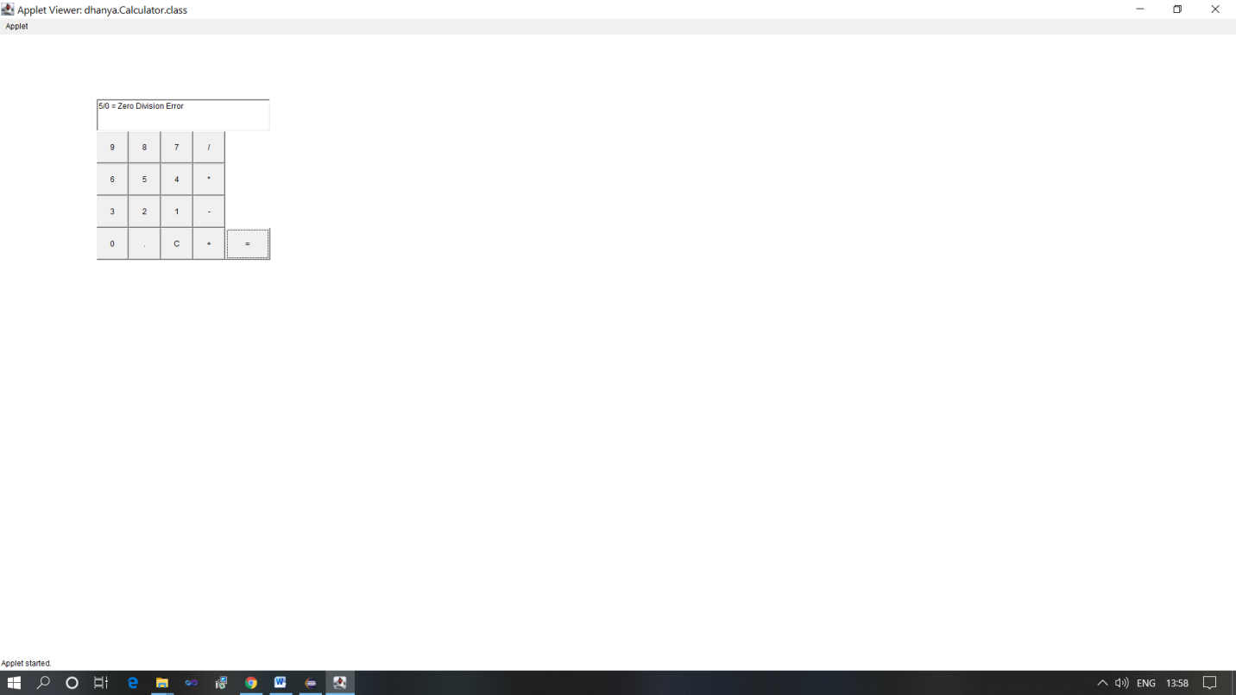

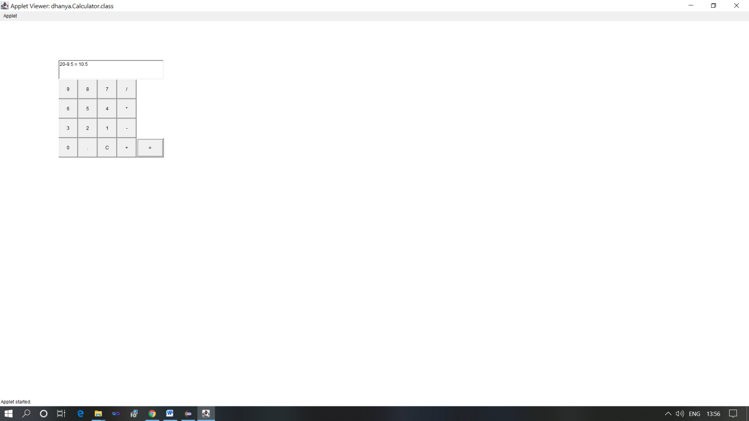

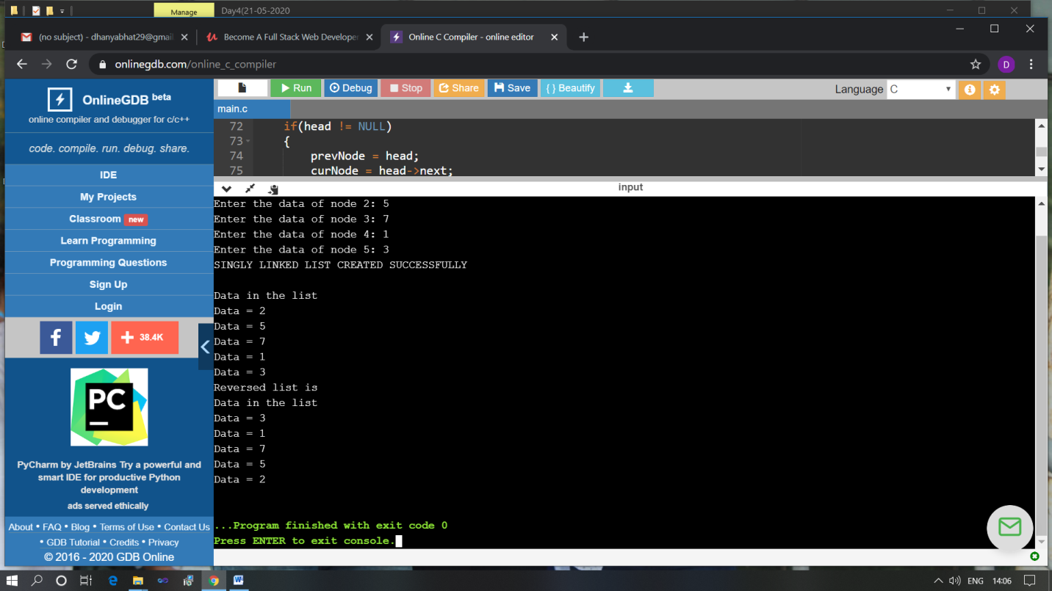

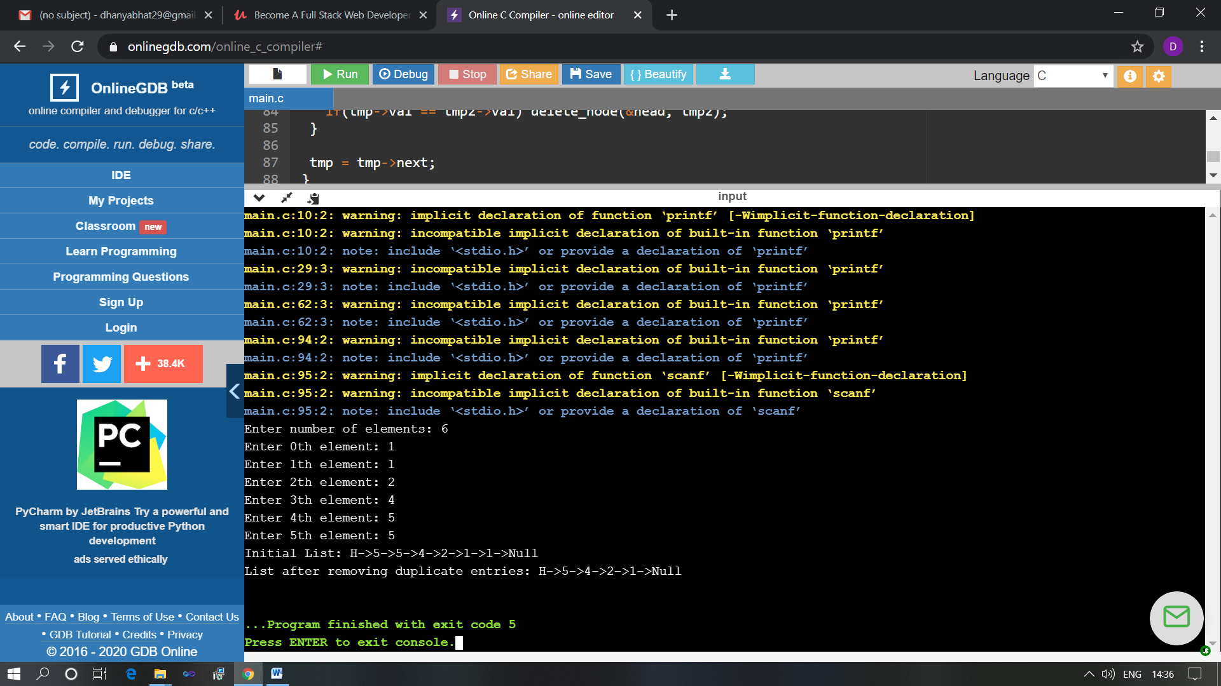

The above Programs were written and executed and the output of the same is displayed above. The code for those 4 programs have been uploaded to the github repository and the link to the same is provided on the form