**DAILY ONLINE ACTIVITIES SUMMARY**

|  |  |  |  |  |  |  |  |  |
| --- | --- | --- | --- | --- | --- | --- | --- | --- |
| **Date:** | **22-06-2020** | | | | | **Name:** | **Dhanya Bhat** | |
| **Sem & Sec** | **6th A** | | | | | **USN:** | **4AL17CS027** | |
| **Online Test Summary** | | | | | | | | |
| **Subject** | | C++ programming quiz | | | | | | |
| **Max. Marks** | |  | | **Score** | | |  | |
| **Pre-Placement Training Summary** | | | | | | | | |
| **Pre-Placement training** | 9.20-11.00: Programming in C++11.10-1.00: Programming in C++ | | | | | | | |
| **Faculty name** | | | **Ankitha shetty and Shilpa gowda** | | **Duration** | | | **4hrs** |
| **Coding Challenges** | | | | | | | | |
| **Problem Statement**: 1. Write a Java program to find maximum repeated words from a file. | | | | | | | | |
| **Status: YES, Completed all Programs.** | | | | | | | | |
| **Uploaded the report in Github** | | | | | **YES** | | | |
| **If yes Repository name** | | | | | <https://github.com/alvas-education-foundation/Dhanya-bhat-4AL17CS027> | | | |
| **Uploaded the report in slack** | | | | | **YES** | | | |

Online test Details: (Attach the snapshot and briefly write the report for the same)

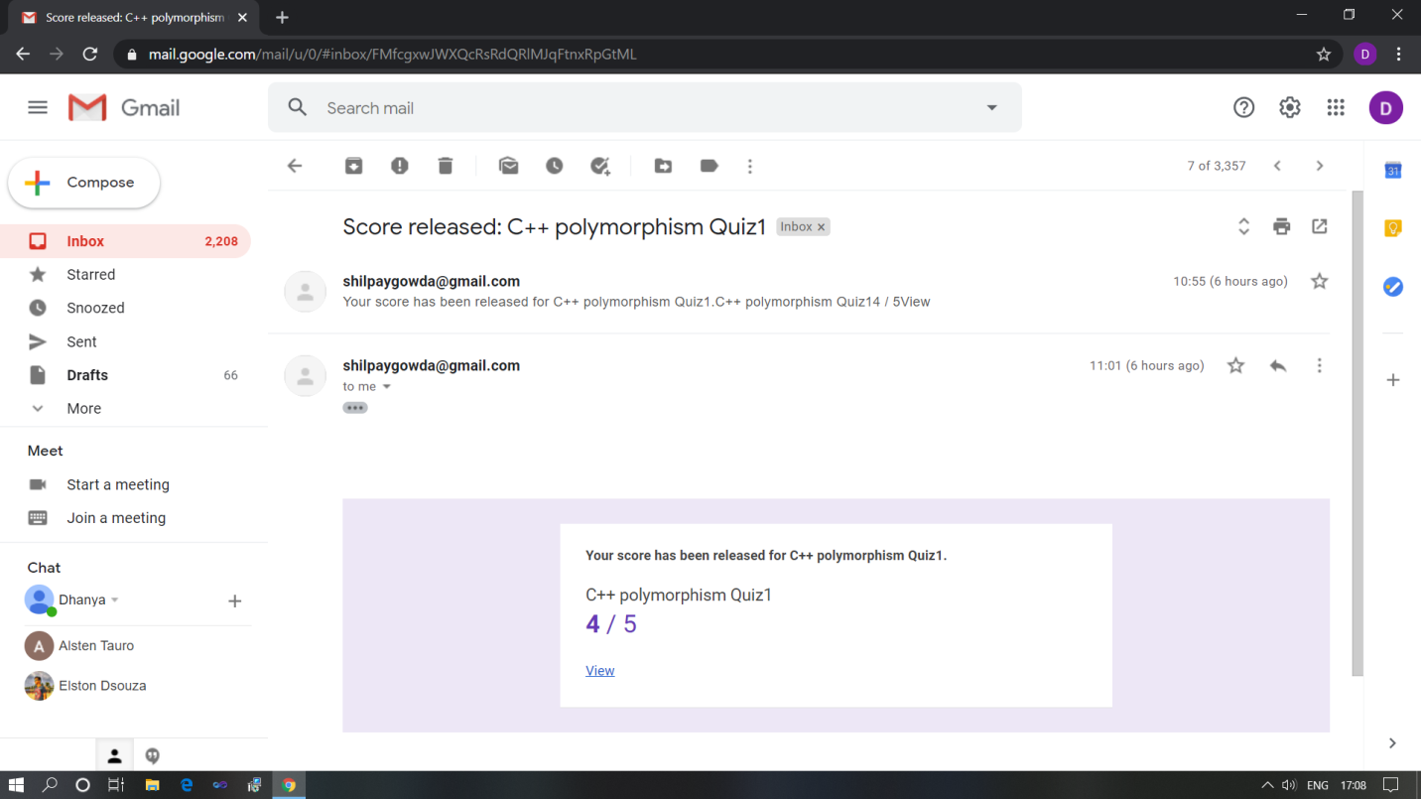

C++ programming quiz

Pre-Placement Course Details: (Attach the snapshot and briefly write the report for the same)

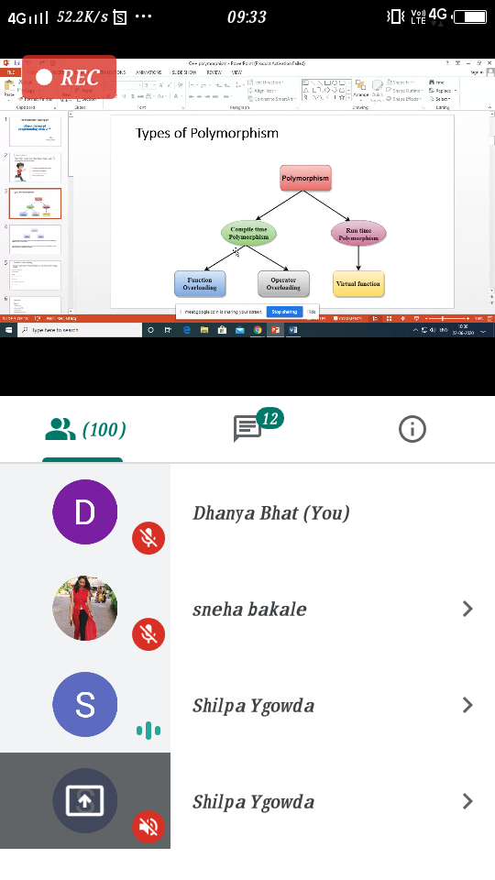

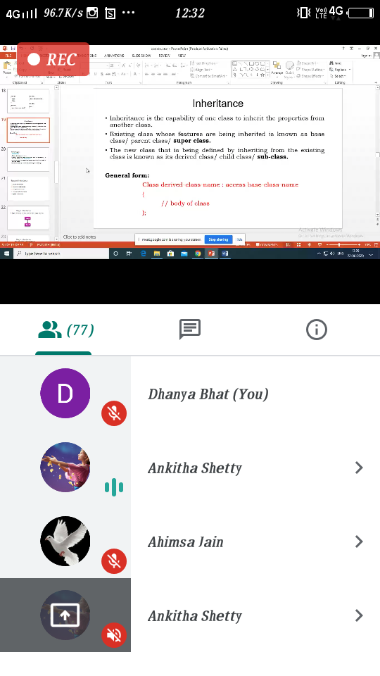

Programming in C++

Today in the session I studied about inheritance, polymorphism, constructor and destructor with C++ programming examples. I also attended 4 quiz in the middle of the session.

Coding Challenges Details: (Attach the snapshot and briefly write the report for the same)

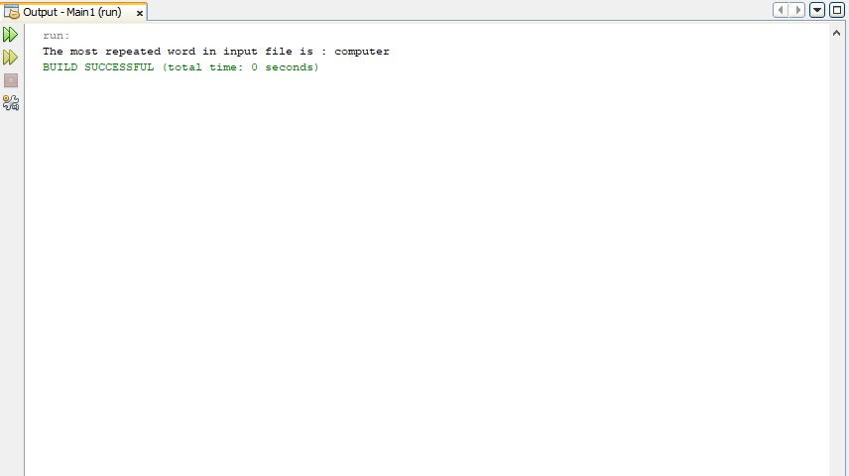

The above Programs were written and executed and the output of the same is displayed above. The code for those 1 programs have been uploaded to the github repository and the link to the same is provided on the form.