**DAILY ONLINE ACTIVITIES SUMMARY**

|  |  |  |  |  |  |  |  |  |
| --- | --- | --- | --- | --- | --- | --- | --- | --- |
| **Date:** | **24-06-2020** | | | | | **Name:** | **Dhanya Bhat** | |
| **Sem & Sec** | **6th A** | | | | | **USN:** | **4AL17CS027** | |
| **Online Test Summary** | | | | | | | | |
| **Subject** | | Java and Data structure quiz | | | | | | |
| **Max. Marks** | |  | | **Score** | | |  | |
| **Pre-Placement Training Summary** | | | | | | | | |
| **Pre-Placement training** | 9.20-11.00: Java & J2EE11.10-1.00: C programming | | | | | | | |
| **Faculty name** | | | **Shilpa and Venkatesh bhat** | | **Duration** | | | **4hrs** |
| **Coding Challenges** | | | | | | | | |
| **Problem Statement**: 1. Create a class named 'Shape' with a method to print "This is This is shape". Then create two other classes named 'Rectangle', 'Circle' inheriting the Shape class, both having a method to print "This is rectangular shape" and "This is circular shape" respectively. Create a subclass 'Square' of 'Rectangle' having a method to print "Square is a rectangle". Now call the method of 'Shape' and 'Rectangle' class by the object of 'Square' class. | | | | | | | | |
| **Status: YES, Completed all Programs.** | | | | | | | | |
| **Uploaded the report in Github** | | | | | **YES** | | | |
| **If yes Repository name** | | | | | <https://github.com/alvas-education-foundation/Dhanya-bhat-4AL17CS027> | | | |
| **Uploaded the report in slack** | | | | | **YES** | | | |

Online test Details: (Attach the snapshot and briefly write the report for the same)

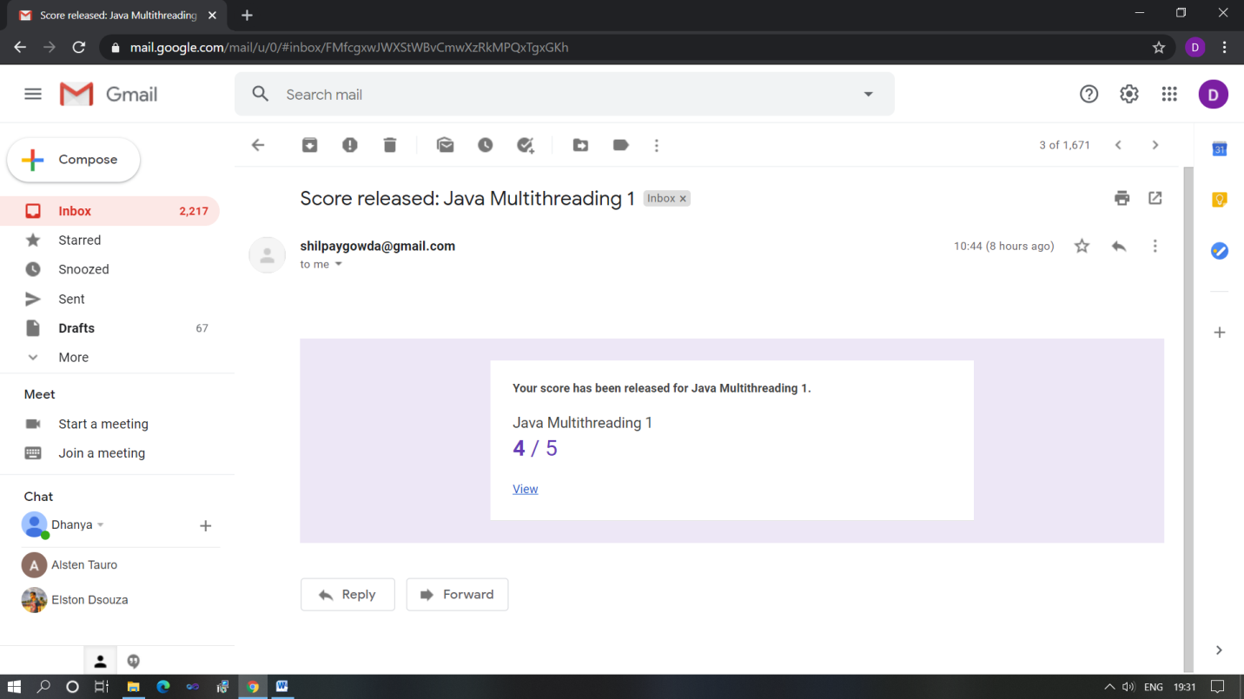

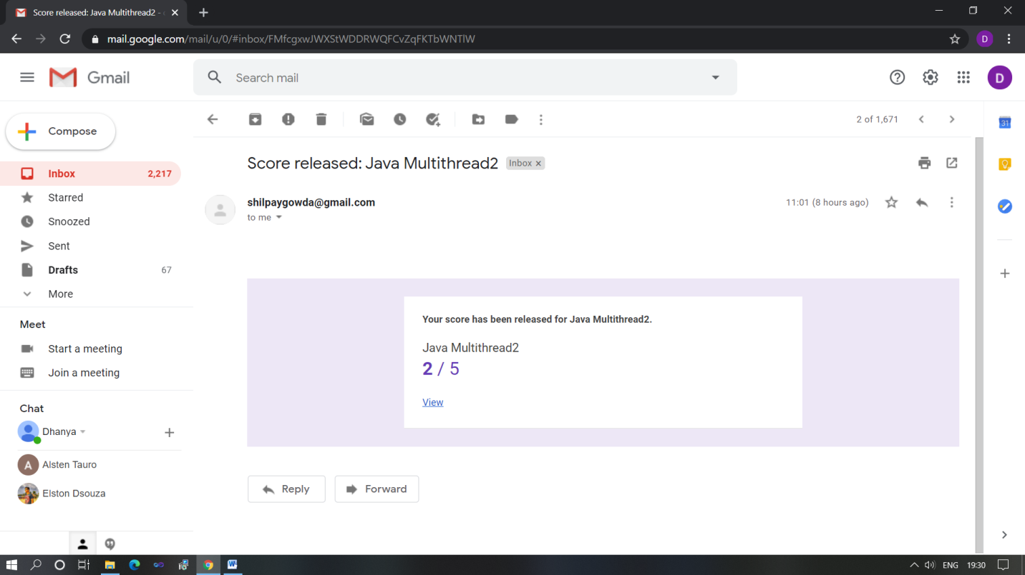

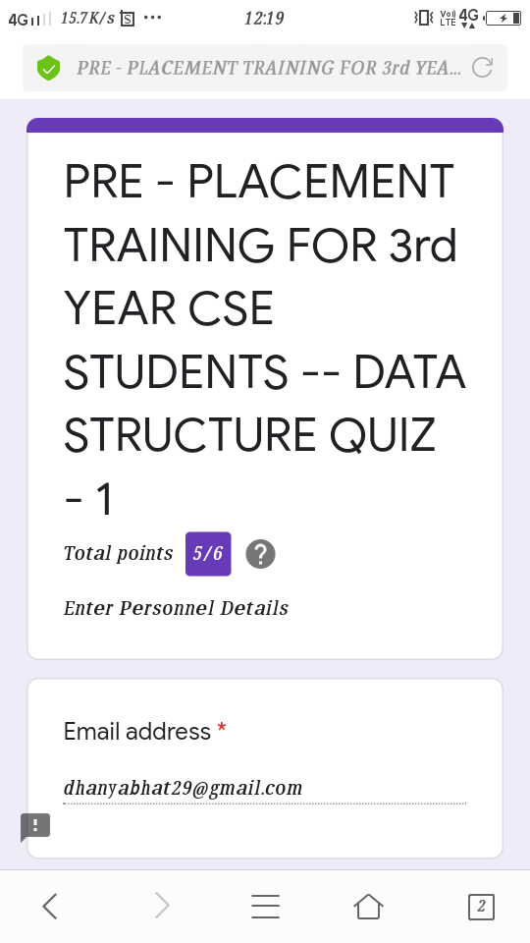

Quiz on Data structure and Java programming

Pre-Placement Course Details: (Attach the snapshot and briefly write the report for the same)

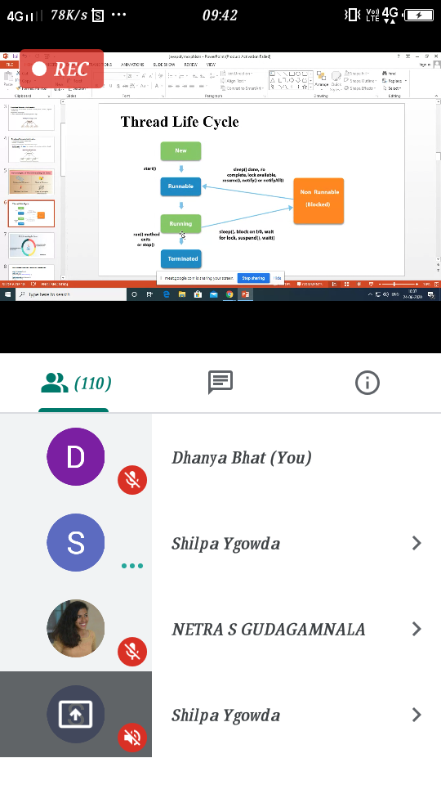

v

Java & J2EE

Today in the session I studied about Multithreading and Multitasking with Java programming examples. I also attended 2 quiz in the middle of the session.

### C:\Users\User\Downloads\Screenshot_20200624_115658.png

C programming

Today in the session I studied about stack, singly and doubly linked list with C programming examples. I also attended 4 quiz in the middle of the session.

Coding Challenges Details: (Attach the snapshot and briefly write the report for the same)

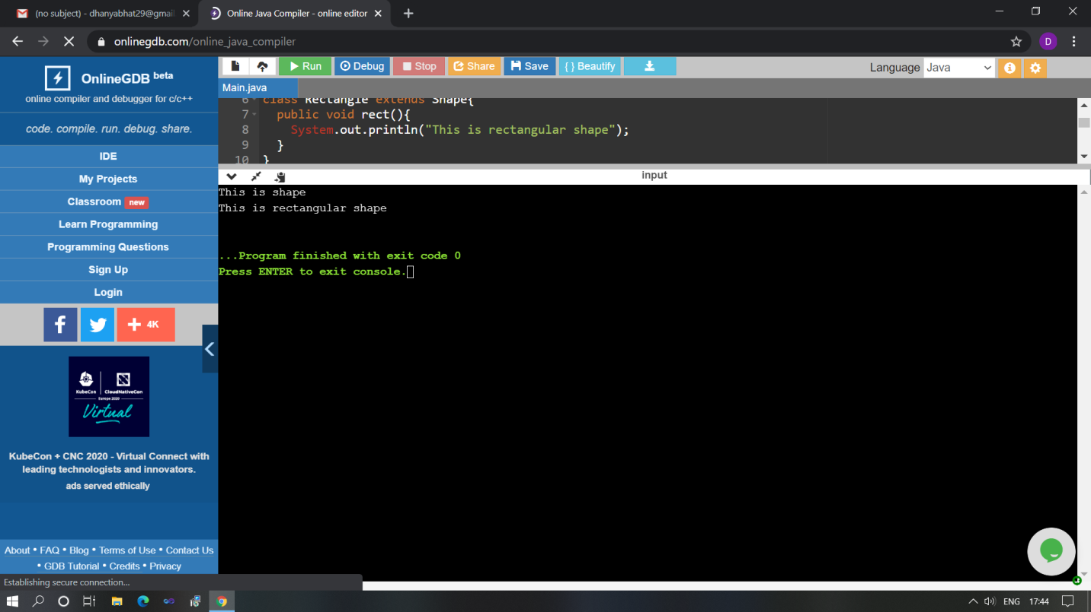

The above Programs were written and executed and the output of the same is displayed above. The code for those 1 programs have been uploaded to the github repository and the link to the same is provided on the form.