**DAILY ONLINE ACTIVITIES SUMMARY**

|  |  |  |  |  |  |  |  |  |
| --- | --- | --- | --- | --- | --- | --- | --- | --- |
| **Date:** | **24-07-2020** | | | | | **Name:** | **Dhanya Bhat** | |
| **Sem & Sec** | **6th A** | | | | | **USN:** | **4AL17CS027** | |
| **Online Test Summary** | | | | | | | | |
| **Subject** | | System software and compiler design (SSCD) | | | | | | |
| **Max. Marks** | | **30** | | **Score** | | | **-** | |
| **Online Course Summary** | | | | | | | | |
| **Online Course**  **name** | Introduction to HTML5 | | | | | | | |
| **Certificate provider** | | | **Coursera** | | **Duration** | | | **12hr** |
| **Coding Challenges** | | | | | | | | |
| Problem Statement: 1. Python program to check the length of the linked list using linked list. | | | | | | | | |
| **Status: YES, Completed all Programs.** | | | | | | | | |
| **Uploaded the report in Github** | | | | | **YES** | | | |
| **If yes Repository name** | | | | | <https://github.com/alvas-education-foundation/Dhanya-bhat-4AL17CS027> | | | |
| **Uploaded the report in slack** | | | | | **YES** | | | |

Online course Details: (Attach the snapshot and briefly write the report for the same)

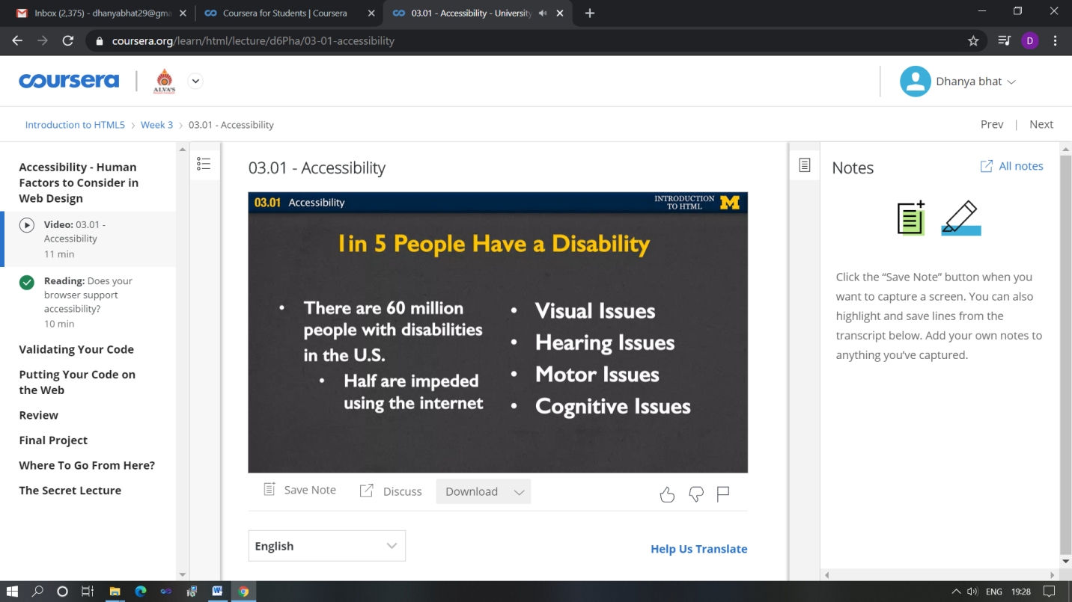

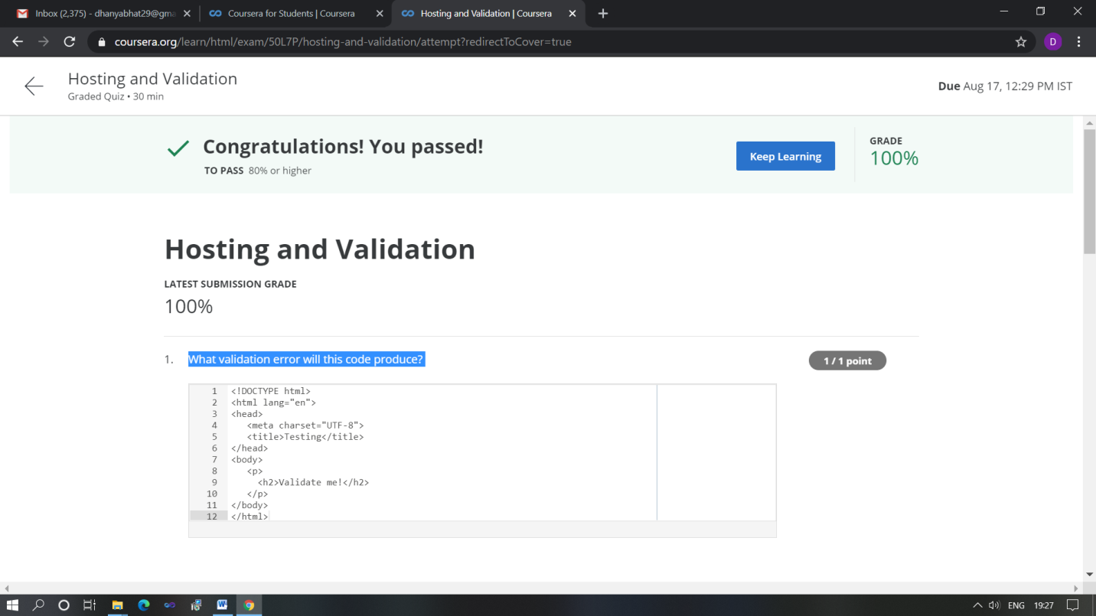

Started Introduction to HTML5 online course Today in this course I studied about some concepts of HTML5.

Coding Challenges Details: (Attach the snapshot and briefly write the report for the same)

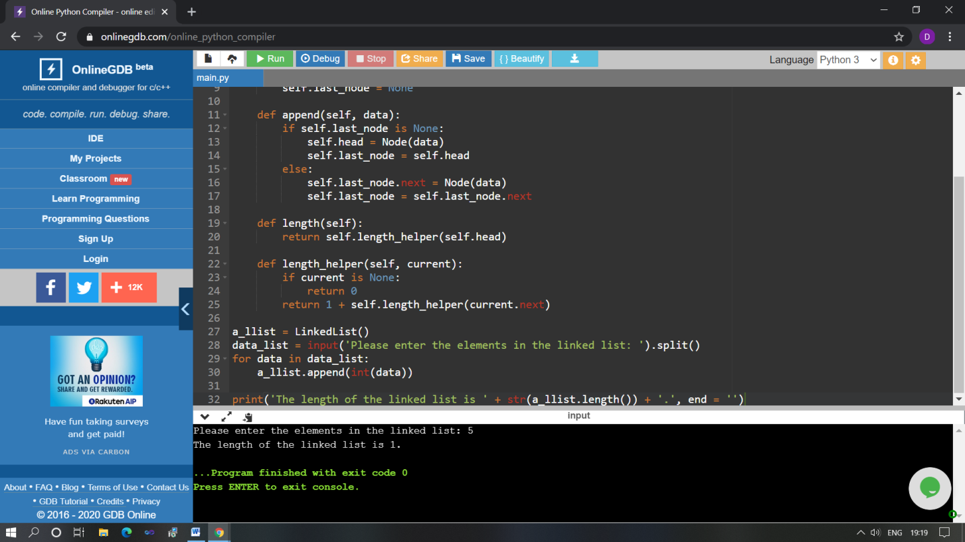

The above Programs were written and executed and the output of the same is displayed above. The code for those 1 programs have been uploaded to the github repository and the link to the same is provided on the form.