**DAILY ONLINE ACTIVITIES SUMMARY**

|  |  |  |  |  |  |  |  |  |
| --- | --- | --- | --- | --- | --- | --- | --- | --- |
| **Date:** | **26-06-2020** | | | | | **Name:** | **Dhanya Bhat** | |
| **Sem & Sec** | **6th A** | | | | | **USN:** | **4AL17CS027** | |
| **Online Test Summary** | | | | | | | | |
| **Subject** | | Cyber security and Data structure quiz | | | | | | |
| **Max. Marks** | |  | | **Score** | | |  | |
| **Pre-Placement Training Summary** | | | | | | | | |
| **Pre-Placement training** | 9.20-11.00: Cyber security and law11.10-1.00: C programming | | | | | | | |
| **Faculty name** | | | **Manjunath kotari and Venkatesh bhat** | | **Duration** | | | **4hrs** |
| **Coding Challenges** | | | | | | | | |
| **Problem Statement**: 1. Write a program to print all permutations of a given string. | | | | | | | | |
| **Status: YES, Completed all Programs.** | | | | | | | | |
| **Uploaded the report in Github** | | | | | **YES** | | | |
| **If yes Repository name** | | | | | <https://github.com/alvas-education-foundation/Dhanya-bhat-4AL17CS027> | | | |
| **Uploaded the report in slack** | | | | | **YES** | | | |

Online test Details: (Attach the snapshot and briefly write the report for the same)

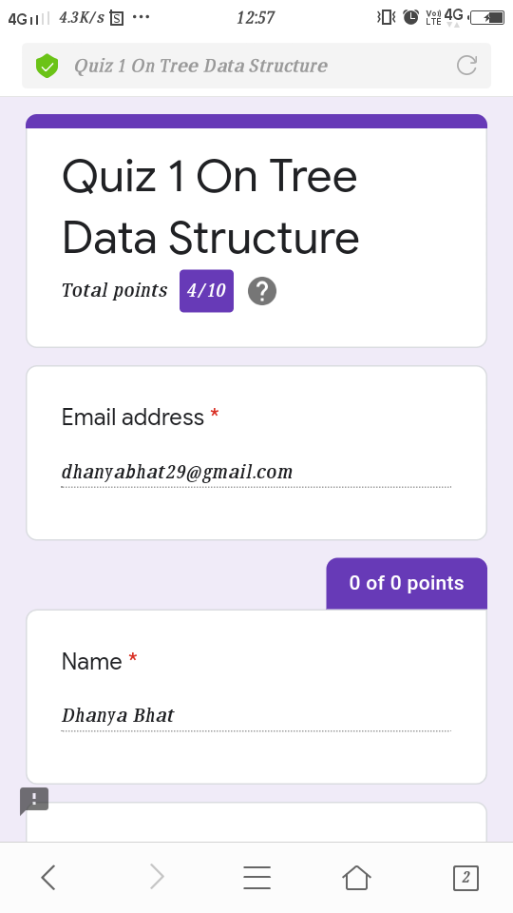

Quiz on Cyber security and Data structure

Pre-Placement Course Details: (Attach the snapshot and briefly write the report for the same)

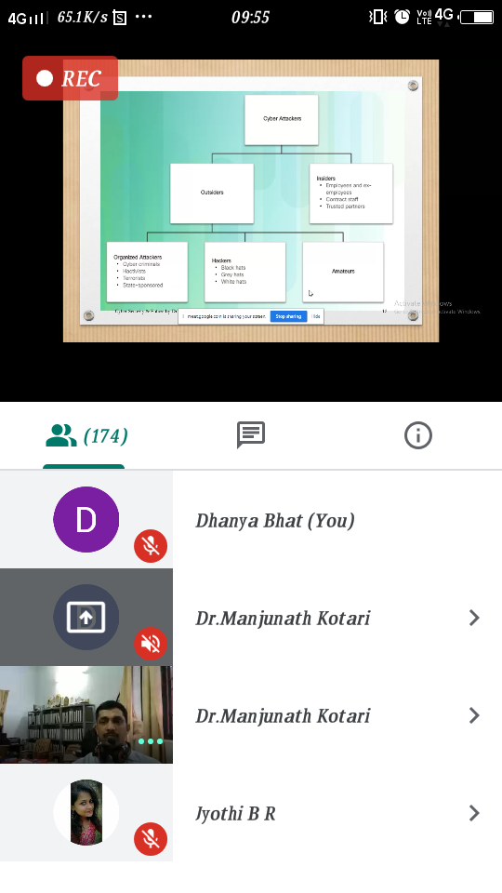

v Cyber security and law

Today in the session I studied about introduction to Cyber scurity. I also attended 2 quiz in the middle of the session.

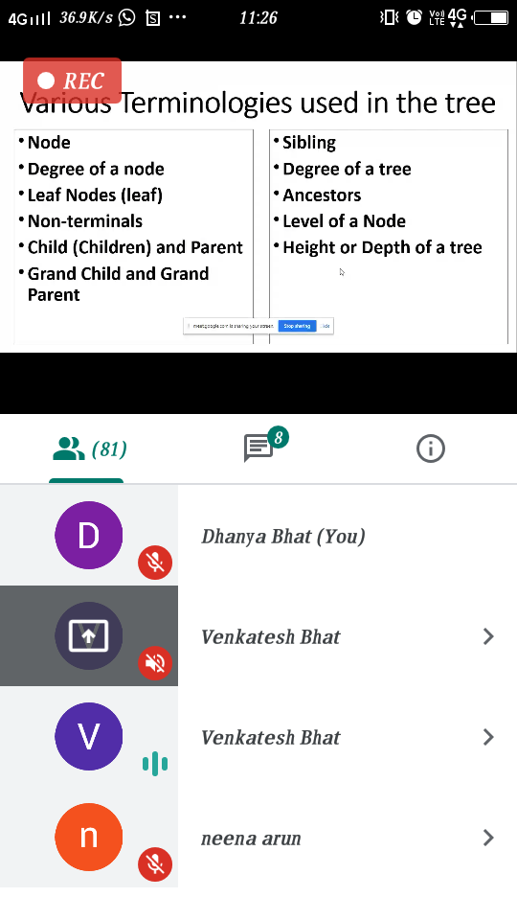

C programming

Today in the session I studied about Tree with C programming examples. I also attended 2 quiz in the middle of the session.

Coding Challenges Details: (Attach the snapshot and briefly write the report for the same)

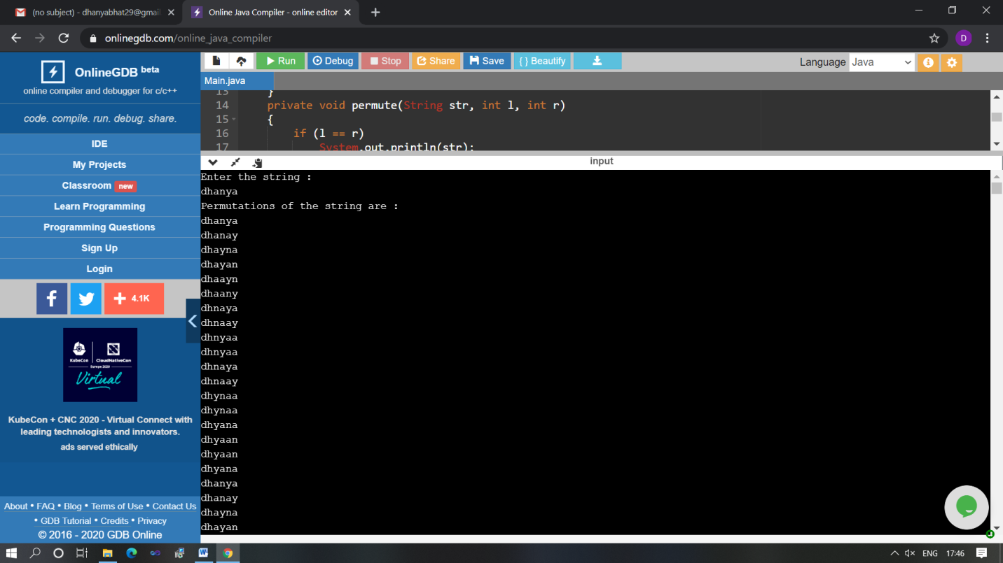

The above Programs were written and executed and the output of the same is displayed above. The code for those 1 programs have been uploaded to the github repository and the link to the same is provided on the form.